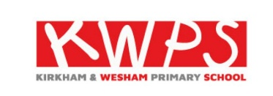
Kirkham and Wesham Primary School
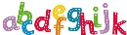  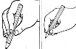  Literacy  Phonics – Phase 2 sounds  Reading – talking about books, turning pages, pointing to the words as we read  Writing – writing our names, starting to mark make with the sounds that we have learnt  Vocabulary – picture, writing, sounds, books, page, letters, sounds, words. | 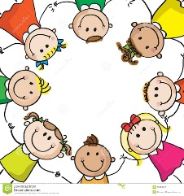  Personal, Social, Emotional Development  Vocabulary - Like, dislike, difference, special, feelings  My Relationships | 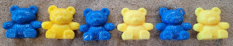  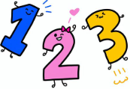  Maths  Matching, sorting, ordering, comparing, making simple patterns  Vocabulary - zero, next, order, match, patterns, forwards, backwards
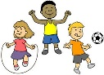  Physical Development  Getting dressed, controlling our bodies, basic skills.  Vocabulary  Run, jump, hop, skip, balance, pinch, cut, thread.  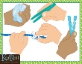  Using tools, fine motor skills | Reception Autumn Term 1  Ourselves  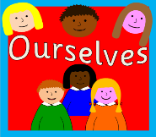 | 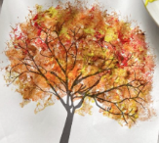  Creating with Materials  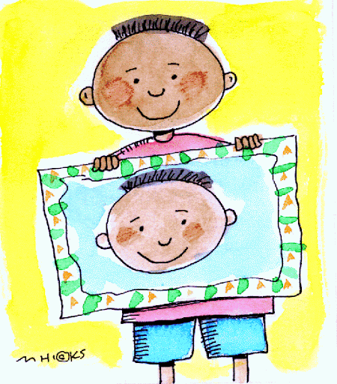  Portraits, printing, sculpture, transient art  Vocabulary – draw, transient, pinch, print
Being Imaginative and Expressive  Me! Singing – Pat- cake, 1,2,3,4,5 Once I caught a fish alive, Fish alive, This Old Man, Five Little Ducks  Name Song, Things for Fingers    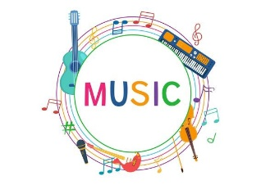 | Communication and Language  Vocabulary  Listen, talk, sentence, news,  Listening to stories. Listening to others, joining in with rhymes, sharing our news  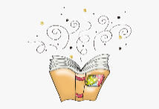  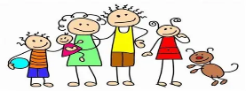 | Understanding the World  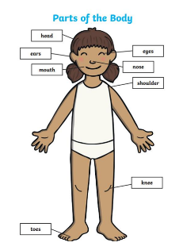  Vocabulary  Different, same, similar, senses, healthy, family, autumn.  Learn about their bodies, talk about their families, explore their environment
This half term, the children will settle into school and learn about themselves. Below is an overview of their learning and key vocabulary to understand and use.

