
Kirkham and Wesham Primary School
This half term, the children will explore a variety of celebrations from around the world. Below is an outline of what they’ll be learning, along with key vocabulary to help them understand and use throughout the topic.
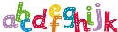  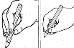  Literacy  Phonics – Phase 2 sounds  Reading – blend sounds that we have learnt to read CVC words, read some tricky words  Writing – record our ideas by writing at least the initial sounds and begin to write more sounds  Vocabulary – picture, writing, sounds, books, page, letters, sounds, words. | 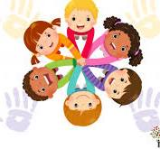  Personal, Social, Emotional Development  Vocabulary – confident, polite, gentle, caring, respect  My Relationships – safe relationships and respecting ourselves | 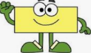  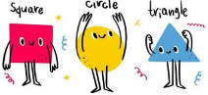  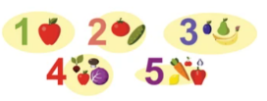  Maths  Vocabulary –  One more, count, altogether, shape, round, straight, square, rectangle  Numbers 1-5  Circles and Triangles  Shapes with 4 sides
Physical Development  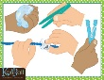  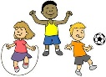  To balance and to move safely.  To move confidently in different ways  Using tools effectively (scissors, pencil, brushes)  Vocabulary  Run, jump, hop, skip, balance, space, control | Reception Autumn Term 2  Celebrations  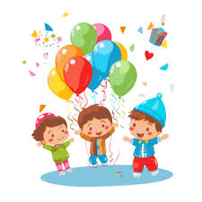 | Creating with Materials  Vocabulary – blending, dabbing, smudging, printing,  swirling  Bonfire night – painting and printing.  Cards and decorations for celebrations    
  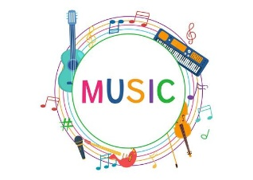  Being Imaginative and Expressive  Vocabulary – pulse, rhythm, pitch, tempo, tune.  My Stories – learn action songs, improvise rhythms and perform.  Listen to music and appraise. | Communication and Language  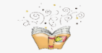  Vocabulary  Listen, talk, sentence, news,  To take turns during speaking and listening times.  To understand and use new vocabulary  To listen carefully and to know why listening is important. | Understanding the Wor  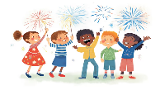  Vocabulary  Celebration, beliefs, festival, Christmas, birthday, traditions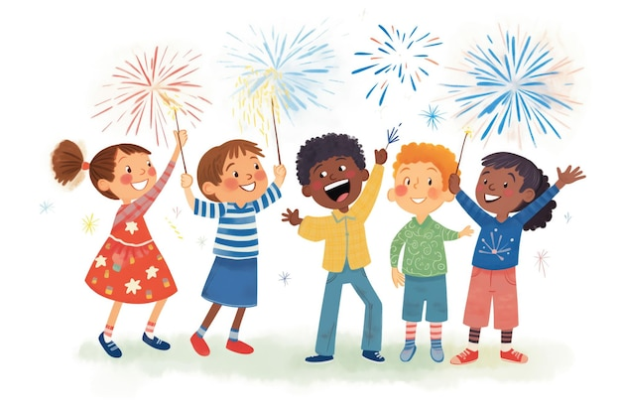  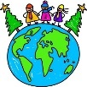  To learn about different celebrations around the world and how they are celebrated now and in the past.

