**The Forest School Association states that:**

Forest School is a child-centred inspirational learning process, that offers opportunities for holistic growth through regular sessions. It is a long-term program that supports play, exploration and supported risk taking. It develops confidence and self-esteem through learner inspired, hands-on experiences in a natural setting.

Forest School has a developmental ethos shared by thousands of trained practitioners around the world, who are constantly developing their learning styles and skills to support new and imaginative learners. Its roots reach back to the open-air culture, friluftsliv, or free air life, seen as a way of life in Scandinavia where Forest School began. It arrived in the UK in 1993 and has grown from strength to strength since then.

The process helps and facilitates more than knowledge-gathering, it helps learners develop socially, emotionally, spiritually, physically, and intellectually. It creates a safe, non-judgemental nurturing environment for learners to try stuff out and take risks. Forest School inspires a deep and meaningful connection to the world and an understanding of how a learner fits within it. Our approach to risk means that learners constantly expand on their abilities by solving real-world issues, building self-belief and resilience. We believe that risk is more than just potential for physical harm, but a more holistic thing, there are risks in everything we do, and we grow by overcoming them. Forest School, therefore, helps participants to become, healthy, resilient, creative, and independent learners.

Forest School is defined by 6 core principles, which were agreed by the Forest School community in 2011. This pre-date the FSA, which was set up in 2012 to support and advocate for these principles. The principles are underpinned by criteria. The FSA has used these as a basis for a set of national professional standards that we can all aspire to.

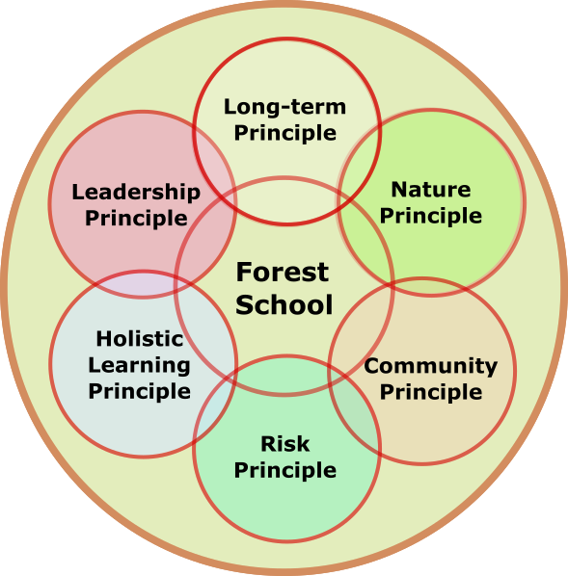

In Forest School no single principle takes precedence over the others; instead, they work harmoniously, interlocking to create a unique environment for learning and growth.

**What is quality Forest School?**

Quality Forest School is delivery which holds to all six key principles that shape and govern the Forest School ethos. There are many forms of outdoor education, and all have enormous value, however, Forest School is unique in its reach, delivery, and effect. These six principles are:

1. Forest School is a long-term process of regular sessions, rather than one-off or infrequent visits; the cycle of planning, observation, adaptation, and review links each session.
2. Forest School takes place in a woodland or natural environment to support the development of a lifelong relationship between the learner and the natural world.
3. Forest School uses a range of learner-centred processes to create a community for being development and learning.
4. Forest School aims to promote the holistic development of all involved, fostering resilient, confident, independent, and creative learners.
5. Forest School offers learners the opportunity to take supported risks appropriate to the environment and to themselves.
6. Forest School is run by qualified Forest School practitioners, who continuously maintain and develop their professional practice.

It is only when we see the 6 principles working together do, we truly see the value of Forest School. Underpinning our principles are some positive core beliefs. These can be summarised as, learners are all:

• equal, unique, and valuable  
• competent to explore & discover  
• entitled to experience appropriate risk and challenge  
• entitled to choose, and to initiate and drive their own learning and development  
• entitled to experience regular success  
• entitled to develop positive relationships with themselves and other people  
• entitled to develop a strong, positive relationship with their natural world

Forest School’s learner-centred approach interweaves with the ever-changing moods and marvels, potential and challenges of the natural world through the seasons to fill every Forest School session and programme with discovery and difference. Making each session and every experience a valuable one.

<https://forestschoolassociation.org/what-is-forest-school/>

**With this in mind at KWPS the intent is:**

To set up an environment from which Forest School can take place. To introduce the children to this outdoor environment and begin to develop a natural process of learning based on the 6 core principles of Forest School.

**Implementation:**

Each year group will attend Forest School for a minimum of 6 weeks. Each week half of the class, 15 learners, will be outside with myself and one other adult for one hour and a half. After a short break, the session is repeated with the other half of the class. Both adults have up to date first-aid training.

Although the setting is in the corner of the playground, there are trees, hedging and areas of wild planting. Natural resources are brought onto site to foster a relationship with nature and as a source of inspiration.

Risk assessments have been written for the site, tools, and fire. Tools and fire will be used with the children if appropriate for the learners after a baseline assessment.

The sessions will link to the school curriculum where appropriate for example The Stone Age. All other sessions will aim to develop the physical, social, cognitive, linguistic, emotional, and spiritual aspects of the learner. There will be elements of free choice and play included in the sessions. The sessions are planned and resourced prior to arriving on site. Activities are modelled to the learners and appropriate language is used. The learners are also encouraged to use their own imagination, and an alternative outcome is encouraged. A ‘failed’ outcome is also valued and the learners are encouraged to value the process as much as the outcome.

A reflection at the end of the session allows the learners and Forest School leader to reflect on the session. The reflection also feeds into the planning of the next session.

**Impact:**

The children feel a connection with the natural world and begin to understand their place within it and their connection to others. They will develop their fine motor skills through crafts, tools, and knots. Their gross motor skills are developed through games and den building. The children will begin to identify the natural world around them such as trees, plants, minibeasts and birds. Understanding that we can grow our own food and enjoy eating it! The children’s vocabulary increases due to the language-rich environment.