
Kirkham and Wesham Primary School
The topic this half term is Food. Below is an outline of what they’ll be learning, along with key vocabulary to help them understand and use throughout the topic.
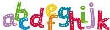  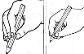  Literacy  Phonics – Phase 3 sounds  Reading – blend sounds that we have learnt in phase 2 and phase 3 to read CVC words, read some tricky words  Writing – to write a CVC word using single sounds and blends. Write letters correctly  Vocabulary – picture, writing, sounds, books, page, letters, sounds, words. | 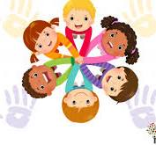  Personal, Social, Emotional Development  Vocabulary – community, belonging, safety, sharing, communicating  Living in the wider world – Belonging to a community and media literacy/digital resilience |   Maths  Vocabulary –  One more, one less, capacity, lighter, heavier  Balance scale  Composition of numbers 1-8, 1 more/1 less  Mass and capacity
Physical Development  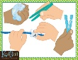  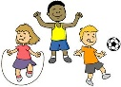  To throw and catch a ball.  To balance, jump and land using a variety of equipment  To hold a pencil with a tripod grip  Vocabulary  Bounce, catch, throw, direction, space, land | Reception Spring Term 1  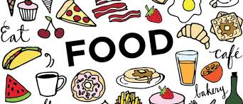 | 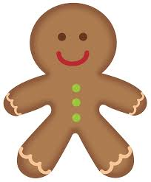  Creating with Materials  Snow dough – 3D sculpture. Digital Media – creating a snowman. Observational drawings of a thistle  Create a gingerbread man with concertina legs.  Vocabulary – decorate, soft, smooth, warm and cold colours, background, foreground
    Being Imaginative and Expressive  Everyone – Listen and respond to music.  Explore and create music with voices and instruments  Sing, play, share and perform  Vocabulary – pulse, rhythm, pitch, tempo, tune. | Communication and Language    Vocabulary  Listen, talk, sentence, news,  To join in with discussions either 1:1, small group or whole class  To understand and use new vocabulary  To listen carefully and to respond with relevant questions or comments | 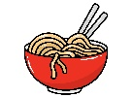  Understanding the World  Vocabulary  Chop, cook, melt, healthy, grocer, baker, butcher.  To learn about food from different countries and cultures, Lunar New Year.  To observe and talk about changes when cooking food and making healthy choices

