Ready Steady Write Progression Overview Year 1
A | B | C | D | E | F
Grammar: Word
Build on previous year & focus on: Regular plural noun suffix -s or -es | Build on previous units & focus on: Reinforce plural noun suffix -s/-es Adding the suffix -er to verbs | Build on previous units & focus on: Reinforce plural noun suffix -s/-es How the prefix un- changes the meaning of verbs and adjectives Adding the suffixes -er and -est to adjectives | Build on previous units & focus on: Adding the suffixes -ing, -ed and -er to verbs Adding the suffixes -er and -est to adjectives How the prefix un- changes the meaning of verbs and adjectives | Build on previous units & focus on: Reinforce plural noun suffix -s/-es Adding the suffixes -er and -est to adjectives Adding the suffixes -ing and -ed to verbs Reinforce how the prefix un- changes the meaning of verbs and adjectives | Build on previous units & focus on: Reinforce plural noun suffix -s/-es Adding the suffixes -ing and -ed to verbs Adding the suffixes -er and -est to adjectives
Grammar: Sentence
Build on previous year & focus on: Combining words to make sentences Joining words and clauses using ‘and’ | Build on previous units & focus on: Combining words to make sentences Joining words and clauses using ‘and’ | Build on previous units & focus on: Combining words to make sentences Joining words and clauses using ‘and’ | Build on previous units & focus on: Combining words to make sentences Joining words and clauses using ‘and’ | Build on previous units & focus on: Combining words to make sentences Joining words and clauses using ‘and’ | Build on previous units & focus on: Combining words to make sentences Joining words and clauses using ‘and’
Grammar: Text
Build on previous year & focus on: Sequencing sentences to form short narratives | Build on previous year & focus on: Sequencing sentences to form short narratives | Build on previous year & focus on: Sequencing sentences to form short narratives | Build on previous year & focus on: Sequencing sentences to form short narratives | Build on previous year & focus on: Sequencing sentences to form short narratives | Build on previous year & focus on: Sequencing sentences to form short narratives
Grammar: Punctuation
Build on previous year & focus on: Separation of words with spaces Capital letters Full Stops | Build on previous year & focus on: Separation of words with spaces Capital letters Full Stops | Build on previous year & focus on: Separation of words with spaces Capital letters Full Stops Question mark Exclamation mark | Build on previous year & focus on: Separation of words with spaces Capital letters Full Stops Question mark Exclamation mark Capital Letters for names and personal pronoun - I | Build on previous year & focus on: Separation of words with spaces Capital letters Full Stops Question mark Exclamation mark Capital Letters for names and personal pronoun - I | Build on previous year & focus on: Separation of words with spaces Capital letters Full Stops Question mark Exclamation mark
Terminology for Pupils
letter, capital letter, word, sentence, plural, singular, full stop, question mark, exclamation mark, punctuation

A |  | B |  | C |  | D |  | E |  | F
The Girl at the Front of the Class  by Onjali Q. Rauf | King Lion by Emma Yarlett | Rapunzel  by Bethan Woollvin |  | Cloud Boy by Greg Stobbs | Whirly Twirly Me by Manjeet Mann | The 3 Little Wolves and the Big Bad Pig  by Eugene Trivizas | Pip  by Jess Rose | There’s a Tiger in the Garden by Lizzy Stewart | How to Find a Yeti by Matt Hunt | The Last Wolf  by Mini Grey
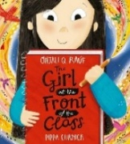 | 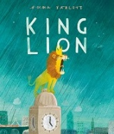 | 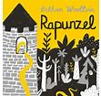 |  |  | 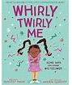 | 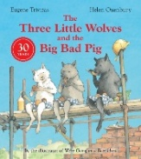 | 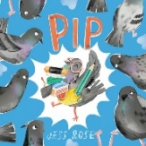 | 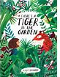 |  | 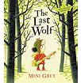
Outcome:  Encodable  Friendship Story Sentences | Outcome:  Encodable Instruction Sentences | Outcome:  Encodable Traditional Tale Sentences | Outcome:  Encodable Instruction Sentences | Outcome:  Encodable Imagination Story Sentences | Outcome:  Encodable Diary Sentences | Outcome:  Encodable Instruction Sentences | Outcome:  Encodable Invention Story Sentences | Outcome:  Encodable Search Story Sentences | Outcome:  Encodable Diary Sentences | Outcome:  Encodable Hunting Story Sentences | Outcome:  Encodable Recipe Sentences
Purpose:  To retell | Purpose:  To instruct | Purpose:  To retell | Purpose:  To instruct | Purpose:  To retell | Purpose:  To recount | Purpose:  To instruct | Purpose:  To retell | Purpose:  To retell | Purpose:  To recount | Purpose:  To retell | Purpose:  To instruct

