The Keele and North Staffordshire Teacher Education SCITT Assessment (of Trainees) Policy 2024/2025

**Approved by:** KNSTE Strategic Board

**Review interval:** Annual

**Last Review date:** March 2024 **Next Review Date:** March 2025 **Audience:** SCITT Partnership

### Date:

### Signed:

### Name: (Print)

### Position:

Contents

Introduction 3

Professional knowledge is a form of relational knowledge 3

Our assessment ethos 3

Co-analysis 4

Our ethos in relation to trainees’ progress 4

Progress Points (PPs) 5

Weekly Development Dialogues (WDDs) 5

Professional Development Analysis (PDA) Tutorials. 6

Assessment in relation to the Academic Award. 6

Assessment in relation to Fundamental Proficiencies. 6

Assessment in relation to Subject Knowledge 6

Quality Assurance of KNSTE’s Assessments 6

What happens if a trainee’s progress is insufficient? 7

Transition to ECF 7

Appendix A – Curriculum Map 8

Appendix B: Summary of KNSTE Forms 9

Appendix C: PGCE Marking Criteria 15

Appendix D Assessment Mechanisms 16

# Introduction

This policy is focused on the assessment of our trainees. In the construction of this policy, we also pay attention as to how we prepare our trainees for the assessment of their pupils. Within KNSTE, at all times, we are aware that our Lead Mentor (LM) team and partnership General Mentors (GMs) need to model our assessment ethos, as well as put our assessment policy into practice. This policy also includes reference to Keele University’s marking policy as members of our tutor team mark PGCE (Professional / Postgraduate Certificate in Education) assignments and for the PCASE Award (Professional / Postgraduate Certificate in the Academic Study of Education). This marking is subject to the requirements and expectations articulated in the Collaborative Partnership Agreement with the University. Educationally the academic award is integrated into our programme, however operationally the award of QTS and PGCE (PCASE) are made separately.

This policy shows how our ambitious curriculum, encapsulated in our dispositions, incorporates the Core Content Framework (CCF). Acknowledgement is also made of the ‘golden thread’ of training and development now available to teachers, and so strong connections are also made with the Early Career Framework (ECF).

This policy has been equality impact assessed and we believe in line with the Equality Act 2010. It does not have an adverse effect on race, gender or disability equality.

## Professional knowledge is a form of relational knowledge

Our programme enables the development of the professional knowledge appropriate to being a public teaching professional. It is informed by KNSTE’s ethos, dispositions and the Core Content Framework. We understand professional knowledge to be a relational knowledge, one that relates contextual experiences (practice) to conceptual understanding, so as to develop new knowledge for the trainee. This is facilitated through the ongoing work of Lead Mentors (LMs) and General Mentors (GMs) who enable trainees to make these connections in an informed and rigorous way.

Therefore our assessment of trainees recognises this and so does not separate out or atomise assessment into centre-based or school-based elements. We make assessments in relation to how each trainee is developing their professional knowledge via our well-sequenced curriculum. This is summarised on our curriculum map (Appendix A) and detailed in the curriculum policy.

It is through the assessment of our trainees that KNSTE also assesses the impact of its curriculum. We use our assessment information to monitor, evaluate and improve our curriculum offer, so that the assessment of our trainees, is also an assessment of our teaching.

# Our assessment ethos

The word ‘assessment’ comes originally from the Latin ‘assidere’, which literally means, ‘to sit beside’ someone. This highlights the importance of productive learning relationships. Our ethos is predicated in a philosophy that through assessment we sit beside our trainees so as to develop, rather than simply to judge their professional development. We recognise that learning happens over time, whereas teaching happens in the moment and so our summative assessments are informed by ongoing professional learning rather than based on single observations.

Our formative assessment occurs during Weekly Development Dialogues (WDDs) and Progress Points (PPs) and is underpinned by our co-analytical approach. Our summative assessment occurs

during the Professional Development Analysis (PDA) tutorials that occur at the end of each placement. The final tutorial is when the recommendation for QTS is determined.

We believe that rigorous and informed formative assessment lies at the heart of effective learning. Appendix B shares the range of forms that support this ongoing process within KNSTE.

We draw heavily on the ‘Creating Learning without Limits’ project (Hart et al, 2004) which was designed to learn from and give a voice to teachers motivated by a particular view of learning; learning free from the unnecessary limits imposed by ability-based labels. Our Characteristics Grid aims to make explicit the strengths and areas for development rather than being used to label achievements.

# Co-analysis

Co-analysis is a reflective and empowering dialogic process that continually drives the improvement of professional practice. It is not mere conversation and it is not just feedback. It is a valuable professional conversation that asks GMs, LMs and trainees to use powerful questions to enquire into the trainee’s pedagogic choices and reasoning by referencing professional knowledge and principles, and by prioritising the five aspects. It contains elements of instructional coaching.

Co-analysis is analytical. In order to be analytical, trainees, GMs and LMs need to refer to content and concepts. Where co-analysis works well:

* It is informed by reference to professional knowledge, rather than personal preferences.
* There is recognition that teaching is a practical profession underpinned by an informed philosophy. It is not just practice.
* There is a recognition that this process is never ‘finished’ and that searching for a deeper understanding of curriculum, pedagogy and assessment should be seen as a positive feature.
* The dialogue is simultaneously rigorous, challenging and nurturing and the asymmetry of the relationship is acknowledged in an empowering and enabling rather than in an authoritarian manner
* The dialogue draws on a range of resources and references, not only those visible within the school context.

This elaborative and evaluative approach enables trainees to become meta-cognitive so that they can develop their professional agency and adaptive teaching capability.

# Our ethos in relation to trainees’ progress

Becoming a public teaching professional involves grappling with a complex array of interconnected knowledges. We strongly believe that learning to teach is a developmental, incremental process. This is not a neatly linear process; rather it involves enabling trainees to make connections between the different aspects of professionalism. We take a spiral approach to our curriculum, revisiting key ideas, and assess a trainee’s progress in relation to these big ideas during each phase of their professional development.

Hence, we profile a trainee’s progress through the use of a Characteristics Grid. Each area of the Core Content Framework (CCF) relates to our dispositions and ultimately to the associated Teachers’ Standard. Trainees gather evidence in relation to each Enquiry, to demonstrate their

knowledge in relation to our curriculum. Each Enquiry relates to the appropriate area of the CCF and has also been mapped to the Early Career Framework (ECF) to show progression. This is used to inform the trainee’s Transition to ECT documentation.

Accordingly, we have identified four phases of development to support trainees’ professional learning and identification of needs. These are the Foundation and Building, phases (placement 1), followed by the Extending and Enrichment phases (placement 2).

We aspire to offer a highly personalised ITTE programme, and so variation is normal. Everyone develops at different rates, partly because there are differing individual learning pathways and progression rates, but also because school contexts and different classes affect how trainees develop. Trainees’ progress is very carefully monitored through a series of progress points.

# Progress Points (PPs)

Our four progress points capture a trainee’s progress and development in relation to their Enquiries, Assignments and the KNSTE’s curriculum, which included the DfE’s Core Content Framework. This is achieved through co-analytical dialogue between the LM, GM and trainee. LMs will also quality assure a trainee’s work in relation to their ongoing enquiries as part of the PP process. The evidence base for the co-analysis includes lesson plans, observations, WDD records, evaluations, activities and enquiries. These are drawn upon discursively during the co-analysis.

The Characteristics Grid is used to make explicit achievements and to agree areas for professional development in the next phase of the programme.

|  |  |  |  |  |
| --- | --- | --- | --- | --- |
| Phases | Professional Knowledge Development | | Progression and Formative Assessment | |
| Building | Placement 1 | Enquiries structure the course expectations for each area of content at each phase | PP1 | The Characteristics Grid identifies the increasing levels of connection that trainees achieve and evidence as the programme develops |
| Foundation | Placement 1 | PP2 |
| Extending | Placement 2 | PP3 |
| Enriching | Placement 2 | PP4 |

Each progress point is informed by and informs the weekly development dialogues (WDDs)

# Weekly Development Dialogues (WDDs)

Weekly Development Dialogues (WDDs) occur between the trainee and their General Mentor (GM). They are in addition to the regular daily contact that each trainee benefits from with their GM. These meetings are significant and so require dedicated time during the week. The meetings are recorded on Vantage, KNSTE’s online system. During a weekly development meeting, formative assessment of the trainee occurs through the following activities (see Appendix B for a summary of KNSTE’s forms and their associated assessment purposes):

* Discussion of lesson plans and evaluations;
* Discussion of Focus Lesson and/ or Lesson Observation Profile (LOP) and/ or other observations;
* Review of targets and summary of these on the WDD proforma;
* Discussion of any achievements relative to the trainee’s developing subject knowledge;
* Discuss the progress that the trainee is making with their Enquiries;
* Identify any new weekly practice based targets;
* Decide on the LOP or Focus Lesson for the following week;
* Prepare for any activities in relation to any enquiries or assignments.

The WDDs feed into the Progress Points (PPs) and both the WDMs and PPs feed into the professional development analysis (PDA) tutorials.

# Professional Development Analysis (PDA) Tutorials.

During each placement, each trainee is required to construct a summative PDA document. To do this they select achievements in relation to each disposition. The evidence in both instances is informed by the phasing of the programme and the Enquiries which are in turn informed by the KNSTE dispositions, CCF and academic award.

The PDA tutorials occur at the end of each placement. The final tutorial determines whether the evidence is sufficient for recommendation for the award of QTS.

# Assessment in relation to the Academic Award.

The ethos of the KNSTE Partnership is that the ‘academic’ and ‘practice’ elements of the programme are fully integrated. As has been stated previously, we see professional knowledge as a relational knowledge. Understanding is developed when contextual experiences are held to account in relation to our five dispositions or key aspects of professionalism. A number of the KNSTE tutor team are also recognised as marking tutors through the collaborative partnership with Keele University. The KNSTE team are fully compliant with the Keele University Marking and Moderation Policy which is available at:

<https://www.keele.ac.uk/policyzone/data/markingandmoderationpolicy/>

Additionally, to ensure that the academic award is fully integrated, trainees are asked to complete a formative learning conversation on Vantage. This is so that the PGCE marking criteria (Appendix C). This also feeds in to the assessment of the trainees’ Fundamental Proficiencies.

# Assessment in relation to Fundamental Proficiencies.

The trainees are introduced to the FAME (Fundamental and Academic Maths and English) Enquiry Guide which links to both online resources and taught sessions. Their progress in relation to their Fundamental Proficiencies is reviewed at PPs and is signed off at the final tutorial. The FAME sessions comprise three English and three Mathematics sessions, the content of which is determined by the NASBTT and UCET Fundamental Proficiencies documents and our own informed partnership expectations. Additionally, for mathematics, trainees are required to achieve at least 80% on the National Numeracy Challenge assessment.

# Assessment in relation to Subject Knowledge

Appendix D outlines the different mechanisms that are used formatively and summatively to assess the development of trainees’ subject knowledge.

# Quality Assurance of KNSTE’s Assessments

Each LM supports both the trainee and the GM in each placement. The LM team therefore have a Quality Assurance role in relation to each GM. Additionally during PP2 and PP3, both GMs are present and engage in a co-analytical professional learning conversation to review their progress and impact as a GM. These dialogues are reviewed by the LM team to highlight training and development needs. This minimises inconsistencies across the partnership. Each LM is then

responsible to a member of the SCITT’s senior leadership team through Recommending Board meetings. Additionally, LMs benefit from joint visits with each other and members of the SCITT leadership team to quality assure our assessments.

The LM Marking team meet regularly to standardise and moderate assessments both in relation to the academic award. The PGCE Director from Keele University quality assures their work.

An external examiner is jointly appointed by the SCITT and University to quality assure both the academic element of the programme and the full award.

KNSTE is a member of both NASBTT and UCET and is a regional provider for the Chartered College of Teaching and so all staff members benefit from professional learning via these organisations.

# What happens if a trainee’s progress is insufficient?

Where a trainee is giving a cause for concern, meaning that without appropriate action, there is every possibility that their assessment will be unsuccessful, the Support for Concern (S4C) procedure can be triggered.

In most circumstances this will be preceded by the ‘Going for Good’ (G4G) procedure. Going for Good (G4G) is often used in its own right or as an interim measure. It is aimed to enable trainees whose development is not progressing as we and they are ambitious for. G4G and S4C both enable trainees to access additional support and time in a rigorous way. They are supportive and enabling procedures and are usually successful in enabling a trainee to ‘get back on track’. Within KNSTE we recognise that:

* It is essential that both procedures are fully adhered to and full records and evidence are kept of all steps of the process, e.g., S4C Form, records of meetings and Lesson Observations Profiles etc.
* The G4G and / or S4C procedure should be applied at a point early enough to allow sufficient time for the full process to be effectively and fairly carried out.
* If necessary, the programme can be extended to allow S4C to be completed in full.
* In the rare case of gross unprofessional behaviour, the programme can be terminated without the need for the S4C procedure.

# Transition to ECF

We promote the notion that learning to teach is career-long, and so whilst we have a final tutorial that summarises the trainee’s progress and enables us to make a recommendation for QTS, this is not an ‘end-point’. We use a series of co-analytical reflective questions to enable the trainee to draw on their PDA and to consider justifying the prioritisation of their professional learning and development as they transition into the support offered by the Early Career Framework.

Appendix A – Curriculum Map

Appendix B – Summary of KNSTE’s forms and their assessment purposes Appendix C – PGCE Marking Criteria

Appendix D – Different assessment mechanisms

# Appendix A – Curriculum Map

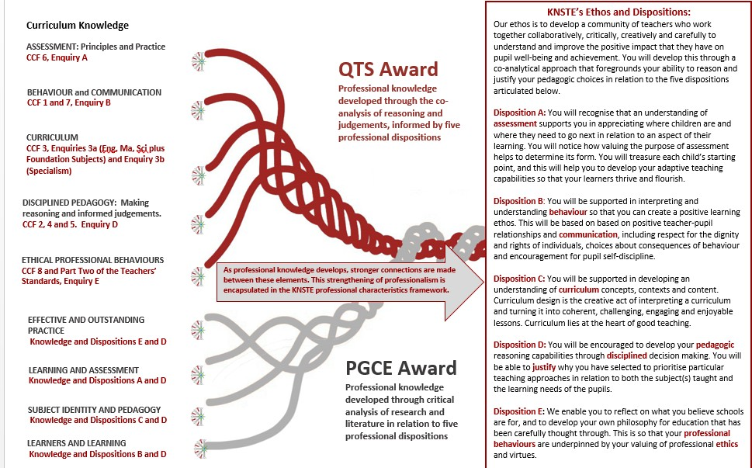



# Appendix B: Summary of KNSTE Forms

|  |  |  |  |
| --- | --- | --- | --- |
| **Name** | **Purpose – why used** | **When / How used** | **Professional Knowledge Development** |
| Weekly Development Dialogue (WDD) | Learning to teach is a life-long project. The WDDs guide you and your GM through a weekly focus of activities that enable you to record your progress and priorities in relation to the Dispositions. | These are completed by you prior to and subsequent to your weekly meetings with your GM. These end up forming your professional learning log as they summarise your progress and targets week by week. They contribute to our ongoing formative assessment of your development professionalism and professional  knowledge. | Through focused dialogue with your GM, you will develop professional insights. Teaching is a collaborative profession and you and your GM will be working together to help you to develop. We are ambitious that your WDDs are co-analytical in nature. |
| Professional Development Analysis (PDA) | This summarises your professional learning in relation to the Dispositions, which are underpinned by the CCF and the Teachers’ Standards. | This sequence of proformas (there is one for each of the five aspects of professional knowledge. The PDA will be completed twice, once at the end of each placement. This is a summative assessment. We will help you to prepare elements of this through your PPs and enquiries. | The process of completing these forms helps you to reflect on your progress over a longer time frame than the WDDs. You will present the associated evidence via an oral presentation at the end of each placement. The end of placement tutorials are the summative moments in the programme. |

|  |  |  |  |
| --- | --- | --- | --- |
| Observing Experienced Colleagues | You will benefit from observing experienced colleagues at ALL stages of your practice and in both your school settings. | Whenever you observe experienced teachers either in school or via video/ online lessons, you should complete an observation form – these will help you to both clarify the focus of your observation and ensure that your observation is analytical. This will be a resource that you draw on formatively in your co-analytical discussions during your WDDs and PPs and you may refer to in your summative PDAs and end-of-placement and end-of-course  tutorials. | We are all always learning from each other. It is vital that you are clear as to why you are observing so that you can be analytical rather than subjective about practice. |
| Lesson Plan / Sequenced Lesson Plan | EVERY lesson that you teach MUST be planned on the KNSTE proforma. This is so that you develop and secure the essential understandings associated with the creative and complex skill of lesson planning. | By the end of both practices you must have at least one lesson plan for EVERY National Curriculum subject, to demonstrate a balance in your professional knowledge. These will be resources that you draw on formatively in your co- analytical discussions during your WDDs and PPs and you may refer to in your summative PDAs and end-of-placement and end-of-course  tutorials. | Lesson planning is a fundamental capability. This is where you carefully consider curriculum connections. You think about why this lesson is taught at this time with this group of children. The Lesson Plan guides you through this process, deliberately and in detail so that you secure this essential skill. |
| Lesson Evaluation | Every lesson that you teach MUST be evaluated in some format.  Lesson Plan: at the end of the lesson plan form.  LOP: At the end of the LOP.  Focus: At the end of the Focus proforma.  Subject Observation: On the Subject Observation Form. | Your lesson evaluations for the week should be shared at or prior to your WDD. This will help inform your co-analysis during your WDDs. This is part of our approach to formative assessment. The WDD records may form part of your summative PDAs. | Being able to reflect in an authentic manner on your teaching is a key capability. You need to be knowledgeable about your practice and your impact so that you can enable your pupils to progress and flourish in their learning. |



|  |  |  |  |
| --- | --- | --- | --- |
| Phonics Lesson Plan | We anticipate that your phonics sessions will follow a different format to your subject sessions. This proforma is supported by SCITT sessions. | When you teach your sequences of phonics lessons in KS2 or when teaching your phonics sessions in KS1/EY. This will help inform your co-analysis during your WDDs. This is part of our approach to formative assessment. The WDD records may form  part of your summative PDAs. | It is important to recognise that different content requires different pedagogy and so this pro-forma helps you to plan for learning appropriately. |
| Lesson Observation Profile (LOP) | This provides detailed observation feedback on your lessons in relation to the Teachers’ Standards. | You should complete one LOP each fortnight (The LOP, alternates with the Focus Lesson). This will help inform your co-analysis during your WDMs. This is part of our approach to formative assessment. The WDD records may form part of your summative PDAs. | This detailed document helps you to focus on the impact that your lesson is having on the pupils. It enables you to draw out key characteristics in relation to your professional development. |
| Phonics Lesson Observation Profile (PLOP) | This form is specific to your Phonics teaching. | It should be used once during each sequence of three sessions of phonics teaching. This means that it should be used at least twice when teaching Key Stage 2 and more regularly when teaching phonics in KS1/EY. | Having an experienced colleague observe your teaching will help you to be explicit about the elements of professional knowledge and understanding that you are securing and those that you need to prioritise developing. |
| Focus Lesson | This highlights the personal teaching capacities that you need to develop. | This should be used once a fortnight (alternating with the LOP).You complete the left hand column prior to the lesson and your TE will then describe your observed actions on the right, ready for you to evaluate and then co-analyse. This will help inform your co-analysis during your WDDs. This is part of our approach to formative assessment. The WDD records may form part of your summative PDAs. | The enables you to focus on your actions and activities as a teacher. It enables you to prioritise certain elements of professionalism and to put them into practice so that you can evaluate and co-analyse their impact. |

|  |  |  |  |
| --- | --- | --- | --- |
| Sequenced Lesson Plan (SLP) | The Sequenced Lesson Plan must only be used for sequences of three or more lesson. Any stand-alone lessons must use the Lesson Plan. You will be introduced to this form prior to placement 2 to prepare you for teaching sequences of lessons as  your teaching commitment builds. | The sequenced lesson plan enables you to provide detail that is appropriate to include to support a sequence of learning rather than an individual plan. | You will appreciate the different level of detail required a different times in your teaching. |
| Subject Observation (SO) | For the teaching of your three weakest subjects and for your specialist observation you will be observed using this proforma. | One of your specialism enquiries you will specifically focus on the significance of subject knowledge. This form will also be used when teaching your 3 identified Foundation subjects. This will help inform your co-analysis during your WDDs. This is part of our approach to formative assessment. The WDD records may form  part of your summative PDAs. | This proforma will help you to focus on the significance of subject knowledge and makes it clear to you how your knowledge enables pupils to develop their knowledge in a particular subject. |
| Subject Knowledge Development | You are asked to annotate your copies of the National Curriculum for English, Maths and Science and the copies of the Foundation Subject Knowledge Organisers. | You are asked to complete this at least weekly. You are asked to have copies with you on each of your SCITT days. This should be a working document and so may end up looking a little scruffy. It will be used to help you inform both your WDDs and PDAs. You are asked to share these documents with your tutors during the PP discussions. | This enables you to make explicit how your sessions and practice has enriched your subject knowledge and to consider areas that you need to target and develop. We also encourage you to have this document with you in your transition to ECT, as it will be a great aide memoire for you. |

|  |  |  |  |
| --- | --- | --- | --- |
| Fundamental Proficiencies Self- Assessment FAME =  Fundamental & Academic Mathematics &  English sessions. | You are asked to complete FAME, updating it regularly, and using this to prioritise your personal learning. This is co-analysed during your PDA tutorials. | You are asked to review this document in relation to each PP point. It is then reviewed by your tutor during your PDA discussions at the end of each placement. You will be asked to bring the audit to each of your FAME sessions. | To be recommended for QTS you must have secured evidence in relation to all the Fundamental Proficiencies. |
| Academic Learning Conversation | For each academic assignment you are required to complete a cover sheet identifying aspects of your academic writing that you wish to prioritise. To enable this to be cumulative and formative, on Vantage there is an academic (Masters) learning conversation. | You are asked to complete this following the marking and review of each assignment. It is then used by your marking tutor to frame your PKR (professional knowledge and reflection) discussion following the return of each assignment. | Being able to communicate effectively via the written word is a key professional capability. The learning conversations enable you to develop your understanding of not only the content of the academic assignments but also make explicit writing conventions and expectations. This will also link with your work in relation to the fundamental proficiencies. |
| Characteristics Grid | This is used to highlight your areas of strength and the areas for development. It makes explicit progression in relation to each of the Dispositions. | The Characteristics Grid is used in PP3 and PP4. It enables you and your GM to summarise achievements. It is then used formatively during the PP co-analytical discussion to prioritise areas for professional development in the next phase of learning. | It is important to recognise your areas of strength and areas that you will benefit from prioritising. Teaching is a complex profession and the areas on the Characteristics Grid inevitably inter-relate. The grid is used so that the PP discussions can be informed and rigorous and based on evidence from across time, not just secured by single lessons. |
| Transition to ECT document | Each enquiry contains a summary grid that clarifies how the enquiry is underpinned by the Core Content Framework and how these can be built upon in your ECT years. Towards the end of the programme you will be asked to reflect on your progress  and to identify targets for the next stage of your development. | This will be shared during your PP4 co- analysis and then developed ready for your final tutorial and transition day. This is a day when we work with you and your ECT Mentor in preparation for your ECT years. It helps you begin to recognise how you  can draw on your ITTE year in relation to your employed role. | Learning to be a public professional who teaches, is a career-long endeavour. Your ITTE year is the start of this journey. We are ambitious that it lays incredibly strong and secure foundations for you to build on. This document is a physical manifestation of this ethos. |



|  |  |  |  |
| --- | --- | --- | --- |
| Going for Good (G4G) | A support process for any trainees who at any point would benefit from additional support so as to secure their progress. | If you, your LM or GM feel that you will benefit from additional time and support in order to secure or develop aspects of your practice then the G4G process should be  implemented. | Our course is personalised within a structure. Colleagues develop and progress at different rates. The G4G process helps to recognise this and enables targeted support when and where  needed. |
| Support for Concern (S4C) | A developmental process to highlight areas of significant concern and further actions to ameliorate these. It also outlines the procedures for exiting a placement prior to the usual completion date. | If there is a sustained or serious concern about your professional learning and development or general professionalism, then the S4C process outlines actions needed. | Developing professional knowledge and the practice of teaching is demanding and the journey is not always straightforward. S4C recognises this in a firm but fair way and is drawn upon when there are concerns that you will not meet the expected Standards in the  usual time period. |





# Appendix C: PGCE Marking Criteria

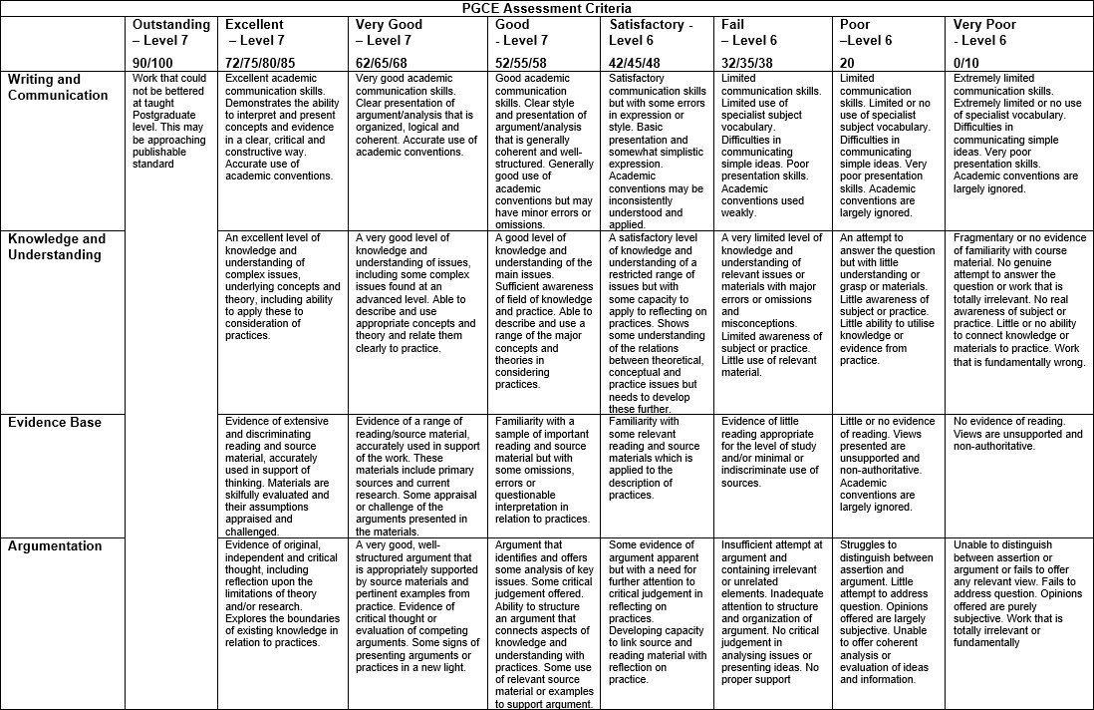

# Appendix D Assessment Mechanisms

