
French Curriculum Map
Year 7

Term | Autumn 1 | Autumn 2 | Spring 1 | Spring 2 | Summer 1 | Summer 2
 | French
 | Healthy Living | Wellbeing | Travel and Tourism | Travel and Tourism | The Environment | The Environment
Year 10 | -Talking about meals and mealtimes  -Talking about good mental health  -Describing illness and accidents  (booking a doctor's appointment/role play) | -Saying what you will do to improve your health in the future  -Talking about lifestyle changes (3 tenses)  -Describing a photo | -Talking about holidays and accommodation  -Talking about your ideal holiday  -Discussing what you can see or do on a holiday (questions/advice-role play) | -Talking about festivals  -Reviewing or booking accommodation  (Role play)  -Talking about staycation activities (weather)  Trial 1-Mock exams  (3 papers) | -Talking about geography and the climate  -Talking about environmental problems  -Discussing how we can work together to protect the environment | -Day to day actions to protect the environment  -Discussing new green technologies  Trial 1-Mock exam –Speaking prep and exam.

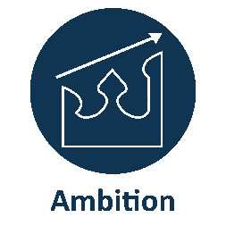

We provide a supportive and challenging environment to ensure our students achieve academic excellence.
We have the highest expectations for academic excellence and personal development and work hard to achieve them.

Term | Autumn 1 | Autumn 2 | Spring 1 | Spring 2 | Summer 1 | Summer 2
 | French
 | My neighbourhood | Trial 1 Exams | Future plans | Trial 2 Exams
Year 11 | -Describing your town or village  -Asking for and understanding directions (role play)  -Talking about shopping for clothes (role plays)  -A past or future visit to another town or city | -Exam prep  -Writing papers -Reading papers  -Listening paper  -Speaking prep  - Speaking trials  - Feedback | -Talking about summer plans  -Talking about future plans and hopes  - Talking about travelling and earning money  -Talking about possible future career paths  and pros and cons | Trial 2  - Feedback  - Speaking trial  - Feedback  -Real Speaking exam after Easter break-final prep  Consolidation & revision writing/translation/listening/reading

