
Spanish Curriculum Map
Year 7

Term | Autumn 1 | Autumn 2 | Spring 1 | Spring 2 | Summer 1 | Summer 2
 | Spanish
 | Healthy Living | Wellbeing | Studying | Studying | My neighbourhood | My neighbourhood
Year 10 | -Learning about typical foods in Spanish speaking countries  -Describing healthy daily routines  -Mealtimes and food trends | -Comparing old and new habits  -Illness and injuries  -Future plans for health and well being | -A typical school day  -My studies  -How you would change your school | -My teachers  -A recent school trip  Trial 1-Mock exams  (3 papers) | -Describing cities  -Describing how a town or a city has changed  -Shopping preferences | -Giving preferences about where you live  -Talking about your area  Trial 1-Mock exam –Speaking prep and exam.

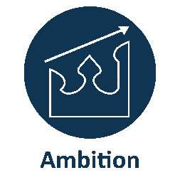

We provide a supportive and challenging environment to ensure our students achieve academic excellence.
We have the highest expectations for academic excellence and personal development and work hard to achieve them.

Term | Autumn 1 | Autumn 2 | Spring 1 | Spring 2 | Summer 1 | Summer 2
 | Spanish
 | The Environment | Trial 1 Exams | Future plans | Trial 2 Exams
Year 11 | -Talking about how you help your community  -Talking about climate change  -Talking about actions to help the environment and solutions | -Exam prep  -Writing papers -Reading papers  -Listening paper  -Speaking prep  - Speaking trials  - Feedback | -Talking about future plans and hopes  - Talking about getting a job  -Talking about possible future career paths  -Talking about the importance of learning languages  -Talking about changes in the world of work and artificial intelligence | Trial 2  - Feedback  - Speaking trial  - Feedback  -Real Speaking exam after Easter break-final prep  Consolidation & revision writing/translation/listening/reading

