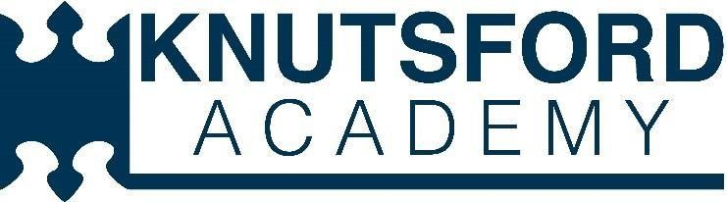



**Provider Access Policy for Knutsford Academy and**

**Cheshire Studio School**

|  |  |
| --- | --- |
| **Policy Lead:** | **Mrs J Pickford** |
| **Last review date:** | **September 2024** |
| **Next review date:** | **September 2025** |
| **Approval needed by:** | **Board of Governors** |

**Introduction:**

This policy statement sets out the arrangements for managing the access of providers to students at Knutsford Academy and Cheshire Studio School, for the purpose of giving them information about the provider’s education or training offer. This complies with the academy and studio school’s legal obligations under Section 42B of the Education Act 1997.

**Student Entitlement:**

All students in years 7 – 13 are entitled:

* to find out about technical education qualifications and apprenticeship opportunities, as part of a careers programme which provides information on the full range of education and training options available at each transition point;
* to hear from a range of local providers about the opportunities they offer, including technical education and apprenticeships – through options’ events, assemblies, group discussions and taster events;
* to understand how to make applications for the full range of academic and technical courses.

**Management of provider access requests:**

**Procedure:**

A provider wishing to request access should contact Mrs J Pickford, Careers IAG Co-ordinator. Email: jpf@knutsfordacademy.org.uk Telephone: (01565) 633294

**Opportunities for access:**

A number of events, integrated into the school careers programme, will offer providers an opportunity to come into school, and/or via Teams, to speak to pupils and/or their parents/carers. These include:

* Academy Careers Fair
* Work experience placements
* AIM Workshops
* Presentations delivered through assemblies
* Workshops can be delivered through lunchtime drop-in sessions or planned PHSCE lessons
* STEM events and activities
* Information evenings for parents and students
* Visits to a provider
* Post 18 masterclass programme
* Employer Readiness Programme

Please speak to our Careers IAG Co-ordinator to identify the most suitable opportunity for you.

**Premises and facilities:**

The academy and studio school will make rooms available for discussions between the provider and students, as appropriate to the activity. The academy will also make available AV and other specialist equipment to support provider presentations. This will all be discussed and agreed in advance of the visit with either the Careers IAG Co-ordinator or other relevant members of staff.

Providers are welcome to send copies of their prospectus or other relevant course literature. These will be available to students in the careers’ office.

**Approval and review:**



Signed: Bob Armstrong, Chair of Governors

Signed: Karen Key Head teacher

Next review: September 2025