Self-harm

**A guide for young people**

**This leaflet is for children and young people who deliberately harm themselves. It attempts to explain what self-harm is and offers self-help advice.**

# What is self-harm

Many young people who self-harm describe hurting themselves as a way of dealing with very difficult feelings, painful memories

or overwhelming situations and experiences that feel out of control. Some people feel they have no other option or way of managing this and turn to self-harm. Although some people who self-harm

may be suicidal, self-harm is often used as a way of managing difficult emotions without being a suicide attempt. However, self-harming

can result in accidental death.

# Young people have told us some of the reasons they may self-harm

* To turn invisible thoughts or feelings into something visible
* To express something that is hard to put into words
* To change emotional pain into physical pain
* To reduce overwhelming feelings or thoughts
* To have a sense of being in control
* To escape traumatic memories
* To have something in life that they can rely on
* To punish themselves for their feelings and experiences
* To stop feeling numb, disconnected, or dissociated
* To create a reason to physically care for themselves
* To express suicidal feelings and thoughts without taking their own life

It can be difficult to talk about self-harm with other people, but it is important not to suffer in silence. People often hide self-harm because they feel ashamed which can get in the way of asking for help, but self-harm is not something to be ashamed of. Getting support to manage the reasons for the difficult feelings and discovering different ways of coping can help you to overcome self-harm.



**Upsetting thoughts**

**Feelings of guilt and shame**

**Self-harm**

**Relief**

Sometimes, young people can find that they are using self-harming behaviours to manage upsetting thoughts and situations more frequently. Often, this can mean that they feel as if they are in a ‘negative cycle’ they find it difficult to break.

1

# Some of the reasons young people say they want to stop self-harming

* ‘It hurts especially if a wound becomes infected’
* ‘I can’t wear the clothes I want to when trying to hide scars’
* ‘The scars sometimes remind me of the things I was trying to escape from which makes me feel low’
* ‘I feel stressed keeping my self- harm a secret from people’
* ‘It upsets the people I am close to’

# Some of the things you may notice if self-harming is becoming unmanageable or more risky

* When the only way you can cope with upsetting emotions is to self-harm.
* When you are not able to take a ‘break’ from self-harming.
* When you are self-harming after drinking alcohol or using substances.
* When you are self-harming when there is no-one around e.g. when you will be alone for a long time.
* When other problems are getting more difficult to manage too, such as anxiety or depression.
* When your wounds need medical attention more frequently.
* When you are getting into risky situations because of self-harming.
* When the usual ways of self-harming are no longer enough to manage your distress.

# What to do if you want to get help to stop or manage self-harm

Although an ideal goal might be to stop

self-harm completely, it is important to think carefully before ‘just stopping’ especially if

it is helping you to manage your distress. You may want to talk to someone who can support you with managing this distress more appropriately and help you to think about a plan for a gradual reduction. This can be a family member, school nurse, GP, counsellor, or mental health professional. Schools and colleges may have staff wo are trained to support young people who are self-harming.

They can listen without judging and can get you help, advice and support to manage your difficulties. Telling someone about

self-harming for the first time can feel quite scary, but young people often feel relieved they have been able to talk so someone.

Find someone you trust to talk with if you struggle to tell them it might be easier to write them down. Try to talk honestly and openly.

**Telling someone about self-harming for the first time can feel quite scary,**

**but young people often feel relieved they have been able to talk to someone.**

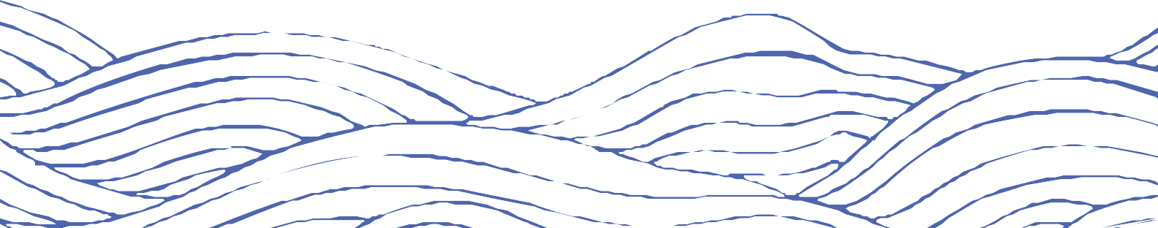

2

# Social media use



3

**“Sometimes joining a social activity or sports group can be helpful as a distraction. This can also provide a form of social support.”**

Whilst we recognise that there are many benefits from social media, there can also be some downsides. We know it can be hard to avoid certain content online but would advise that it can be unhelpful to look at

images or positive accounts of other people’s self-harm online.

* Social media can have positive and negative experiences.
* There are many benefits of social media.
* Be aware of the dangers of viewing particular types of content.
* Try to reduce or stop looking at sites which appear to promote self-harming behaviours.
* Be aware excessive internet use can reduce our ability to regulate our emotions.



# Other ways to help

It is important to think of other ways you can manage your feelings. These can include distraction, stress management techniques, and thinking of alternative methods of discharging/coping with extreme emotions. Sometimes joining a social activity or sports group can be helpful as a distraction. This can also provide a form of social support.

Some people find that putting off harming themselves can decrease or get rid of the urge. Reducing the accessibility of objects that might be used for self-harm may help to delay the impulse to self-harm.

Below is a list of things to do to take your mind off self- harming, look after yourself and concentrate on activities that can be helpful. They don’t all work for everyone but experiment and see what works for you.

* Going for a walk, looking at things and listening to sounds
* Create something: drawing, writing, music or sculpture
* Going to a public place, away from the house
* Keeping a diary or weblog
* Stroking or caring for a pet
* Watching TV or a movie
* Getting in touch with a friend
* Listening to soothing music
* Having a relaxing bath
* Connecting with people, especially those who make us feel good
* Helping others, volunteering at school or getting involved in a project
* Being active, exercise or just moving around

# Releasing emotions



4

* + Clenching an ice cube in the hand until it melts
  + Sports or physical exercise
  + Using a punchbag
  + Hitting a pillow or other soft object
  + Writing things down
  + Talking it out with a trusted person

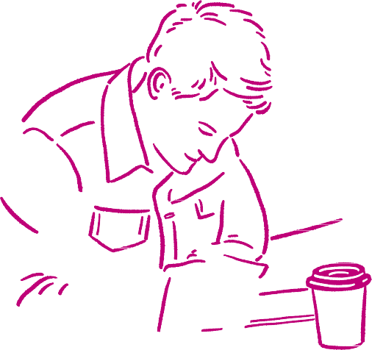

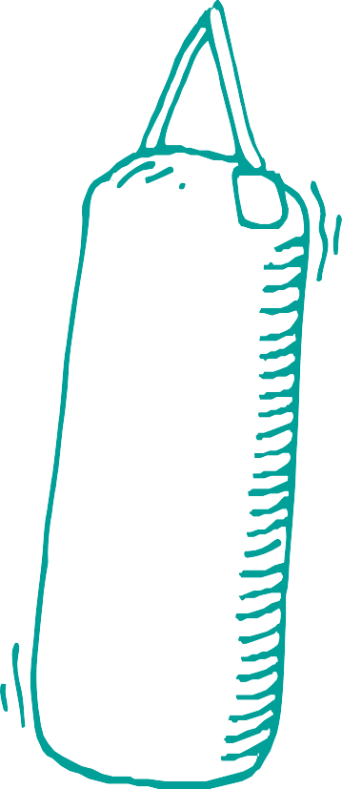

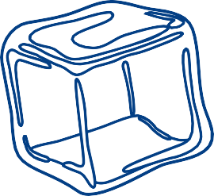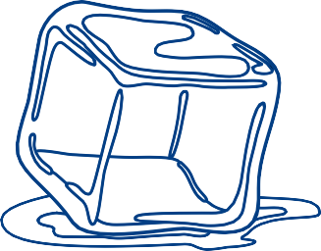

# “Don’t ever be ashamed of talking about self-harm… I guarantee there are loads of other people feeling the same way”

# People you can talk to

**24/7 support: Crisis helplines in Cheshire and Merseyside**

If you feel you need urgent mental health support, contact **NHS 111** **option 2** (for mental health).

If there is an immediate risk of danger to life, you should ring **999.**

### The Samaritans

They provide emotional support for any worries you may have 24 hours a day, 365 days a year. [**www.samaritans.org**](https://www.samaritans.org/)

**Helpline: 116 123**

### Childline

Get help and advice about a wide range of worries. You can call them on **0800 1111**, talk to a counsellor online, send them an email or post on the message boards. [**www.childline.org.uk/**](http://www.childline.org.uk/)

### Hopeline UK

For children and young people under the age of 35 who are experiencing thoughts of suicide or anyone concerned that a young person could be thinking about suicide. Contact HOPELINE247 for confidential support and advice.

**Call: 0800 068 4141**

**Text: 88247**

**Email:** [**pat@papyrus-uk.org**](mailto:pat@papyrus-uk.org)

[**www.papyrus-uk.org/papyrus-hopeline247/**](http://www.papyrus-uk.org/papyrus-hopeline247/)

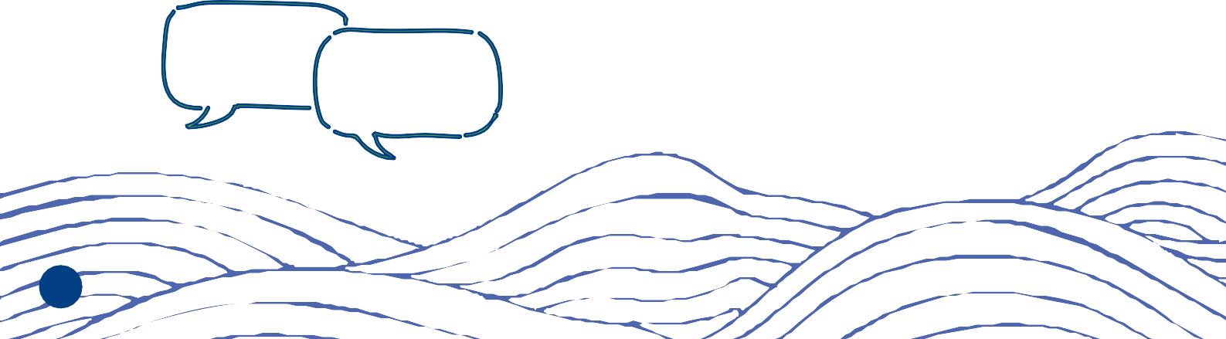

5

### CALM

[**www.thecalmzone.net**](http://www.thecalmzone.net)

**Helpline: 0800 58 58 58** (open 5pm to midnight, 365 days a year). Support also available via live chat and WhatsApp

### SHOUT

Shout is a free, confidential 24/7 text message

service for anyone in the U.K who needs support.

If you are struggling to cope and need to talk

trained volunteers are there for you

Text **SHOUT** to **85258**

[**Give us a Shout 85258**](https://giveusashout.org/)

### Your GP

You can speak to a GP if:

* You’re self-harming
* You’re having thoughts about harming yourself
* You’re worried about minor injuries, such as small cuts or burns - without treatment there is a risk of infection

It’s important to get support or treatment as soon as possible to help with the underlying cause and prevent suicidal thoughts developing.

## Free digital mental wellbeing support

Join the community and access free, safe and anonymous professional support online. There are no waiting lists for support and no referral needed. Access to these platforms is available instantly 24/7.

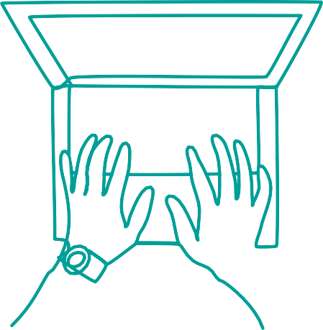Support available includes:

* + Live chat or messaging with qualified mental health professionals
  + Self-help tools and activities
  + Online community

**Kooth** (for ages 10 to 25) [**www.kooth.com**](http://www.kooth.com/)

**Qwell** (for ages 26+) [**www.qwell.io/**](http://www.qwell.io/)

**\*Please note the above services are only available in certain areas**

## Websit[es](http://www.42ndstreet.org.uk/)

**<sppcm.co.uk>**

A local (Cheshire & Merseyside) website offering information and support.

[**harmless.org.uk**](https://harmless.org.uk/)

A national organisation offering information and support.

#### [www.selfharm.co.uk](https://www.selfharm.co.uk/)

A safe online space available to inform and support young people who self-harm.

6

With thanks to the Greater Manchester Integrated Care Partnership for granting permission to utilise this booklet within the Cheshire and Merseyside sub-region.

Original date of publication: August 2023

Date of publication in Cheshire and Merseyside: October 2024