Self-harm

**A guide for parents and carers**

**This leaflet is for parents and carers who are concerned that their child may be self-harming. It attempts to explain what self-harm is and offers advice.**

# What is self-harm

Many people describe hurting themselves as a way of dealing with difficult feelings or overwhelming situations. Often people who self-harm are experiencing extreme distress and self-harm is the only way that

they can think of to cope. People might harm themselves in different ways such as:

* Cutting
* Taking too much medication
* Burning
* Hair pulling
* Excessive scratching
* Hitting themselves
* Tying things around parts of the body
* Starting fights or punching things
* Headbanging



# Reasons for self-harm

Self-harm can serve several different functions and many young people tell us that there are lots of reasons why they do it. These reasons may include:

* To manage or distract from emotional upset
* To reduce tension, frustration or anger that has built up in the body
* To express emotions such as hurt, shame or fear
* To regain control over feelings, situations, people or problems
* To create physical pain that distracts from emotional pain
* To feel something (anything)
* To bring themselves back to the present (grounding)
* To create a sense of numbness
* To punish themselves or avoid hurting others
* To draw attention to needing care and support from others
* To see if it helps (particularly when others around you are doing it)

# Suicide

Most young people who self-harm don’t feel suicidal and don’t intend to end their own life. However, self-harm is a risk factor for suicide and deep feelings of distress can lead to thoughts of suicide. If your child is

self-harming they should be asked if they are thinking of suicide or ending their life. Often people are worried to ask about suicidal thoughts, but the evidence is very clear

that this is helpful and does not increase risk. Approached sensitively, your child will know they can approach you if they ever do experience thoughts that worry them.

A young person also needs to be aware that by hurting themselves there may be a risk of accidental death.

## Free online training from Zero Suicide Alliance

Free online training courses to help you gain knowledge, skills and confidence to talk to someone who may be feeling suicidal or socially isolated. [**www.zerosuicidealliance.**](http://www.zerosuicidealliance.com/training)[**com/training**](http://www.zerosuicidealliance.com/training)

# Could your child be

# self-harming

As a parent you may suspect that your child is self-harming. If you are worried, and have ruled out other potential abuse, look out for these potential signs:

* Unexplained cuts, burns or bruises.
* Blood stains on clothing or dirty tissues in the bin.
* Keeping themselves covered, avoiding swimming or changing clothes around others.

**Let them know you are not judging them or putting them down, and that you love them and that this will not change.**

* Items such as razors or kitchen utensils going missing in the home.
* Being withdrawn or isolated from friends and family.
* Low mood, lack of interest in life or depression.
* Blaming themselves for problems or expressing feelings of failure, uselessness, hopelessness or anger.

It can feel difficult to talk about self-harm, but it is important not to suffer in silence. People often hide self-harm because they feel ashamed or worried, which can get

in the way of asking for help. Self-harm is not something to be ashamed of. Getting support for your child to manage the underlying reasons for the feelings causing the self-harm and discovering different ways of coping can help you to overcome self-harm as a family.

# Discovering self-harm

Some children may tell their parents directly

about their self-harm. Other parents find

out from friends, teachers or health professionals. Discovering that your child is

self-harming can feel very upsetting,

unsettling and stressful. Parents may

experience a range of emotions, including

anger, sadness, helplessness, shame or

disgust. It’s normal to feel strong emotions,

and important to try and understand and

accept them, so that you don’t risk

misdirecting them at your child. Try to

think of their self-harming behaviour as

an expression of deep emotions they can’t

handle any other way.

# Helping your child who self-harms

Although an ideal goal might be to stop

self-harm completely, it is important to think carefully before ‘just stopping’ especially if it is helping your child to manage distress.

You may want to support your child to think about a plan for a gradual reduction first whilst they develop other ways to cope (unless their self-harm is life threatening).

# Social media use

Whilst we recognise that there are many benefits from social media, there can also be some downsides. We know it can be hard to avoid certain content online but would advise that it can be unhelpful to look at images or positive accounts of other people’s self-harm online.

* Social media can have positive and negative experiences.
* There are many benefits of social media.
* Be aware of the dangers of viewing particular types of content.
* Try to reduce or stop looking at sites which appear to promote self-harming behaviours.
* Excessive internet use can reduce our ability to regulate our emotions.

## 

**The important thing to remember is that you and your child are not alone**

**- lots of young people go through this and come out the other side with different ways of coping with their feelings and new ways of solving problems.**

## Having difficult conversations:

* + Have a conversation, but don’t feel pressured to bring up self-harm straight away.
  + You could organise this around another activity, like a walk or drive.
  + Ask if anything is worrying them and how they have been feeling.
  + Let them know you are not judging them or putting them down, and you

love them and this will not change.

* If your child does not want to talk, see if they will write you a note, email or text message about how they feel.
* Show that you are prepared to listen to whatever your child has to say.
* Ask if they would rather speak to someone else (e.g., a GP, counsellor or helpline).
* If your child is open to talking about their self-harm, try to help them work out feelings and situations that may trigger it.
* Try to think together of ways to handle strong feelings that don’t involve self-harm.
* Help them think through their problems and see possible solutions.
* Encourage them to think about the long view and how things may change in the future.
* Support them with any plans they make to stop or limit the self-harm.
* Try not to ask them directly to stop the self-harm, help them to feel that they want to.
* Help them to see any return to self-harm is part of the normal process of recovering and not a failure or a disaster.

# Other ways to help

Self-harm may be helping your child to cope with difficult feelings. It is therefore important to support them to think of other ways they might cope. These can include distraction, stress management techniques, and thinking of alternative methods of discharging extreme emotions. Sometimes joining a social activity or sports group can be helpful as a distraction. This can also provide a form of social support.

Some people find that ‘delaying’ harming themselves can decrease or get rid of the urge. Work with the young person to reduce access to objects that they may use to self- harm (e.g., knives, medication) which could help protect them against any immediate impulse to self-harm.’

It’s important to balance a combination of distraction and emotion release techniques. Some activities that young people, parents and professionals have found helpful include:

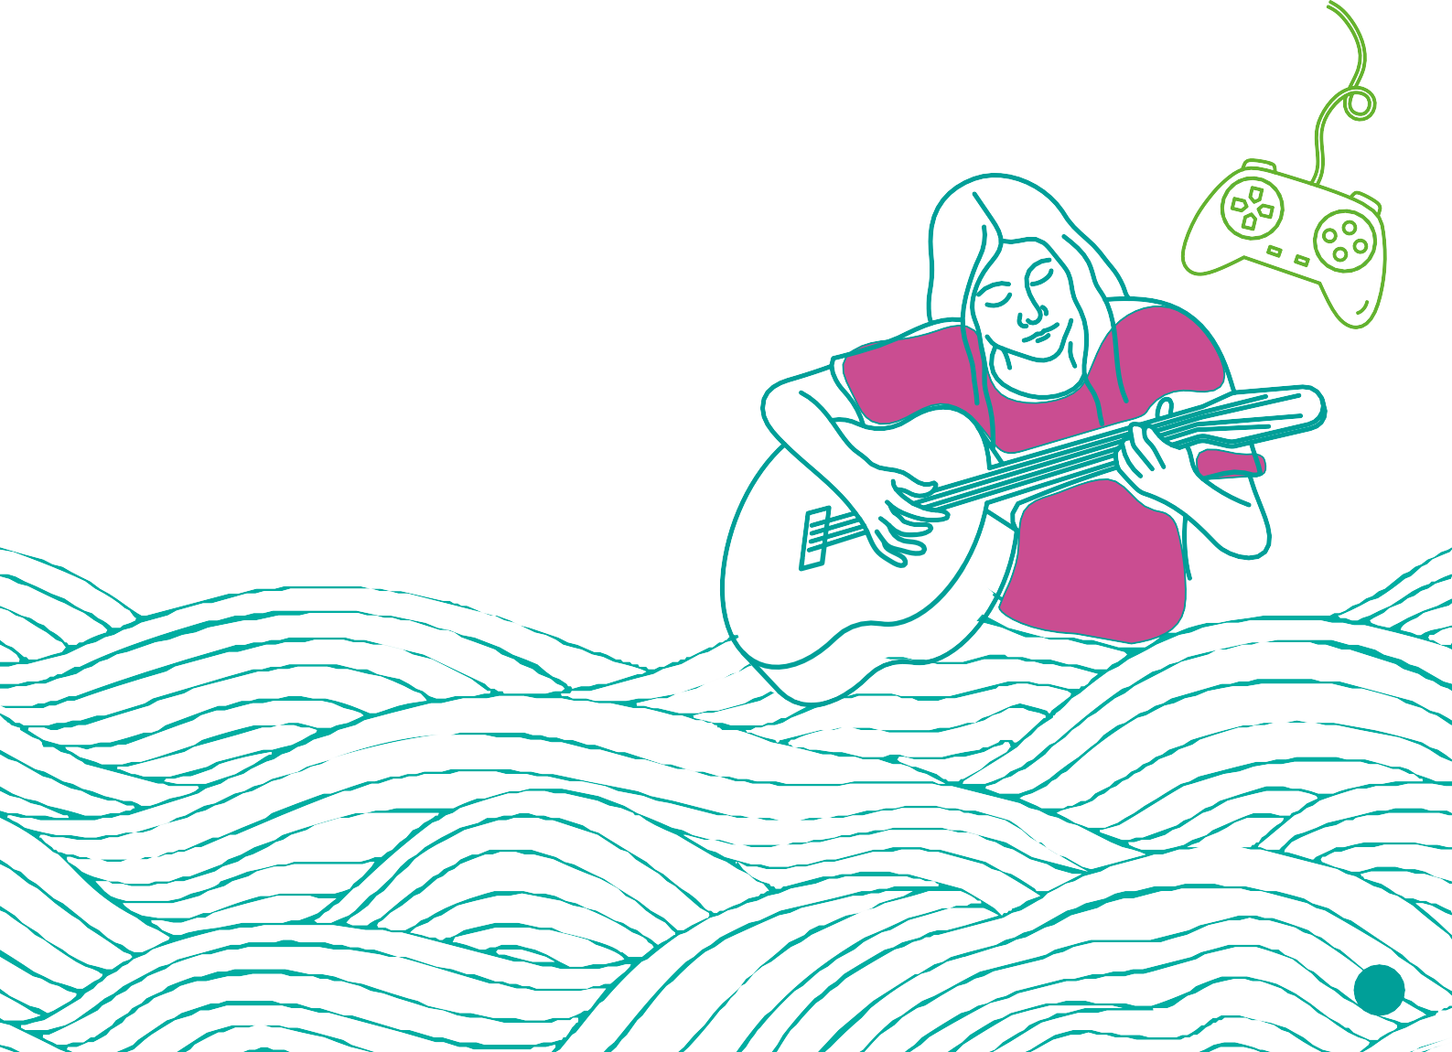

## Distraction: activities, self-soothing, stress relief

* + Going for a walk, looking at things and listening to sounds
  + Creating something: drawing, colouring, writing, music or sculpture
  + Going to a public place, away from the house
  + Making or using a self soothe box
  + Playing a board game
  + Exercise
* Stroking or caring for a pet
* Watching TV or a movie
* Playing computer games
* Watching videos on YouTube
* Getting in touch with a friend
* Listening to your favourite music
* Having a relaxing bath
* Wrapping up in soft, heavy blankets
* Creating a safe place (real or imaginary)

## Releasing emotions:

* Crying
* Let feelings out by talking
* Writing down how you feel in a journal, weblog or letter
* Creating a piece or art or music that demonstrates your feelings
* Sports or physical exercise
* Using a punchbag
* Hitting a pillow or other soft object
* Throwing a ball hard against a wall
* Listening to loud music
* Ring a helpline to talk

## Grounding techniques

If your child becomes very distressed it can be useful to know some grounding techniques that you have previously agreed feel helpful. These could include:

* + Give yourself a butterfly hug (arms wrapped around yourself and tapping alternative shoulders)
  + Clenching an ice cube in the hand until it melts
  + Cold flannel on face or back of the neck
  + Smelling a strong scent
  + Breathing exercises
  + Grounding to the room e.g.,

name 5 things you see, 4 things you can feel, 3 things you can hear, 2 things you can smell, 1 thing you can taste

* + The alphabet game e.g., a word on a topic they like beginning with each letter of the alphabet (animals, Marvel characters, celebrities)
  + The rainbow game e.g., name all the things in the room that are blue, green, etc

## Involving other family members

* + You and your child can think together about how much you want to tell other family members, including siblings. You can explain that your child is going through a difficult time without giving details.
  + Recognise that siblings will also need support from you and may feel angry and express that their sibling is being selfish or causing distress in the family by self- harming. Be vigilant for any signs of self- harm with your other children.
* You’re still the parent. Don’t be afraid to maintain the usual boundaries on your child’s behaviour (e.g., how they treat siblings) they may express frustration, but boundaries help children to feel safe.
* The wider family may or may not understand why a child would self-harm, so you and your immediate family will have to think about how they might react and how you want to manage this together in a calm, supportive way. This may include coming up with a plan of ‘what to say’ to help reassure your child should other people ask questions they don’t feel comfortable with.

# Looking after yourself

It can be easier said than done when you are worrying about your child, but it is important that you give yourself permission to look after your own needs too. Supporting a child who self-harms can be upsetting, frustrating and worrying and you will need to feel that you have your own places or people to go

to for support. Often parents tell us that they can feel lonely in this situation as they feel that they are letting their child down or breaking their trust if they tell others. It is essential that you feel able to talk to your own friends or family, if you want to, you don’t have to tell them details, you could focus on how you feel about the situation and how you are coping. There are also

support groups listed in this guide.

**Don’t ever be ashamed of talking about self-harm… I guarantee there are fifty other people in the same boat.”**

**HealthTalk.org parent interview**

# Practical Advice

The information below is from Coping with Self-Harm: A Guide for Parents and Carers developed by researchers from the University of Oxford.

## Overdose (use of medicine in excess of intended or prescribed dose)

* Get your child to an emergency department as soon as possible.
* Try to find out what they have taken and tell emergency medical staff.
* If your child won’t tell you, look around for empty pill bottles or blister packs.

## Cuts and Wounds:

* Apply pressure to bleeding cuts using a bandage or towel (a tea towel may be less likely to stick to the wound).
* Clean the wound under running tap water and apply a sterile adhesive dressing.

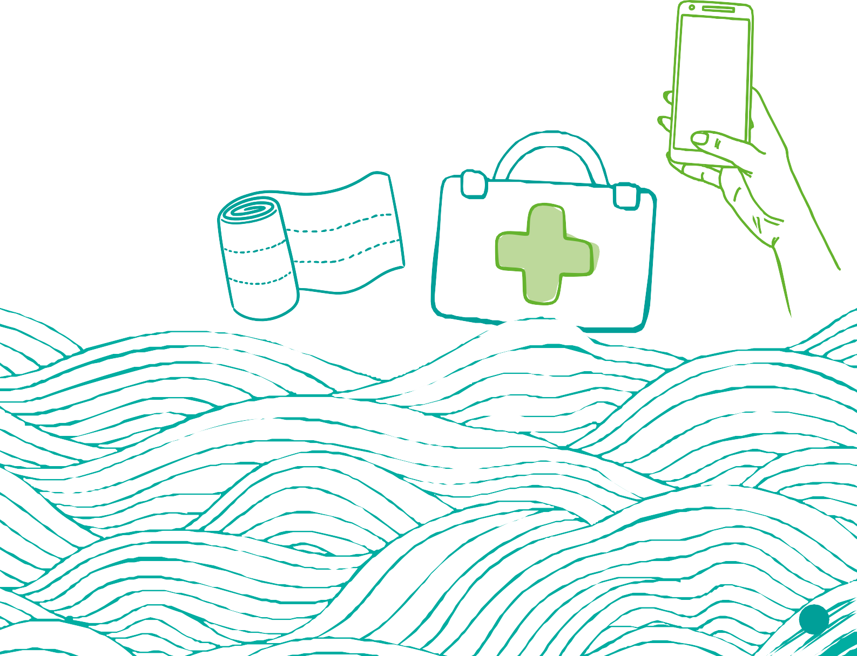

* If the wound has become infected (e.g., swelling, pus forming or spreading redness) seek medical help.

## Burns:

* Cool with cold water for 10 to 30 minutes, then cover with a sterile dressing.
* Don’t use ice or any creams or greasy substances such as butter.
* For more information on handling wounds and burns, and information about when to see a doctor,

see [**www.nhs.uk**](https://www.nhs.uk/)or ring **NHS Direct on 111.**

## Scars:

* If your child has scars, they’re embarrassed about you can look into commercial products that may help them fade.
* Scars can also be covered by makeup.
* Remind your child that most scars will eventually fade.

**111**

# Seeking further help

## Your GP

If you are concerned about your child, particularly if the self-harm or distress increases or you notice problems such as anxiety or low mood, you should seek further help. This is best done through your general practitioner (GP), who may refer your child to a community Child and

Adolescent Mental Health Services (CAMHS) where an assessment would be done and

a plan made for support and treatment. If your child is reluctant to get help or doesn’t acknowledge the risks, you can still receive advice from your GP.

If your child goes to hospital for any reason related to self-harm, they should be seen by someone who will talk to them about self- harm and assess their mental well-being. If it is not clear whether this has happened, ask the staff about it.

## Organisations

**24/7 support: Crisis helplines in Cheshire and Merseyside**

If you need urgent mental health support for you or your child, contact **NHS 111** **option 2** (for mental health).

If there is an immediate risk of danger to life, you should ring **999.**

### The Samaritans

They provide emotional support and help

24 hours a day, 365 days a year. [**www.samaritans.org**](http://www.samaritans.org) **Helpline: 116 123**

### CALM

[**www.thecalmzone.net**](http://www.thecalmzone.net)

**Helpline: 0800 58 58 58** (open 5pm to midnight, 365 days a year).

### Young Minds Parent Helpline

You can call their Parent Helpline on

**0808 802 5544**, Monday - Friday 9:30am to 4:00pm. Alternatively, you can contact them via their webchat by clicking the chat icon. [**www.youngminds.org.uk/parent/parents-**](https://www.youngminds.org.uk/parent/parents-helpline-and-webchat/)[**helpline-and-webchat/**](https://www.youngminds.org.uk/parent/parents-helpline-and-webchat/)

**Hopeline UK**

For children and young people under the

age of 35 who are experiencing thoughts

of suicide or anyone concerned that a young person could be thinking about suicide. Contact HOPELINE247 for confidential support and practical advice.

**Call: 0800 068 4141**

**Text: 88247**

**email:** [**pat@papyrus-uk.org**](mailto:pat@papyrus-uk.org)

[**www.papyrus-uk.org/papyrus-hopeline247/**](http://www.papyrus-uk.org/papyrus-hopeline247/)

**SHOUT**

Shout is a free, confidential 24/7 text message

service for anyone in the U.K who needs support.

If you are struggling to cope and need to talk

trained volunteers are there for you

Text **SHOUT** to **85258**

[**Give us a Shout 85258**](https://giveusashout.org/)

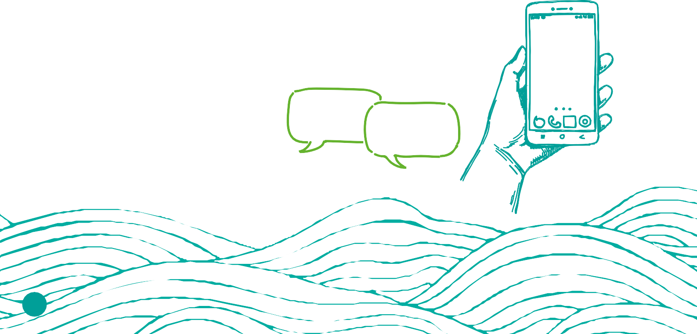

## Free digital mental wellbeing support

Join the community and access free, safe and anonymous professional support online. There are no waiting lists for support and no referral needed. Access to these platforms is available instantly 24/7.

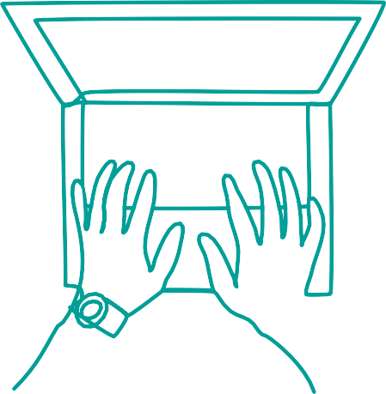

Support available includes:

* Live chat or messaging with qualified mental health professionals
* Self-help tools and activities
* Online community

**Kooth** (for ages 10 to 25) [**www.kooth.com**](http://www.kooth.com/) **Qwell** (for ages 26+) [**www.qwell.io/**](http://www.qwell.io/)

**\*Please note the above services are only available in certain areas**

## Websit[es](http://www.42ndstreet.org.uk/)

[**sppcm.co.uk**](sppcm.co.uk)

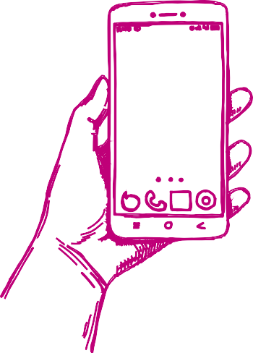A local (Cheshire & Merseyside) website offering information and support.

#### [harmless.org.uk](https://harmless.org.uk/)

A national organisation offering information and support.

#### [www.selfharm.co.uk](https://www.selfharm.co.uk/)

A safe online space available to inform and support young people who self-harm.

With thanks to the Greater Manchester Integrated Care Partnership for granting permission to utilise this booklet within the Cheshire and Merseyside sub-region.

Original date of publication: August 2023

Date of publication in Cheshire and Merseyside: October 2024