Knowledge and understanding | Reception – All About Me | The Curriculum
History:  We will talk about members of our family and their relationship to us. We will use the language of time when talking about past and present events in our own lives. We will also talk about and understand changes in our own lifetime and what happens when we get older.  As scientist we will be learning about…  We will have discussions around human lifecycles and how we grow and change – we will understand how we have grown and how we continue to grow. We will look at how we look now and how people older than us look – what is the same and what is different. We will name body parts and how to keep ourselves healthy. We will talk about the seasons and have some understanding about the change that happens in the world. We will also know that it is Autumn and will soon be winter. | Reading and Writing Outcomes  - We will learn GPCs, the formation of graphemes, blending for reading, and segmenting for writing in line with the Little Wandle Phonics scheme.  - We will begin 3 weekly Reading Squad sessions matched to each child’s individual stage of progression in phonics.  - We will be able to recognise and begin to learn how to write our names.  - We will promote pre-writing skills through such activities as Dough Disco.  - We will enjoy listening to and joining in with rhymes, poems and songs and learning new vocabulary.  - We will engage in Nursery Rhyme Challenge each week to promote language, vocabulary, and literacy development.  - We will listen to and enjoy sharing a range of books both fiction and non-fiction related to our theme.  - We will learn basic reading skills such as how to turn pages and hold a book correctly.  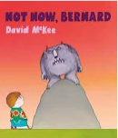  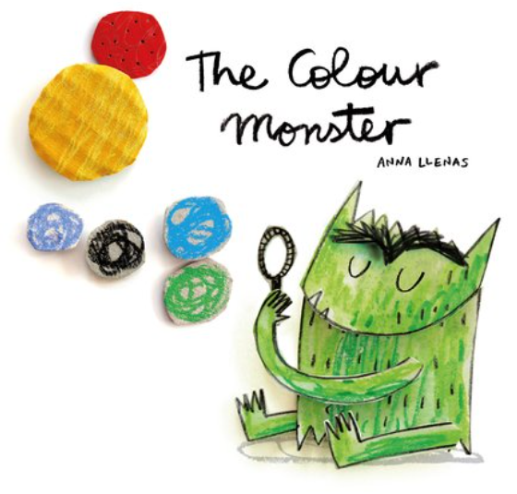  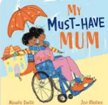 | P.E: Catching & Throwing  We will be able to use both underarm and overarm throws with some accuracy when using a beanbag or tennis ball. We will practise rolling, throwing and stopping circular equipment. We will also begin to be able to catch a moving ball.  RE: Why is the word God so important to Christians?  We will learn about the Christian belief that God created the heavens and the earth. We will learn the key events from the creation story found in Genesis 1.  PSHE: Being me in my world  - Feeling special and safe  - Being part of a class  - Rights and responsibilities  - Rewards and feeling proud  - Consequences  - Owning the Learning Charter  Spanish- Greetings  We will learn how to say ‘hello’, ‘good morning’, our name, ask how somebody is feeling and give a reply and say ‘goodbye’ and ‘see you later’ in Spanish.  DT: Junk Modelling-My House  We will junk model with different materials and select the tools and techniques needed to assemble and join materials we are using for a specific reason. We will use one-handed tools and equipment, for example, making snips in paper with scissors.  Music- Who Shall I Be Today? / A Sky Full of Colour  We will sing simple well-known songs and rhymes, also introducing new rhymes. We will describe the sounds we can hear.  Art- Rainbows and Waves for Grey Days  We will understand how to grip a pencil comfortably and explore making marks, creating lines and circles, and giving meaning to marks made. We will recognise and name colours and print with our hands, feet, and fingers.
Parental Involvement- This term we will be going on an Autumn Welly Walk with our families, we will host a Halloween themed Stay and Play and we will be inviting parents to a consultation to discuss their child’s progress.

Celebrations & Experiences-
- Halloween
- Black History Month

Fabulous Fifty-
- Nature Welly Walk.
- Receive a letter in the post.
- Make a phone call to our family.

Visitis and Visitors
- Author visitor
- Autumn Welly Walk
Maths

Match pictures and objects.
Identify a set.
Sort objects to a type.
Explore sorting techniques.
Create sorting rules.
Compare size, mass, capacity.
Explore, copy, continue and create simple patterns.
Find, subitise and represent 1,2 and 3.
1 more, 1 less.
Composition of 1,2 and 3.
Writing numerals.
Days of the week, seasons •Sequence daily events

