Geography – Enquiry Question  Study of an Alphine Region | Y5- Our Wild Word | The Curriculum – Threshold Concepts
Working goegraphically to:  - Locational knowledge: locate the world’s countries, using maps to focus on Europe concentrating on their environmental regions, key physical and human characteristics  - Place knowledge: understand geographical similarities and differences through the study of human and physical geography of a region in a European country.  - Human and physical geography: describe and understand key aspects of: mountains, climate zones, types of settlement and land use, economic activity  - Geographical skills and fieldwork: use maps, globes and digital/computer mapping to locate countries and describe features studied.  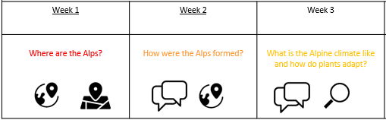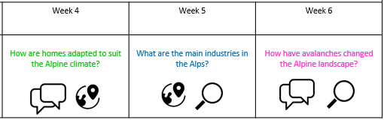 | 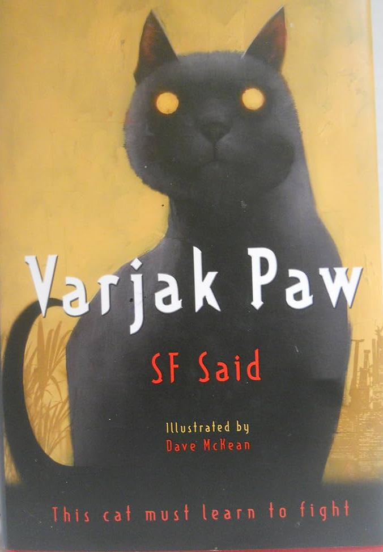  English Focus text:  Micheal Morpurgo: Varjak Paw  Writing Outcomes:  Non- Chronological report – Writing a fact file on a rare breed of cat. Either a Mesopotamian Blue, Khao Manee or Japanese bobtail.  Letter – Writing a letter to the society for protection of rare cats.  Reading Outcomes:  Reading skills: predicting, clarifying, questioning and summarising.  Grammatical Skills:  3rd person, past tense, technical vocabulary., sentence structure, apostrophes, parenthesis  Maths: White Rose  Fractions A  Multiplication and Division B  - multiply and divide numbers mentally drawing upon known facts  - multiply and divide whole numbers and those involving decimals by 10, 100 and 1000  - multiply numbers up to 4 digits by a one- or two-digit number using a formal written method, including long multiplication for two-digit numbers  - divide numbers up to 4 digits by a one-digit number using the formal written method of short division and interpret remainders appropriately for the context identify multiples and factors, including  - solve problems involving multiplication and division including using their knowledge of factors and multiples, squares and cubes  Fractions B  - recognise and use thousandths and relate them to tenths, hundredths and decimal equivalents compare and  - order fractions whose denominators are all multiples of the same number  - read, write, order and compare numbers with up to three decimal places  - round decimals with two decimal places to the nearest whole number and to one decimal place  - add and subtract fractions with the same denominator and multiples of the same number  - recognize mixed numbers and improper fractions and convert from one form to the other and write mathematical statements | P.E  Gymnastics: Sports Coach  To be able to perform forwards rolls with a range of entrances and exits. To perform a range of routines with rolling. To be able to perform backwards rolls with a range of entrances and exits.  ICT  E-safety: Project Evolve Online Reputation  Computer Science: Lightbot – Algorithms Procedures. Loops and Debugging  PSHE  Jigsaw: Dreams and Goals  Understanding the role of money  Exploring job opportunities and different roles  Understanding self-motivation, different cultures and broaden aspiration  R.E  Enquiry Question: Why is the Torah so important for Jewish people?  Religion: Judaism  -pupils will build on their learning about the Jewish worldview and way of life.  -investigate the centrality of Torah through examining how a Sefer Torah is constructed, it’s place within the synagogue and how different Jews may interpret the Torah in diverse ways.  MUSIC  Unit 3 Life Cycles  Pupils appreciate and understand a wide range of recorded music drawn from different traditions, styles, and genres, including the works of the great composers and musicians  Pupils develop an understanding of musical composition  Pupils play and perform in solo and ensemble contexts, using their voices and playing musical instruments with increasing accuracy, fluency, control, and expression  MFL  Unit: Vikings  Objective 1: I will learn how to decode unfamiliar and more complex language by my knowledge of cognates and history.  Objective 2: I will learn how to describe myself and others physically in terms of height and character using the verb ‘ser’ (to be).  Objective 3: I will learn how to describe myself and others physically in terms of hair colour and type using the verb ‘tener’ (to have).  Objective 4: I will learn how to describe myself by eye colour using the verb ‘tener’ (to have).  Objective 5: I will learn how to describe a Viking’s typical daily routine using time phrases.  DT Unit Focus: Electrical Systems: Circuits and Switches  That mechanical and electrical systems have an input process and output  Constructed a simple series electrical circuit in science.
Science Biology – Animals including humans
Working Scientifically to:
- Describe the changes as humans develop to old age.
- Different animals mature at different rates and live to different ages.
- Puberty is something we all go through, a process which prepares our bodies for being adults, and reproduction and Hormones control these changes, which can be physical and/or emotional.

Scientific Enquiry:

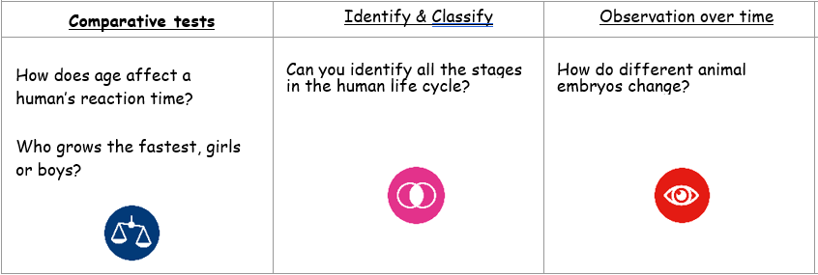

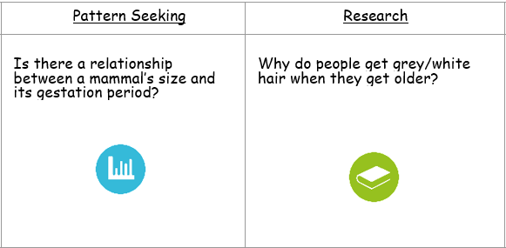
Wild

