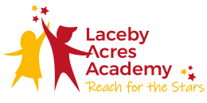

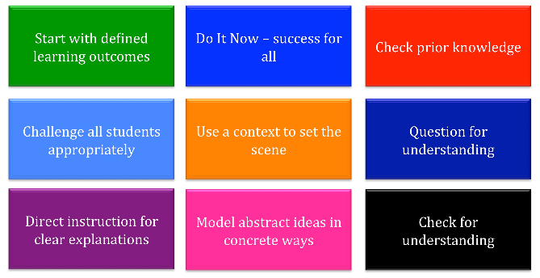
The Primary Science Classroom at Laceby Acres Academy

Enquiry Skills
Children must be given the opportunity to practise scientific enquiry skills. These are the skills that scientists need to carry out research and are sometimes referred to as a cycle of plan, do, review.
Teachers should be aware of the progression of these skills across the primary phases and plan to teach and assess these skills within children's practical investigations. For example, if children are recording data in a table:
- With children (ages 5-7), you might model how to use a pre-prepared table with column headings to record observations before you ask children to do this independently.
- With children (ages 7-9), you might provide a table (with or without column headings) for children to record their observations.
- With children (ages 9-11), you might expect children to draw their own table with appropriate column headings to record their findings (including for repeat readings and averages).

Enquiry Skills can be represented using the following symbols (explanations found in the curriculum document). These symbols can be displayed around the classroom or in books to help the children identify and recall the particular science skills they are using in their science investigations.

Enquiry Approaches

Over the course of an academic year, pupils should carry out several investigations that involve different types of enquiry. This ensures the lesson and task design has a primary science focus (isn’t a hidden literacy task). Allowing the children to progress as scientists.
Enquiry approaches can be represented using the following symbols (explanations found in the curriculum document). The symbols could be displayed in your classroom to help the children identify what type of investigation they are doing.

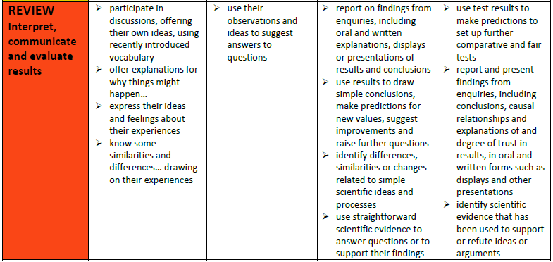
Skills Progression
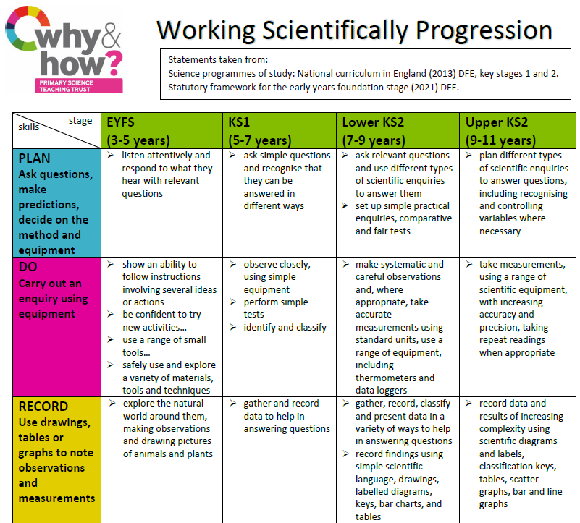

Sample Unit Plans – Animals Including Humans

