

What a good lesson looks like.

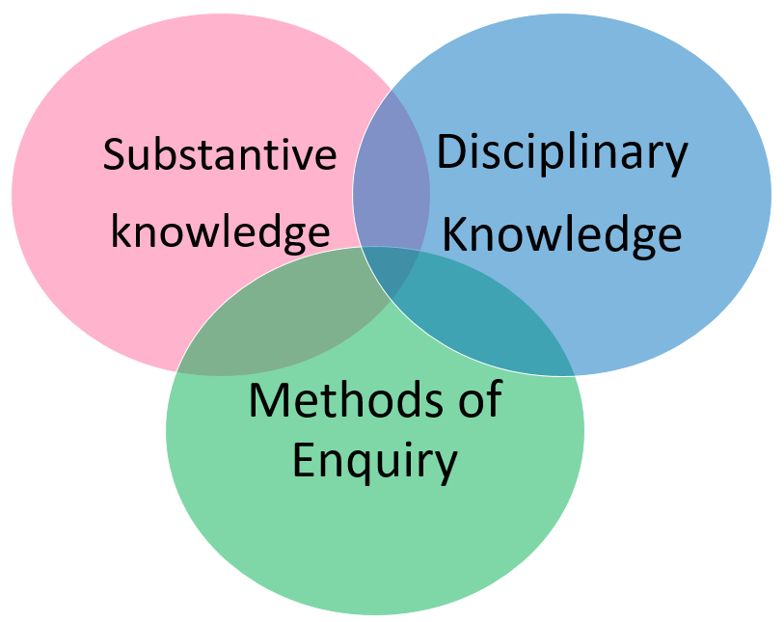
Examples of Excellence

- Carefully considered building blocks of progress.
- Identifying knowledge that is essential to pupils understanding.
- Building pupils substantive knowledge.
- Challenging vocabulary.
- Explicit teaching of concepts
- Assessing pupils knowledge of identified concepts.
- Pupils chronological knowledge.
- Pupils ability to place their learning in context and across subjects.
- Knowledge is regularly revisited.
- Pupils can confidently discuss the periods they had studied.

