We are adding the following information to our Behaviour Policy in light of the extra expectations regarding behaviour in school due to Covid 19.
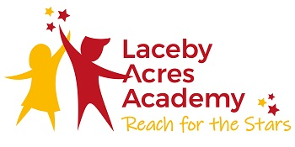

⏰
We expect the children to arrive at school and be collected from school at the allocated times for their group. Children will not be accepted into school unless they keep to their times.
We expect the children to follow our hygiene and handwashing and sanitizing procedures from the moment that they enter the school grounds.
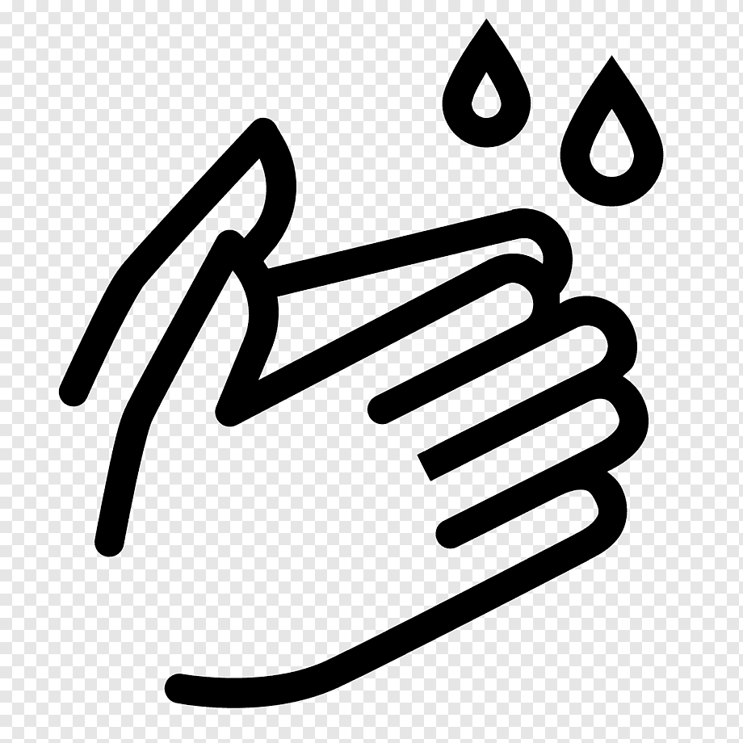

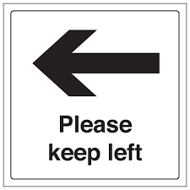
We expect the children to walk down the left hand side of corridors; signs to remind them have been installed.

✏️
We expect the children to use only their own equipment pack provided by the school and the water bottle brought in from home.

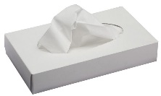
We expect the children to ‘Catch it, Bin it, Kill it’ – there are supplies of tissues in all classrooms and communal areas of the school.

🚽
We expect that only one child will use a toilet facility at any time.
Deliberate spitting or coughing at another person will never be tolerated.
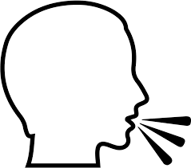

We shall use rewards and sanctions as deemed appropriate. We shall use exclusion should any child deliberately refuse to abide by our rules, putting the safety of other children or adults at risk.

