Geography Focus – The Anglo-Saxons  Enquiry Question: Was the Anglo-Saxon period really a Dark Age? | Year 5 – King Arthur and the Knights of the Round Table | The Curriculum – Threshold Concepts
History  - develop a chronologically secure knowledge and understanding of British and world history  - develop the appropriate use of historical terms  - understand how our knowledge of the past is constructed from a range of sources  - construct informed responses that involve thoughtful selection and organisation of relevant historical information  - note connections, contrasts and trends over time  - regularly address and devise historically valid questions about significance.  Science  Physics – Properties and Changes of Materials  (Mixtures and Separation)  - when two or more substances are mixed and remain present the mixture can be separated  - some changes can be reversed and some cannot  - materials change state by heating and cooling  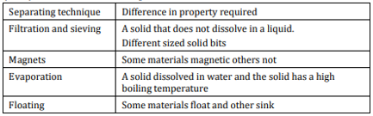 | 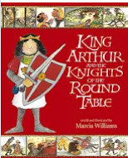  English focus text: King Arthur and the Knights of the Round Table by Marcia Williams  Extended writing outcomes:  -Play script describing one of Lancelot’s adventures. Children will use period vocabulary and create a cast of supporting characters.  Short writing outcomes:  -Recount of a specific event from another character’s point of view.  Link Reading:  Illustrated Tales of King Arthur – Usborne  (fiction)  Lady of Shallot – Lord Alfred Tennyson  (poetry)  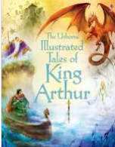  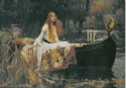  Maths – White Rose  Place Value  Addition and Subtraction | P.E: Hockey  - choose and combine techniques in game situations  - work as part of a team to score points or gain possession  - field, defend or attack tactically by anticipating the direction of play  - uphold the spirit of fair play and respect in all competitive situations  I.C.T: Digital Literacy (E-Safety)  - Give examples of the risks of online communities, demonstrate knowledge how to minimise risks and report problems, Understand the effect of online comments and show responsibility and sensitivity when online.  RE: Religion: Sikhism  Theme: Belief into action  Key Question: How far would a Sikh go for his / her religion?  • Present the key teachings and beliefs of a religion.  • Refer to religious figures and holy books to explain answers  PSHE: Jigsaw Being Me In My World.  Music: Music Express.  Musical Focus: Performance.  Unit: Our Community  Children will be looking at changes through time.  MFL: Spanish
The Curriculum:
Art and Design: Drawing – Typography and Maps.
We are going to explore how some artists use graphic skills to create pictorial maps using symbols (personal and cultural) to map identity as well as geography. We will create pictorial / 3-dimensional maps which showcase our personalities.
DT: Frame Structures – Spaghetti Towers
Hands-on workshop challenging students to build the highest tower possible with limited supplies.

