Geography Focus – The Anglo-Saxons  Enquiry Question: Was the Anglo-Saxon period really a Dark Age? | Year 5 – Anglo-Saxon Boy | The Curriculum – Threshold Concepts
History  - develop a chronologically secure knowledge and understanding of British and world history  - develop the appropriate use of historical terms  - understand how our knowledge of the past is constructed from a range of sources  - construct informed responses that involve thoughtful selection and organisation of relevant historical information  - note connections, contrasts and trends over time  - regularly address and devise historically valid questions about significance.  Science  Physics – Properties and Changes of Materials  (Mixtures and Separation)  - when two or more substances are mixed and remain present the mixture can be separated  - some changes can be reversed and some cannot  - materials change state by heating and cooling  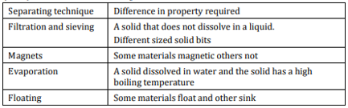 | 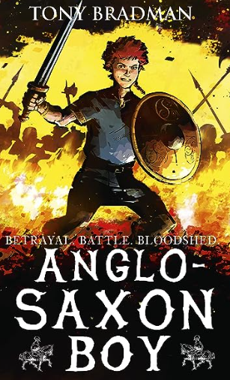  English focus text: Anglo-Saxon Boy  Extended writing outcomes:  Diary entry in role as a central character, as well as diary entries from the perspective of historical figures chronicling key historical events  Letters in role as the central characters.  Fact-files outlining what the children have learned about the Anglo-Saxons  Autobiographies of select characters.  Link Reading:  King Arthur and the Knights of the Round Table by Marcia Williams Illustrated Tales of King Arthur – Usborne  (fiction)  Shield Maiden – Richard Denning  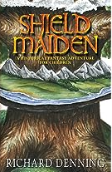  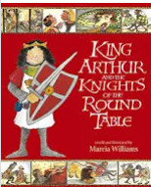  Maths – White Rose  Place Value  Addition and Subtraction | P.E: Gymnastics 1  This unit focuses on forward rolls, backward rolls and a range of routines with rolling. Pupils will also learn how to vault safely.  I.C.T: Digital Literacy (E-Safety)  - Give examples of the risks of online communities, demonstrate knowledge how to minimise risks and report problems, Understand the effect of online comments and show responsibility and sensitivity when online.  RE: Religion: Sikhism  Theme: Belief into action  Key Question: How far would a Sikh go for his / her religion?  • Present the key teachings and beliefs of a religion.  • Refer to religious figures and holy books to explain answers  PSHE: Jigsaw Being Me In My World.  Music: Music Express.  Musical Focus: Performance.  Unit: Our Community  Children will be looking at changes through time.  MFL: Spanish  Phonics 3(XT) an Do you have a pet?
The Curriculum:
Art and Design: Drawing – Typography and Maps.
We are going to explore how some artists use graphic skills to create pictorial maps using symbols (personal and cultural) to map identity as well as geography. We will create pictorial / 3-dimensional maps which showcase our personalities.
DT: Frame Structures – Spaghetti Towers
Hands-on workshop challenging students to build the highest tower possible with limited supplies.

