Geography Focus - Threshold Concepts | Y4 The Americas | Art and Design - Threshold Concepts
Geography  Investigate Places:  - Use maps, atlases, globes and digital/computer mapping to locate countries and describe features.  - Ask and answer geographical questions about the physical and human characteristics of a location.  - Use a range of resources to identify the key physical and human features of a location.  - Name and locate the countries of Europe and identify their main physical and human characteristics.  - Name and locate counties and cities of the Americas geographical regions and their identifying human and physical characteristics, including hills, mountains, cities, rivers, key topographical features and land-use patterns; and understand how some of these aspects have changed over time.  Communicate Geographically:  - Use the eight points of a compass, four-figure grid references, symbols and key to communicate knowledge of the United Kingdom and the wider world. | Enquiry Question:  Can you come on a great American road trip?  Class Text  Themes: an exciting story with a diary theme. A young child travels to the Amazon rainforest but after an unexpected incident they find themselves on a wild adventure. All captured in their jungle diary, this is a tale of survival and discovery.  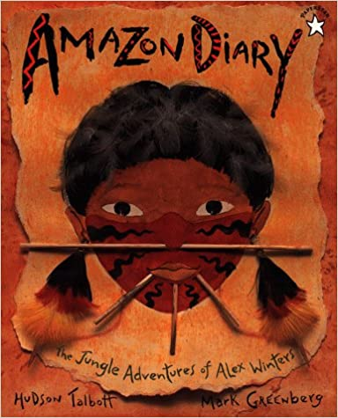  Supporting Text  Themes: A tale of mystery and suspense on a fast moving train from Chicago to San Francisco. A young boy goes on an exciting journey with his uncle only to find the adventure is just beginning.  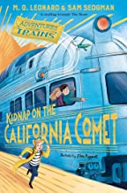  R.E  Focus: Pilgrimage. Understand practices and lifestyles. Understand beliefs and teachings across religions.  SMSC and PSHE:  Focus: Being me in My World – recognise and understand how my actions and the actions of others affect my school community. Know what I can do to make people in my school community feel valued and included.  D&T  Focus: Levers and linkages. Master techniques and design processes. Understand and develop skills using a range of materials. | Exploring Abstract Art  Develop Ideas  - Adapt and refine ideas as they progress.  - Explore ideas in a variety of ways.  - Comment on artworks using visual language.  Master Techniques  - Use a number of brush techniques using thick  and thin brushes to produce shapes, textures,  patterns and lines.  - Mix colours effectively.  - Use watercolour paint to produce washes for  backgrounds then add detail.  - Experiment with creating mood with colour  - Take inspiration from the greats  Artist Spotlight: Wassily Kandinsky  - Replicate some of the techniques used by notable artists, artisans and designers.  - Create original pieces that are influenced by studies of others.
Science  Understand electrical circuits:  - Identify common appliances that run on electricity.  - Construct a simple series electrical circuit, identifying and naming its basic parts, including cells, wires, bulbs, switches and buzzers.  - Identify whether or not a lamp will light in a simple series circuit, based on whether or not the lamp is part of a complete loop with a battery.  - Recognise that a switch opens and closes a circuit and associate this with whether or not a lamp lights in a simple series circuit.  - Recognise some common conductors and insulators, and associate metals with being good conductors. |  | Cross Curricular Opportunities  English: speaking and listening; poetry; research skills, note-taking, non-chronological reports.  Extended Writing Process – diary entry.  Mini Process – Note taking, summaries, questioning and predictions.  Maths: direction and compass points, populations, historical dates.  Computing: Use some of the advanced features of applications and devices in order to communicate ideas, work or messages professionally.  History: exploration; use reliable sources to investigate the

