History Focus – Ancient Egypt | Y4 Ancient Egypt | Art and Design - Threshold Concepts
History  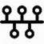  Understand Chronology  - Use existing knowledge of history to place the time of Ancient Egypt chronologically.  Interpret Historically / Historical Enquiry  - Understand how and why Ancient Egyptians were able to proper in the desert.  - Understand why we know so much about Ancient Egypt.  Communicate Historically  - Ask and answer historically valid questions about the events during the time of Ancient Egypt  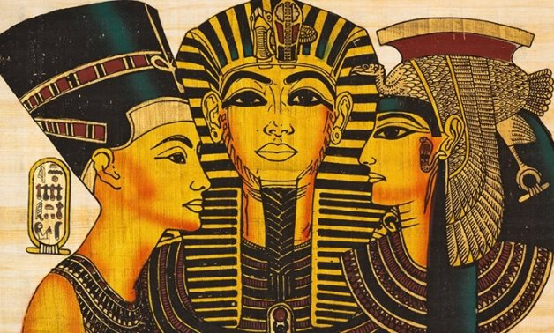  - Recognise how different groups contributed to the success of ancient Egyptian civilization. | Enquiry Question:  How Much did the Ancient Egyptians achieve?  Class Text  Themes: It's November, 1922. In a valley in Egypt the tomb of a long dead pharaoh is about to be discovered. The world watches and waits for news with baited breath. Thirteen-year-old Lilian Kaye is eagerly following the story. One morning the news takes a sinister turn: a man- a famous Egyptologist- disappears. All that remains of him are his feet.  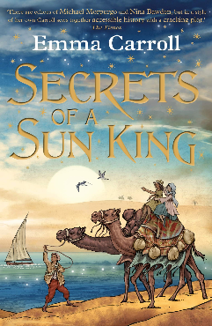  Extended Written piece: Historical Recount  Write with purpose  Expanded noun phrases  Pronouns  Chronological order  Factual information  Plan, draft, edit and improve writing.  Supporting Text  Themes: Topher and his father are trying to get over the death of Topher's mother, an Egyptologist, when they take in a stray cat. Topher becomes very attached to Ka and is puzzled by her mysterious absences.. Could Ka really be leading a double life and what is she trying to tell Topher?  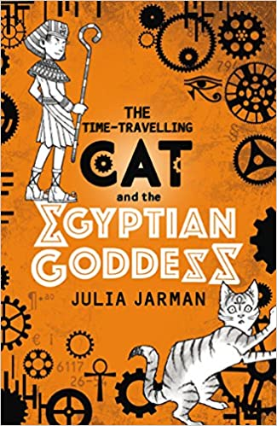  Supporting piece: procedure text.  Write with purpose  Factual information  Present tense  Imperative verbs  Chronological order.  R.E  Focus: Buddhism and Humanism. Is it possible for everyone to be happy? Understand the life of Buddha and how he tried to be and stay happy.  SMSC and PSHE:  Focus: Celebrating Difference – understand how to respect similarities and differences. Discuss and learn about Anti-bullying and being unique.  D&T  Focus: Levers and linkages. Master techniques and design processes. Understand and develop skills using a range of materials. | Exploring Portraits  Develop Ideas  - Adapt and refine ideas as they progress.  - Explore ideas in a variety of ways.  - Comment on artworks using visual language.  Master Techniques  - Use a number of brush techniques using thick  and thin brushes to produce shapes, textures,  patterns and lines.  - Mix colours effectively.  - Use watercolour paint to produce washes for  backgrounds then add detail.  - Experiment with creating mood with colour  - Take inspiration from the greats  Artist Spotlight: Hans Holbien  - Replicate some of the techniques used by notable artists, artisans and designers.  - Create original pieces that are influenced by studies of others.
Science  Sound:  - Know that Sound travels from its source in all directions  - Know that Changing the shape, size and material of an object will change the sound it produces.  - Work scientifically to investigate how sound is produced when an object vibrates.  - Know that sound moves through all materials by making them vibrate.  - Recognise that bigger vibrations produce louder sounds and smaller vibrations produce quieter sounds and faster vibrations (higher frequencies) produce higher pitched sounds. |  | Cross Curricular Opportunities  English: Recognise vocabulary associated with Ancient Egypt, use and identify terminology associated with Ancient Egypt in writing and reading sessions.  Maths: Historical dates, chronology, ordering events and sequencing.  Computing: Use some of the advanced features of applications and devices in order to communicate ideas, work or messages professionally.  Geography : Map reading, contrasting ancient civilizations with current locations.

