The Early Years Curriculum | FS2 All around Me (Class Texts)
Understanding the World  People, Culture and the Communities  Enquire Geographically  - Ask and answer geographical questions-where have I been? What is there? What do people do there?  - Mapping: Look at simple maps of the UK- identify where Grimsby is. Look at simple aerial maps and identify physical and human features of the local different environments.  - Locate and Identify Physical features: Locate England, London and Grimsby and the North Sea. Identify the key features of a town (Town Hall, Schools, streets and road network, parks, rivers -Grimsby Docks and Dock Tower. Countryside- Fields, farms, villages. Seaside- Coastline).  - Physical processes: Daily weather and seasons.  Communication and Language  Communicate Geographically  Use simple locational and directional language- (near/far and names of features- shop, park, trees, grass, coastal, countryside).  - Listen to stories and respond with appropriate comments and questions, particularly how and why questions  - Use appropriate geographical vocabulary to communicate knowledge  - Use language to organise, sequence and clarify thinking  The Natural World  Explore the different, familiar plants and flowers in their environment.  - To sketch the flower petal shapes and flowers that they see in the environment  - To begin to identify some of the common flowers  - To use some of the recently introduced vocabulary relating to the parts of a plant  - To use flowers to make a picture and take a photograph, identifying the flowers used  - To look after some plants | Personal, Social and Emotional Development :  Being Me in My World  Jigsaw Programme  - Help others to feel welcome  - Try to make our Pre-school community a better place  - Think about everyone’s right to learn  - Care about other people’s feelings  - Work well with others  - Choose to follow the Learning Charter  .  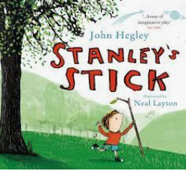  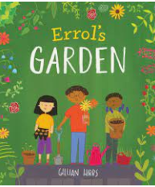  RE- Myself  - Recognise and understand feelings  - Understand why some things are special/precious  - Establish effective relationships with other children and adults  - Recognise and respond appropriately to key figures in their lives  - Recognise special times and feel good about themselves  - Recognise and respond key religious events throughout the year  - Respond to key elements in religion using their five senses | Expressive Arts and Design- Creating with materials  Impressionism  - Exploring colour. Mixing chalk, liquid, pastel, paint colours.  - Short brush strokes, thick paint, mix on the paper.  - Berthe Morisot- Summer’s Day.  Autumn Day  - Structures- natural materials- Autumn  Being Imaginative and Expressive  Exploring natural materials in the role of Stanley from the text Stanley’s Stick
Communication and Language:
Listening, Attention and Understanding:
- Make comments about what they have heard and ask questions to clarify their understanding
- Use conversation to discuss their understanding and develop prediction and reasoning skills
Literacy: Comprehension:
- To listen to the story and recall the events through drama, pictures and discussion.
- To use their own words and recently introduced vocabulary to retell the story and in the drama
- Using prediction at key events in the story when applicable and appropriate
- To introduce the story within the role play
- To use the recently introduced vocabulary in discussions and play where appropriate.
Writing:
To describe the marks they have created.
Maths: Match and sort
- Use Natural materials and match and sort
- Match and sort the features of a place- animals at a farm, shells at a beach, lampposts in a town etc
- Colour sorting
Shape- Pattern making
- Using natural materials to create a pattern.
Thread and make a natural materials bracelet, making a pattern

