Geography Focus - Threshold Concepts | Y6 South America – The Amazon | Art and Design - Threshold Concepts
Geography  Investigate Places  - Collect and analyse statistics and other information in order to draw clear conclusions about locations.  - Identify and describe how the physical features affect the human activity within a location.  - Use a range of geographical resources to give detailed descriptions and opinions of the characteristic features of a location.  - Use different types of fieldwork  - Analyse and give views on the effectiveness of different geographical representations of a location  - Name and locate the countries of North and South America and identify their main physical and human characteristics.  Investigate Patterns  - Understand some of the reasons for geographical similarities and differences between countries.  - Describe how locations around the world are changing and explain some of the reasons for change.  Communicate Geographically  - physical geography, including: climate zones, biomes and vegetation belts, rivers, mountains, volcanoes and earthquakes and the water cycle.  - human geography, including: settlements, land use, economic activity including trade links, and the distribution of natural resources including energy, food, minerals, and water supplies. | Enquiry Question:  What is life like in the Amazon?  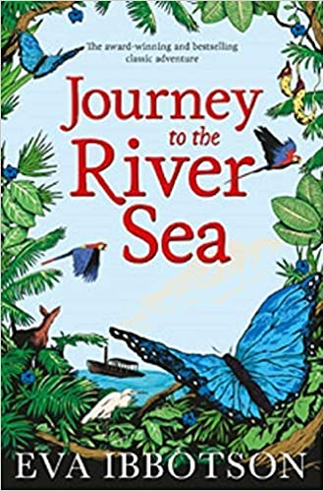  Class Text  Themes: an exciting adventure story with themes of family and class, each individual's responsibility for their own actions, the importance of embracing new experiences and of choosing your own outlook on life.  Supporting Text  Themes: A tale of survival and perseverance with an appreciation of the natural environment. An exploration of love, friendship, self-discovery and emotional development.  R.E  Focus: Pilgrimage. Understand practices and lifestyles. Understand beliefs and teachings across religions.  SMSC and PSHE:  Focus: My year ahead. Identifying goals for the year, understanding emotions and knowing how to express them. Understand and value the importance of community and how to promote the positive values.  D&T  Focus: Textiles. Master techniques and design processes. Understand and develop skills using textiles. | Exploring Expressionism  Develop Ideas  - Develop and imaginatively extend ideas from starting points throughout the curriculum.  - Collect information, sketches and resources and present ideas imaginatively in a sketch book.  - Use a range of quality materials to enhance ideas.  - Comment on artworks with a fluent grasp of visual language.  Master Techniques  - Sketch before painting to combine line and colour.  - Create a colour palette based upon colours observed in the natural or built world.  - Use the qualities of watercolour and acrylic paints to create visually interesting pieces.  - Combine colours and tones to enhance the mood.  - Develop a personal style of painting, drawing upon ideas from other artists.  Take inspiration from the greats  Artist Spotlight: Henri Matisse  - Give details including own sketches about the style of some notable artists, artisans and designers.  - Show how the work of those studied was influential in both society and to other artists  - Create original pieces that show a range of influences and styles
Science  To understand light and seeing  - Understand that light appears to travel in straight lines.  - Use the idea that light travels in straight lines to explain that objects are seen because they give out or reflect light into the eyes.  - Use the idea that light travels in straight lines to explain why shadows have the same shape as the objects that cast them, and to predict the size of shadows when the position of the light source changes.  - Explain that we see things because light travels from light sources to our eyes or from light sources to objects and then to our eyes. |  | Cross Curricular Opportunities  English: speaking and listening; poetry; research skills, note-taking, non-chronological reports.  Extended Writing Process – Informal Letter, diary entry, narrative and autobiography.  Mini Process – (Reading to writing) note taking, summaries, questioning and predictions.  Maths: direction and compass points, distance  Science: habitats and adaptation, states of matter – properties of liquids  Computing: coding - making an animation; e-safety – using the internet safely and effectively for research  History: exploration; food and farming.

