History Focus-Threshold concepts | Year 2- Bonfire and The Great Fire of London | Art and Design – Threshold Concepts
History-  Investigate and interpret the past  Build an overview of world history  Understand chronology.  Milestones- Observe or handle evidence to ask questions and find answers to questions about the past.  Ask questions such as: What was it like for people? What happened? How long ago?  Use artefacts, pictures, stories, online sources and databases to find out about the past  Describe historical events.  Describe significant people from the past  Place events and artefacts in order on a time line.  Label time lines with words or phrases such as: past, present, older and newer.  Science  Everyday materials  Distinguish between an object and the material from which it is made (Y1).  • Identify and name a variety of everyday materials, including wood, plastic, glass, metal, water and rock (Y1).  • Describe the simple physical properties of a variety of everyday materials (Y1)  • Find out how the shapes of solid objects can be changed by squashing, bending, twisting and stretching.  Plants  • Identify and describe the basic structure of a variety of common flowering plants, including trees.  • Observe and describe how seeds and bulbs grow into mature plants.  • Find out and describe how plants need water, light and a suitable temperature to grow and stay healthy.  Linked texts: | 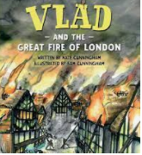  English Focus.  English focus text:  Extended writing outcomes:  Diary entry linked to the Great Fire of London.  Narrative in the style of Vlad and The Great Fire of London.  Shorter writing outcomes:  -Instructions for how to make a fire engine  - Non chronological report into The Great Fire of London  -News reports of the events  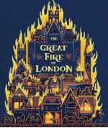  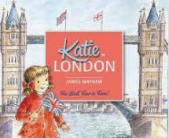  Supporting Texts | Artist Spotlight: Artemisia Gentileschi  Art Period: 1600’s  Art Style: Baroque  To master techniques:  - To use strong contrasts between light and dark.  - To use bold and strong brushstrokes  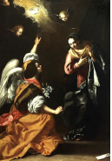
Curriculum coverage:
DT: Wheels and axles- Making fire engines
PSHE: Being me in my world. Jigsaw.
Music: Charanga. Hands, Feet, Heart.
I.C.T: Coding
P.E: Dance 1. Striver.

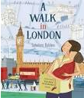
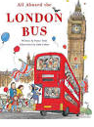
Linked texts:

