History Focus - Threshold Concepts | Y6 The Maya Civilisation | Art and Design - Threshold Concepts
History  Investigate and interpret the past  - Use sources of evidence to deduce information about the past.  - Seek out and analyse a wide range of evidence in order to justify claims about the past.  - Understand that no single source of evidence gives the full answer to questions about the past.  - Refine lines of enquiry as appropriate.  Build and overview of world history  - Describe the social, ethnic, cultural or religious diversity of past society.  - Describe the characteristic features of the past, including ideas, beliefs, attitudes and experiences of men, women and children.  Understand Chronology  - Describe the main changes in a period of history (using terms such as: social, religious, political, technological and cultural).  - Use dates and terms accurately in describing events.  Communicate Historically  - Use appropriate historical vocabulary to communicate, including: dates, time period, era, chronology, continuity, change, century, decade and legacy.  - Use literacy, numeracy and computing skills to a exceptional standard in order to communicate information about the past.  - Use original ways to present information and ideas. | Enquiry Question:  Why should we remember the Maya?  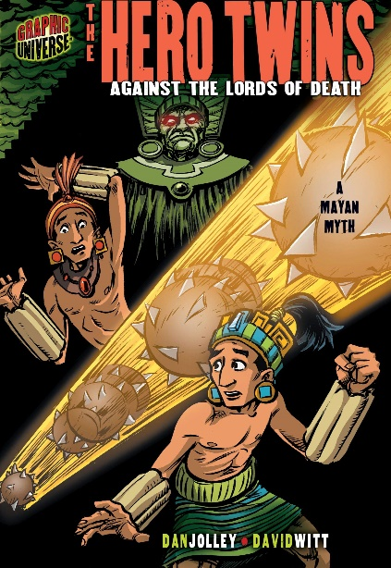  Class Text  Themes: an exciting adventure story, a Mayan folktale detailing Based on an ancient Mayan Myth, this tale is of two brothers who discover they are destined to compete in a game called Poke a Poke with inhabitants of an underground city.  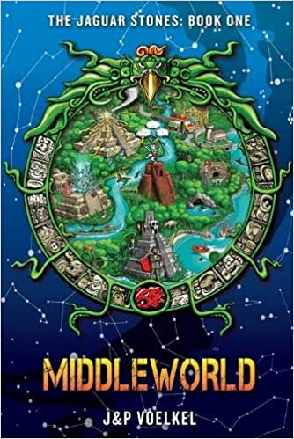  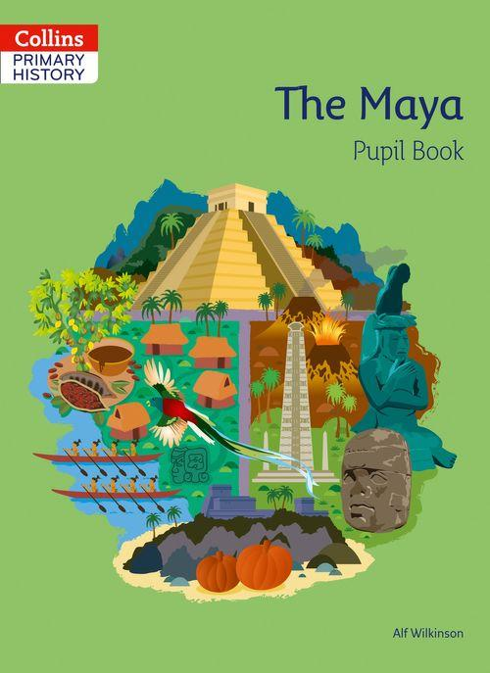  Supporting Texts  The Maya  Packed with information, source materials, questions and activities, allowing children to explore, interpret and develop knowledge of the Mayan Civilisation  Middle world  Links the Mayan folklore and traditions to a modern-day story focused on a young boy who rescues his parents from the Mayan underworld.  R.E  Focus: Theme: Christmas Concept: Incarnation Key Question: How significant is it that Mary was Jesus’ mother? Religion: Christianity  PSHE:  Focus: (Celebrating Difference) Respect for similarity and difference. Anti-bullying and being unique  D&T  Focus: Textiles. Master techniques and design processes. Understand and develop skills using textiles. Making pots in the style of the ancient Maya | Exploring Art and Religion  Develop Ideas  - Develop and imaginatively extend ideas from starting points throughout the curriculum.  - Collect information, sketches and resources and present ideas imaginatively in a sketch book.  - Use a range of quality materials to enhance ideas.  - Comment on artworks with a fluent grasp of visual language.  Master Techniques  - Sketch before painting to combine line and colour.  - Create a colour palette based upon colours observed in the natural or built world.  - Use the qualities of watercolour and acrylic paints to create visually interesting pieces.  - Combine colours and tones to enhance the mood.  - Develop a personal style of painting, drawing upon ideas from other artists.  Take inspiration from the greats  Artist Spotlight El Greco  - Give details including own sketches about the style of some notable artists, artisans and designers.  - Show how the work of those studied was influential in both society and to other artists  - Create original pieces that show a range of influences and styles
Science – Biology  To investigate living things and their habitats  - Describe the differences in the life cycles of a mammal, an amphibian, an insect and a bird.  - Describe the life process of reproduction in some plants and animals.  - Describe how living things are classified into broad groups according to common observable characteristics.  - Give reasons for classifying plants and animals based on specific characteristics.  - Develop scientific enquiry skills  - Carry out different forms of scientific enquiry |  | Cross Curricular Opportunities  English: speaking and listening; poetry; research skills, note-taking, non-chronological reports.  Extended Writing Process – Informal Letter, diary entry, narrative, character and setting descriptions  Mini Process – (Reading to writing) note taking, summaries, questioning and predictions.  Maths: calculations in different types of number systems  Music: percussion and wind instrument music in the style of the Maya  Computing: Digital literacy – Sketchup  Geography: impact of changes to the climate on a society  P.E: Striver: Gymnastics and body movements

