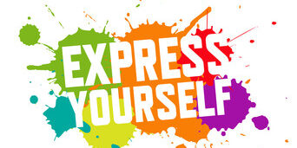

Competition Time

As part of Children’s Mental Health Week 2021 (1st-5th February) Compass Go… are hosting a competition for students aged 5-16, there will be one primary school winner and one secondary school winner!

This years theme is “express yourself” – we would like you to express yourself and help design a mascot for our service, Compass Go…

Use your imagination and get really creative in drawing or crafting a mascot, then submit a picture via email:

NELINCSMHST@compass-uk.org

Make sure to include your name, age, school, and the name for your character.

The winners will receive a £20 Amazon Voucher – Good Luck!

Entries must be received by the 5th February 2021

The winners will be contacted via email by the 22nd February 2021

To find out more about Children’s Mental Health Week visit: https://www.childrensmentalhealthweek.org.uk/
