us

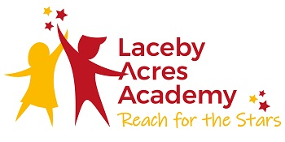

Curriculum Document



Laceby Acres Academy Curriculum

|  |  |  |
| --- | --- | --- |
| 🏹  Intent  At Laceby Acres Academy we believe that learning is a change to long-term memory.  *‘If nothing in the long term memory has been altered, nothing has been learned’: Sweller et al (2011)*  We ensure that our children experience a wide breadth of study based on the National Curriculum.  Our Curriculum is shaped by our Curriculum Drivers, which are: *Enquiry, Possibilities, The Arts and Diversity.*  This have been chosen because of the needs of our children and our local community and also because of our beliefs about a high quality education and our values.  Cultural capital gives our children the vital background knowledge required to allow them to develop into informed and thoughtful members of society, who understand and believe in British Values (Democracy, English Law, Accountability, Individual Liberty, Equality and Tolerance)  Our curriculum has been carefully designed around three main elements: Threshold Concepts, Breadth of Contexts and Milestones for Progress. Threshold concepts shape children’s thinking within each subject of the curriculum. These same concepts are explored in every year group and children gradually increase their understanding of them. The exploration of these threshold concepts will never be complete and children will continue to explore them for as long as they study a subject. The use of threshold concepts results in a ‘less is more’ approach to curriculum design.  Meyer and Land identify five key characteristics of Threshold Concepts:  **Transformative**- once a Threshold Concept is understood it potential effect on learning is to allow a significant shift in the perception of a subject. This could lead to a change in values or attitudes.  **Probably Irreversible** – unlikely to be forgotten  **Integrative** – mastery of a Threshold Concept allows the learner to make connections that were hidden from view  **Possibly bounded** – ‘any conceptual space will have terminal frontiers, bordering with thresholds into new conceptual areas. It might be that such boundedness in certain instances serves the demarcation between disciplinary areas, to define academic territories.’ Meyer and Land (2006)  **Potentially troublesome** – ideas that may conflict with children’s own ideas, they may be tacit among teachers (experts) so we do not explicitly teach them.  Meyer and Land also suggest that learning involves the occupation of a ‘liminal space’ during the mastery of a Threshold Concept. This is an unstable space where a learner may oscillate between old and emergent understandings. Once a learner enters the liminal space they are engaged in the process of mastery. This is a powerful way of remembering that learning is both affective and cognitive and that it can entail troublesome unsafe journeys. Children can often construct their own safe conditions of safety through mimicry. We do not want a permanent strategy of mimicry, learning can become the product of ritualised performances rather than integrated understandings. Teachers need to ‘hold’ their pupils through the liminal spaces. They need to design activities that allow children to see that they are not the only ones who are stuck. Through our research into Threshold Concepts, especially the work of Meyer and Land, we understand the notion of learning as excursive, as a journey or an excursion, which has an intended direction and outcome. However we know that there will be deviations and unexpected outcomes within the excursion. We know that there will be digression and revisiting (recursion). The final destination may be reached or it may have changed. There is no simple passage in learning from ‘easy’ to ‘difficult: mastery of a threshold often involves messy journeys back and forth across conceptual terrain.  High quality children’s literature is also central to our curriculum design. Each term the children experience access to a range of high quality texts and poetry. Teachers all read aloud to the children on a daily basis, giving all children, especially the disadvantaged, the opportunity to access literature, which is beyond their reading ability. This approach ensures that the curriculum remains vibrant, exciting and always challenging.  A final and crucial aspect of our curriculum design is a focus on the development of a child’s vocabulary. The National Curriculum comments on vocabulary development several times:  ‘Teachers should develop pupils’ spoken language, reading and writing and vocabulary as integral aspects of teaching of **every** subject.’  ‘English is both a subject in its own right and the medium for teaching. For pupils, understanding the language provides access to the whole curriculum.’  ‘Pupils’ acquisition and command of vocabulary are key to their learning and progress across the whole curriculum.’  ‘It is particularly important to induce pupils into the language which defines each subject in its own right, such as accurate mathematical and scientific language. ‘ | 🔩  Implementation  ‘Implementation – the process of putting a decision or plan into effect.’ (Oxford English Dictionary)  ‘Vision without implementation is hallucination.’ (Thomas Edison)  We believe that it does not matter how great an educational idea or intervention is in principle, what really matters is how it looks in the day-to-day work of the people in the school.  Central to our implementation strategy are the concepts drawn from cognitive science in particular metacognition and self regulated learning.  Cognition is seen as the mental process involved in knowing, understanding and learning. By cognitive strategies, we mean skills like memorisation strategies or subject specific strategies, Cognitive strategies are fundamental to acquiring knowledge and completing learning tasks.  Metacognition is about the ways that learners monitor and purposefully direct their learning. By metacognitive strategies we mean strategies we use to monitor or control our cognition.  Motivation is about our willingness to engage our cognitive and metacognitive skills and apply them to learning. .  Cognition, metacognition and motivation all interact together in complex ways.  The EEF carried out research into metacognition and self regulated learning. In order to implement these techniques through the delivery of the curriculum we are implementing the EEF summary of recommendations:  **Teachers should** acquire the professional understanding and skills to develop their pupils’ metacognitive knowledge  **Teachers should** explicitly teach pupils metacognitive strategies, including how to plan, monitor and evaluate their learning knowledge  **Teachers should** model their own thinking to help pupils to develop their metacognitive and cognitive skills  **Teachers should** set an appropriate level of challenge to develop pupils’ self regulation and metacognition (they should take the children into the ‘liminal space’)  **Teachers should** promote and develop metacognitive talk in the classroom  **Teachers should** explicitly teach pupils how to organise and effectively manage their learning independently  **Schools should** support teachers to develop knowledge of these approaches and expect them to be applied appropriately  We see implementation as a process and we plan for it and evaluate it at different stages. We are creating a leadership environment and school climate that is conducive to good implementation. The first step towards the implementation of our curriculum has been to explore. We have investigated many theories about curriculum design and we believe that we now have in place a well-designed curriculum. We are now in the process of developing a clear implementation plan. This is necessary in order for us to prepare staff and resources to deliver our curriculum. We are creating a shared understanding of the implementation process and we are providing appropriate support. We are introducing new skills, knowledge and strategies with our teaching team with explicit, up front CPD. We shall then be trialling how best to deliver our new curriculum. We have developed a flexible and motivating leadership approach during our initial attempts at implementation. We will reinforce initial training in order to commit the skills and learning to the long term memory of staff. Peer to peer collaboration will ensure that all members of staff have the support that they require. We shall also make thoughtful adaptations to our curriculum and to our pedagogical approaches only when the main ingredients are securely understood and implemented.  Finally we need to ensure that we have a plan for sustaining our curriculum and pedagogical approaches. We need to continue to review whether our implementation is fit for purpose and we shall continue to acknowledge, support and reward good implementation practices.  A successful model we follow is to:  Research –Trial – Drip Feed – Small Steps – Re-visit | 📈  Impact  FS Reading: Expected 82.8% (National 77% 2018) Exceeding 31% (National 18.6% 2018)  KS1 Phonics Screening: 93% (National 82%)  (NB the two children who did not meet the expected standard scored 31 marks)  KS1 Reading: Expected 83% (National 75%). GDS 27% (National 25%)  KS2 Reading: Expected 90% (National 73%). GDS 33.3% (National 23%)  FS Writing: Expected 79.3% (National 62.6% 2018) Exceeding 17.2% (National 11.1% 2018)  KS1 Writing: Expected 83% (National 69%). GDS 23% (National 15%)  KS2 Writing: Expected 97% (National 81%) GDS 33.3% (National 21%)  FS Maths: Expected 82.8% (National 80.6%) Exceeding 24% (National 15.5%)  KS1 Maths: Expected 90% (National 76%) GDS 27% (National 22%)  KS2 Maths: Expected 97% (National 79%) GDS 50% (National 21%)  These successes in Reading and Maths at each Key Stage show how our children are developing the necessary core skills, knowledge and understanding to allow them to access the broader curriculum confidently and successfully. Our strong readers are able to use their reading skills to research and record their learning in all subjects. The development of Reading Acumen means that the children are discerning and skilled readers who can question what they are reading in order to deepen their learning and also to retain knowledge because they have fully understood what they have read. Strong maths skills ensure that children can also successfully access other areas of the curriculum. Good computational skills are useful in Science and Geography for instance and strong reasoning skills enable them to problem solve across all subjects. The school’s writing process supports teachers in teaching writing in a highly effective way. The children quickly become used to this process, which means that they can transfer their writing skills successfully across all areas of the curriculum. |

**Threshold Concepts**

Threshold Concepts are:

Transformative – they cause the learner to experience a shift in perspective

Integrative – they bring together separate concepts (often identified as learning objectives or competencies)

Irreversable – once grasped they cannot be ungrasped

Troublesome – they are often counter-intuitive, the place where learners stumble or get stuck

Bounded – they may help define the boundaries of a particular discipline, they are perhaps unique to the discipline

English

Write with purpose

Use imaginative description

Organise writing appropriately

Use paragraphs

Use sentences appropriately

Present neatly

Spell correctly

Punctuate accurately

Analyse writing

Present writing

Read words accurately

Understand texts

Listen carefully and understand

Develop a wide and varied vocabulary

Speak with clarity

Tell stories with structure

Hold conversations and debates

**Maths:**

Know and use numbers

Add and subtract

Multiply and divide

Use fractions

Understand the properties of shapes

Describe position, direction and movement

Use measures

Use statistics

Use algebra

**Personal Development**

**Try new things Work hard Concentrate Push oneself Imagine Improve Understand others Not give up**

**Science:**

Subject Specific Threshold Concepts

Understand plants

Understand animals and humans

Investigate living things

Understand evolution and inheritance

Investigate materials

Understand movement forces and magnets

Understand earth’s movement in space

Investigate light and seeing

Investigate sound and hearing

Understand electrical circuits

**Art:**

Develop ideas

Master techniques

Take inspiration from the greats

**Design and Technology:**

Master practical skills

Design, make, evaluate, improve

Take Inspiration from design throughout History

**Music:**

Perform

Compose

Transcribe

Describe

**Computing:**

Code

Connect

Communicate

Collect

**Geography:**

Investigate places

Investigate patterns

Communicate geographically

**History:**

Investigate and interpret the past

Understand world history

Understand chronology

Communicate historically

**P.E:**

Develop practical skills in order to participate, compete and lead a healthy lifestyle

**R.E:**

Understand beliefs and teachings

Understand practices and lifestyles

Understand how beliefs are conveyed

Reflect

Understand values

**Languages:**

Read fluently

Write imaginatively

Speak confidently

Understand the culture of the countries in which the language is spoken

|  |  |  |  |  |  |  |
| --- | --- | --- | --- | --- | --- | --- |
| Curriculum Map – Whole School | | | | | | |
|  | Autumn 1 | Autumn 2 | Spring 1 | Spring 2 | Summer 1 | Summer 2 |
| Geography |  |  |  |  |  |  |
| History |  |  |  |  |  |  |
| Science |  |  |  |  |  |  |
| Art |  |  |  |  |  |  |
| DT |  |  |  |  |  |  |
| Music |  |  |  |  |  |  |
| PE |  |  |  |  |  |  |
| SMSC and RSE |  |  |  |  |  |  |
| French |  |  |  |  |  |  |
| Computing |  |  |  |  |  |  |
| RE |  |  |  |  |  |  |
| Suggested Texts |  |  |  |  |  |  |
|  |  |  |  |  |  |  |

|  |  |  |  |  |  |  |
| --- | --- | --- | --- | --- | --- | --- |
| Curriculum Map – Foundation Stage | | | | | | |
|  | Autumn 1 | Autumn 2 | Spring 1 | Spring 2 | Summer 1 | Summer 2 |
| KUW - Geography |  |  |  |  |  |  |
| KUW - History |  |  |  |  |  |  |
| KUW - Science |  |  |  |  |  |  |
| Art |  |  |  |  |  |  |
| DT |  |  |  |  |  |  |
| Music |  |  |  |  |  |  |
| PE |  |  |  |  |  |  |
| SMSC and RSE | Being me in my World | Celebrating Difference | Dreams and Goals | Healthy Me | Relationships | Changing Me |
| French |  |  |  |  |  |  |
| Computing |  |  |  |  |  |  |
| RE | Special People  Christianity/Judaism | Christmas  Christianity - Incarnation | Celebrations  Hinduism | Easter  Christianity - Salvation | Story Time  Christianity/Islam/Hinduism/Sikhism | Special Places  Christianity/Islam/Judaism |
| Suggested Texts |  |  |  |  |  |  |
|  |  |  |  |  |  |  |

|  |  |  |  |  |  |  |
| --- | --- | --- | --- | --- | --- | --- |
| Curriculum Map – Year One | | | | | | |
|  | Autumn 1 | Autumn 2 | Spring 1 | Spring 2 | Summer 1 | Summer 2 |
| Geography | Our Local Area |  | People and their Communities |  | Animals and their Habitats |  |
| History |  | My Family History |  | The Greatest Explorers |  | Great Inventions – The First Flight |
| Science | Plants | Seasonal Change | Every Day Materials | Seasonal Change | Animals Including Humans | Seasonal Change |
| Art | At the Seaside  Claude Monet | Portraits  Thomas Gainsborough | Time for Play  Georges Seurat | Weather  J.M.W Turner | In the Jungle  Henri Rousseau | Ancient Art  The Mesopetanians |
| DT | Structures  Freestanding Structures | Structures  Freestanding Structures | Mechanisms  Sliders and Leavers | Mechanisms  Sliders and Leavers | Food  Preparing Fruit and Vegetables | Food  Preparing Fruit and Vegetables |
| Music | Charanga  Hey You | Charanga  Rhythmn in the Way we Walk | Charanga  In the Groove | Charanga  Round and Round | Charanga  Your Imagination | Charanga  Reflect, Rewind, Replay |
| PE | Striver  Games 1  Nutrition | Striver  Dance 1 | Striver  Gymnastics 1  Sleep | Striver  Gymnastics 2 | Striver  Games 2  Yoga | Striver  Games 3 |
| SMSC and RSE | Being me in my World | Celebrating Difference | Dreams and Goals | Healthy Me | Relationships | Changing Me |
| Spanish |  |  |  |  |  |  |
| Computing | Online Safety/Exploring Purple Mash  Grouping and Sorting | Pictograms  Lego Builders | Maze Explorers  Spreadsheets | Animated Story Books | Coding | Technology out of School |
| RE | Creation Story  Christianity/Humanism | Christmas  Christianity - Incarnation | Jesus as a Friend  Christianity | Easter – Palm Sunday  Christianity | Shabbat  Judaism | Rosh Hashanah/Yom Kippur  Judaism |
| Suggested Texts | ‘Skyfishing’ Gideon Steer  ‘Fishing with Grandma’ Susan Avingaq  Hand over Hand’ Alma Fullerton  ‘Down by the River’ Andrew Weiner | ‘When Gran was a girl’ Jo Nelson  ‘Cooking with Grandma’ Rosemary Mastrak  ‘The Hello Goodbye Window’ Norton Juster and Chris Raschka  ‘Me with You’ Kirsty Demsey  ‘Grandpa and Bo’ Kevin Hanks | ‘City Shapes’ Diana Murray  ‘Green, Green a Community Gardening Story’ Marie Lamba  ‘The Lemon Tree’ Katherine Graham  ‘It Takes a Village’ Jane-Cowan Fletcher  ‘The One Day House’ Julia Durango | ‘Mia’s Story’ Michael Foreman  ‘Journey’ Aaron Becker  ‘Quest’ Aaron Becker  ‘The Amazing Adventures of Ibn Battutu’ Fatima Sharafeddine  ‘Travelling Man: The Journey of Ibn Battutu 1325-1354’ James Rumford  ‘Scott of the Antarctic’ Evelyn and Julian Dowdeswell  ‘Tom’s Cream Rabbit’ Meredith Hooper | ‘The Dandelion Seed’ Joseph Anthony  ‘Flip, Float, Fly’ JoAnn Early Macken  ‘Tops and Bottoms’ Janet Stevens  ‘Nature’s Patchwork Quilt’ Mary Miche  ‘Listen to our World’ Bill Martin Jnr | ‘Abuela’ Arthur Dorros  ‘Rosie Revere Engineer’ Andrea Batty  ‘Those Magnificent Sheep in their Flying Machine’ Peter Bentley  ‘Leonardo’s First Flight’ Shannon D H Montague  ‘Who were the Wright Brothers?’ James Buckley Jnr  ‘Taking Flight: How the Wright Brothers Conquered the Skies’ Adam Hancher |



|  |  |  |  |  |  |  |
| --- | --- | --- | --- | --- | --- | --- |
| Curriculum Map – Year Two | | | | | | |
|  | Autumn 1 | Autumn 2 | Spring 1 | Spring 2 | Summer 1 | Summer 2 |
| Geography | Seasons |  | Journeys |  | Our Wonderful World |  |
| History |  | Bonfire Night and The Great Fire of London |  | Holidays |  | Our Local Heroes |
| Science | Uses of Every Day Materials  Plants | Uses of Every Day Materials  Plants | Living things and their Habitats  Plants | Living things and their Habitats  Plants | Animals including Humans  Plants | Animals including Humans  Plants |
| Art | The Beauty of Flowers  Georgia O Keefe | In the Dark of Night  Artemisia Gentileschi | Food  Paul Cezanne | Scenes of the Sea  Ivan Aivazovsky | Love for Landscapes  John Constable | Dreams and Nightmares  William Blake |
| DT | Mechanisms  Wheels and Axles | Mechanisms  Wheels and Axles | Food  Preparing Fruit and Vegetables | Food  Preparing Fruit and Vegatables | Textiles  Templates and Joining Techniques | Textiles  Templates and Joining Techniques |
| Music | Charanga  Hands and Feet | Charanga  Ho Ho Ho | Charanga  I Wanna Play in a Band | Charanga  Zootime | Charanga  Friendship Song | Charanga  Reflect, Rewind, Replay |
| PE | Striver  Gymnastics 1 | Striver  Dance 1 | Striver  Gymnastics 2 | Striver  Hockey | Striver  Tag Rugby | Striver  Football |
| SMSC and RSE | Being me in my World | Celebrating Difference | Dreams and Goals | Healthy Me | Relationships | Changing Me |
| Spanish |  |  |  |  |  |  |
| Computing | Online Safety  Effective Searching | Coding | Questioning | Spreadsheets | Creating Pictures | Making Music  Presenting Ideas |
| RE | What did Jesus Teach?  Christianity - Gospel | Christmas – Jesus as a Gift from God  Christianity | Passover – Judaism  Prayer at Home - Islam | Easter – Ressurection  Christianity - Salvation | The Covenant – Judaism  Community and Belonging - Islam | Rites of Passage and Good Works – Judaism  Hajj – Islam |
| Suggested Texts | ‘The Sky Tree’ Seeing Science through Art’ Thomas Locker  ‘When the Wind Stops’ Charlotte Zolotow  ‘Winter’s Child’ Angela McAllister  ‘The Little Island’ Margaret Wise Brown | ‘The Great Fire of London’ Emma Adams  ‘Madeline in London’ Ludwig Bemelmans  ‘A Walk in London’ Salvatore Rubbino  ‘All Aboard the London Bus’ Patricia Toht  ‘Katie in London’ James Mayhew | ‘Auntie Yon’s Great Soybean Picnic’ Ginnie Lo  ‘Bring me some Apples and I will make you a Pie’ Robbin Gourley  ‘Chicken Sunday’ Patricia Polacco  ‘Cloudy with a Chance of Meatballs’ Judi Barrett  ‘Everyone Cooks Rice’ Noran Dooley  ‘The Seven Silly Eaters’ Mary Ann Hoberman | ‘At the Beach’ Rowland Harvey  ‘Katie Morag’s Island Adventures’ Mairi Hedderwick  ‘Town is by the Sea’ Joanne Schwarz  ‘Beach’ Elisha Cooper  ‘The Seashore Book’ Charlotte Zolotow | ‘An Atlas of Adventures – A Collection of Natural Wonders from the Four Corners of the Globe’  ‘T is for Taj Mahal – An Indian Alphabet’ Varsha Bajaj  ‘The Lost City – the Discovery of Machu Pichu’ Ted Lewin  ‘Patterns in Peru’ Cindy Neuschwander  ‘Mei Mei Loves the Morning’ Margaret Holoway  ‘Madeliene and the Cats of Rome’ John Bemelmans Marciano | ‘Back of the Bus’ Aaron Reynolds  ‘Henry’s Freedom Bow’ Ellen Levine  ‘The Bell Rang’ James E Ransome  ‘The Listeners’ Gloria Whelan |





|  |  |  |  |  |  |  |
| --- | --- | --- | --- | --- | --- | --- |
| Curriculum Map – Year Three | | | | | | |
|  | Autumn 1 | Autumn 2 | Spring 1 | Spring 2 | Summer 1 | Summer 2 |
| Geography |  | Climate and Weather |  | Our World |  | Coasts |
| History | The Stone Age |  | The Bronze Age and the Iron Age |  | Our Local Area |  |
| Science | Rocks | Plants | Forces and Magnets | Animals Including Humans | Light | Plants and Rocks |
| Art | The Renaissance  Leonardo Da Vinci | Family Life  Rembrandt | Myths and Legends  Peter Paul Rubens | A Journey into Space  Robert McCall | Cityscape Art  Camille Pissarro | Impressionism  Pierre-Auguste Renoir |
| DT | Structures  Shell Structures | Structures  Shell Structures | Food  Healthy and Varied Diet | Food  Healthy and Varied Diet | Textiles  2D Shape to 3D Produce | Textiles  2D Shape to 3D Product |
| Music | Charanga  Let your Spirit Fly | Charanga  Glockenspiel Stage 1 | Charanga  Three Little Birds | Charanga  The Dragon Song | Charanga  Bringing us Together | Charanga  Reflect, Rewind, Replay |
| PE | Striver  Gymnastics 1 | Striver  Dance 1 | Striver  Gymnastics 2 | Striver  Hockey | Striver  Tag Rugby | Striver  Football |
| SMSC and RSE | Being me in my World | Celebrating Difference | Dreams and Goals | Healthy Me | Relationships | Changing Me |
| Spanish |  |  |  |  |  |  |
| Computing | Coding | Online Safety  Spreadsheets | Touch Typing  Simulations | Email | Branching Data Bases | Graphing |
| RE | Divali – Hinduism  The Amrit Ceremony and the Khalsa - Sikhism | Christmas – Incarnation  Christianity | Jesus – ‘Miracles’ – Incarnation  Christianity | Easter – Forgiveness – Salvation  Christianity | Hindu Beliefs – Hinduism  Sharing and Community - Sikhism | Pilgrimage to the River Ganges – Hinduism  Prayer and Worship - Sikhism |
| Suggested Texts | ‘Stone Age Boy’ Satoshi Kitamura  ‘Cave Baby’ Julia Donaldson  ‘The First Drawing’ Mordical Gerstein  ‘The Secrets of Stonehenge’ Mick Manning  ‘Stone Girl, Bone Girl’ Laurence Anholt and Sheila Moxley | ‘The Akimbo Adventures’ Alexander McCall Smith  ‘The Hunter’ Paul Geraghty  ‘Sleep Well Siba and Saba’ Nansuboga Nagadya  ‘Butterfly Lion’ Michael Morpurgo | ‘The Boy with the Bronze Axe’ Kathleen Fidler  ‘Wolf Brother’ Michelle Paver  ‘Secret Tales from Wales’ Daniel Morden  ‘Assassin’ Tony Bradman  ‘Magical Celtic Tales’ Una Leavy | ‘Zoom’ Istan Banyai  ‘The Jungle’ Helen Borten | ‘Tom’s Midnight Garden’ Philippa Pearce  ‘Daisy Saves the Day’ Shirley Hughes | ‘Journey to the River Sea’ Eva Ibbotson  ‘Song of the Dolphin Boy’ Elizabeth Laird  ‘Old Harry Rock and Tales of the Jurassic Coast’ Barbara Townsend  ‘Storm Whale’ Sarah Brennan  ‘The Mousehole Cat’ |



|  |  |  |  |  |  |  |
| --- | --- | --- | --- | --- | --- | --- |
| Curriculum Map – Year 4 | | | | | | |
|  | Autumn 1 | Autumn 2 | Spring 1 | Spring 2 | Summer 1 | Summer 2 |
| Geography | The Americas |  | Rivers and the Water Cycle |  | Earthquakes and Volcanos |  |
| History |  | The Ancient Egyptians |  | Roman Britain |  | Crime and Punishment |
| Science | Electricity | Living Things and Habitats | Living Things and Habitats | Sound | State of Matter | Animals including Humans |
| Art | Abstract Art  Wassily Kandinsky | Royalty  Hans Holbein the Younger | Symbolism  Edvard Munch | Art Deco  Tamara de Lempicka | All Work and no Play  L.S. Lowry | Animals  Rosa Bonheur |
| DT | Mechanical Systems  Levers and Linkages | Mechanical Systems  Levers and Linkages | Electrical Systems  Programming and Control | Electrical Systems  Programming and Control | Food  Healthy Varied Diet | Food  Healthy Varied Diet |
| Music | Charanga  Mamma Mia | Charanga  Glockenspiel Stage 2 | Charanga  Stop! | Charanga  Lean on Me | Charanga  Blackbird | Charanga  Reflect, Rewind, Replay |
| PE | Striver  Swimming | Striver  Dance 1 | Striver  Gymnastics 1 | Striver  Basketball | Striver  Gymnastics 2 | Striver  Handball |
| SMSC and RSE | Being me in my World | Celebrating Difference | Dreams and Goals | Healthy Me | Relationships | Changing Me |
| Spanish |  |  |  |  |  |  |
| Computing | Coding | Online Safety  Hardware Investigators | Spread Sheets | Writing for Different Audiences | Animation  Effective Searching | LOGO |
| RE | Beliefs and Practices – Judaism  Buddah’s Teachings - Buddhism | Christmas – Incarnation  Christianity | Passover – Judaism  The 8-fold Path  Buddhism | Easter – Salvation  Christianity | Rites of Passage and Good Works – Judaism  The 8-fold Path - Buddhism | Prayer and Worship  Christianity |
| Suggested Texts | ‘Blue Sky, White Stars’ Sarvinder Naberhaus  ‘Ada’s Violin – the Story of the Recycled Orchestra of Paraguay’ Susan Hood  ‘Amazon Diary’ The Jungle Adventures of Alex Winter Hudson Talbott | ‘The Time Travelling Cat and the Egyptian Goddess’ Julia Jarman  ‘The Egyptian Cinderella’ Shirley Climo  ‘Secrets of a Sun King’ Emma Carroll | ‘The Ascent of Everest’ John Hunt  ‘This Morning I met a Whale’ Michael Morpurgo  ‘The Wind in the Willows’ Kenneth Graham  ‘The Tower Bridge Cat’ Tee Robinson  ‘Grandpa’s Great Escape’ David Walliams | ‘The Leopard in the Golden Cage’ Julia Edwards  ‘The Thieves of Ostia’ Caroline Lawrence  ‘V-Mail – Letters from the Romans at Vindola Fort near Hadrian’s Wall’ Katherine Hoare | ‘King of the Cloud Forests’ Michael Morpurgo  ‘The Broken Spectre’ Linda Newberry  ‘Hurricane’ Jonathon London | ‘Street Child’ Bertie Doherty  ‘Oliver Twist’ Charles Dickens  ‘A Question of Courage’ Marjorie Darke  ‘Emmeline and the Plucky Pup’ Megan Rix  ‘The Making of Molly’ Anna Carey  ‘Girls for the Vote’ Linda Newberry  ‘My best Friend the Suffragette’ Sally Morgan |



|  |  |  |  |  |  |  |
| --- | --- | --- | --- | --- | --- | --- |
| Curriculum Map – Year Five | | | | | | |
|  | Autumn 1 | Autumn 2 | Spring 1 | Spring 2 | Summer 1 | Summer 2 |
| Geography |  | Changes in our Local Environment |  | A Study of an Alpine Region |  | Journeys - Clothes |
| History | The Anglo Saxons |  | The Vikings |  | Journeys |  |
| Science | Properties and Changes of Materials | Forces | Animals Including Humans | Living Things and Their Habitats | Earth and Space | Earth and Space |
| Art | Amazed by Architecture  Zaha Hadid | The Power of Love  Auguste Rodin | The Explosion of Pop Art  Andy Warhol | The Art of Anatomy  Albrecht Durer | Cultural Tradition in Art  Richard Kimbo | Art and Fashion  Piet Mondrian |
| DT | Structures  Frame Structures | Structures  Frame Structures | Electrical Systems | Electrical Systems | Food  Celebrating Culture and Seasonality | Food  Celebrating Culture and Seasonality |
| Music | Charanga  Livin on a Prayer | Charanga  Classroom Jazz 1 | Charanga  May you feel my Love | Charanga  The Fresh Prince of Belair | Charanga  Dancing in the Street | Reflect, Rewind, Replay |
| PE | Striver  Hockey | Striver  Dance 1 | Striver  Gymnastics 1 | Striver  Tag Rugby | Striver  Gymnastics 2 | Striver  Football |
| SMSC and RSE | Being me in my World | Celebrating Difference | Dreams and Goals | Healthy Me | Relationships | Changing Me |
| Spanish |  |  |  |  |  |  |
| Computing | Coding | Online Safety  Concept Maps | Spreadsheets | Game Creator | Data Bases | Modelling |
| RE | Belief into Action – Sikhism  Prayer and Worship - HInduism | Christmas – Incarnation  Christianity | Beliefs and Moral Values – Sikhism  Hindu Beliefs - Hinduism | Easter – Salvation  Christianity | Prayer and Worship – Sikhism  Beliefs and Moral Values - Hinduism | Beliefs and Practices  Christianity |
| Suggested Texts | ‘Beowulf’ Michael Morpurgo  ‘Anglo Saxon Boy’ Tony Bradman  ‘King Arthur and the Knights of the Round Table’ Marcia Williams  ‘Shield Maiden’ Richard Denning  ‘Arthur – High King of Britain’ Michael Morpurgo | ‘Bombs and Blackberries –WW11 – a play script Julia Donaldson  ‘An Archive of WW11 Memories’ Google search, ‘the effects of WW11 on Grimsby’ | ‘Saving the Unicorn’s Horn’ Julia Edwards  ‘Myths of the Norsemen’ Lancelyn Green  ‘Norse Mythology’ Neil Gairman  ‘Odd and the Frost Giants’ Neil Gairman  ‘Arthur and the Golden Rope’ Joe Todd Stanton  ‘Viking Boy’ Tony Bradman | ‘Heidi’ Johanna Spyri  ‘Banner in the Sky’ James Ramsey Ullman  ‘When the Mountain Roared’ Jess Butterworth  ‘Frost Fire’ Jaimie Smith  ‘The Mapmakers’ Race’ Eirlys Hunter | ‘Polar, the Titanic Bear’ Daisy Corning Stone  ‘Kaspar: King of Cats’ Michael Morpurgo  ‘Titanic’ Anna Claybourne and Katie Daynes  ‘Titanic (I was there) Margi Mcallister | ‘The Everyday Journeys of Ordinary Things’ Libby Deutsch  ‘Diver’s Daughter’ Patricia Lawrence  ‘My Friend Walter’ Michael Morpurgo  ‘You wouldn’t want to Explore with Sir Francis Drake’ David Stewart |

|  |  |  |  |  |  |  |
| --- | --- | --- | --- | --- | --- | --- |
| Curriculum Map – Year Six | | | | | | |
|  | Autumn 1 | Autumn 2 | Spring 1 | Spring 2 | Summer 1 | Summer 2 |
| Geography | South America  The Amazon |  | Global Warming and Climate Change |  | Our World in the Future |  |
| History |  | The Maya Civilisation |  | The Ancient Greeks |  | The Impact of War |
| Science | Light | Light | Electricity | Electricity | Evolution and Inheritance | Animals Including Humans |
| Art | Exploring Impressionism  Henri Matisse | Art and Religion  El Greco | A study of Surrealism  Salvador Dali | Keeping it Real  Gustave Courbet | Futurism  Umberto Boccioni | Capturing Conflict  Paul Nash |
| DT | Textiles | Textiles | Mechanical Systems  Pulleys and Gears | Mechanical Systems  Pulleys and Gears | Food  Celebrating Culture and Seasonality | Food  Celebrating Culture and Seasonality |
| Music | Charanga  Happy | Charanga  Classroom Jazz 2 | Charanga  A New Year Carol | Charanga  New Unit | Charanga  Youv’e got a Friend | Reflect, Review, Replay |
| PE | Striver  Basketball | Striver  Gymnastics 1 | Striver  Dance 1 | Striver  Gymnastics 2 | Striver  Handball | Striver  Outdoor and Adventurous |
| SMSC and RSE | Being me in my World | Celebrating Difference | Dreams and Goals | Healthy Me | Relationships | Changing Me |
| Spanish |  |  |  |  |  |  |
| Computing | Coding | Online Safety  Networks | Spreadsheets | Blogging | Text Adventures | Quizzing |
| RE | Beliefs and Practices  Islam | Christmas – Incarnation  Christianity | Beliefs and Meaning – Salvation  Christianity | Easter – Gospel  Christianity | Beliefs and Moral Values | Beliefs and Moral Values  Islam |
| Suggested Texts | ‘The Explorer’ Katherine Rundell  ‘Shaman’s Apprentice – A Tale of the Amazon Rainforest’  ‘Journey to the River Sea’ Eva Ibbotson  ‘The Vanishing Rainforest’ Richard Platt | ‘The Chocolate Tree – A Mayan Folklore’ – Linda Lowery | ‘John Mure and Stickeen’ Julie Dunlop  ‘Cecil the Pet Glacier’ Matthea Harvey  ‘When the Mountain Roared’ Jess Butterworth | ‘Greek Myths’ Marcia Williams  ‘the Oddyssey’ Gillian Cross  ‘The Girl of Ink and Stars’ Kiran Millwood Hargrave | ‘Where the Forest meets the Sea’ Jeannie Baker | ‘Goodnight Mr Tom’ Michelle Magorian  ‘Past in Pictures: A Photographic View of World War One’ Alex Woolf  ‘The Machine Gunners’ Robert Westall  ‘Carrie’s War’ Nina Bawden  ‘The Skylark’s War’ Hilary McKay  ‘Wave’ Paul Dowsell |

Characteristics of Scientists

* The ability to think independently and raise questions about working scientifically and the knowledge and skills that it brings.
* Confidence and competence in the full range of practical skills, taking the initiative in, for example, planning and carrying out scientific investigations.
* Excellent scientific knowledge and understanding which is demonstrated in written and verbal explanations, solving challenging problems and reporting scientific findings.
* High levels of originality, imagination or innovation in the application of skills.
* The ability to undertake practical work in a variety of contexts, including fieldwork.
* A passion for science and its application in past, present and future technologies.

Science Intent and Implementation

🔩

🏹

Intent   
  
Science teaching at Laceby Acres Primary Academy aims to give all children a strong understanding of the world around them whilst acquiring specific skills and knowledge to help them to think scientifically, to gain an understanding of scientific processes and also an understanding of the uses and implications of Science, today and for the future (Murray & Reiss, 2002).

At Laceby Acres Primary Academy, scientific enquiry skills are embedded in each topic the children study and these topics are revisited and developed throughout their time at school. Topics, such as Plants, are taught in Key Stage One and studied again in further detail throughout Key Stage Two. This model allows children to build upon their prior knowledge and increases their enthusiasm for the topics whilst embedding this procedural knowledge into the long-term memory (Millar, 2011).

All children are encouraged to develop and use a range of skills including observations, planning and investigations, as well as being encouraged to question the world around them and become independent learners in exploring possible answers for their scientific based questions (Cronin-Jones, 1991). Specialist vocabulary for topics is taught and built up, and effective questioning to communicate ideas is encouraged. Concepts taught should be reinforced by focusing on the key features of scientific enquiry, so that pupils learn to use a variety of approaches to answer relevant scientific questions (Education Endowment Fund, 2017).

Ultimately, a strong understanding of Science will allow children to understand concepts, recognise the importance of rational explanation, develop their ability to explain the world around them, predict, analyse and broaden their vocabulary, all while developing a sense of curiosity and excitement for the natural world. Here at Laceby Acres Academy our belief is that science is vital to the world’s future prosperity, and as educators, our role is to develop key scientific skills and knowledge alongside a sense of curiosity and excitement and in doing so we will be creating the scientists of the future.

Science Intent and Implementation

🔩

🏹

Implementation

In Science, we seek to develop a broad, rich and rigorous curriculum that stretches and challenges all our students (Gott & Duggan, 1995). Our clear and precise progression framework outlined below, allows teachers to plan for progression and ensure they are aware of the continuity across year groups and topics. The framework documentation highlights the key teaching points as well as making explicit links to the enquiry skills and approaches being alluded to in each task.

Ofsted's 2013 report, [Maintaining Curiosity](https://assets.publishing.service.gov.uk/government/uploads/system/uploads/attachment_data/file/379164/Maintaining_20curiosity_20a_20survey_20into_20science_20education_20in_20schools.pdf), recommends that *school leaders and governing bodies should provide sufficient weekly curriculum time [for science] so that individual pupils develop good scientific enquiry skills as well as the knowledge they need*. The Wellcome Trust's 2018 report, [A review of Ofsted inspection reports: in relation to science and maths](https://wellcome.ac.uk/sites/default/files/review-of-ofsted-inspection-reports-2018.pdf), states that *schools should deliver sufficient weekly curriculum time for science.* Children need regular, enquiry-based learning to develop the practical skills necessary for future work in science, technology or engineering. At Laceby Acres, science is taught on a weekly basis for the duration of half a day, this can be an A.M or P.M slot.

Children should have the opportunity to carry out practical investigations in science that help them to develop their scientific skills. These are the skills that scientists need to carry out research and are sometimes referred to as a cycle of *plan, do, review*. Our children will be given the opportunity explore practical experiments as well as having access to equipment, providing them with a sense of ownership to be able plan their own scientific investigation.

Our curriculum design allows for the inclusion of all learners, achieved through differentiation and wide range of assessment opportunities.   
The ‘Big Questions’ outlined within the progression documentation, allow for AFL to take place and enables teachers to plan the topic in response to the children’s specific needs (P.S.S.T, 2013).

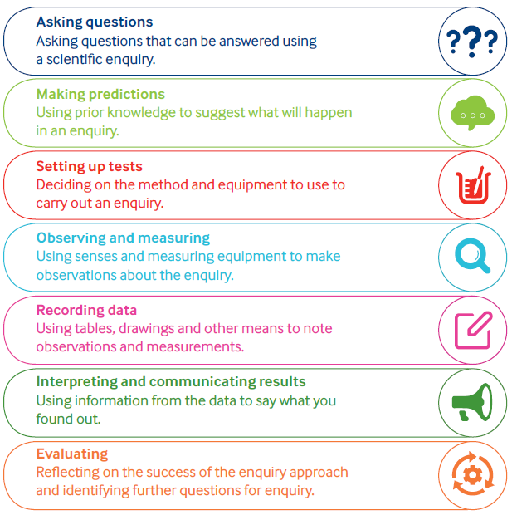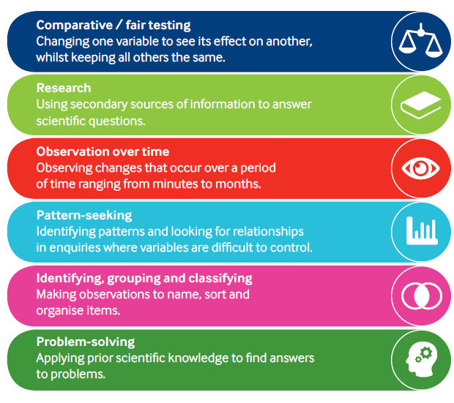 Enquiry Approaches Enquiry Skills

🔩

🏹

Science Coverage

(Possible coverage for 2021-22)

|  |  |  |  |  |  |  |
| --- | --- | --- | --- | --- | --- | --- |
| Laceby Acres Academy – Science Topic List | | | | | | |
| Year | Autumn Term 1 | Autumn Term 2 | Spring Term 1 | Spring Term 2 | Summer Term 1 | Summer Term 2 |
| EYFS | Plants | Animals including humans | Animals including humans | Seasons and how they change | Seasons and how they change | Materials |
| Year One | Plants | Animals including humans | Animals including humans | Seasons and how they change | Seasons and how they change | Materials |
| Year Two | Plants | Animals including humans | Living things and their Habitats | Living things and their Habitats | Forces | Materials |
| Year Three | Plants | Animals including humans | Animals including humans | Forces and magnetism | Energy - light and sight | Materials |
| Year Four | Animals including humans | Living things and their habitats | Living things and their habitats | Electricity | Energy - sound | Materials – solids liquids and gases |
| Year Five | Animals including humans | Living things and their habitats | Forces | Earth and space | Materials – mixtures and separation | Materials - changes |
| Year Six | Animals including humans | Evolution and inheritance | Evolution and inheritance | Living things and their habitat | Electricity | Energy – light and sight |

Progression Framework

🔩

|  |  |  |  |  |  |  |  |  |
| --- | --- | --- | --- | --- | --- | --- | --- | --- |
| **Year 1 – Plants** | | | | | | | | |
| **National Curriculum Objectives** | | **Sticky Knowledge** | | | | **Vocabulary** | | |
| * **Identify and name a variety of common wild and garden plants, including deciduous and evergreen trees.** * **Identify and describe the basic structure of a variety of common flowering plants.** * **Identify and name the roots, trunk, branches and leaves of trees.** | | * Plants grow from seeds/bulbs * Plants need light and water to grow and survive * Plants are important * We can eat lots of plants | | | | Leaves, trunk, branch, root, seed, bulb, flower, stem, wild, garden, deciduous, evergreen | | |
| Key Scientists | | Linked Texts |
| Beatrix Potter (Author & Botanist) | | ***Tree: Seasons Come, Seasons Go***  *(Patricia Hegarty and Britta Teckentrup)*  ***A Little Guide to Wild Flowers***  *(Charlotte Voake)*  ***The Things That I LOVE about TREES***  *(Chris Butterworth)*  ***Harry’s Hazelnut***  *(Ruth Parsons)* |
| **Prior Learning** | | **Key Question(s):** | | | | **Future Learning** | | |
| **In EYFS Children should:**   * **Make observations of plants** * **Know some names of plants, trees and flowers** * **May be able to name and describe different plants, trees and flowers** * **Show some care for their world around them** | | * How do Plants grow? * What do Plants need to grow? * Do all plants need water? * Are all plants green? * Why do seeds look different? * Can plants grow as big in the shade? * What is the biggest/smallest/smelliest (etc) tree/flower/plant on the planet? | | | | In Year 2 Children will:   * Observe and describe how seeds and bulbs grow into mature plants. * Find out and describe how plants need water, light and warmth to grow and stay healthy. | | |
| **Teaching Ideas** | | | | | | | | |
| **Comparative tests** | Identify & Classify | | Observation over time | Pattern Seeking | Research | | BIG Question: Assessment Opportunity | |
| **Which type of compost grows the tallest sunflower?**  **Which tree has the biggest leaves?** | How can we sort the leaves that we collected on our walk? | | How does a daffodil bulb change over the year?  How does my sunflower change each week?  How does the oak tree change over the year? | Do trees with bigger leaves lose their leaves first in autumn?  Is there a pattern in where we find moss growing in the school grounds? | What are the most common British plants and where can we find them?  How did Beatrix Potter help our understanding of mushrooms and toadstools? | | How many types of plant are there? | |

|  |  |  |  |  |  |  |  |  |
| --- | --- | --- | --- | --- | --- | --- | --- | --- |
| **Year 2 – Plants** | | | | | | | | |
| **National Curriculum Objectives** | | **Sticky Knowledge** | | | | **Vocabulary** | | |
| * **Observe and describe how seeds and bulbs grow into mature plants.** * **Find out and describe how plants need water, light and warmth to grow and stay healthy.** | | * Plants grow from seeds/bulbs * Plants need light, water and warmth to grow and survive * Flowers make seeds to make more plants (reproduce) * Plants are important * We need plants to survive (to clean air, to eat) * We can eat different parts of the plants (leaves, stems, roots, seeds, fruit) | | | | Leaves, trunk, branch, root, seed, bulb, flower, stem, wild, garden, deciduous, evergreen, observe, grow, compare, record, temperature, predict, measure, diagram, germinate, warmth, sunlight. | | |
| Key Scientists | | Linked Texts |
| Agnes Arber (Botanist)  Alan Titchmarsh (Botanist & Gardener) | | ***The Tin Forest***  *(Helen Ward)*  ***Jack and the Beanstalk***  *(Richard Walker)*  ***Ten Seeds***  *(Ruth Brown)*  **A Seed Is Sleepy**  (Dianna Aston) |
| **Prior Learning** | | **Key Question(s):** | | | | **Future Learning** | | |
| **In Year 1 Children should:**   * **Identify and name a variety of common wild and garden plants, including deciduous and evergreen trees.** * **Identify and describe the basic structure of a variety of common flowering plants.** * **Identify and name the roots, trunk, branches and leaves of trees.** | | * Do cress produce seeds, how could we find out? * Do all plants produce flowers and seeds? * What is different between freshly cut and planted flowers? * Do plants flower all year round? * What are flowers for? * What happens to a plant after it has produced seeds? | | | | In Year 3 Children will:   * Identify and describe the functions of different parts of the flowering plant: roots, stem/trunk/leaves and flowers * Explore the part flowers play in a flowering plant’s life cycle, including pollination, seed formation and seed dispersal * Explain the requirements of plants for life and growth (air, light, water, nutrients from soil, room to grow) and how they vary between plants * Know the way in which water is transported between plants | | |
| **Teaching Ideas** | | | | | | | | |
| **Comparative tests** | Identify & Classify | | Observation over time | Pattern Seeking | Research | | BIG Question – Assessment Opportunity | |
| **Do cress seeds grow quicker inside or outside?** | How can we identify the trees that we observed on our tree hunt? | | What happens to my bean after I have planted it? | Do bigger seeds grow into bigger plants? | How does a cactus survive in a desert with no water? | | What should I do to grow a healthy plant? | |

|  |  |  |  |  |  |  |  |  |
| --- | --- | --- | --- | --- | --- | --- | --- | --- |
| **Year 3 – Plants** | | | | | | | | |
| **National Curriculum Objectives** | | **Sticky Knowledge** | | | | **Vocabulary** | | |
| * **Identify and describe the functions of different parts of the flowering plant: roots, stem/trunk/leaves and flowers** * **Explore the part flowers play in a flowering plants life cycle, including pollination, seed formation and seed dispersal** * **Explain the requirements of plants for life and growth (air, light, water, nutrients from soil, room to grow) and how they vary between plants** * **Know the way in which water is transported between plants** | | * Plants are producers, they make their own food. * Their leaves absorb sunlight and carbon dioxide * Plants have roots, which provide support and draw water from the soil * Flowering plants have specific adaptations which help it to carry out pollination, fertilisation and seed production * Seed dispersal improves a plants chances of successful reproduction * Seeds/bulbs require the right conditions to germinate and grow. * Seeds contain enough food for the plant’s initial growth | | | | Air, light, water, nutrients, soil, support, anchor, reproduction, pollination, dispersal, transportation, flower, energy, growth, seedling, carbon dioxide, oxygen, sugar, material, photosynthesis, chlorophyll | | |
| Key Scientists | | Linked Texts |
| **Jan Ingenhousz**  (Photosynthesis)  **Joseph Banks**  (Botanist) | | ***The Hidden Forest***  *(Jeannie Baker)*  ***George and Flora’s Secret Garden***  *(Jo Elworthy)* |
| **Prior Learning** | | **Key Question(s):** | | | | **Future Learning** | | |
| **In Year 2 Children should:**   * **Observe and describe how seeds and bulbs grow into mature plants.** * **Find out and describe how plants need water, light and warmth to grow and stay healthy.** | | * How do plants reproduce? * Do all flowers look the same? * How do insects know which flowers to pollinate? * Why do flowers smell? * What do seeds do? * Can a plant live without its leaves? * Do grass/trees make flowers? * What conditions are perfect for a seed to grow? * Where do weeds come from? * How does the space between seeds affect how well they grow? * Does seed size match plant size? * Do plants take in water through their roots? * How does water move through the plant? * How do plants make their food? * How does light affect plant growth? * How does a plant get carbon dioxide? | | | | In Year 6 Children will:   * Recognise that living things have changed over time and that fossils provide information about living things * Recognise that living things produce offspring of the same kind, but normally offspring vary and are not identical to their parents * Identify how animals and plants are adapted to suit their environment in different ways, and that adaptation can lead to evolution. | | |
| **Teaching Ideas** | | | | | | | | |
| **Comparative tests** | Identify & Classify | | Observation over time | Pattern Seeking | Research | | BIG Question – Assessment Opportunity | |
| **How does the length of the carnation stem affect how long it takes for the food colouring to dye the petals?**  **Which conditions help seeds germinate faster?** | How many ways can you group our seed collection? | | What happens to celery when it is left in a glass of coloured water?  How do flowers in a vase change over time? | What colour flowers do pollinating insects prefer? | What are all the different ways that seeds disperse? | | Why do plants have flowers? | |

|  |  |  |  |  |  |  |  |  |
| --- | --- | --- | --- | --- | --- | --- | --- | --- |
| **Year 1 – Animals, including Humans** | | | | | | | | |
| **National Curriculum Objectives** | | **Sticky Knowledge** | | | | **Vocabulary** | | |
| * **Identify and name a variety of common animals including fish, amphibians, reptiles, birds and mammals. •** * **Identify and name a variety of common animals that**   **are carnivores, herbivores and omnivores** | | * There are many different animals with different characteristics. * Animals have senses to help individuals survive. When animals sense things they are able to respond. * Animals need food to survive. * Animals need a variety of food to help them grow, repair their bodies, be active and stay healthy. | | | | Amphibians, birds, fish, mammals, reptiles, carnivores, herbivore, omnivore, sight, hearing, touch, taste, smell, head, neck, ear, mouth, shoulder, hand, fingers, leg, foot, thumb, eye, nose, knee, toes, teeth, elbow | | |
| Key Scientists | | Linked Texts |
| Chris Packham  (Animal Conservationist) | | ***One Year with Kipper***  *(Mick Inkpen)*  **Snail Trail**  (Ruth Brown)  **Superworm**  (Julia Donaldson & Axel Scheffler) |
| **Prior Learning** | | **Key Question(s):** | | | | **Future Learning** | | |
| **In Early Years children should: •**   * **be able to identify different parts of their body.** * **Have some understanding of healthy food and the need for variety in their diets. •** * **Be able to show care and concern for living things. •** * **Know the effects exercise has on their bodies.** * **Have some understanding of growth and change. •** * **Can talk about things they have observed including**   **animals** | | * What do animals eat? * Do all animals eat the same food? * Which of our senses is the most accurate at identifying food? * Do all animals hunt? * Why are animals different colours and patterns? | | | | In Year 2 children will: •   * Know that animals, including humans, have offspring which grow into adults • * Know the basic stages in a life cycle for animals, including humans. • * Find out and describe the basic needs of animals, including humans, for survival (water, food and air). • * Describe the importance for humans of exercise, eating the right amounts of different types of food, and hygiene. | | |
| **Teaching Ideas** | | | | | | | | |
| **Comparative tests** | Identify & Classify | | Observation over time | Pattern Seeking | Research | | BIG Question – Assessment Opportunity | |
| **Is our sense of smell better when we cannot see?** | How can we organise all the zoo animals?  What are the names for all the parts of our bodies? | | How does my height change over the year? | Do you get better at smelling as you get older? | Do all animals have the same senses as humans? | | What are animals like? | |

|  |  |  |  |  |  |  |  |  |
| --- | --- | --- | --- | --- | --- | --- | --- | --- |
| **Year 2 – Animals, including Humans** | | | | | | | | |
| **National Curriculum Objectives** | | **Sticky Knowledge** | | | | **Vocabulary** | | |
| * **Know that animals, including humans, have offspring which grow into adults •** * **Know the basic stages in a life cycle for animals, including humans. •** * **Find out and describe the basic needs of animals,**   **including humans, for survival (water, food and air).**   * **Describe the importance for humans of exercise, eating the right amounts of different types of food, and hygiene.** | | * Animals move in order to survive. * Different animals move in different ways to help them survive. * Exercise keeps animal’s bodies in good condition and increases survival chances. * All animals eventually die. * Animals reproduce new animals when they reach maturity. * Animals grow until maturity and then do not grow any larger. | | | | Living, dead, never alive, habitats, micro-habitats, food, food chain, leaf litter, shelter, seashore, woodland, ocean, rainforest, conditions, desert, damp, shade, | | |
| Key Scientists | | Linked Texts |
| Steve Irwin (Crocodile Hunter) | | ***The Gruffalo***  *(Julia Donaldson)* |
|  | | Robert Winston (Human Scientist) | | ***Meerkat Mail***  *(Emily Gravett)* |
|  | | Joe Wicks (Personal Trainer) | | ***Tadpole's Promise***  *(Jeanne Willis and Tony Ross)* |
| **Prior Learning** | | **Key Question(s):** | | | | **Future Learning** | | |
| **In Year 1 children should: •**   * **Identify and name a variety of common animals**   **including fish, amphibians, reptiles, birds and mammals. •**   * **Identify and name a variety of common animals that**   **are carnivores, herbivores and omnivores.** | | * How long do should my pets live for? * Do all animals grow and live the same way? * Do bigger animals live longer? * Why are we all different heights? * How and why do we grow and change? | | | | In Year 3 children will: •   * Identify that animals, including humans, need the right types and amount of nutrition, and they cannot make their own food; they get their nutrition from what they eat. • * Know how nutrients, water and oxygen are transported within animals and humans. * Know about the importance of a nutritious, balanced diet. • * Identify that humans and some other animals have skeletons and muscles for support, protection and movement: | | |
| **Teaching Ideas** | | | | | | | | |
| **Comparative tests** | Identify & Classify | | Observation over time | Pattern Seeking | Research | | BIG Question – Assessment Opportunity | |
| **Do amphibians have more in common with reptiles or fish?** | Which offspring belongs to which animal? | | How does a tadpole change over time? | Which age group of children wash their hands the most in a day? | What food do you need in a healthy diet and why? | | Do living things change or stay the same? | |
| **Do bananas make us run faster?** | How would you group things to show which are living, dead, or have never been alive? | | How much food and drink do I have over a week? |  | What do you need to do to look after a pet dog/cat/lizard and keep it healthy? | |  | |
|  |  | |  |  |  | |  | |

|  |  |  |  |  |  |  |  |  |
| --- | --- | --- | --- | --- | --- | --- | --- | --- |
| **Year 3 – Animals, including Humans** | | | | | | | | |
| **National Curriculum Objectives** | | **Sticky Knowledge** | | | | **Vocabulary** | | |
| * **Identify that animals, including humans, need the right types and amount of nutrition, and they cannot make their own food; they get their nutrition from**   **what they eat. •**   * **Know how nutrients, water and oxygen are**   **transported within animals and humans.**   * **Know about the importance of a nutritious, balanced diet. •** * **Identify that humans and some other animals have**   **skeletons and muscles for support, protection and movement:** | | * Different animals are adapted to eat different foods. * Many animals have skeletons to support their bodies and protect vital organs. * Muscles are connected to bones and move them when they contract. * Movable joints connect bones. | | | | Nutrients, nutrition, carbohydrates, protein, fats, vitamins, minerals, water, fibre, skeleton, bones, joints, endoskeleton, exoskeleton, hydrostatic skeleton, vertebrates, invertebrates, muscles, contract, relax, | | |
| Key Scientists | | Linked Texts |
| **Adelle Davis**  (20th Century Nutritionist)  **Marie Curie**  (Radiation / X-Rays) | | ***The Story of Frog Belly Rat Bone***  *(Timothy Basil Ering)*  ***Funnybones***  *(Janet and Allan Ahlberg)*  ***I Will Never Not Ever Eat a Tomato***  *(Lauren Child)*  ***Goldilocks and the Three Bears***  *(Samantha Berger)* |
| **Prior Learning** | | **Key Question(s):** | | | | **Future Learning** | | |
| **In Year 2 children should: •**   * **Know that animals, including humans, have offspring which grow into adults •** * **Know the basic stages in a life cycle for animals, including humans. •** * **Find out and describe the basic needs of animals,**   **including humans, for survival (water, food and air).**   * **Describe the importance for humans of exercise, eating the right amounts of different types of food, and hygiene.** | | * Why do we need a skeleton? * What types of skeleton are there? * Are all skeletons the same? * Can something survive without a skeleton? * What happens if we break a bone? * How do we move? * Are bones that are bigger, stronger? * Why do we need joints? * Why do muscles get tired? * Can we ‘break’ muscles? | | | | In Year 4 children will: •   * Describe the simple functions of the basic parts of the digestive system in humans. * Identify the different types of teeth in humans and their simple functions. * Construct and interpret a variety of food chains, identifying producers, predators and prey | | |
| **Teaching Ideas** | | | | | | | | |
| **Comparative tests** | Identify & Classify | | Observation over time | Pattern Seeking | Research | | BIG Question – Assessment Opportunity | |
| **How does the angle that your elbow/knee is bent affect the circumference of your upper arm/thigh?**  **How does the skull circumference of a girl compare with that of a boy?** | How do the skeletons of different animals compare? | | How does our skeleton change over time? (from birth to death) | Do male humans have larger skulls that female humans? | Why do different types of vitamins keep us healthy and which foods can we find them in? | | Why do animals have skeletons?  What is a healthy diet and why is it important? | |

|  |  |  |  |  |  |  |  |  |
| --- | --- | --- | --- | --- | --- | --- | --- | --- |
| **Year 4 – Animals, including Humans** | | | | | | | | |
| **National Curriculum Objectives** | | **Sticky Knowledge** | | | | **Vocabulary** | | |
| * **Describe the simple functions of the basic parts of the digestive system in humans.** * **Identify the different types of teeth in humans and their simple functions.** * **Construct and interpret a variety of food chains, identifying producers, predators and prey** | | * Animals have teeth to help them eat. * Different types of teeth do different jobs. * Food is broken down by the teeth and further in the stomach and intestines where nutrients go into the blood. * The blood takes nutrients around the body. * Nutrients produced by plants move to primary consumers then to secondary consumers through food chains. | | | | Herbivore, Carnivore, Digestive system, tongue, mouth, teeth, oesophagus, stomach, gall bladder, small intestine, pancreas, large intestine, liver, tooth, canine, incisor, molar, premolar, producer, consumer. | | |
| Key Scientists | | Linked Texts |
| **Ivan Pavlov**  (Digestive System Mechanisms)  **Joseph Lister**  (Discovered Antiseptics) | | ***Human Body Odyssey***  *(Werner Holzwarth)*  ***Crocodiles Don't Brush Their Teeth***  *(Colin Fancy)*  ***Wolves***  *(Emily Gravett)* |
| **Prior Learning** | | **Key Question(s):** | | | | **Future Learning** | | |
| **In Year 3 children should: •**   * **Identify that animals, including humans, need the**   **right types and amount of nutrition, and they cannot make their own food; they get their nutrition from what they eat. •**   * **Know how nutrients, water and oxygen are**   **transported within animals and humans.**   * **Know about the importance of a nutritious, balanced diet. •** * **Identify that humans and some other animals have**   **skeletons and muscles for support, protection and movement** | | * What different types of food are there? * Why do we need a variety of different foods? * Do all organisms eat the same things? * Why do some people need different diets? (weightlifter vs marathon runner) * Why are teeth important? * What happens to our food? * What is our digestive system? * How does our food turn into poo and wee? | | | | In Year 5 children will: •   * Know the life cycle of different living things, e.g. Mammal, amphibian, insect bird. * Know the differences between different life cycles. * Know the process of reproduction in plants. * Know the process of reproduction in animals | | |
| **Teaching Ideas** | | | | | | | | |
| **Comparative tests** | Identify & Classify | | Observation over time | Pattern Seeking | Research | | BIG Question – Assessment Opportunity | |
| **In our class, are omnivores taller than vegetarians?** | What are the names for all the organs involved in the digestive system?  How can we organise teeth into groups? | | How does an eggshell change when it is left in cola? | Are foods that are high in energy always high in sugar? | How do dentists fix broken teeth? | | What do our bodies do with the food we eat? | |

|  |  |  |  |  |  |  |  |  |
| --- | --- | --- | --- | --- | --- | --- | --- | --- |
| **Year 5 – Animals, including Humans** | | | | | | | | |
| **National Curriculum Objectives** | | **Sticky Knowledge** | | | | **Vocabulary** | | |
| * **Describe the changes as humans develop to old age.** | | * Different animals mature at different rates and live to different ages. * Puberty is something we all go through, a process which prepares our bodies for being adults, and reproduction * Hormones control these changes, which can be physical and/or emotional. | | | | Foetus, Embryo, Womb, Gestation, Baby, Toddler, Teenager, Elderly, Growth, Development, Puberty, Hormone, Physical, Emotional,  . | | |
| Key Scientists | Linked Texts | |
| **Dr Steve Jones**  (Geneticist)  Prof Robert Winston (Human Scientist) | | ***Hair in Funny Places***  *(Babette Cole)*  ***Giant***  *(Kate Scott)*  ***You're Only Old Once!***  *(Dr. Seuss)* |
| **Prior Learning** | | **Key Question(s):** | | | | **Future Learning** | | |
| **In Year 4 children should: •**   * **Describe the simple functions of the basic parts of the**   **digestive system in humans.**   * **Identify the different types of teeth in humans and their simple functions.** | | * What do humans look like? * Do all animal embryos look the same? * How do humans change? * Why do humans change? * What causes puberty? * What changes do we go through during puberty? * Are there any patterns between vertebrate animals and their gestation periods? | | | | In Year 6: •   * Identify and name the main parts of the human circulatory system, and describe the functions of the heart, blood vessels and blood. * Recognise the impact of diet, exercise, drugs and lifestyle on the way their bodies function. * Describe the ways in which nutrients and water are transported within animals, including humans. | | |
| **Teaching Ideas** | | | | | | | | |
| **Comparative tests** | Identify & Classify | | Observation over time | Pattern Seeking | Research | | BIG Question – Assessment Opportunity | |
| **How does age affect a human’s reaction time?**  **Who grows the fastest, girls or boys?** | Can you identify all the stages in the human life cycle? | | How do different animal embryos change? | Is there a relationship between a mammal’s size and its gestation period? | Why do people get grey/white hair when they get older? | | Why and how does the human body change over time? | |

|  |  |  |  |  |  |  |  |  |
| --- | --- | --- | --- | --- | --- | --- | --- | --- |
| **Year 6 – Animals, including Humans** | | | | | | | | |
| **National Curriculum Objectives** | | **Sticky Knowledge** | | | | **Vocabulary** | | |
| * **Identify and name the main parts of the human circulatory system, and describe the functions of the heart, blood vessels and blood.** * **Recognise the impact of diet, exercise, drugs and lifestyle on the way their bodies function.** * **Describe the ways in which nutrients and water are transported within animals, including humans.** | | * The heart pumps blood around the body. * Oxygen is breathed into the lungs where it is absorbed by the blood. * Muscles need oxygen to release energy from food to do work. (Oxygen is taken into the blood in the lungs; the heart pumps the blood through blood vessels to the muscles; the muscles take oxygen and nutrients from the blood.) | | | | Oxygenated, Deoxygenated, Valve, Exercise, Respiration Circulatory system, heart, lungs, blood vessels, blood, artery, vein, pulmonary, alveoli, capillary, digestive, transport, gas exchange, villi, nutrients, water, oxygen, alcohol, drugs, tobacco. | | |
| Key Scientists | | Linked Texts |
| **Justus von Liebig**  (Theories of Nutrition and Metabolism) | | ***Pig-Heart Boy***  *(Malorie Blackman)* |
|  | | **Sir Richard Doll**  (Linking Smoking and Health Problems) | | ***Skellig***  *(David Almond)* |
|  | | **Leonardo Da Vinci**  (Anatomy) | | ***A Heart Pumping Adventure***  *(Heather Manley)* |
| **Prior Learning** | | **Key Question(s):** | | | | **Future Learning** | | |
| **In Year 5 children should: •**   * Describe the changes as humans develop to old age. Yea | | * Why do we need oxygen? * How do we breathe? * Do fish and plants breathe? * Do all living things need oxygen? * How does the size of a person’s lungs affect their lung capacity? * Are there ways to increase/decrease our lung capacity? Is lung capacity fixed? * Why do we have blood? * How does our heart work? * How does size of muscle affect our pulse rate? * How does exercise effect our pulse rate? * How might the circulatory system of an elephant, a hummingbird, or a polar bear differ? * Is the air you breathe out, the same as that you breathe in? | | | | In Key Stage 3 children will learn about: •   * the hierarchical organisation of multicellular organisms: from cells to tissues to organs to systems to organisms. * the tissues and organs of the human digestive system, including adaptations to function and how the digestive system digests food (enzymes simply as biological catalysts) * calculations of energy requirements in a healthy daily diet * the consequences of imbalances in the diet, including obesity, starvation and deficiency diseases * the structure and functions of the gas exchange system in humans, including adaptations to function * the effects of recreational drugs (including substance misuse) on behaviour, health and life processes. | | |
| **Teaching Ideas** | | | | | | | | |
| **Comparative tests** | Identify & Classify | | Observation over time | Pattern Seeking | Research | | BIG Question – Assessment Opportunity | |
| **How does the length of time we exercise for affect our heart rate?**  **Can exercising regularly affect your lung capacity?**  **Which type of exercise has the greatest effect on our heart rate?** | Which organs of the body make up the circulation system, and where are they found? | | How does my heart rate change over the day?  How much exercise do I do in a week? | Is there a pattern between what we eat for breakfast and how fast we can run? | How have our ideas about disease and medicine changed over time? | | How do our choices affect how our bodies work? Why does my heart beat? | |
|  |  | |  |  |  | |  | |

|  |  |  |  |  |  |  |  |  |
| --- | --- | --- | --- | --- | --- | --- | --- | --- |
| **Year 6 – Evolution & Inheritance** | | | | | | | | |
| **National Curriculum Objectives** | | **Sticky Knowledge** | | | | **Vocabulary** | | |
| * **Know about evolution and can explain what it is.** * **Know how fossils can be used to find out about the past.** * **Recognise that living things produce offspring of the same kind, but normally offspring vary and are not identical to their parents** * **Identify how animals and plants are adapted to suit their environment in different ways and that adaptation may lead to evolution- recognise that living things have changed over time and that fossils provide information about living things that inhabited the Earth millions of years ago** | | * Life cycles have evolved to help organisms survive to adulthood. * Over time the characteristics that are most suited to the environment become increasingly common.   *NB: The following could be duplicated in Year 6 Living things and their habitats*.   * Organisms best suited to their environment are more likely to survive long enough to reproduce. Organisms are best adapted to reproduce are more likely to do so. * Organisms reproduce and offspring have similar characteristic patterns. * Variation exists within a population (and between offspring of some plants) * Competition exists for resources and mates | | | | Fossils, Adaptation, Evolution, Characteristics, Reproduction, Genetics, Variation, Inherited, Environmental, Mutation, Competition, Survival of the Fittest, Evidence, | | |
| Key Scientists | | Linked Texts |
| **Charles Darwin and Alfred Russel Wallace**  (Theory of Evolution by Natural Selection)  **Jane Goodall**  (Chimpanzees) | | ***One Smart Fish***  *(Christopher Wormell)*  ***The Molliebird***  *(Jules Pottle)*  ***Our Family Tree***  *(Lisa Westberg Peters)* |
| **Prior Learning** | | **Key Question(s):** | | | | **Future Learning** | | |
| From Key Stages 1 & 2, children should:   * **Understand there is a variety of life on Earth** * **Know that some animal’s differences are important to their survival** * **Know how animals and plants reproduce** * **Know how fossils form over time** | | * Why are we all different? * What is variation, and why is it important? * How did life begin on Earth? * How do we change? * What is evolution? * What evidence is there for evolution? * How does evolution happen? * What reasons do animals become extinct? * Polar Bears’ habitat is rapidly changing, what possible futures do they face, and can we predict which is most likely? * How did Darwin come up with the theory? * Why was his theory not initially accepted? | | | | In Key Stage 3 children will learn about: •   * heredity as the process by which genetic information is transmitted from one generation to the next * the variation between individuals within a species being continuous or discontinuous, to include measurement and graphical representation of variation * the variation between species and between individuals of the same species means some organisms compete more successfully, which can drive natural selection * changes in the environment may leave individuals within a species, and some entire species, less well adapted to compete successfully and reproduce, which in turn may lead to extinction * the importance of maintaining biodiversity and the use of gene banks to preserve hereditary material. | | |
| **Teaching Ideas** | | | | | | | | |
| **Comparative tests** | Identify & Classify | | Observation over time | Pattern Seeking | Research | | BIG Question – Assessment Opportunity | |
| **What is the most common eye colour in our class?** | Compare the skeletons of apes, humans, and Neanderthals – how are they similar, and how are they different?  Can you classify these observations into evidence for the idea of evolution, and evidence against? | | How has the skeleton of the horse changed over time? | Is there a pattern between the size and shape of a bird’s beak and the food it will eat? | What happened when Charles Darwin visited the Galapagos islands?  What ideas did American geneticist Barbara McClintock have about genes that won her a Nobel Prize? | | What is evolution, how does it happen and how do scientists know? | |

|  |  |  |  |  |  |  |  |  |
| --- | --- | --- | --- | --- | --- | --- | --- | --- |
| **Year 2 – Living Things & their Habitats** | | | | | | | | |
| **National Curriculum Objectives** | | **Sticky Knowledge** | | | | **Vocabulary** | | |
| * **Explore and compare the difference between things that are living, dead and things that have never been alive.** * **Identify that most living things live in habitats to which they are suited and describe how different habitats provide for the basic needs of different kinds of animals and plants, and how they depend on each other.** * **Identify and name a variety of plants and animals in their habitats, including micro habitats.** * **Describe how animals obtain their food from plants and other animals, using the idea of a simple food chain, and identify and name the different sources of food.** | | * Some things are living, some were once living but now dead and some things never lived. * There is variation between living things. * Different animals and plants live in different places. Living things are adapted to survive in different habitats. * Environmental change can affect plants and animals that live there. | | | | Living, dead, never alive, habitats, micro-habitats, food, food chain, leaf litter, shelter, seashore, woodland, ocean, rainforest, conditions, desert, damp, shade, | | |
| Key Scientists | | Linked Texts |
| Terry Nutkins (TV Presenter)  Liz Bonnin (Conservationist) | | ***The Gruffalo***  *(Julia Donaldson)*  ***Meerkat Mail***  *(Emily Gravett)*  ***No Place Like Home***  *(Jonathon Emmett)* |
| **Prior Learning** | | **Key Question(s)** | | | | **Future Learning** | | |
| **In Early Years children should:**   * **Comments and questions about the place they live or the natural world.** * **Shows care and concern for living things and the environment.** * **Can talk about things they have observed such as plants and animals.** * **Notices features of objects in their environment.** * **Comments and asks questions about their familiar world.** | | * How to animals eat? * Do all animals eat the same thing? * Which animals hunt, and which animals are hunted? Why? * What animals live in our school environment? * How are animals and plants ‘adapted’ to live in their habitats * Why do animals and plants like to live in different places? * How do seasons affect our animals and plants? * Which animals hibernate and why? * Why do snails hibernate, but slugs do not? * How to habitats change over our school year? | | | | In Year 4 children will: •   * Recognise that living things can be grouped in a variety of ways. * Explore and use classification keys to help group, identify and name a variety of living things in their local and wider environment. * Know and label the features of a river * Recognise that environments can change and that this can sometimes pose danger to living things. | | |
| **Teaching Ideas** | | | | | | | | |
| **Comparative tests** | Identify & Classify | | Observation over time | Pattern Seeking | Research | | BIG Question – Assessment Opportunity | |
| **Which pets are the easiest to look after?**  **Is there the same level of light in the evergreen wood compared with the deciduous wood?** | How would you group these plants and animals based on what habitat you would find them in? | | How does the school pond change over the year? | What conditions do woodlice prefer to live in?  Which habitat do worms prefer – where can we find the most worms? | How are the animals in Australia different to the ones that we find in Britain?  How does the habitat of the Arctic compare with the habitat of the rainforest?  What ideas did botanist Arthur Tansley have about habitats in 1935? | | Why do different animals live in different places? | |

|  |  |  |  |  |  |  |  |  |
| --- | --- | --- | --- | --- | --- | --- | --- | --- |
| **Year 4 – Living Things & their Habitats** | | | | | | | | |
| **National Curriculum Objectives** | | **Sticky Knowledge** | | | | **Vocabulary** | | |
| * **Recognise that living things can be grouped in a variety of ways.** * **Explore and use classification keys to help group, identify and name a variety of living things in their local and wider environment.** * **Recognise that environments can change and that this can sometimes pose danger to living things.** | | * Living things can be divided into groups based upon their characteristics * Environmental change affects different habitats differently * Different organisms are affected differently by environmental change * Different food chains occur in different habitats * Human activity significantly affects the environment | | | | Environment, flowering, nonflowering, plants, animals, vertebrates, fish, amphibians, reptiles, mammals, invertebrate, human impact, nature reserves, deforestation. | | |
| Key Scientists | | Linked Texts |
| **Cindy Looy**  (Environmental Change and Extinction)  **Jaques Cousteau**  (Marine Biologist) | | ***The Vanishing Rainforest***  *(Richard Platt)*  ***The Morning I Met a Whale***  *(Michael Morpurgo)*  ***Journey to the River Sea***  *(Eva Ibbotson)* |
| **Prior Learning** | | **Key Question(s):** | | | | **Future Learning** | | |
| **In Year 2, children should:**   * **Explore and compare the difference between things that are living, dead and things that have never been alive.** * **Identify that most living things live in habitats to which they are suited and describe how different habitats provide for the basic needs of different kinds of animals and plants, and how they depend on each other.** * **Identify and name a variety of plants and animals in their habitats, including micro habitats.** * **Describe how animals obtain their food from plants and other animals, using the idea of a simple food chain, and identify and name the different sources of food.** | | * What food chains and webs are there in our local habitat? * How does energy move through the food chain? * How does removal of one species from an environment, affect others? (keystone species) * How does environmental change affect different organisms? * What are the most important things we could do to improve our outside area? (big hotels, pond, compost, wildflowers) * How does human activity affect our environment (ferries on the Solent? Sandown Airport? KFC?) | | | | In Year 5:   * Describe the differences in the life cycles of a mammal, an amphibian, an insect and a bird. * Describe the life process of reproduction in some plants and animals. | | |
| **Teaching Ideas** | | | | | | | | |
| **Comparative tests** | Identify & Classify | | Observation over time | Pattern Seeking | Research | | BIG Question – Assessment Opportunity | |
| **Does the amount of light affect how many woodlice move around?**  **How does the average temperature of the pond water change in each season?** | Can we use the classification keys to identify all the animals that we caught pond dipping? | | How does the variety of invertebrates on the school field change over the year? | How has the use of insecticides affected bee population? | Why are people cutting down the rainforests and what effect does that have? | | Are living things in danger? | |

|  |  |  |  |  |  |  |  |
| --- | --- | --- | --- | --- | --- | --- | --- |
| **Year 5 – Living things and their Habitats** | | | | | | | |
| **National Curriculum Objectives** | | **Sticky Knowledge** | | | | **Vocabulary** | |
| * Know the life cycle of different living things, e.g. Mammal, amphibian, insect bird. * Know the process of reproduction in plants. * Know the process of reproduction in animals. | | * Different animals mature at different rates and live to different ages. * Some organisms reproduce sexually where offspring inherit information from both parents. * Some organisms reproduce asexually by making a copy of a single parent. * Environmental change can affect how well an organism is suited to its environment. * Different types of organisms have different lifecycles. | | | | Reproduction, Sexual, Asexual, Pollination, Dispersal, reproduction, cell, fertilisation, pollination, male, female, pregnancy, young, mammal, metamorphosis, amphibian, insect, egg, embryo, bird, plant  . | |
|  | | Key Scientists | Linked Texts |
|  | | **James Brodie of Brodie**  (Reproduction of Plants by  Spores) | ***The Land of Neverbelieve***  *(Norman Messenger)* |
|  | | **David Attenborough** (Naturalist and Nature Documentary Broadcaster) | ***Mummy Laid an Egg***  *(Babette Cole)* |
| **Prior Learning** | | **Key Question(s):** | | | | **Future Learning** | |
| **In Year 4 children should: •**   * **Construct and interpret a variety of food chains,**   **identifying producers, predators and prey**   * **Identify that most living things live in habitats to which they are suited and describe how different habitats provide for the basic needs of different kinds of animals and plants, and how they depend on each other.** * **Identify and name a variety of plants and animals in their habitats, including micro habitats.** | | * What is a life cycle? What types of life cycles are there? * Are life cycles the same? * Do plants reproduce in the same ways as us? * How do plants spread their seeds? | | | | In Year 6:   * Classify living things into broad groups according to observable characteristics and based on similarities and differences. * Give reasons for classifying plants and animals based on specific characteristics. | |
| **Teaching Ideas** | | | | | | | |
| **Comparative tests** | Identify & Classify | | Observation over time | Pattern Seeking | Research | | BIG Question – Assessment Opportunity |
| **How does the level of salt affect how quickly brine shrimp hatch?** | Compare this collection of animals based on similarities and differences in their lifecycle. | | How do brine shrimp change over their lifetime?  How does a bean change as it germinates? | Is there are relationship between number of petals and number of stamens? | What are the differences between the life cycle of an insect and a mammal? | | Do all plants and animals reproduce in the same way? |
|  |  | |  |  |  | |  |

|  |  |  |  |  |  |  |  |  |
| --- | --- | --- | --- | --- | --- | --- | --- | --- |
| **Year 6 – Living Things & their Habitats** | | | | | | | | |
| **National Curriculum Objectives** | | **Sticky Knowledge** | | | | **Vocabulary** | | |
| * **Classify living things into broad groups according to observable characteristics and based on similarities and differences.** * **Give reasons for classifying plants and animals based on specific characteristics.** | | * Variation exists within a population (and between offspring of some plants) *– NB: this Key Idea is duplicated in Year 6 Evolution and Inheritance.* * Organisms best suited to their environment are more likely to survive long enough to reproduce. * Organisms are best adapted to reproduce are more likely to do so. * Organisms reproduce and offspring have similar characteristic patterns. * Competition exists for resources and mates. | | | | Variation Organisms Populations. Classification Characteristics Environment, flowering, nonflowering, plants, animals, vertebrates, fish, amphibians, reptiles, mammals, invertebrate, human impact, nature reserves, deforestation. Classify, compare, bacteria, microorganism, organism, invertebrates, vertebrates, Linnaean. | | |
| Key Scientists | | Linked Texts |
| **Carl Linnaeus**  (Identifying, Naming and Classifying Organisms) | | ***Beetle Boy***  *(M G Leonard)*  ***Insect Soup***  *(Barry Louis Polisar)*  ***Fur and Feathers***  *(Janet Halfmann)* |
| **Prior Learning** | | **Key Question(s):** | | | | **Future Learning** | | |
| **In Year 4, children should:**   * **Recognise that living things can be grouped in a variety of ways.** * **Explore and use classification keys to help group, identify and name a variety of living things in their local and wider environment.**   **Recognise that environments can change and that this can sometimes pose danger to living things.** | | * Why do we need to classify living things? * How do we classify? * What are the difficulties with classification? (penguins, whales, platypus) * How do animals change over time? * Why does variation exist? * What happens if animals of different species breed? (hybrids) * What happens to house plants outside? * What are microorganisms? * How can we prevent the spread of disease? * Why do animals and plants compete – and what for? | | | | In Key Stage 3 children will learn about:   * the dependence of almost all life on Earth on the ability of photosynthetic organisms, such as plants and algae, to use sunlight in photosynthesis to build organic molecules that are an essential energy store and to maintain levels of oxygen and carbon dioxide in the atmosphere * the adaptations of leaves for photosynthesis. * the interdependence of organisms in an ecosystem, including food webs and insect pollinated crops * the importance of plant reproduction through insect pollination in human food security * how organisms affect, and are affected by, their environment, including the accumulation of toxic materials. | | |
| **Teaching Ideas** | | | | | | | | |
| **Comparative tests** | Identify & Classify | | Observation over time | Pattern Seeking | Research | | BIG Question – Assessment Opportunity | |
| **How does the temperature affect how much gas is produced by yeast?**  **Which is the most common invertebrate on our school playing field?** | How would you make a classification key for vertebrates/invertebrates or microorganisms? | | What happens to a piece of bread if you leave it on the windowsill for two weeks? | Do all flowers have the same number of petals? | What do different types of microorganisms do? Are they always harmful? | | In what ways can we sort living things? | |

|  |  |  |  |  |  |  |  |  |
| --- | --- | --- | --- | --- | --- | --- | --- | --- |
| **Year 4 – Electricity** | | | | | | | | |
| **National Curriculum Objectives** | | **Sticky Knowledge** | | | | **Vocabulary** | | |
| * **Identify common appliances that run on electricity.** * **Construct a simple series electrical circuit, identifying and naming its basic parts, including cells, wires, bulbs, switches and buzzers.** * **Identify whether a lamp will light in a simple series circuit, based on whether the lamp is part of a complete loop with a battery.** * **Recognise that a switch opens and closes the circuit and associate this with whether a lamp lights in a simple series circuit. Recognise some common conductors and insulators, and associate metals with being good conductors.** * **Know the difference between a conductor and an insulator, giving examples of each.** * **Safety when using electricity.** | | * A source of electricity (mains of battery) is needed for electrical devices to work. * Electricity sources push electricity round a circuit. * More batteries will push the electricity round the circuit faster. * Devices work harder when more electricity goes through them. * A complete circuit is needed for electricity to flow and devices to work. * Some materials allow electricity to flow easily and these are called conductors. Materials that don’t allow electricity to flow easily are called insulators. | | | | Electricity, electric current, appliances, mains, crocodile clips, wires, bulb, battery cell, battery holder, motor, buzzer, switch, conductor, electrical insulator, component. | | |
| Key Scientists | | Linked Texts |
| Thomas Edison  (First Working Lightbulb)  Joseph Swan (Incandescent Light Bulb) | | Until I Met Dudley (Roger McGough)  Oscar and the Bird: A Book about Electricity (Geoff Waring)  Electrical Wizard: How Nikola Tesla Lit Up the World  (Elizabeth Rusch) |
| Prior Learning | | Key Question(s): | | | | Future Learning | | |
| **In Early Years children:**   * **May have some understanding that objects need electricity to work.** * **May understand that a switch will turn something on or off.** | | * What would life be like without electricity? * What sorts of things use/need electricity? * What electricity do I use? * In which ways can we ‘get’ electricity? (mains/plugs/batteries/wireless) * How do we make electricity? * How do batteries work? * How quickly can batteries run out? Does this make a difference depending on number of components? * How does the number of batteries added to the circuit affect a device? * What materials can carry electricity? (conductors/insulators) | | | | In Year 6 children will:   * Associate the brightness of a lamp or the volume of a buzzer with the number and voltage of cells used in the circuit. * Compare and give reasons for variations in how components function, including the brightness of bulbs, the loudness of buzzers and the on/off position of switches. * Use recognised symbols when representing a simple circuit in a diagram. | | |
| **Teaching Ideas** | | | | | | | | |
| **Comparative tests** | Identify & Classify | | Observation over time | Pattern Seeking | Research | | BIG Question – Assessment Opportunity | |
| **How does the thickness of a conducting material affect how bright the lamp is?**  **Which metal is the best conductor of electricity?** | How would you group these electrical devices based on where the electricity comes from? | | How long does a battery light a torch for? | Which room has the most electrical sockets in a house? | How has electricity changed the way we live?  How does a light bulb work? | | What can we do with electricity? | |

|  |  |  |  |  |  |  |  |  |
| --- | --- | --- | --- | --- | --- | --- | --- | --- |
| **Year 6 – Electricity** | | | | | | | | |
| **National Curriculum Objectives** | | **Sticky Knowledge** | | | | **Vocabulary** | | |
| * Associate the brightness of a lamp or the volume of a buzzer with the number and voltage of cells used in the circuit. * Compare and give reasons for variations in how components function, including the brightness of bulbs, the loudness of buzzers and the on/off position of switches. * Use recognized symbols when representing a simple circuit in a diagram. | | * Batteries are a store of energy. This energy pushes electricity round the circuit. When the battery’s energy is gone it stops pushing. Voltage measures the ‘push.’ * The greater the current flowing through a device the harder it works. * Current is how much electricity is flowing round a circuit. * When current flows through wires heat is released. The greater the current, the more heat is released. | | | | Electricity, neutrons, protons, electrons, nucleus, atom, electric current, appliances, mains, crocodile clips, wires, bulb, battery cell, battery holder, motor, buzzer, switch, conductor, electrical insulator, conductor. | | |
| Key Scientists | | Linked Texts |
| Alessandro Volta (Electrical Battery)  Nicola Tesla (Alternating Currents) | | Goodnight Mister Tom (Michelle Magorian)  Blackout (John Rocco)  Hitler's Canary (Sandi Toksvig) |
| **Prior Learning** | | **Key Question(s):** | | | | **Future Learning** | | |
| In Year 4, children should:   * **Identify common appliances that run on electricity.** * **Construct a simple series electrical circuit, identifying and naming its basic parts, including cells, wires, bulbs, switches and buzzers.** * **Identify whether a lamp will light in a simple series circuit, based on whether the lamp is part of a complete loop with a battery.** * **Recognise that a switch opens and closes the circuit and associate this with whether a lamp lights in a simple series circuit. Recognise some common conductors and insulators, and associate metals with being good conductors.** * **Know the difference between a conductor and an insulator, giving examples of each.** * **Safety when using electricity.** | | * Do all batteries push as hard as each other? * What is electricity? * How does the voltage of a batters affect how much current is pushed? * How does the length of time I leave the current flowing for affect the brightness of the bulb? * How does number of bulbs affect the brightness of a bulb? * Are all types of wires as good as conducting electricity? * Why are wires insulated in plastic? Does type of material make a difference? * Does length of wire make a difference? * Does the type of circuit affect how the components work/long the battery lasts? * What renewable ways can we generate electricity? * How does current affect heat? * What are the dangers of a short circuit? | | | | In Key Stage Three children will learn:   * Electric current, measured in amperes, in circuits, series and parallel circuits, currents add where branches meet and current as flow of charge * Potential difference measured in volts, battery and bulb ratings, resistance measured in ohms, as the ratio of potential difference (p.d.) to current * Differences in resistance between conducting and insulating components (quantitative). * Separation of positive or negative charges when objects are rubbed together: transfer of electrons, forces between charged objects * The idea of electric field, forces acting across the space between objects not in contact. | | |
| **Teaching Ideas** | | | | | | | | |
| **Comparative tests** | Identify & Classify | | Observation over time | Pattern Seeking | Research | | BIG Question – Assessment Opportunity | |
| **How does the voltage of the batteries in a circuit affect the brightness of the lamp? How does the voltage of the batteries in a circuit affect the volume of the buzzer?**  **Which make of battery lasts the longest?**  **Which type of fruit makes the best fruity battery?** | How would you group electrical components and appliances based on what electricity makes them do? | | How does brightness of bulb change as the battery runs out?  How can we measure how quickly a battery is used up? | Does the temperature of a light bulb go up the longer it is on? | How has our understanding of electricity changed over time? | | Can we vary the effects of electricity? | |

|  |  |  |  |  |  |  |  |  |
| --- | --- | --- | --- | --- | --- | --- | --- | --- |
| **Year 2 – Forces** | | | | | | | | |
| **National Curriculum Objectives** | | **Sticky Knowledge** | | | | **Vocabulary** | | |
| **There are no specified National Curriculum Objectives for forces at KS1** | | * Pushing and pulling can make things move faster or slower. * Pushing and pulling can make things move or stop. * Things can move in different ways. * Larger masses take bigger pushes and pulls to move or stop them. * Pushing and pulling can change the shape of things. * Bigger pushes and pulls have bigger effects | | | | Force, push, pull, surface, attract, repel, compass | | |
| Key Scientists | | Linked Texts |
| The Wright Brothers (Aeroplanes)  Henry Ford (Cars) | | Traction Man (Mini Grey)  Three Little Pigs (Lesley Sims) |
| **Prior Learning** | | **Key Question(s):** | | | | **Future Learning** | | |
| **In Early Years children should:**   * **know about similarities and differences in relation to places, objects, materials and living things.** * **talk about the features of their own immediate environment and how environments might vary from one another.** * **make observations of animals and plants, explain why some things occur, and talk about changes.** | | * How can we move objects? * How can we change the way an object moves? * How does a material affect how fast a ball rolls down a slope? * How does the length/steepness of a slope affect how far a ball/car/tin will roll off the end? * What it a push or a pull that makes it go further? * How does how hard/long I press a pop-up toy for affect how high it jumps? * On what surface do objects roll the best on? Is it the same for sliding? * Which material would be best for a teddy bungee cord? * How does length of an elastic band affect how elastic it is? * Which sock is the most elastic? * Which tights are the most elastic (denier)? * Which recipe play dough needs the greatest push to squash it? * How does the height an egg is dropped from affect how big the splat pattern is? (you could use wet tissue paper balls) | | | | In Year 3 children will:   * Compare how things move on different surfaces. * Know how a simple pulley works and use making lifting an object simpler * Notice that some forces need contact between two objects, but magnetic forces can act at a distance. * Observe how magnets attract and repel each other and attract some materials and not others. * Compare and group together a variety of everyday materials based on whether they are attracted to a magnet and identify some magnetic materials. * Describe magnets as having two poles. * Predict whether two magnets with attract or repel each other, depending on which poles are facing.   • | | |
| **Teaching Ideas** | | | | | | | | |
| **Comparative tests** | Identify & Classify | | Observation over time | Pattern Seeking | Research | | BIG Question – Assessment Opportunity | |
| **Which material would be best for the roof of the little pig’s house?** | Which materials will float and which will sink? | | Would a paper boat float forever? | How does changing the force change the speed of a toy car? | Why do objects float or sink? | | How can we change how things move? | |

|  |  |  |  |  |  |  |  |  |
| --- | --- | --- | --- | --- | --- | --- | --- | --- |
| **Year 3 – Forces (& Magnetism)** | | | | | | | | |
| **National Curriculum Objectives** | | **Sticky Knowledge** | | | | **Vocabulary** | | |
| * **Compare how things move on different surfaces.** * **Know how a simple pulley works and use making lifting an object simpler** * **Notice that some forces need contact between two objects, but magnetic forces can act at a distance.** * **Observe how magnets attract and repel each other and attract some materials and not others.** * **Compare and group together a variety of everyday materials based on whether they are attracted to a magnet and identify some magnetic materials.** * **Describe magnets as having two poles.** * **Predict whether two magnets with attract or repel each other, depending on which poles are facing.** | | * Magnets exert attractive and repulsive forces on each other. * Magnets exert non-contact forces, which work through some materials. * Magnets exert attractive forces on some materials. * Magnet forces are affected by magnet strength, object mass, distance from object and object material. | | | | Force, push, pull, friction, surface, magnet, magnetic, magnetic field, pole, north, south, attract, repel, compass | | |
| Key Scientists | | Linked Texts |
| William Gilbert (Theories on Magnetism)  Andre Marie Ampere  (Founder of Electro-Magnetism) | | The Iron Man (Ted Hughes)  Mrs Armitage: Queen of the Road (Quentin Blake)  Mr Archimedes’ Bath  (Pamela Allen) |
| **Prior Learning** | | **Key Question(s):** | | | | **Future Learning** | | |
| **In Year 2 children:**   * **May have an awareness of how to make things stop and start, using simple pushes and pulls.** * **They may know about floating and sinking.** | | * What are magnetic materials? How can we find out? * Can I make a magnetic material non-magnetic? * How far away does a magnet have to be before it attracts a magnetic material? * How far away can the magnetic attraction between two magnets be experiences? * Is the repulsive force the same size? * How is the magnetic attraction of repulsion force affected by putting materials between the magnets? * Are bigger magnets stronger? * How could you use magnets to measure the number of pages in a book? | | | | In Year 5 children will:   * Explain that unsupported objects fall towards the Earth because of the force of gravity acting between the Earth and the falling object and the impact of gravity on our lives. * Identify the effects of air resistance, water resistance and friction, which act between moving surfaces. * Recognise that some mechanisms, including levers, pulleys, and gears, allow a smaller force to have a greater effect. * Describe the movement of the Earth, and other planets, relative to the Sun in the solar system * Describe the movement of the Moon relative to the Earth * Describe the Sun, Earth and Moon as approximately spherical bodies * Describe the idea of the Earth’s rotation to explain day and night and the apparent movement of the sun across the sky. | | |
| **Teaching Ideas** | | | | | | | | |
| **Comparative tests** | Identify & Classify | | Observation over time | Pattern Seeking | Research | | BIG Question – Assessment Opportunity | |
| **How does the mass of an object affect how much force is needed to make it move?**  **Which magnet is strongest?**  **Which surface is best to stop you slipping?** | Which materials are magnetic? | | If we magnetize a pin, how long does it stay magnetized for? | Do magnetic materials always conduct electricity?  Does the size and shape of a magnet affect how strong it is? | How have our ideas about forces changed over time?  How does a compass work? | | How can we move magnets? | |

|  |  |  |  |  |  |  |  |  |
| --- | --- | --- | --- | --- | --- | --- | --- | --- |
| **Year 5 – Forces** | | | | | | | | |
| **National Curriculum Objectives** | | **Sticky Knowledge** | | | | **Vocabulary** | | |
| * **Explain that unsupported objects fall towards the Earth because of the force of gravity acting between the Earth and the falling object and the impact of gravity on our lives.** * **Identify the effects of air resistance, water resistance and friction, which act between moving surfaces.** * **Recognise that some mechanisms, including levers, pulleys, and gears, allow a smaller force to have a greater effect.** | | * Air resistance and water resistance are forces against motion caused by objects having to move air and water out of their way. * Friction is a force against motion caused by two surfaces rubbing against each other. * Some objects require large forces to make them move; gears, pulley and levers can reduce the force needed to make things move | | | | Air resistance, Water resistance, Friction, Gravity, Newton, Gears, Pulleys, force, push, pull, opposing, streamline, brake, mechanism, lever, cog, machine, pulley. | | |
| Key Scientists | | Linked Texts |
| Galileo Galilei  (Gravity and Acceleration)  Isaac Newton (Gravitation)  Archimedes of Syracuse (Levers)  John Walker (The Match) | | The Enormous Turnip (Katie Daynes)  Leonardo's Dream (Hans de Beer)  The Aerodynamics of Biscuits (Clare Helen Welsh) |
| **Prior Learning** | | **Key Question(s):** | | | | **Future Learning** | | |
| **In Year 3 children should:**   * **Compare how things move on different surfaces.** * **Know how a simple pulley works and use making lifting an object simpler** * **Notice that some forces need contact between two objects, but magnetic forces can act at a distance.** * **Observe how magnets attract and repel each other and attract some materials and not others.** * **Compare and group together a variety of everyday materials based on whether they are attracted to a magnet and identify some magnetic materials.** * **Describe magnets as having two poles.** * **Predict whether two magnets with attract or repel each other, depending on which poles are facing.** | | * What is a force? * How can a force act on an object? * How can we see forces? * How can we measure forces? * How does the saltiness (salinity) of water affect the water resistance? * How does the length of a piece of a paper helicopter’s wings affect the time it takes to fall? * How does the changing the shape of a piece of plasticine affect water resistance? * How does adding holes to a parachute affect the time it takes to fall? * How does the amount/depth of tread affect the friction between a shoe and a surface? * How can we use levers to lift heavy objects? * What is the most effective way to move an object? * How do see-saws work? * Can you create a pulley system to life a given load? | | | | In KS3 children will learn about:   * opposing forces and equilibrium: weight held by stretched spring or supported on a compressed surface * forces being needed to cause objects to stop or start moving, or to change their speed or direction of motion (qualitative only) * change depending on direction of force and its size. | | |
| **Teaching Ideas** | | | | | | | | |
| **Comparative tests** | Identify & Classify | | Observation over time | Pattern Seeking | Research | | BIG Question – Assessment Opportunity | |
| **How does the angle of launch affect how far a paper rocket will go?**  **How does the surface area of an object affect the time it takes to sink?** | Can you label and name all the forces acting on the objects in each of these situations? | | How long does a pendulum swing for before it stops? | Do all objects fall through water in the same way?  How does surface area of parachute affect the time it takes to fall? | How do submarines sink if they are full of air? | | How and why do objects move? | |



|  |  |  |  |  |  |  |  |  |
| --- | --- | --- | --- | --- | --- | --- | --- | --- |
| **Year 5 – Earth & Space** | | | | | | | | |
| **National Curriculum Objectives** | | **Sticky Knowledge** | | | | **Vocabulary** | | |
| * **Describe the movement of the Earth, and other planets, relative to the Sun in the solar system** * **Describe the movement of the Moon relative to the Earth** * **Describe the Sun, Earth and Moon as approximately spherical bodies** * **Describe the idea of the Earth’s rotation to explain day and night and the apparent movement of the sun across the sky.** | | * Stars, planets and moons have so much mass they attract other things, including each other due to a force called gravity. Gravity works over distance. * Objects with larger masses exert bigger gravitational forces. * Objects like planets, moons and stars spin. * Smaller mass objects like planets orbit large mass objects like stars. * Stars produce vast amounts of heat and light. * All other objects are lumps of rock, metal or ice and can be seen because they reflect the light of stars. | | | | Earth, Sun, Moon, Axis, Rotation, Day, Night, Phases of the Moon, star, constellation, waxing, waning, crescent, gibbous. Mercury, Venus, Mars, Jupiter, Saturn, Uranus, Neptune, planets, solar system, day, night, rotate, orbit, axis, spherical, geocentric, heliocentric. | | |
| Key Scientists | | Linked Texts |
| **Claudius Ptolemy and Nicolaus Copernicus**  (Heliocentric vs Geocentric Universe)  **Neil Armstrong**  (First man on the Moon)  **Helen Sharman**  (First British astronaut)  **Tim Peake**  (First British ESA astronaut) | | ***The Skies Above My Eyes***  *(Charlotte Guillain & Yuval Zommer)*  ***George’s Secret Key to the Universe***  *(Lucy and Stephen Hawking with Christophe Galfard)*  ***The Way Back Home***  *(Oliver Jeffers)* |
| **Prior Learning** | | **Key Question(s):** | | | | **Future Learning** | | |
| **In Key Stage 1 and in Year 3 children should:**   * **Understand changes in weather patterns and seasons.** * **Compare how things move on different surfaces.** * **Notice that some forces need contact between two objects, but magnetic forces can act at a distance.** * **Describe magnets as having two poles. Predict whether two magnets with attract or repel each other, depending on which poles are facing** | | How does temperature/size/day length/year length change as you get closer/further to the sun?  How does distance from a light source affect how much light hits an object? Does having more moons result in more light hitting a planet? How could you test this?  How does speed/size of a meteorite affect the size of the moon crater formed? If the moon became heavier as a result of meteorite collisions what would happen to its position relative to Earth?  If the mass of the Earth is 80x that of the moon, why is the gravity at the Earth’s surface only 6x greater than at the surface of the moon?  Why do we have day/night/months/years/seasons? Why does day length change?  Why does shadow size change over the course of a day? | | | | In KS3 children will learn about:   * Gravity force, weight = mass x gravitational field strength (g), on Earth g=10 N/kg, different on other planets and stars; gravity forces between Earth and Moon, and between Earth and Sun (qualitative only) * Our Sun as a star, other stars in our galaxy, other galaxies * The seasons and the Earth’s tilt, day length at different times of year, in different hemispheres the light year as a unit of astronomical distance | | |
| **Teaching Ideas** | | | | | | | | |
| **Comparative tests** | Identify & Classify | | Observation over time | Pattern Seeking | Research | | BIG Question – Assessment Opportunity | |
| **How does the length of daylight hours change in each season?** | How could you organise all the objects in the solar system into groups? | | Can you observe and identify all the phases in the cycle of the Moon? | Is there a pattern between the size of a planet and the time it takes to travel around the Sun? | What unusual objects did Jocelyn Bell Burnell discover?  How do astronomers know what stars are made of?  How have our ideas about the solar system changed over time? | | Sun, Earth & Moon: What is moving and how do we know? | |

|  |  |  |  |  |  |  |  |  |
| --- | --- | --- | --- | --- | --- | --- | --- | --- |
| **Year 1 – (ENERGY) Seasons and How they Change** | | | | | | | | |
| **National Curriculum Objectives** | | **Sticky Knowledge** | | | | **Vocabulary** | | |
| * **Observe changes across the four seasons** * **Observe and describe weather associated with the seasons and how day length varies.** | | * Weather can change * There are lots of different types of weather: Rain, Sun, Cloud, Wind, Snow, etc * Days are longer and hotter in the summer * Days are shorter and colder in the winter * There are four seasons: Spring, Summer, Autumn, Winter | | | | Seasons, spring, summer, autumn, winter, windy, sunny, overcast, snow, rain, temperature | | |
| Key Scientists | | Linked Texts |
| Dr Steve Lyons (Extreme Weather)  Holly Green (Meteorologist) | | Tree: Seasons Come, Seasons Go (Patricia Hegarty and Britta Teckentrup)  One Year with Kipper (Mick Inkpen)  After the Storm (Nick Butterworth) |
| **Prior Learning** | | **Key Question(s):** | | | | **Future Learning** | | |
| **In Early Years children should:**   * **Developing an understanding of change.** * **Observe and explain why certain things may occur (e.g. leaves falling off trees, weather changes).** * **Look closely at similarities, differences, patterns and change.** * **Comments and questions about the place they live or the natural world.** | | * Why do more frequent days of rain saturate the ground? * How long does it take for the ground to dry after it has been raining? * Does more rain take longer to dry? * Do countries with higher temperatures have less rain? * How does rainfall and temperature change over time in our school grounds? * Which leaf is the strongest/best shade cover/best at directing water? * What do you notice about different leaves? * What purpose to leaves serve for a tree? * Why do you think leaves turn brown in Winter? * What colours can we find outside? Does this change across the seasons? * What effect does rain have on the environment? * What would happen if there was too much rain? * What would happen if there wasn’t enough rain? | | | | In Year 3 children will:   * Recognise that they need light in order to see things and that dark is the absence of light. * Notice that light is reflected from surfaces. * Recognise that light from the sun can be dangerous and that there are ways to protect their eyes. * Recognise that shadows are formed when the light from a light source is blocked by a solid object. * Find patterns in the way that the sizes of shadows change. | | |
| **Teaching Ideas** | | | | | | | | |
| **Comparative tests** | Identify & Classify | | Observation over time | Pattern Seeking | Research | | BIG Question – Assessment Opportunity | |
| **In which season does it rain the most?** | How could you organise all the objects in the solar system into groups? | | How does the colour of a UV bead change over the day? | Does the wind always blow the same way? | Are there plants that are in flower in every season? What are they? | | What is it like in Winter, Spring, Summer and Autumn? | |

|  |  |  |  |  |  |  |  |  |
| --- | --- | --- | --- | --- | --- | --- | --- | --- |
| **Year 3 – (ENERGY) Light & Sight** | | | | | | | | |
| **National Curriculum Objectives** | | **Sticky Knowledge** | | | | **Vocabulary** | | |
| * **Recognise that they need light in order to see things and that dark is the absence of light.** * **Notice that light is reflected from surfaces.** * **Recognise that light from the sun can be dangerous and that there are ways to protect their eyes.** * **Recognise that shadows are formed when the light from a light source is blocked by a solid object.** * **Find patterns in the way that the sizes of shadows change.** | | * There must be light for us to see. Without light it is dark. * We need light to see things even shiny things. * Transparent materials let light travel through them, and opaque materials don’t let light through. * Beams of light bounce off some materials (reflection). * Shiny materials reflect light beams better than non-shiny materials. * Light comes from a source | | | | Light source, dark, reflect, ray, mirror, bounce, visible, beam, sun, glare, travel, straight, opaque, shadow, block, transparent, translucent. | | |
| Key Scientists | | Linked Texts |
| **James Clerk Maxwell**  (Visible and Invisible Waves of Light) | | The Owl Who Was Afraid of the Dark (Jill Tomlinson)  The Dark (Lemony Snicket)  The Firework-Maker's Daughter  (Philip Pullman) |
| **Prior Learning** | | **Key Question(s):** | | | | **Future Learning** | | |
| **In Year 1 children should have:**   * **Observed changes across the four seasons** * **Observed and describe weather associated with the seasons and how day length varies.**   **Children may:**   * **have some knowledge of were light comes from.** * **have seen their shadows and may know they appear when it is sunny.** * **Have some understanding of a reflection.** * **May understand they need light to be able to see things.** | | * A coin is lost, what would be the best way to find it? (Turn the lights out and see it shine? Use a torch to see it reflect?) * How does distance from a light source affect how bright it looks? * How does being in darkness affect your sense of hearing? * What colour would be the best to make a safety jacket from? * How does the colour of a material affect how reflective it is? * What would be the best material to make a blind for a baby’s room? * How does thickness of a material affect how much light can pass through it? * How many pieces of tracing paper are as translucent as a single piece of white paper? * How does the shape of a mirror affect how the light reflects? * How can we change the darkness, size and shape of a shadow? | | | | In Year 6 children will:   * Recognise that light appears to travel in straight lines. * Use the idea that light travels in straight lines to explain that objects are seen because they give out or reflect light into the eye. * Explain that we see things because light travels from light sources to our eyes or from light sources to objects and then to our eyes. * Use the idea that light travels in straight lines to explain why shadows have the same shape as the objects that cast them. * Know how simple optical instruments work, e.g. periscope, telescope, binoculars, mirror, magnifying glass etc. | | |
| **Teaching Ideas** | | | | | | | | |
| **Comparative tests** | Identify & Classify | | Observation over time | Pattern Seeking | Research | | BIG Question – Assessment Opportunity | |
| **How does the distance between the shadow puppet and the screen affect the size of the shadow?**  **Which pair of sunglasses will be best at protecting our eyes?** | How would you organise these light sources into natural and artificial sources? | | When is our classroom darkest?  Is the Sun the same brightness all day? | Are you more likely to have bad eyesight and to wear glasses if you are older? | How does the Sun make light? | | What is a shadow? | |

|  |  |  |  |  |  |  |  |  |
| --- | --- | --- | --- | --- | --- | --- | --- | --- |
| **Year 4 – (ENERGY) Sound** | | | | | | | | |
| **National Curriculum Objectives** | | **Sticky Knowledge** | | | | **Vocabulary** | | |
| * **Know how sound is made associating some of them with vibrating.** * **Know what happens to a sound as it travels from its source to our ears.** * **Know the correlation between the volume of a sound and the strength of the vibrations that produced it.** * **Know how sound travels from a source to our ears.** * **Know the correlation between pitch and the object producing a sound.** | | * Sound travels from its source in all directions and we hear it when it travels to our ears. * Sound travel can be blocked. * Sound spreads out as it travels. * Changing the shape, size and material of an object will change the sound it produces. * Sound is produced when an object vibrates. * Sound moves through all materials by making them vibrate. * Changing the way an object vibrates changes its sound. * Bigger vibrations produce louder sounds and smaller vibrations produce quieter sounds. * Faster vibrations (higher frequencies) produce higher pitched sounds | | | | Amplitude, volume, quiet, loud, ear, pitch, high, low, particles, instruments, wave. | | |
| Key Scientists | | Linked Texts |
| **Aristotle**  (Sound Waves)  **Gailileo Galilei**  (Frequency and Pitch of Sound Waves)  **Alexander Graham Bell**  (Invented the Telephone) | | ***Horrid Henry Rocks***  *(Francesca Simon)*  ***Moonbird***  *(Joyce Dunbar)*  ***The Pied Piper of Hamelin***  *(Natalia Vasquez)* |
| **Prior Learning** | | **Key Question(s):** | | | | **Future Learning** | | |
| **In KS1 children:**   * **May have some understanding that objects make different sounds.** * **Some understanding that they use their ears to hear sounds.** * **Know about their different senses.** | | * How can you change the volume of a sound? * How does the size of an ear trumpet affect the volume of sound detected? * How does the type of material affect how well is blocks a sound? * How does thickness of material affect how well it blocks a sound? * Which materials vibrate better and produce louder sounds? Can we identify any patterns? * Which materials make the best string telephone components? (tin cans, paper cups, plastic cups, wire, cable, string, plastic or elastic – predict and test) * How does length of the tube (when making a straw oboe) affect the pitch and volume? * Can you predict the relative pitch of tuning forks from the patterns of ripples they make in the water? | | | | In KS3 children will learn about:   * frequencies of sound waves measured in hertz (Hz), echoes, reflection and absorption of sound * sound needs a medium to travel, the speed of sound in air, in water, in solids * sound produced by vibrations of objects, in loudspeakers, detected by their effects on microphone diaphragm and the ear drum; sound waves are longitudinal * auditory range of humans and animals. | | |
| **Teaching Ideas** | | | | | | | | |
| **Comparative tests** | Identify & Classify | | Observation over time | Pattern Seeking | Research | | BIG Question – Assessment Opportunity | |
| **How does the volume of a drum change as you move further away from it?**  **How does the length of a guitar string/tuning fork affect the pitch of the sound?**  **Are two ears better than one?** | Which material is best to use for muffling sound in ear defenders? | | When is our classroom the quietest? | Is there a link between how loud it is in school and the time of day? If there is a pattern, is it the same in every area of the school? | Do all animals have the same hearing range? | | How can we make different sounds? | |

|  |  |  |  |  |  |  |  |  |
| --- | --- | --- | --- | --- | --- | --- | --- | --- |
| **Year 6 – (ENERGY) Light and Sight** | | | | | | | | |
| **National Curriculum Objectives** | | **Sticky Knowledge** | | | | **Vocabulary** | | |
| * **Recognise that light appears to travel in straight lines.** * **Use the idea that light travels in straight lines to explain that objects are seen because they give out or reflect light into the eye.** * **Explain that we see things because light travels from light sources to our eyes or from light sources to objects and then to our eyes.** * **Use the idea that light travels in straight lines to explain why shadows have the same shape as the objects that cast them.** * **Know how simple optical instruments work, e.g. periscope, telescope, binoculars, mirror, magnifying glass etc.** | | * Animals see light sources when light travels from the source into their eyes. * Animals see objects when light is reflected off that object and enters their eyes. * Light reflects off all objects (unless they are black). Non shiny surfaces scatter the light, so we do not see the beam. * Light travels in straight lines. | | | | Light source, dark, reflect, ray, mirror, bounce, visible, beam, sun, glare, travel, straight, opaque, shadow, block, transparent, translucent. Reflect Absorb Emitted Scattered Refraction | | |
| Key Scientists | | Linked Texts |
| **Thomas Young**  (Wave Theory of Light)  **Ibn al-Haytham (Alhazen)**  (Light and our Eyes)  Percy Shaw (The Cats Eye) | | ***Letters from the Lighthouse***  *(Emma Carroll)*  ***The Gruffalo’s Child***  *(Julia Donaldson)*  ***The King Who Banned the Dark***  *(Emily Haworth-Booth)* |
| **Prior Learning** | | **Key Question(s):** | | | | **Future Learning** | | |
| **In Year 3 children should:**   * **Recognise that they need light in order to see things and that dark is the absence of light.** * **Notice that light is reflected from surfaces.** * **Recognise that light from the sun can be dangerous and that there are ways to protect their eyes.** * **Recognise that shadows are formed when the light from a light source is blocked by a solid object.** * **Find patterns in the way that the sizes of shadows change.** | | * How does the size of an object affect the size of a shadow? * How does the distance between the light and the object change the size of a shadow? * How does the distance between the object and the size of the screen affect the size of a shadow? * How would a solar eclipse be different if:   + The moon was a different size?   + The earth span faster or slower?   + The sun was larger or smaller?   + If the earth and moon where the same size but further away in the solar system? * How does the amount of aluminium foil scrunched affect how much light is scatters? * How does the amount of polishing affect how well a piece of metal scatters light? * How perfect are our mirrors? Do some scatter light more than others? * What happens to light when it is shone through water? How is this affected by putting glitter, salt or talc in the water? * How does a periscope/microscope/telescope work? | | | | In Key Stage 3, children will learn about:   * the similarities and differences between light waves and waves in matter * light waves travelling through a vacuum; speed of light * the transmission of light through materials: absorption, diffuse scattering and specular reflection at a surface Science * use of ray model to explain imaging in mirrors, the pinhole camera, the refraction of light and action of convex lens in focusing (qualitative), the human eye * light transferring energy from source to absorber leading to chemical and electrical effects; photo-sensitive material in the retina and in cameras * colours and the different frequencies of light, white light and prisms (qualitative only); differential colour effects in absorption and diffuse reflection. | | |
| **Teaching Ideas** | | | | | | | | |
| **Comparative tests** | Identify & Classify | | Observation over time | Pattern Seeking | Research | | BIG Question – Assessment Opportunity | |
| **How does the angle that a light ray hits a plane mirror affect the angle at which it reflects off the surface?**  **Which material is most reflective?** | Can you identify all the  colours of light that make white light when mixed together? What colours do you get if you mix different colours of light together? | | Does the temperature of a light bulb go up the longer it is on?  How does my shadow change over the day? | Is there a pattern to how bright it is in school over the day? And, if there is a pattern, is it the same in every classroom? | Why do some people need to wear glasses to see clearly?  How do our eyes adapt to different conditions? | | Why does my shadow change length over the course of a day? | |

|  |  |  |  |  |  |  |  |  |
| --- | --- | --- | --- | --- | --- | --- | --- | --- |
| **Year 1 – Materials** | | | | | | | | |
| **National Curriculum Objectives** | | **Sticky Knowledge** | | | | **Vocabulary** | | |
| * **Distinguish between and object and the material from which it is made.** * **Identify and name a variety of everyday materials, including wood, metal, plastic, glass, water and rock,** * **Describe the simple physical properties of a variety of everyday materials.** * **Compare and group together a variety of everyday materials based on their simple properties** | | * There are many different materials that have different describable and measurable properties. * Materials that have similar properties are grouped into metals, rocks, fabrics, wood, plastic and ceramics (including glass). * The properties of a material determine whether they are suitable for a purpose. | | | | Hard, soft, stretchy, stiff, shiny, dull, rough, smooth, bendy/not bendy, waterproof/not waterproof, absorbent, opaque, | | |
| Key Scientists | | Linked Texts |
| William Addis (Toothbrush Inventor)  Charles Mackintosh (Waterproof coat)  John McAdam (roads) | | ***The Great Paper Caper***  *(Oliver Jeffers)*  ***Who Sank the Boat***  *(Pamela Allen)*  ***The Story of Cinderella***  *(Walt Disney)* |
| **Prior Learning** | | **Key Question(s):** | | | | **Future Learning** | | |
| **In Early Years children should:**   * **be able to ask questions about the place they live.** * **Talk about why things happen and how things work.** * **Discuss the things they have observed such as natural and found objects.** * **Manipulates materials to achieve a planned effect.** | | It is recommended that materials be taught three times through KS1. Give a theme for each topic e.g. buildings, exploration, toys, the seaside. Plan to investigate a couple of classes of materials and properties in each topic so children get a depth of experience each topic and cover all the classes of materials over the key stage  Buildings   * Which rocks are the least crumbly? * Which materials absorb the most water? * Which type of brick would be the easiest to drag to make a pyramid? * Which material would be the strongest to use as a floor tile?   Toys & Nice things   * Which fabric would make the softest blanket? * The baby has spilt her drink, which material would absorb the drink the best? * We want to make a really slippery slide; which liquid would be best to use? * Which chocolate will melt the fastest on a warm plate (a model of a warm hand) * Which wrapping papers are strong enough to wrap and send a present?   Clothing & Materials   * Which material could be used to make a waterproof hat for the teacher when she is on the playground at playtime? * Which plastic would be flexible enough to make a belt? * Which material could I wrap my ice egg / snowman in to stop it melting, or would it make it melt quicker? * What could I wrap a chicken egg in to keep it warm when it is waiting to hatch? * What could you paint on the runaway gingerbread man that would allow him to swim the river and get away from the fox and not turn to mush? | | | | In Year 2 children will:   * Identify and compare the suitability of a variety of everyday materials, including wood, metal, plastic, glass, brick, rock, paper and cardboard for particular uses. * Find out how shapes of solid objects made from some materials can be changed by squashing, bending, twisting and stretching. | | |
| **Teaching Ideas** | | | | | | | | |
| **Comparative tests** | Identify & Classify | | Observation over time | Pattern Seeking | Research | | BIG Question – Assessment Opportunity | |
| **Which materials are the most flexible?**  **Which materials are the most absorbent?** | We need to choose a material to make an umbrella. Which materials are waterproof? | | What happens to materials over time if we bury them in the ground?  What happens to shaving foam over time? | Is there a pattern in the types of materials that are used to make objects in a school? | How are bricks made?  Which materials can be recycled? | | What are the things I use made from? | |

|  |  |  |  |  |  |  |  |  |
| --- | --- | --- | --- | --- | --- | --- | --- | --- |
| **Year 2 – Materials** | | | | | | | | |
| **National Curriculum Objectives** | | **Sticky Knowledge** | | | | **Vocabulary** | | |
| * **Identify and compare the suitability of a variety of everyday materials, including wood, metal, plastic, glass, brick, rock, paper and cardboard for particular uses.** * **Find out how shapes of solid objects made from some materials can be changed by squashing, bending, twisting and stretching.** | | * Materials can be changed by physical force (twisting, bending, squashing and stretching) | | | | Waterproof, fabric, rubber, cars, rock, paper, cardboard, wood, metal, plastic, glass, brick, twisting, squashing, bending, matches, cans, spoons, | | |
| Key Scientists | | Linked Texts |
| William Addis (Toothbrush Inventor)  Charles Mackintosh (Waterproof coat)  John McAdam (roads) | | ***The Tin Forest***  *(Helen Ward)*  ***Traction Man***  *(Mini Grey)*  ***Three Little Pigs***  *(Lesley Sims)* |
| **Prior Learning** | | **Key Question(s):** | | | | **Future Learning** | | |
| **In Year 1 children should:**   * **Distinguish between and object and the material from which it is made.** * **Identify and name a variety of everyday materials, including wood, metal, plastic, glass, water and rock,** * **Describe the simple physical properties of a variety of everyday materials.** * **Compare and group together a variety of everyday materials based on their simple properties.** | | It is recommended that materials be taught three times through KS1. Give a theme for each topic e.g. buildings, exploration, toys, the seaside. Plan to investigate a couple of classes of materials and properties in each topic so children get a depth of experience each topic and cover all the classes of materials over the key stage  Buildings   * Which rocks are the least crumbly? * Which materials absorb the most water? * Which type of brick would be the easiest to drag to make a pyramid? * Which material would be the strongest to use as a floor tile?   Toys & Nice things   * Which fabric would make the softest blanket? * The baby has spilt her drink, which material would absorb the drink the best? * We want to make a really slippery slide; which liquid would be best to use? * Which chocolate will melt the fastest on a warm plate (a model of a warm hand) * Which wrapping papers are strong enough to wrap and send a present?   Clothing & Materials   * Which material could be used to make a waterproof hat for the teacher when she is on the playground at playtime? * Which plastic would be flexible enough to make a belt? * Which material could I wrap my ice egg / snowman in to stop it melting, or would it make it melt quicker? * What could I wrap a chicken egg in to keep it warm when it is waiting to hatch? * What could you paint on the runaway gingerbread man that would allow him to swim the river and get away from the fox and not turn to mush? | | | | In Year 3 children will:   * Compare and group together different kinds of rocks based on their appearance and simple physical properties * Describe in simple terms how fossils are formed when things that have lived are trapped within rock * Recognise that soils are made from rocks and organic matter. | | |
| **Teaching Ideas** | | | | | | | | |
| **Comparative tests** | Identify & Classify | | Observation over time | Pattern Seeking | Research | | BIG Question – Assessment Opportunity | |
| **Which shapes make the strongest paper bridge?**  **Which material would be best for the roof of the little pig’s house?** | Which materials will float and which will sink?  Which materials will let electricity go through them, and which will not?  Which materials are shiny and which are dull? | | How long do bubble bath bubbles last for?  What will happen to our snowman? | How do materials change with heat? *leave outside in sunshine/windowsill/radiator*  How does amount of water affect the strength of a kitchen towel? | How have the materials we use changed over time?  How are plastics made? | | Can we change materials?  How do we choose the best material? | |

|  |  |  |  |  |  |  |  |  |
| --- | --- | --- | --- | --- | --- | --- | --- | --- |
| **Year 3 – Materials** | | | | | | | | |
| **National Curriculum Objectives** | | **Sticky Knowledge** | | | | **Vocabulary** | | |
| * **Compare and group together different kinds of rocks based on their appearance and simple physical properties** * **Describe in simple terms how fossils are formed when things that have lived are trapped within rock** * **Recognise that soils are made from rocks and organic matter** | | * There are different types of rock. * There are different types of soil. * Soils change over time. * Different plants grow in different soils. * Fossils tell us what has happened before. * Fossils provide evidence. * Palaeontologists use Fossils to find out about the past. * Fossils provide evidence that living things have changed over time. | | | | Rocks, igneous, metamorphic, sedimentary, anthropic, permeable, impermeable, chemical fossil, body fossil, trace fossil, Mary Anning, cast fossil, mould fossil, replacement fossil, extinct, organic matter, topsoil, sub soil, base rock. | | |
| Key Scientists | | Linked Texts |
| **Mary Anning**  (Discovery of Fossils)  **Inge Lehmann**  (Earth’s Mantle) | | ***The Pebble in My Pocket***  *(Meredith Hooper)*  ***Stone Girl, Bone Girl***  *(Laurence Anholt)*  ***The Street Beneath My Feet***  *(Charlotte Guillain & Yuval Zommer)* |
| **Prior Learning** | | **Key Question(s):** | | | | **Future Learning** | | |
| **In Year 2 children should:**   * **Identify and compare the suitability of a variety of everyday materials, including wood, metal, plastic, glass, brick, rock, paper and cardboard for particular uses.** * **Find out how shapes of solid objects made from some materials can be changed by squashing, bending, twisting and stretching.**   **Children may:**   * **May have some understanding of a variety of different rocks in the natural world.** * **Some understanding of what soil is. (how to identify soil etc)** * **May have some knowledge of what a fossil is.** | | * How are the soils different? * Which do you think has best drainage? * Which is more likely to lead to flooding? * How many soil types have we found? * Where might you find more? * How might the soil be different in different countries? * What rock is best for a kitchen chopping board? What might be the issues with various materials and what they must withstand? * What types of rocks are there? * How do rocks change? * What would grow best in your soil? * Why do you think worms are important to the creation of soil? * How can we use composting to make our own soil? * Does it currently look like real soil? * How long do you think this process will take and why? * How are fossils created? * Why do fossils help us find out about historical events? * If you could fossilise an object what would it be? | | | | In Year 4 children will:   * Compare and group materials together, according to whether they are solids, liquids or gases. * Observe that some materials change state when heated or cooled, and measure and research the temperature at which this happens in degrees Celsius. * Identify the part played by evaporation and condensation in the water cycle and associate the rate of evaporation with temperature.   In Year 6 children will:   * Recognise that living things have changed over time and that fossils provide information about living things that inhabited the Earth millions of years ago. | | |
| **Teaching Ideas** | | | | | | | | |
| **Comparative tests** | Identify & Classify | | Observation over time | Pattern Seeking | Research | | BIG Question – Assessment Opportunity | |
| **How does adding different amounts of sand to soil affect how quickly water drains through it?**  **Which soil absorbs the most water?** | Can you use the identification key to find out the name of each of the rocks in your collection? | | How does tumbling change a rock over time?  What happens when water keeps dripping on a sandcastle? | Is there a pattern in where we find volcanos on planet Earth? | Who was Mary Anning and what did she discover? | | What are rocks and soils like? | |

|  |  |  |  |  |  |  |  |  |
| --- | --- | --- | --- | --- | --- | --- | --- | --- |
| **Year 4 – Materials - Solids, Liquids & Gases** | | | | | | | | |
| **National Curriculum Objectives** | | **Sticky Knowledge** | | | | **Vocabulary** | | |
| * **Compare and group materials together, according to whether they are solids, liquids or gases.** * **Observe that some materials change state when heated or cooled, and measure and research the temperature at which this happens in degrees Celsius.** * **Identify the part played by evaporation and condensation in the water cycle and associate the rate of evaporation with temperature.** | | * Solids, liquids and gases are described by observable properties. * Materials can be divided into solids, liquids and gases. * Heating causes solids to melt into liquids and liquids evaporate into gases. d) Cooling causes gases to condense into liquids and liquids to freeze into solids. * The temperature at which given substances change state are always the same. | | | | Solid, liquid, gas, particles, state, materials, properties, matter, melt, freeze, water, ice, temperature, process, condensation, evaporation, water vapour, energy, precipitation, collection, | | |
| Key Scientists | | Linked Texts |
| **Anders Celsius**  (Celsius Temperature Scale)  **Daniel Fahrenheit**  (Fahrenheit Temperature Scale / Invention of the Thermometer) | | ***Once Upon a Raindrop: The Story of Water***  *(James Carter)*  ***Sticks***  *(Diane Alber)* |
| **Prior Learning** | | **Key Question(s):** | | | | **Future Learning** | | |
| **In KS1 children should:**   * **Distinguish between an object and the material from which it is made.** * **Identify and name a variety of everyday materials, including wood, plastic, glass, metal, water, and rock.** * **Describe the simple physical properties of a variety of everyday materials.** * **Compare and group together a variety of everyday materials based on their simple physical properties.** * **Identify and compare the suitability of a variety of everyday materials, including wood, metal, plastic, glass, brick, rock, paper and cardboard for particular uses.** * **Find out how the shapes of solid objects made from some materials can be changed by squashing, bending, twisting and stretching.** | | * How does the amount of water added to flour affect its state? * How does the amount of detergent added to water affect how slippery it is? * How does the temperature affect how viscous a liquid is (use cooking oil)? * Place a peach in a glass of lemonade and watch it spin. Why does it behave that way, and can you prove it? * How does the material sprinkled on ice and snow affect how quickly it melts? * What chocolate would be best to smuggle? How does the type of chocolate affect its melting temperature? * What is the melting temperature of ice and how does it compare with the freezing temperature of water? * Is the melting temperature of wax the same as its freezing temperature? | | | | In Year 5 children will:   * Compare and group together everyday materials based on their properties, including their hardness, solubility, transparency, conductivity (electrical and thermal), and response to magnets. * Know that some materials will dissolve in liquid to form a solution and describe how to recover a substance from a solution. * Use knowledge of solids, liquids, and gases to decide how mixtures might be separated, including through filtering, sieving and evaporating. * Give reasons based on evidence from comparative and fair tests, for the uses of everyday materials, including wood, metals and plastic. * Demonstrate that dissolving, mixing and changes of state are reversible changes. * Explain that some changes result in the formation of new materials, and this kind of change is usually not reversible, including changes associated with burning and the action of acid on bicarbonate of soda. | | |
| **Teaching Ideas** | | | | | | | | |
| **Comparative tests** | Identify & Classify | | Observation over time | Pattern Seeking | Research | | BIG Question – Assessment Opportunity | |
| **How does the mass of a block of ice affect how long it takes to melt?**  **How does the surface area of water affect how long it takes to evaporate?**  **Does seawater evaporate faster than fresh water?** | Can you group these materials and objects into solids, liquids, and gases?  How would you sort these objects/materials based on their temperature? | | Which material is best for keeping our hot chocolate warm?  How does the level of water in a glass change when left on the windowsill? | Is there a pattern in how long it takes different sized ice lollies to melt?  How does evaporation rate change as you add more salt to your water? | What are hurricanes, and why do they happen? | | Where do ice cubes go when they disappear? Why does it rain and hail? | |

|  |  |  |  |  |  |  |  |
| --- | --- | --- | --- | --- | --- | --- | --- |
| **Year 5 – Materials (Mixtures & Separation)** | | | | | | | |
| **National Curriculum Objectives** | | **Sticky Knowledge** | | | **Vocabulary** | | |
| * **Identify the part played by evaporation and condensation in the water cycle and associate the rate of evaporation with temperature.** * **Know that some materials will dissolve in liquid to form a solution and describe how to recover a substance from a solution.** * **Use knowledge of solids, liquids, and gases to decide how mixtures might be separated, including through filtering, sieving and evaporating.** | | * When two or more substances are mixed and remain present the mixture can be separated. * Some changes can be reversed, and some cannot. * Materials change state by heating and cooling. | | | Solid, liquid, gas, particles, state, materials, properties, matter, melt, freeze, water, ice, temperature, process, condensation, evaporation, water vapour, energy, precipitation, collection, | | |
| Key Scientists | | Linked Texts |
| **Spencer Silver,**  **Arthur Fry and Alan Amron**  (Post-It Notes) | | ***Itch***  *(Simon Mayo)* |
|  | | **Ruth Benerito**  (Wrinkle-Free Cotton) | | ***Kensuke's Kingdom***  *(Michael Morpurgo)* |
| ***The BFG***  *(Roald Dahl)* |
| **Prior Learning** | | **Key Question(s):** | | | **Future Learning** | | |
| **In KS1 children should:**   * **Distinguish between an object and the material from which it is made.** * **Identify and name a variety of everyday materials, including wood, plastic, glass, metal, water, and rock.** * **Describe the simple physical properties of a variety of everyday materials.** * **Compare and group together a variety of everyday materials based on their simple physical properties.** * **Identify and compare the suitability of a variety of everyday materials, including wood, metal, plastic, glass, brick, rock, paper and cardboard for particular uses.** * **Find out how the shapes of solid objects made from some materials can be changed by squashing, bending, twisting and stretching.** | | * What are mixtures? * What does dissolve mean? * Which of the following dissolve in water: sugar, bicarbonate of soda, oil, chocolate, coffees, dark vinegar and wax? * How does the amount of water used affect how much sugar will dissolve in it? * Which sweets dissolve in water? * How can we separate mixtures? * How can we clean our dirty water? | | | In Year 5 children will:   * Compare and group together everyday materials based on their properties, including their hardness, solubility, transparency, conductivity (electrical and thermal), and response to magnets. * Give reasons based on evidence from comparative and fair tests, for the uses of everyday materials, including wood, metals and plastic. * Demonstrate that dissolving, mixing and changes of state are reversible changes. * Explain that some changes result in the formation of new materials, and this kind of change is usually not reversible, including changes associated with burning and the action of acid on bicarbonate of soda | | |
| **Teaching Ideas** | | | | | | | |
| **Comparative tests** | Identify & Classify | Observation over time | Pattern Seeking | Research | | BIG Question – Assessment Opportunity | |
| **How does the temperature of tea affect how long it takes for a sugar cube to dissolve?** | Can you group these materials based on whether they are  transparent or not? | How does a container of saltwater change over time? | Do all stretchy materials stretch in the same way? | What are microplastics and why are they harming the planet? | | How can we separate a mixture of water, iron filings, salt and sand? | |
| **Which type of sugar dissolves the fastest?** |  | How does a sugar cube change as it is put in a glass of water? | How does temperature affect how much solute we can dissolve? |  | |  | |

Resources to support Enquiry Approaches and Teaching Ideas

Comparative Tests

Identify and Classify

Pattern Seeking

Research Skills

Observation over time

Fair Tests

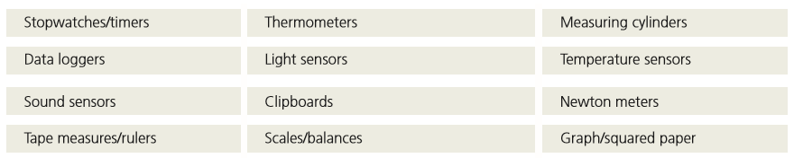

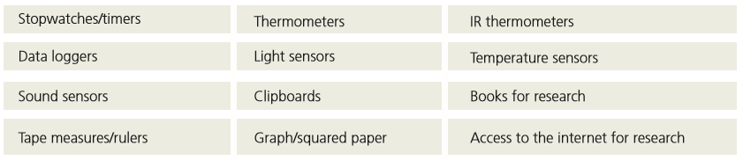

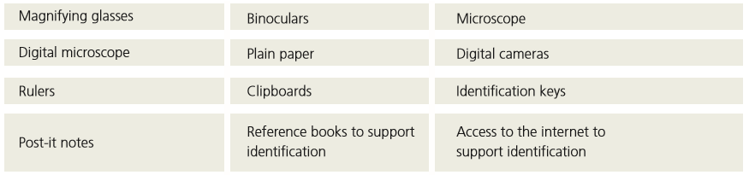

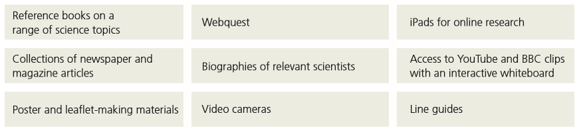

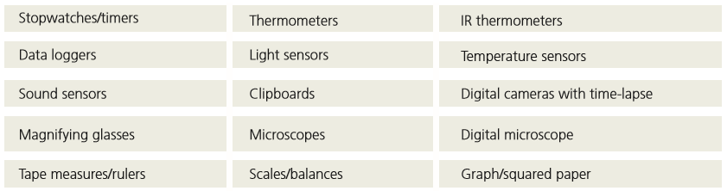

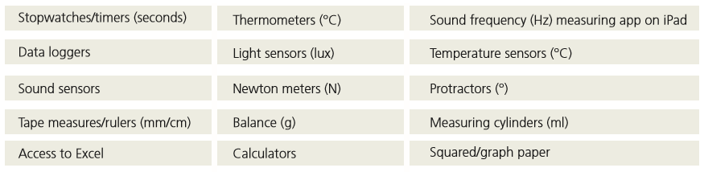

Working Scientifically: Progression Statements

🔩

*Statements taken from: Science programmes of study: key stages 1 and 2, National curriculum in England (2013) DFE Statutory framework for the early years foundation stage (2017) DFE*

|  |  |  |  |  |
| --- | --- | --- | --- | --- |
|  | EYFS | KS1 | Lower KS2 | Upper KS2 |
| Plan |  |  |  |  |
| Do |  |  |  |  |
| Record |  |  |  |  |
| Review |  |  |  |  |

Progression of Enquiry Skills from EYFS to Key Stage 1  
*Taken from the CIEC framework.*

🔩

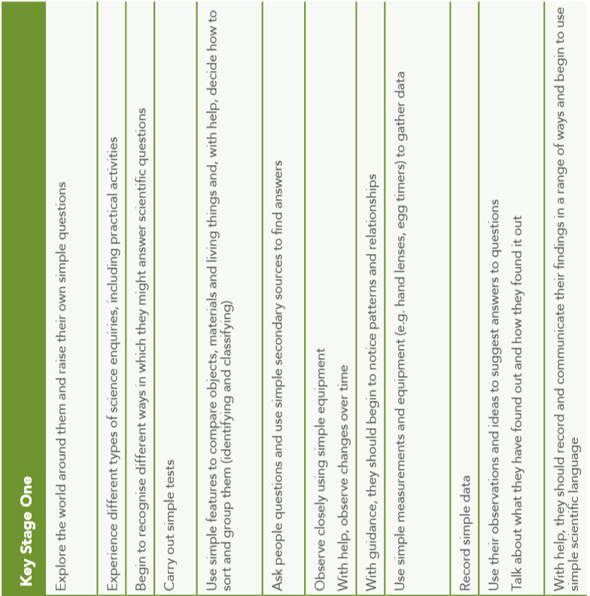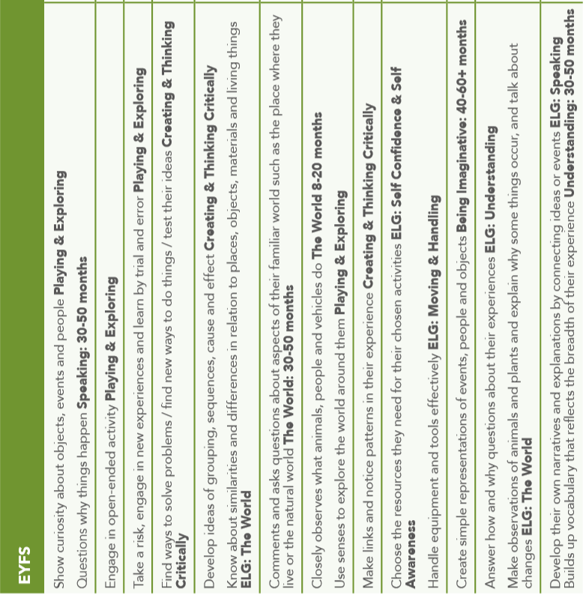Progression of Enquiry Skills from Key Stage 1 to Lower Key Stage 2 and Upper Key

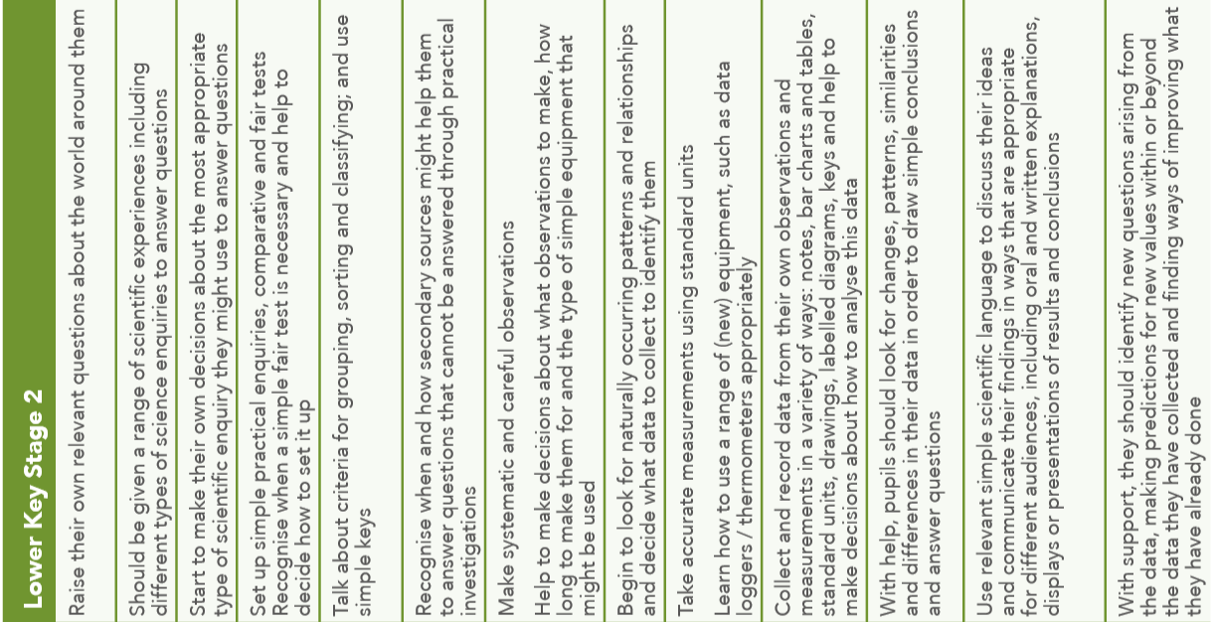

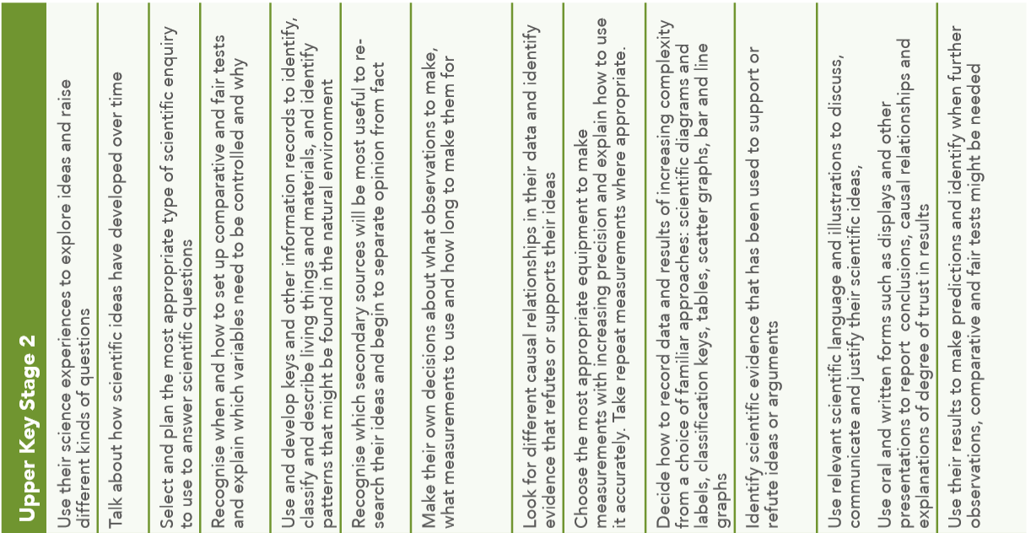

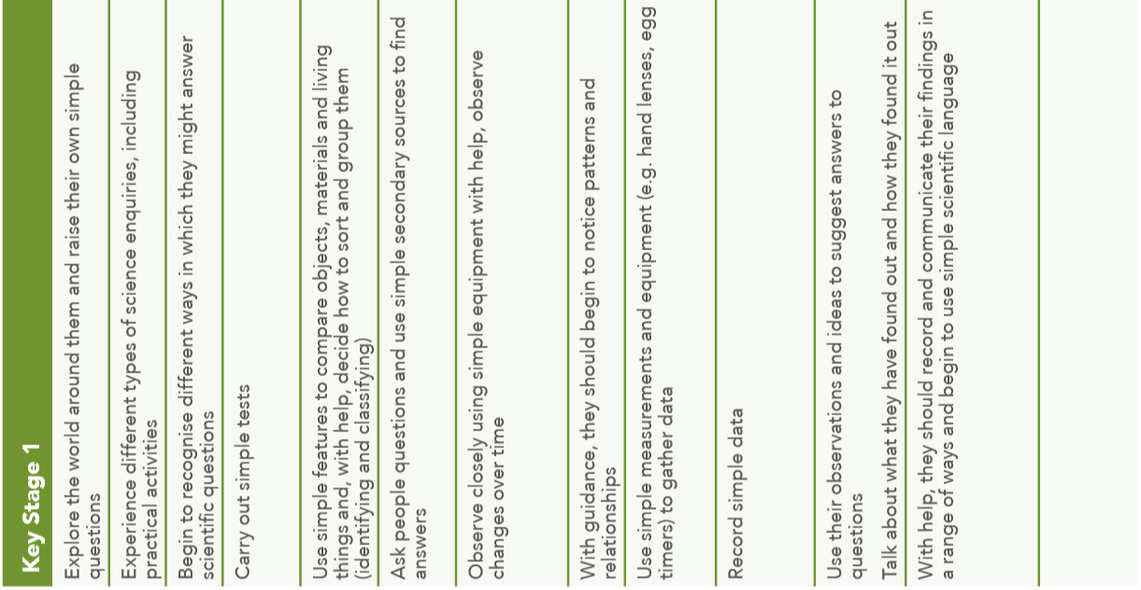

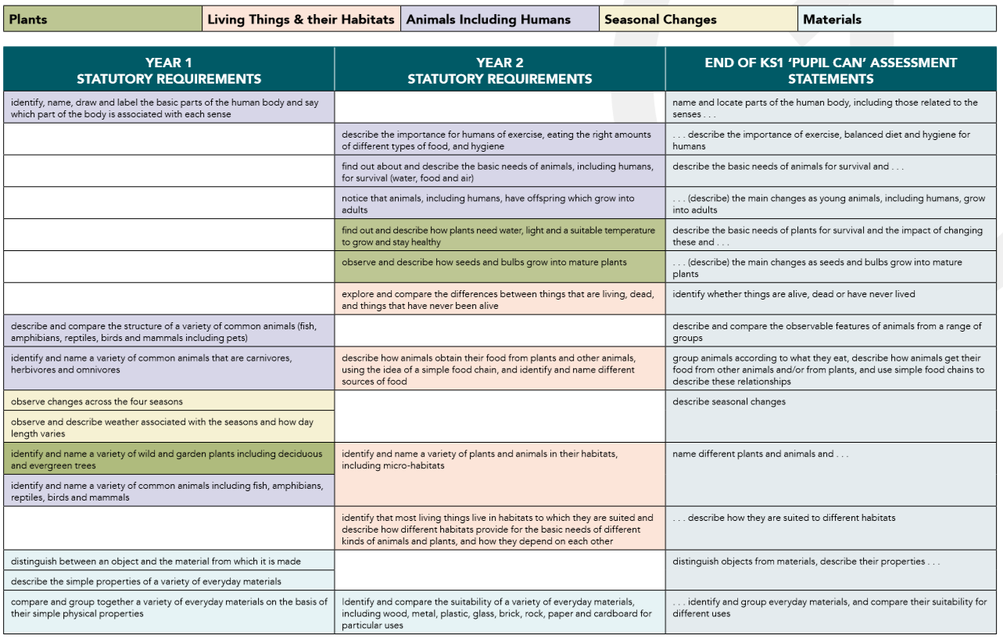

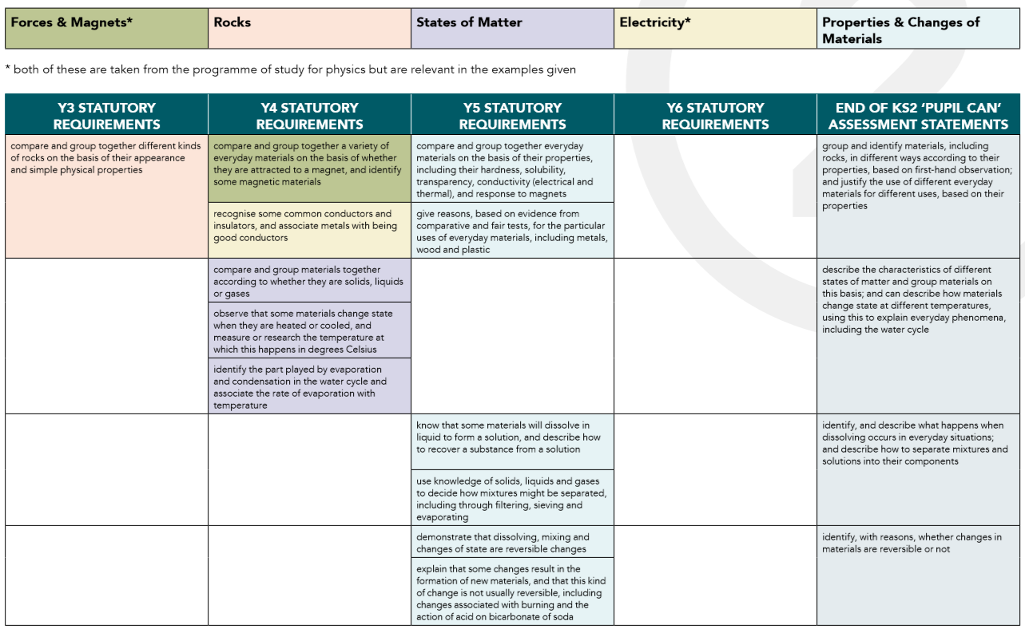

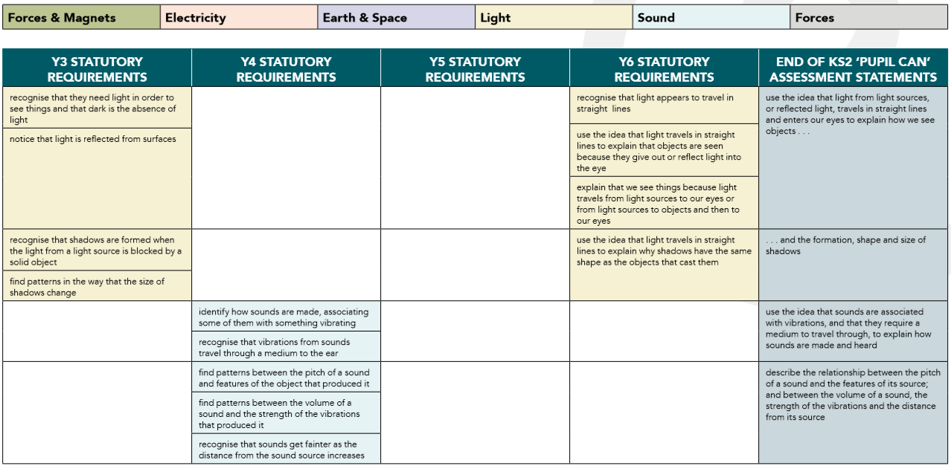

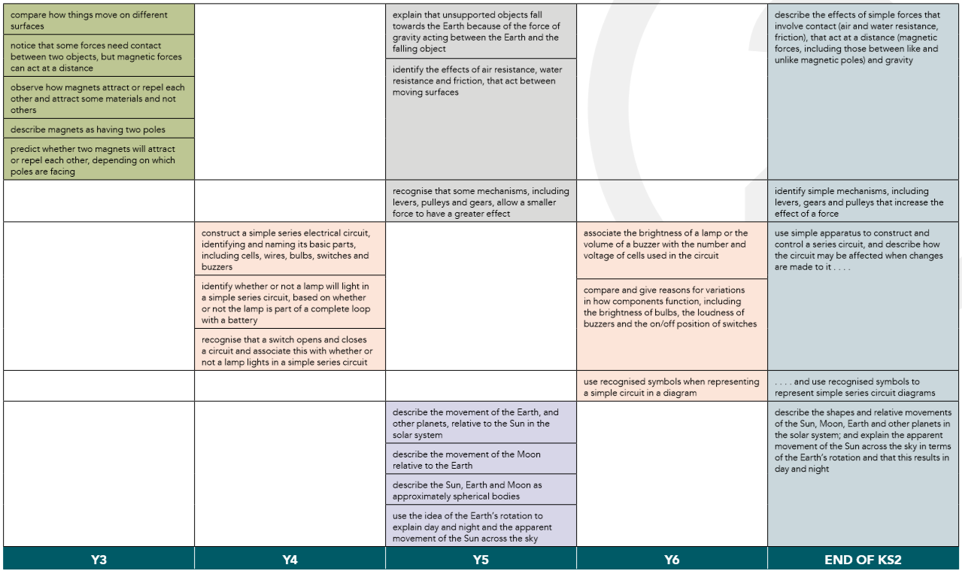

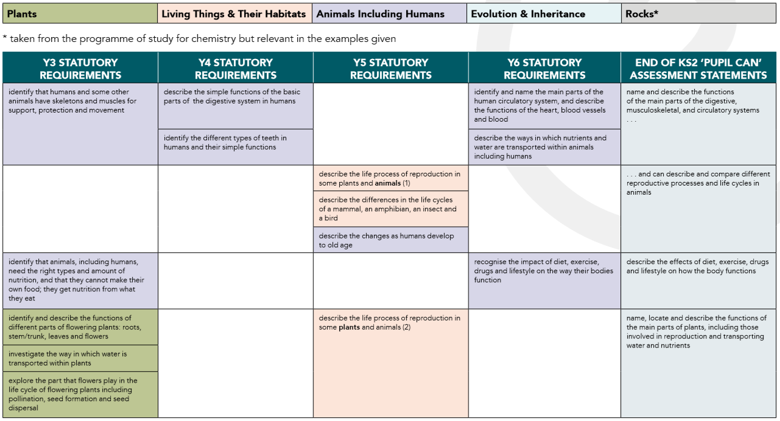

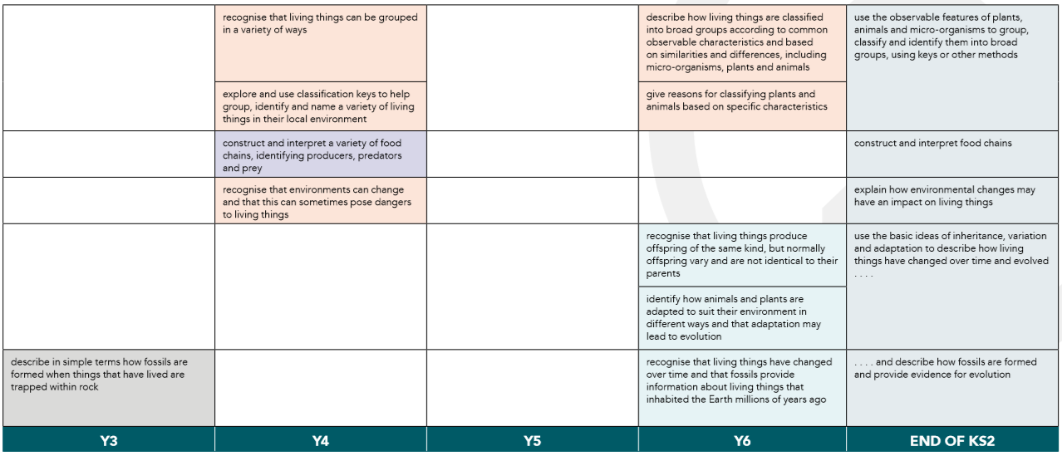





Characteristics of Historians

* An excellent knowledge and understanding of people, events and contexts from a range of historical periods and of historical concepts and processes
* The ability to think critically about history and communicate ideas very confidently in styles appropriate to a range of audiences
* The ability to consistently support, evaluate and challenge their own and others’ views using detailed, appropriate and accurate historical evidence derived from a range of sources
* The ability to think, reflect, debate, discuss and evaluate the past, formulating and refining questions and lines of enquiry
* A passion for history and an enthusiastic engagement in learning, which develops their sense of curiosity about the past and their understanding of how and why people interpret the past in different ways
* A respect for historical evidence and the ability to make robust and critical use of it to support their explanations and judgements
* A desire to embrace challenging activities, including opportunities to undertake high-quality research across a range of history topics

History Intent and Implementation

🔩

🏹



Intent

‘Competent historical thinkers understand both the vast differences that separate us from our ancestors and the ties that bind us to them; they can analyse historical artefacts and documents, which can give them some of the best understandings of times gone by; they can assess the validity and relevance of historical accounts, when they are used to support entry into a war, voting for a candidate, or any of the myriad of decisions knowledgeable citizens in a democracy must make. All this requires ‘knowing the facts’, but ‘knowing the facts’ is not enough. Historical thinking does not replace historical knowledge: the two are related and interdependent.’ (Seixas, 2008)

The developmental psychologist Howard Gardner also agrees that the mind can be disciplined to think about the processes underlying a subject as well as the content of the subject itself. (Gardner, 1999)

Planning for progress might therefore be better understood, not by the creation of a series of level-like steps from the most basic operations to the most complex, but in setting out clear descriptions of good quality history and then slowly challenging the misconceptions that prevent students from achieving this. It is this challenging of misconceptions, in the context of historical periods, which defines progress in historical thinking.

Our History Curriculum is, therefore, designed to allow the children to revisit the Threshold Concepts for History as they study different historical periods during their time at Primary School and beyond.

Threshold Concepts for History

Investigate and interpret the past

Understand world history

Understand chronology

Communicate historically



History Intent and Implementation

🔩

🏹

Implementation

We have chosen to use the Rising Stars History scheme of work as the basis for our History Curriculum. In each unit of work the key knowledge, skills and vocabulary are identified, which ensures that the children are revisiting the Threshold Concepts in each unit. A progression framework for History has been developed, which allows us to make accurate assessments as to whether the children are working towards, working at or exceeding expectations. A high quality children’s text is central to our delivery of each historical unit of work. Suggestions for texts to use have been identified in our Curriculum Map for each year group.

We use a range of pedagogical approaches, which support the teaching of History, information about these approaches can be found on the Historical Association website. (Control and Click on the links below to find out more information)

|  |  |
| --- | --- |
| * [Questions and Questioning](https://www.history.org.uk/primary/module/3657/primary-teaching-methods/3658/questions-and-questioning) * [Speaking and listening](https://www.history.org.uk/primary/module/3657/primary-teaching-methods/3659/speaking-and-listening) * [Reading books](https://www.history.org.uk/primary/module/3657/primary-teaching-methods/3660/reading-books) * [Reading documents](https://www.history.org.uk/primary/module/3657/primary-teaching-methods/3661/reading-documents) * [Children writing](https://www.history.org.uk/primary/module/3657/primary-teaching-methods/3662/children-writing) * [Learning about Time](https://www.history.org.uk/primary/module/3657/primary-teaching-methods/3663/learning-about-time) * The Visual Image | * [Objects](https://www.history.org.uk/primary/module/3657/primary-teaching-methods/3665/objects) * [Maps and Plans](https://www.history.org.uk/primary/module/3657/primary-teaching-methods/3666/maps-and-plans) * Story-telling * [Sites and the environment](https://www.history.org.uk/primary/module/3657/primary-teaching-methods/3671/sites-and-the-environment) * [History Investigations](https://www.history.org.uk/primary/module/3657/primary-teaching-methods/3672/history-investigations) |



📈

History Impact

We measure the impact of our History Curriculum in several ways. Firstly we use the History Progression Framework to measure whether a child is working towards, meeting or exceeding expectations in Knowledge, Skills and Understanding of the Threshold Concepts. The teacher assessments are recorded on a curriculum coverage and progression chart. At Laceby Acres Academy, we expect all children to produce beautiful work and to take pride in their learning outcomes. We regularly scrutinise work books to check that these standards are being upheld. We also use ‘Now Dos’ and unit tests to make sure that the children are retaining the important knowledge, resulting in a change in their long term memory.

|  |  |  |  |  |
| --- | --- | --- | --- | --- |
| Laceby Acres Academy – History Topic List | | | | |
| Year | Topic Name | Enquiry Question | Main Curriculum Focus | Big Finish |
| EYFS |  |  |  |  |
|  |  |  |  |
|  |  |  |  |
| Year One | My Family History | What was life like when our Grandparents were children? | Changes within living memory | Spend a day at Grandad’s school |
| The Greatest Explorers | Who were the greatest explorers? | Lives of significant individuals | Design a memorial to the greatest explorer |
| Great Inventions – Transport | How did the first flight change the world/why were the Rainhill Trials important? | Events beyond living memory nationally or globally | Design a commemorative train |
| Year Two | Bonfire Night and The Great Fire of London | Should we still celebrate Bonfire Night/Did the Great Fire make London a better or worse place? | Events beyond living memory nationally or globally |  |
| Holidays | How have holidays changed over time? | Changes within living memory | Create a pop-up seaside from the 1950s |
| Our Local Heroes | Who are our Local Heroes? | Local History Study: lives of significant individuals | Create a mini museum dedicated to your local heroes |
| Year Three | The Stone Age | What was new about the New Stone Age? | Changes in Britain from the Stone Age to the Iron Age | Perform a play depicting the changes in the Stone Age |
| The Bronze Age and the Iron Age | What was more impressive – The Bronze Age or the Iron Age? | Changes in Britain from the Stone Age to the Iron Age | Hold your own debate on the greatest development in this period |
| Local History | Why should we preserve our locality? | Local History Study: A theme in British history that extends knowledge beyond 1066 | Create a campaign to preserve a local treasure |
| Year Four | The Ancient Egyptians | How much did the Ancient Egyptians achieve? | The achievements of the earliest civilisations | Create an Egyptian time capsule |
| Roman Britain | What happened when the Romans came to Britain? | The Roman Empire and its impact on Britain | Stage a Roman army experience |
| Crime and Punishment | How has Crime and Punishment changed over time? | A study of a theme in British History that extends knowledge beyond 1066 | Create a display of the changes in crime and punishment |
| Year Five | The Anglo Saxons | Was the Anglo-Saxon period really a Dark Age? | Britain’ settlement by Anglo-Saxons and Scots | Carry out an archaeological excavation |
| The Vikings | Would the Vikings do anything for money? | The Viking and Anglo-Saxon struggle for the Kingdom of England | Write your own version of a Viking Saga |
| Journeys | What makes people go on a journey? | A study of a theme in British History that extends knowledge beyond 1066 | Hold an assembly to link migration today with events in the past |
| Year Six | The Maya Civilisation | Why should we remember the Maya? | The achievements of a non-European society | Make your own Maya codex |
| The Ancient Greeks | What did the Greeks do for us? | A study of Greek life and achievements and the impact on the Western World | Lead a special social event about the legacies and influences of the Ancient Greeks |
| The Impact of War | Did WW1 or WW2 have the biggest impact on our locality? |  |  |











Historical Vocabulary

|  |  |  |  |
| --- | --- | --- | --- |
|  | Term One | Term Two | Term Three |
| EYFS |  |  |  |
| Year One | Same, different, before, after, 20th Century, 21st Century, grandparent, past, now, timeline, year, growing up, 1950s 1960s, clue, object, artefact, matching, modern, old, types of houses (terraced, flats, bungalow etc.), features of houses (bathrooms, heating etc.) inventions, materials, condition, design, packaging, similar, comics, classify, locality, supermarket, shopping mall, shopkeeper, parade of shops, grocer, greengrocer, market, tobacconist, delivery vans, cash register, rationing, playground games, punishments, rote, 3Rs, school, chalk board, dip pen and ink. | Explorer, map, discover, equipment, adventure, trade, great, desert, caravan, Haii, uncharted, navigation, botanist, naturalist, indigenous, pirate, territory, replica, polar, hero, equipment, recent, astronaut, space, memorial, achievement, significant. | Inventor, invented, flight, century, eye-witness account, travel, journey, evidence, aviation, transport, propeller, steer, pilot, glider, modern, cockpit, elevators, engine, fuselage, jet, landing gear, rudder, impact, trade, leisure, canal, toll, source, evidence, locomotive, freight, significance, commemorate, livery, modern. |
| Year Two | Stuart period, King James 1, earlier, treason, plot, Catholic, Protestant, evidence, sources, traditional, rhyme, orally, hero, villain, terrorist, customs, commemorate, importance, relevance, effigy, law, repeal, now, then, cause, important, water squirt, fire bucket, fire hook, eye witness, diary, interpretation, consequences, impact, benefit | Holiday, recent past, twentieth century, seaside resort, accommodation, leisure, souvenir, bank holiday, infer, promenade, entertainment, deckchair, pier, Punch and Judy, bandstand, seawall, value, fiction, fact, research, continuity, change, same, different, tourist, tourism, anachronism, reconstruction, modern, interpretation. | Portrait, hero, significant, local, courage, past, sequence, chronological order, source, image, photograph, experts, heroes, evidence, clues, artefact, fragile, experts, objects, (and related words eg texture, material, inscription), document (and related vocabulary, e.g. census, return, handwritten), information, museum, display, exhibit, curator. |
| Year Three | Stone Age, prehistory, prehistoric, Palaeolithic, Mesolithic, Neolithic, archaeology, flint, artefacts, Ice Age, quarry, forage, hunter-gatherer, domesticated, reconstruction drawing, decay, evidence, settlement, community, slave, crop, revolution, role, significance, inference, saddle quern, midden, dresser, tomb, dolmens, barrows, mounds, henge, solstice, grave, goods, aerial photograph, sacred, monument, megalith, significant, technology, social, agriculture. | Impressive, smelting, bronze, hoard, ore, mould, period, status, beaker, archer, evidence, interpretations, radiocarbon dating, DNA testing, beliefs, afterlife, torc, inference, marine archaeology, persuasive argument, technology, tribe, viewpont, wattle and daub, roundhouses, crannog, broch, ingot. | Significant, listed, period names, architecture, names of features related to buildings, architectural terms, terms relating to time periods, campaign, migration, leisure, worship, heritage. |
| Year Four | Ancient, civilisation, fertile, shaduf, irrigation, achievement, hieroglyph, archaeologists, cartouche, antiquities, scribes, society, seals, sarcophagus, excavation, inscription, papyrus, mummification, role, achievement, hierarchy, priest, farmer, agriculture, pharaoh, archaeobotanical, pyramid, engineering, technology, stonemaison, ramp, construction, lever, sphinx, creation, mummification, Canopic jar, shabti, time capsule | Invade, invasion, conquer, republic, empire, emperor, status, glory, barbaric, legacy, resistance, primary evidence, interpretations, conquer, client kings, centurion, tablet, Picts, heritage, forts, garrisons, camber, groma, impact, transport system, positive, negative, significant, representation, interpretation, legions, legionaries, auxiliaries, testudo, centurion, names of uniform and equipment. | Rules, society, crime, punishment, values, poaching, witchcraft, riot, pillory, transportation, flogging, attitudes, execution, vagabond, highwayman, smuggling, police, respect, hostile, truncheon, cartoon, severe crime, lesser crime, liberty, prison, hulks, gaol, separate system, silent system, oakum, suffrage, suffragettes, discrimination, prejudice, terrorist, extremism, democracy, parliament, change, continuity, attitudes, values. |
| Year Five | Invasion, settle, reconstruction, Dark Ages, pagan, plunder, Scandinavia, grave goods, archaeologist, excavation, function, sceptre, garnet, millefiori, hoard metal detecting, saga, chronicle, illuminated manuscript, ecclesiastical, conversion, monastery, Old English, proof, evidence, counter argument, decay, excavate, preserved, deducation, interpretation, stratigraphy, classification, cataloguing, strata, shard, site, trench. | Raid, raider, monk, monastery, Viking, sacked, looted, abbey, migrate, settle, overpopulation, inheritance, causes, invader, settler, push and pull factors, significant, Wessex, monarch, cult, runes, longhouses, saga. | Journey, migrations, emigration, immigration, migrant, refugee, invader, settler, explorer, impact, voyage, status, Tudor, indigenous, portrait, symbol, adventurer, charter, Edwardian, sentimental, class, fact, opinion, persecution, anti-Semetism, pogrom, Kindertransport, Great Depression, prejudice, discrimination, settle, interpretation, British Empire, calypso, colour-bar, asylum seeker, economic migrant, illegal migrant. |
| Year Six | Religious, social, economic, cultural, political, civilisation, pyramid, temple, conclusion, evidence, reconstruction, archaeology, city state, sacrifice, Meso-America, nobles, creation, hierarchy, bloodletting, conquistadors, technology, culture, glyphs, agriculture, astronomy, calendar, trade, interpretations, theory, climate change, conquer, decline, codex/codices, pagan, scribe, significance. | Minoan, Mycenaean, classical, Hellenistic, Roman, Greek, city state, democracy, architecture, empire, culture, terrain, predict, polis, agora, triremes, monarchy, oligarchy, citizens, slaves, suffrage, stadium, Olympic, revival, marathon, myth, temple, priest, hoplite, phalanx (strong block formation), trireme, interpret, legacy, impact. | Sources, evidence, reliability, bias, utility, memorial, thankful village civilian, inscription, casualty, protected/reserved occupations, conscription, volunteer, blitz, evacuee, Kindertransport, refugee, logbook, rationing, imports, rural, urban, propaganda, home guard, Zeppelins, Luftwaffe, casualties, barrage, shells, bombs, memorial, commemorate, symbolism, inscription, plaque, frieze, Tommy, patriotism, mourning. |



Characteristics of Geographers

* An excellent knowledge of where places are and what they are like
* An excellent understanding of the ways in which places are interdependent and interconnected and how much human and physical environments are interrelated
* An extensive base of geographical knowledge and vocabulary
* Fluency in complex, geographical enquiry and the ability to apply questioning skills and use effective analytical and presentational techniques
* The ability to reach clear conclusions and develop a reasoned argument to explain findings
* Significant levels of originality, imagination or creativity as shown in interpretations and representations of the subject matter
* Highly developed and frequently used fieldwork and other geographical skills and techniques
* A passion for and commitment to the subject and a real sense of curiosity to find out about the world and the people who live there
* The ability to express well-balanced opinions, rooted in very good knowledge and understanding about current and contemporary issues in society and the environment



🏹

🔩

Geography Intent and Implementation

Intent

‘In the primary curriculum, geography is referred to, unsurprisingly, as the ‘umbrella’ subject because of its capacity to make tangible and effective connections across subjects. Geography’s fundamental role lies in helping children to understand the world, its environments and places near and far, and the processes that create and affect them. It encourages a holistic appreciation of how the world works and of the interconnections between concepts such as scale, community, cultural diversity, interdependence and sustainability. Geography is a subject that contextualises and extends the possibilities for developing and applying language and mathematics, and enriches understanding of, and in, subjects from science and history to art and design.’ Catling S and Willy T (2018)

The report of the geography national curriculum working group for England and Wales provided a useful definition of geography: Geography explores the relationship between the Earth and its peoples through the study of place, space and environment. (DES, 1990, p. 6) 'Place', 'space' and 'environment', they argued, are the key ideas at the core of geographical studies.

Threshold Concepts for Geography

Investigate places

Investigate patterns

Communicate geographically





Geography Intent and Implementation

🔩

Implementation

We have chosen to use the Rising Stars Geography scheme of work as the basis for our Geography Curriculum. In each unit of work the key knowledge, skills and vocabulary are identified, which ensures that the children are revisiting the Threshold Concepts in each unit. A progression framework for Geography has been developed, which allows us to make accurate assessments as to whether the children are working towards, working at or exceeding expectations. A high quality children’s text is central to our delivery of each Geographical unit of work. Suggestions for texts to use have been identified in our Curriculum Map for each year group.

We use a range of pedagogical approaches, which support our teaching of Geography. These approaches stem from the different aspects of Geographical enquiry. We take into account outdoor learning and fieldwork, children’s personal geographies, spatial awareness, mapwork and graphicacy, learning technologies and environmental Geography. These are all used to deepen children’s understanding of challenging and, at times, controversial realities, events and concepts. ‘The enquiry approach to learning is one of Georgraphy’s strongest assets.’ (Pike, 2016) Enquiry develops the children’s ability to ask relevant questions, collect and analyse data and draw conclusions.

Outdoor Learning and Fieldwork – ‘Geography provides transformative opportunities for learning in the environment as well as from it, about it and for it.’ (Pickering, 2017) Fieldwork contributes to learning about the outdoor environment, through children developing their knowledge and understanding in the environment and their sense of responsibility and a desire to care for – even improve – what is around them.

Children’s personal geographies – individual to each child – can be compared, contrasted and brought together through collaboration to provide insight into the nature, variety and lives of the neighbourhoods and communities in a school’s catchment area and beyond (Blundell, 2016) (Malone, 2018) (Nairn and Kraftl, 2016). This involves the consideration of resolutions for potential issues (linking with social, moral, spiritual and cultural (SMSC) education), and encourages articulation and expression through writing, debating and persuasion. Scientific and mathematical investigations contribute to understanding the physical environment when investigating the location and distribution of local flora in local stream, river or coastal studies, and in mapping patterns of housing and services. Learning that interconnects subjects gives greater meaning and significance to enquiries and, in presenting findings, subjects such as art and design are engaged through modelling, map-making and informative displays. Children can apply and adapt their developing subject understanding and skills to propose ideas and solutions to topics as diverse as conflicting proposals for local improvements, the need to provide additional energy sources nationally, and ways in which international fair trade may develop communities across the world. Through heir geographical studies, children develop autonomy and empowerment, applicable across their lives (Catling and Willy, 2018).

An important aspect of the primary geography curriculum is the development of children’s **spatial awareness** in and about the environment. Studying locations, places and environments develops children’s sense of place and space in the world at a range of scales. Studies of human and natural features and phenomena develop children’s spatial awareness. They may examine the location and distribution of features, whether of local postboxes or of volcanoes globally, to notice and map their patterns, leading them to consider the reasons for and impacts of these and to ask further questions to investigate.

Maps are the ‘tool’ of the geographer – the medium through which geography is recorded, analysed and communicated. Developing the skills of decoding, interpreting, comprehending and analysing information and messages from maps is invaluable, not simply to understand where you are and find your way but to recognise the features and aspects of an urban, rural or wild area (Wiegand, 2016). Historical contexts can provide opportunities for good geography. Studying maps alongside descriptive texts and pictures about a battle involves recognising and appreciating the relief and state of the landscape where it was fought, how the armies were aligned on the battlefield and how they made use of the terrain for attack and defence. This is as important as understanding the politics of the time. Reading maps is one of the skills of graphicacy, which is about interpreting visual images such as pictures, graphs, sketches, charts, photographs and diagrams. It stands alongside oracy, literacy and numeracy (Boardman, 1983). Graphicacy skills enable children to demonstrate their understanding through non-text media, a vital skill that appeals to children in an increasingly visual age. Harnessing such skills alongside using maps helps children to understand what is happening in an area, tying together the past, the present and what may occur in the future.

Geography is well served by accessible graphic learning technologies. Google maps, [OS maps](http://digimapforschools.edina.ac.uk/) and geographic information systems (GIS) motivate and enable children to delve into and enhance their understanding of places and environments, helping to develop their geographical awareness and articulate their geographical learning. Websites such as [Google My Maps](https://www.google.com/maps/d/u/0/?hl=en) can enrich children’s understanding of the world around them at all scales, engaging and encouraging their curiosity.

Environmental geographyfulfils children’s desire to know more about their physical and human world and the interplay of those two for environmental management and sustainability. Children can begin to understand the potential of their role and the impact that they might have through their actions and interests, as primary geography takes them beyond their immediate world and what they currently know to deepen their environmental knowledge and nurture their stewardship of places (Nolet, 2016).

Teachers who are good at creating their geography curriculum use a wide variety of the subject’s pedagogical repertoire. They listen to and are actively engaged as a ‘critical friend’ to children’s perspectives and ideas, valuing and engaging with children’s personal geographies. They provide an informed sense of direction in and for children’s graphical studies, as the person with clarity about where their geographical learning needs to go – teachers hold the curriculum ‘map’ for their learning, provide the overview of its landscape, and discern and help their children select effective routes to realise their potential.





Geography Impact

|  |  |  |  |  |
| --- | --- | --- | --- | --- |
| Laceby Acres Academy – Geography Topic List | | | | |
| Year | Topic Name | Enquiry Question | Main Curriculum Focus | Big Finish |
| EYFS |  |  |  |  |
|  |  |  |  |
|  |  |  |  |
| Year One | Our Local Area | What’s it like where we live? | Use maps to identify the UK and its countries | Make models of your local area |
| People and their Communities | Where in the World do these people live? | Understand Geographical features by contrasting the UK with a Non-European country | Make a passport ready for take off |
| Animals and their Habitats | Where do our favourite animals live? | Use compass directions to describe features and routes on a map | Create a ‘home in a box’ |
| Year Two | Seasons | What are seasons? | Identify seasonal and daily weather patterns in the UK | Create drawings and paintings inspired by seasonal change |
| Journeys: Food | Where does our food come from? | Describe and understand key aspects of human geography, including trade links | Go on a Great British Picnic |
| Our Wonderful World | What are the seven wonders of our world? | Devise a map and use basic symbols in a key | Choose your own seven ‘wonders of the world’ |
| Year Three | Climate and Weather | Why is climate important? | Identify seasonal/daily weather patterns in the UK | Produce a ‘Big Finish’ climate report |
| Our World | Where on Earth are we? | Locate the World’s countries using maps | Invent a locational map game, quiz or puzzle |
| Coasts | Do we like to be beside the seaside? | Name geographical regions and their identifying characteristics in the UK | Create a television advert or presentation to promote a coastal area |
| Year Four | The Americas | Can you come on a Great American Road Trip? | Locate the World’s countries using maps, including North and South America | Create a song or a rap about America |
| Rivers and the Water Cycle | How does the water go round and round? | Describe and understand key aspects of physical geography including the Water Cycle | Design and make a model river |
| Earthquakes and Volcanoes | How does the earth shake, rattle and roll? | Describe and understand key aspects of physical geography including volcanoes | Make a real life erupting volcano |
| Year Five | Changes in our Local Environment | How is our country changing? | Identify geographical characteristics of the UK and understand how some have changed | Create pieces of art that represent your local area |
| Europe: A study of an Alpine Region | Where should we go on holiday? | Locate the World’s countries using maps | Create your very own mobile app about the Alpine region |
| Journeys: Trade | Where does all our stuff come from? | Use maps, atlases and digital mapping to locate countries and describe features | Write an adventure story about the journey of your chosen product |
| Year Six | South America: The Amazon | What is life like in the Amazon? | Understand similarities and differences of a region of the UK and one of South America | Produce and exciting stop-motion animation |
| Protecting the Environment | Are we damaging our World? | Describe and understand key aspects of human Geography including settlement and land use | Develop a campaign to help protect the planet |
| Our World in the Future | How will our world look in the future? | Name and locate counties and cities in the UK/understand how aspects have changed | Create your own plan for the future of your local area |



Geographical Vocabulary



|  |  |  |  |
| --- | --- | --- | --- |
|  | Term One | Term Two | Term Three |
| EYFS |  |  |  |
| Year One | Restaurant, high street, supermarket, place of worship, bus stop, train station, hospital, car park, river, pond, park, playground, wood, hill, block of flats (medium height) and tall, bungalow, semi-detached, stone cottage, near, far, Edinburgh, Cardiff, London, Birmingham, Snowdon, Isle of Wight, Fort William, Caernarfon castle, Manchester, East Anglia, map, plan, above Familiar, see clearly (plain view), hidden, map, navigation, plan, grid, symbols, above, aerial, aerial, birds-eye, open space, green space, field, park, forest, woodland, landmark, park, golf club, allotments, beach, cliffs, promenade (as appropriate) map, symbols, often, rarely, | World, United Kingdom, England, Wales, Scotland, Northern Ireland school, car, coach, plane, buildings, high street, landmark, sea, seaside, coast, coastline, sand, water, waves, rocks, pebbles, buoys, windsurfs/surfboards, windbreaks, cafe, deckchair, inflatable boat, bucket, spade, lifeboat rainforest, remote, hot, wet, home, different, tall trees, animals, noisy, sun, Rainforest, remote, hot, wet, home, different, tall trees, animals, noisy, sun, Africa, hot, dry, glass, steel, brick, concrete, wood, Timbuktu, Mali, mosque, climate, equator, same, different, similar, Continent, country, city, capital, landmark, mountains, harbour, sea, coast, | World, continent, Europe, Africa, North America, South America, Oceania, Asia and Antarctica, country, Great Britain, Ireland, South, North and South Pole, Southern Ocean, polar, emperor penguin, World, continent, Europe, Africa, North America, South America, Oceania, Asia and Antarctica, country, Great Britain, China, Indonesia, Pakistan, Bangladesh, Turkey, India, Russia, Japan, hot, cold, wet, dry, windy, calm, snowy, Ocean, sea, underwater, Arctic, Atlantic, Indian, (South) Pacific and Southern, Australia, Ningaloo Reef, harmless, filter feeders, shark, warm and cold water. Seas such as Coral Sea, Tasman sea, Continent names, Namibia, carnival, red pandas, whale sharks, savannah, herd, Africa, South Africa, continent, journey, distance, far, near, land, sea or air, thousand, warmer, spring, summer, autumn, winter, globe, migration, penguin, panda, elephant, whale shark, swallow , dark, bright, sunny, empty, busy |
| Year Two |  |  |  |
| Year Three |  |  |  |
| Year Four |  |  |  |
| Year Five |  |  |  |
| Year Six |  |  |  |



🔩

Art Intent and Implementation

Intent

**The value of cultural learning**

The Cultural Learning Alliance (CLA), in their research report ImagineNation: The value of Cultural Learning, state that: ‘Not every child is born with the same chances to achieve and thrive. More than a quarter of all children in the UK live in poverty, and for 1.7 million children that poverty is severe. This has a significant impact on the social fabric of our society: on the health, education and everyday lives of children in our poorest families. They tend not to do so well in school, are more likely to suffer chronic illness and they cannot afford the same level of school trips or extracurricular lessons. Cultural learning has a significant part to play in addressing this inequality.’ (Cultural Learning Alliance (CLA) (2017), ImagineNation: The value of Cultural Learning, page 7. www.culturallearningalliance.org.uk/evidence

The CLA argue that: ‘There is a diverse range of routes into the creative industries that suit the aptitudes and abilities of all children and young people: from GCSEs to apprenticeships to Masters degrees. Apprenticeships in the cultural sector have seen the fastest growth in uptake over the last five years, four times faster than in any other area. Leading employers from across the Creative Industries and beyond are calling for job-ready, innovative, analytical and inventive problem solvers: they want a workforce with both creative and scientific skills’. (CLA, ImagineNation, page 15) To support the thriving creative economy, it is essential that every pupil from any socio-economic background has access to the arts, and opportunities to study creative subjects. These opportunities should not be reserved for the privileged few, or be dependent on the ability to pay for extracurricular lessons. Creative subjects should be accessible to all and given equal status and visibility in school curriculums. (CLA, ImagineNation, page 15)

At Laceby Acres Academy, we believe that Art is a vital and integral part of each child’s education. It provides children with opportunities to develop a range of ways in which they can share and express their individual creativity, whilst learning about and making links with a wide range of different types of art in our society. Art contributes to each child’s personal development in creativity, independence, judgement and self reflection. Moreover, it enables our children to develop a natural sense of wonder and curiosity about the world around them and therefore links strongly to our school values and the drivers for our curriculum. Our Art curriculum develops the children’s critical abilities and understanding of their own and others’ cultural heritages through learning about a diverse range of male and female artists and designers throughout history. Children develop their understanding of the visual language of art with effective teaching and carefully thought out sequences of lessons and experiences.

Threshold Concepts for Art

Develop ideas

Master techniques

Take inspiration from the greats





Art Intent and Implementation

Implementation

***“Every child is an artist. The problem is how to remain an artist once we grow up.” Pablo Picasso***

We have identified three Threshold Concepts for Art and Design:

**Develop Ideas** – understanding how ideas develop through an artistic process

**Master Techniques** – developing procedural knowledge so that ideas may be communicated

**Take Inspiration from the Greats** – learning from both the artistic process and techniques of great artists and artisans throughout history

Each of these Threshold Concepts has its own body of knowledge, which helps to strengthen the art schema allowing children to organise knowledge in a meaningful way, making connections between facts.

**Develop Ideas Knowledge: Emotions, Process, Visual Language, Vocabulary**

**Master Practical Skills Knowledge: Media and Materials, Techniques, Effects and Colour Theory**

**Take Inspiration Knowledge: Artists and Artisans, Styles and Periods**

**Develop Ideas Knowledge**

**Emotions** – Emotional responses are often regarded as the key to experiencing art. The children build a knowledge of how artists and designers have used techniques and media to create emotive pieces and use this knowledge in their own artwork to express different emotions. Examples of knowledge include:

The emotional impact of using line, colour, texture and shape

The creation of abstract art works to convey an emotional state

The knowledge of artists and designers who are well known for creating emotional responses through their work

Styles of art and design that are known for conveying particular emotions

Visual language to describe emotion through pieces of art

**Master Practical Skills Knowledge:**

**Media and Materials** – Artists use a variety of media and materials to create a piece of artwork, these include: drawing, painting, sculpture, collage, print, textiles and digital media.

**Techniques** – techniques in art and design involve the children in developing and refining procedures in order to communicate their ideas and create different effects. These are dependent on the medium that they are using. Techniques can include: colour mixing, sketching, shading and hatching, texture mixing, moulding and carving, layering and replicating to create patterns, weaving and stitching and editing and animating.

**Effects** – Artists and designers develop a range of techniques to create powerful visual effects which engage the observer. These can include:

Light and shadow - e.g. through shading or brush technique

Tone and texture – e.g. through hatching and cross hatching, mixing materials

Movement and perspective – e.g. through applying different line thicknesses, using wire frameworks and moulds, digital animation

Pattern – e.g. through weaving, creating prints, stitching, tessellation

Tinting – e.g. through applying colour theory

Reflection – e.g. through sketching lightly or brush technique

**Colour Theory** – Colour theory explains how humans perceive colour and how colours mix, match or clash. It helps pupils to understand the messages that colours can communicate and the methods used to replicate colour. The children should learn about:

Primary and secondary colours, colour systems and the colour wheel, adding white and black to colours to make tints and tones, layering colours, complementary and contrasting colours, warm and cool colours and associations with emotions.

**Take Inspiration Knowledge**

**Artists and Artisans** – Children need to take inspiration from ‘classic’ and ‘modern’ artists and designers by describing their work, replicating their techniques and creating original pieces influenced by their style. Examples of knowledge include:

Notable artists and designers

How they were educated and how they developed their style

How their style has influenced other artists and society

Notable styles and periods, for example; Surrealism, Impressionism, Art Deco, Renaissance

**Styles and Periods** – The History of Art is immense. Humans have always tried to demonstrate their feelings through the creation of art. Their work (architecture, paintings, drawings, sculpture) has allowed us to see how artists viewed their world in their time. Aspects of knowledge include:

Development and changes in art through time – e.g. from Stone Age carving to contemporary art

Availability of materials and developments in technology

Common themes expressed through art – e.g. love, war, food, religion, home

Historical events e.g. social and political influences

Artistic pioneers who created an art movement or are significant within a specific period or for a particular style

Teachers plan lessons using our progression document and the Chris Quigley Curriculum Companion for Art and Design to ensure skills, knowledge and understanding build year on year. Sequences of lessons are planned which are inspiring and exciting, stimulating and relevant to the children’s interests and enthusiasms.

Each term teachers inspire the children to explore and extend their skills, knowledge and understanding in two different areas across **drawing, painting, printing, collage, textiles, sculpture/3D and art through technology**. The introduction to the project stimulates curiosity with sensory stimuli or ideas, which capture the children’s imagination and involves skills and media exploration before the children work on their finished piece of art work in response. Teachers recognise that in developing children’s individuality it is important to proceed flexibly to enhance the children’s creativity. Projects may be blocked across a 1/ 2 week period or build across the term as appropriate. Drawing is likely to form part of the termly projects but throughout the school children complete drawing tasks using a variety of media and techniques regularly. These drawings are used to enhance the beautiful cross-curricular work that the children produce.

**Sketch books** are used across school to explore and investigate ideas, media and techniques, to develop observational drawings and representations of imaginary worlds. By annotating sketches the older children begin to use sketchbooks to map out their responses, explaining what they are doing in order to further enhance the quality of their learning outcomes.

Children learn about a range of artists, designers and crafts people, art movements and styles across time and cultures. Links are made to their own projects but children also study an artist in depth each half term and use their observations and understanding to inspire their own art work. This allows the children to talk about art, to understand art in its historical context, to question art and to think like artists. These skills add a depth and context to the artwork that the children create in the classroom.

Recognising children’s natural curiosity and desire to express their understanding of their experiences creatively, art and design is a celebrated means of communicating ideas across all areas of the curriculum.

A dedicated ‘Art Room’ has been established and a successful after school art club is up and running.

Art Impact



|  |  |  |  |
| --- | --- | --- | --- |
| Laceby Acres Academy – Art Topic List | | | |
| Year | Topic Name and Artist Spotlight | Media and Materials | Books |
| EYFS |  |  |  |
|  |  |  |
|  |  |  |
|  |  |  |
|  |  |  |
|  |  |  |
| Year One | At the Seaside  Claude Monet | Painting | ‘Katie and the Waterlily Pond’ James Mayhew  ‘The Magical Garden of Claude Monet’ Laurence Anholt |
| Portraits  Thomas Gainsborough | Digital Media  Painting | ‘Katie and the Mona Lisa’ James Mayhew  ‘Andy Warhol’ Mike Venezia |
| Time for Play  Georges Seurat | Painting | ‘Sunday with Seurat’ Julie Merberg |
| Weather  J.M.W. Turner | Painting |  |
| In the Jungle  Henri Rousseau | Printing  Collage | ‘The Fantastic Jungles of Henri Rousseau’ Michelle Markel |
| Ancient Art  The Mesapotanians | Sculpture |  |
| Year Two | The Beauty of Flowers  Georgia O’Keefe | Sculpture  Painting | ‘My Name is Georgia’ Jeanette Winter, ‘Georgia’s Bones’ Jon Bryant, ‘Through Georgia’s Eyes’ Rachel Isadora |
| In the Dark of Night  Artemisia Gentileschi | Painting | ‘Katie and the Starry Night’ James Mayhew |
| Food  Paul Cezanne | Painting | ‘Meeting Cezanne’ Michael Morpurgo  ‘Cezanne and the Apple Boy’ Laurence Anholt |
| Scenes of the Sea  Ivan Aivazovsky | Drawing  Printing | ‘The Great Wave: A children’s book inspired by Hokusai’ Veronique Massenot  ‘One day in Japan with Hokusai’ Julia Altmann |
| Love for Landscapes  John Constable | Drawing  Painting | ‘Come Look With Me’ Gladys S Blizzard |
| Dreams and Nightmares  William Blake | Sculpture  Painting | ‘A Life Made by Hand: The story of Ruth Asawa’ Andrea D’Aquino |

|  |  |  |  |  |
| --- | --- | --- | --- | --- |
| Year | Topic Name and Artist Spotlight | Media and Materials | Books | |
| Year Three | The Renaissance  Leonardo Divinci | Sculpture  Painting | ‘Leonardo and the Flying Boy’ Laurence Anholt  ‘Leonardo for Kids’ Janis Herbert | |
| Family Life  Rembrandt | Sculpture  Painting |  | |
| Myths and Legends  Peter Paul Rubens | Printing, Photography  Textiles |  | |
| A Journey into Space  Robert McCall | Drawing  Collage |  | |
| Cityscape Art  Camille Pissarro | Painting, Drawing  Photography |  | |
| Impressionism  Pierre-Auguste Renoir |  |  | |
| Year Four | Abstract Art  Wassily Kandinsky | Printing, Collage  Painting | ‘Action Jackson’ Jan Greenberg  ‘Jackson Pollock Splashed Paint and Wasn’t Sorry.’ Fausto Gilberti | |
| Royalty  Hans Holbein the Younger | Collage Megan Coyle | ‘Faces’ Zoe Millar and David Goodman | |
| Symbolism  Edvard Munch | Printing: Lithographs and  Japanese Wood Cuts |  | |
| Art Deco  Tamara de Lempicka | Textiles, Illustration  Pottery |  | |
| All Work and No Play  L.S. Lowry | Drawing  Painting | ‘The Little Lowry’ Catherine De Duve  ‘L S Lowry’ Damian Harvey | |
| Animals  Rosa Bonheur | Drawing | ‘The Story of Rosa Bonheur’ Maryann Macdonald | |
| Year Five | Amazed by Architecture  Zaha Hadid | Architecture  Design | ‘Zaha Hadid (Little People Big Dreams)’ Maria Isabel Sanchez Vegara  ‘Zaha Hadid’ Philip Vegara | |
| The Power of Love  Auguste Rodin | Sculpture | ‘Little Sap and Monsieur Rodin’ Michelle Lord | |
| The Explosion of Pop Art  Andy Warhol | Printing  ICT | ‘Andy Warhol – Meet the Artist’ Rose Blake, ‘Andy Warhol’ Mike Venzia  ‘Andy Warhol So Many Stars’ Andy Warhol, ‘Andy Warhol Happy Bud Day’ Andy Warhol | |
| The Art of Anatomy  Albrecht Durer | Drawing, Printing  Graphic Design |  | |
| Cultural Tradition in Art  Richard Kimbo | Pattern (Madhubani Art)  Textiles - Batik | ‘Under the Sea’ Nor Azhar Ishak | |
| Art and Fashion  Piet Mondrian | Design, Drawing  Collage | ‘Little People Big Dreams – Coco Chanel’ Isabel Sanchez Vegara  ‘Fancy Party Gowns: The Story of Fashion Designer Ann Cole Lowe’ Deborah Blumenthal | |
| Year Six | Exploring Expressionism  Henri Matisse | Collage | ‘Colourful Dreamer. The Story of Artist Henri Matisse’ Marjorie Blain Parker, ‘Henri Matisse – Drawing with Scissors’ Jane O’Conner, ‘Matisse the King of Colour’ Laurence Anholt | |
| Art and Religion  El Greco | Pattern  Printing | ‘The Children’s Guide to Islamic Art’ Mary Beardwood  ‘Discovering Islamic Art’ Mary Beardwood’ | |
| A Study of Surrealism  Salvador Dali | Collage, Painting  Printing | ‘Magritte’s Marvelous Hat’ D.B Johnson | |
| Keeping it Real  Gustave Courbet |  |  | |
| Futurism  Umberto Boccioni |  |  |  |
| Capturing Conflict  Paul Nash |  |  |  |

Art Vocabulary



|  |  |  |  |  |
| --- | --- | --- | --- | --- |
|  | Term One | Term Two | Term Three | Additional Vocabulary |
| Foundation Stage |  |  |  |  |
| Year One | Inspiration, Impressionist, Romantic, shimmering, feature, renaissance, realist, pop artist, idealised, mastered, perfect | Complex, criticise, pixels, experts, banks, contrast, landscape, significant, romantic, expressive, influenced, critic, palette knife, textured | Surrounded, lush, exotic, foreground, back ground, contrast, governments, tablets, murals, elaborately, trading, mosaics, honour, kiln, styluses | Alter, arrange, artisan, artist, brush, carving, classic, collage, create, cut, designer, develop, digital media, dot, effect, experiment, explore, glue, join, line, materials, method, modern, moulding, object, paint, pattern, plaiting, primary colours, print, sculpture, secondary colours, shading, shadow, sort, stitching, technique, textile, texture, thickness, tint, tones, tool, visual, weaving |
| Year Two | Significance, context, symmetrical, base, sorrow, themes, wilting, fantasy, dim, visible, depth, mist, expressive, tones, symbolise | Still life, rich colours, portrait, Baroque, Post-Impressionist, contemporary, lavish, seascape, glassy, scrolls, maritime, naval, nation, primary colour, secondary colour | Imaginary, speciality, dedicating, appreciate, apply, blend, definition, ominous, vastness, Surrealism, spontaneity, meditation, automatic, medium, combination, recognise |
| Year Three | Renaissance, humanism, knowledgeable, classical, realism, depth, perspective, frescos, permanent, etchings, complications, apprentice, commissioned, chiaroscuro, restrained | Myths, legends, Pre-Raphaelite, frustrated, props, relics, astronomical, emerged, lunar, flourished, technical, compositional | Urban, skylines, photorealism, hyperrealism, aerial, formations, inanimate, distort, porcelain, meticulous, graphite, canopy, foreground subtle, charm | Accurate, adapt, annotate, back stitch, blocks, coiling collect, cross hatching, cross stitch, distinctive, dye, elaborate, feeling hardness, hatching, influenced, layers mix, montage mod, mosaic, movement, notable, original overlapping, palette, patterned, plain, precise, quilt, recognisable, recordings, refine, replicate, resources, rough, sketch, smooth, striking, style, tessellation, washes, watercolour |
| Year Four | Random, geometrical, outline, contrasts, transparent, chromatic, physical, epidemic, precise, silverpoint, tempera, miniatures, limning, masterpiece, mournful, aloof, vacant | Personal, obscure, transition, noirs, lithography, hollow, distinctive, biography, exposed, luminous, independence, empowered, Expressionism, simplifying | Industrial, initial, rough, restricted, opaque, earthy, tinting, charcoal, smear, source, livestock, domestic, originally, layered, mythical, fascination, values, strands |
| Year Five | Skyscrapers, specialise, memorials, structural, aesthetic, crisp, underdrawing, renowned, individuality, interplay, fine-tuned, compositions, craftpersons | Commercial, icons, elite, masses, Dadaism, ridiculed, silkscreen, master, meticulous, volume, foreshortening, topography, contours, gouges, chisels, brayer, printing press | Batiks, originated, canting, Swahili, calling, occupation, clan, plane, neo-plasticism, eliminating, non-essential | Abstract, acrylic, animation, ceramic, convey, enhance, expression, extend, fluent, frameworks, grasp, interpretation, lifelike, mimic, perspective, proportion, provoke, qualities, stability, tactile |
| Year Six | Mystical, Fauvism, determined, instinct, intellect, communal, prominent, elongating, adoration, Mannerism, resonated, mystic, coarse, ecstatic, psychological | Subconscious, logically, crescent, abyss, stylised, enigmatic, emphasis, automatism, gesso, vulgar, crude, replicated, consistently, persisting, insistence | Rebellious, dynamism, manifesto, sensations, derived, synthesise, advocated, theories, contorted, animate, macabre, iconic, brooding, disillusionment, enchanting, remnants, atrocities |

Characteristics of Musicians

* A rapidly widening repertoire which they use to create original, imaginative, fluent and distinctive composing and performance work
* A musical understanding underpinned by high levels of aural perception, internalisation and knowledge of music, including high or rapidly developing levels of technical expertise
* Very good awareness and appreciation of different musical traditions and genres
* An excellent understanding of how music provenance – the historical, social and cultural origins of music – contributes to the diversity of music styles
* The ability to give precise written and verbal explanations, using musical terminology effectively, accurately and appropriately
* A passion for and commitment to a diverse range of musical activities





Music Intent and Implementation

Intent

There has been a wealth of scientific research over the last few years that is proving that music education is a powerful tool for attaining children’s full intellectual, social and creative potential.

*‘Musical activity involves nearly every region of the brain that we know about, and nearly every neural subsystem.’ Daniel Levitin – This is your Brain on Music, p. 299*

*‘The theory of relativity occurred to me by intuition, and music is the driving force behind this intuition. My parents had me study the violin from the time I was six. My new discovery is the result of musical perception.’ Albert Einstein.*

Music education can:

* Speed up the development of speech and reading skills
* Train the children to focus their attention for sustained periods of time,
* Help the children to gain a sense of empathy for others

Our aims for our Music Curriculum are taken from the National Curriculum.

The national curriculum for music aims to ensure that all pupils:

* Perform, listen to, review and evaluate music across a range of historical periods, genres, styles and traditions, including the works of great composers and musicians
* Learn to sing and to use their voices, to create and compose music on their own and with others, have the opportunity to learn a musical instrument, use technology appropriately and have the opportunity to progress to the next level of musical excellence
* Understand and explore how music is created, produced and communicated, including through the inter-related dimensions: pitch, duration, dynamics, tempo, timbre, texture, structure and appropriate musical notations
* Pulse – the regular heartbeat of the music; its steady beat
* Rhythm – long and short sounds or patterns that happen over the pulse
* Pitch – high and low sounds
* Tempo – the speed of the music; fast or slow or in-between
* Dynamics – how loud or quiet the music is
* Timbre – all instruments, including voices, have a certain sound quality e.g. the trumpet has a very different sound to the violin
* Texture – layers of sound. Layers of sound working together make music very interesting to listen to
* Structure – every piece of music has a structure e.g. and introduction, verse and chorus ending
* Notation – the link between the sound and the symbol

Threshold Concepts for Music

Perform

Compose

Transcribe

Describe





Music Intent and Implementation

Implementation

At Laceby Acres Academy we use the Charanga Musical School Scheme. This is a scheme of work which provides teachers with week-by-week lesson support for each year group in the school. We use this scheme because it is designed for both specialist and non-specialist teachers. This scheme provides lesson plans, assessment, clear progression, and engaging and exciting whiteboard resources to support every lesson. It also supports all the requirements of the national curriculum. This scheme allows us to:

Plan for pupils’ good musical progression through and across the curriculum by:

* giving sufficient and regular curriculum time for the thorough and progressive development of pupils’ aural awareness and musical understanding
* providing robust curriculum plans that identify the landmarks of musical understanding pupils are expected to achieve, in addition to the range of musical styles and traditions that they are to experience

We ensure that different initiatives, including whole-class instrumental and vocal programmes, are planned as part of an overall curriculum vision for music for the school.

In line with the curriculum for music and guidance from Ofsted, we use the Charanga Scheme because it moves away from the previous learning objective/outcome concepts to an integrated, practical, exploratory and child-led approach to musical learning.

Ofsted have stated that “We will not always know the learning outcomes” so segregated learning objectives at the start of each lesson are not appropriate. Instead the interrelated dimensions of music weave through the units to encourage the development of musical skills as the learning progresses through listening and appraising, differing musical activities (including creating and exploring) and performing.

Each Unit of Work is comprised of the strands of musical learning which correspond with the national curriculum for music:

Listening and Appraising, Musical Activities, Warm-Up Games, Optional Flexible Games, Singing, Playing Instruments, Improvisation, Composition and Performing.

There is a manual with the scheme, which gives our teachers the knowledge, understanding and support they need when preparing and delivering their music lessons. It explains the supporting ideas and methodology and how each strand of musical learning within the Units of Work corresponds with the national curriculum. It is a useful tool to support the delivery of music teaching.

The units of work within the Charanga Scheme enable our children to understand musical concepts through a repetitive approach to learning. The children learn about the threshold concepts for Music through different musical activities, which leads to a more secure, deeper learning and mastery of musical skills. The scheme guides teachers through each strand of musical learning across each year group to allow them to see the opportunities to embed deeper learning, knowledge and skills. We know that Musical teaching and learning is not linear so the strands of musical learning are part of a learning spiral, which allows the children to re-visit musical skills and concepts.



Music Impact

|  |  |  |  |
| --- | --- | --- | --- |
| Laceby Acres Academy – Music Topic List | | | |
| Year | Unit Title | Style of Main Song | Topic and Cross Curricular Links |
| Foundation Stage |  |  |  |
|  |  |  |
|  |  |  |
|  |  |  |
|  |  |  |
|  |  |  |
| Year One | Hey You! | Old-School Hip Hop | Make up own Rap that could link to any topic in school e.g. 80’s Hip Hop |
| Rhythm In The Way We Walk and Banana Rap | Reggae | Action songs that link to the foundations of music e.g Ee-Oh – Freestyle |
| In The Groove | Blues, Baroque, Latin, Bhangra, Folk, Funk | Six styles of music that link to History, Geography, countries and culture |
| Round and Round | Bossa Nova, Big Band, Jazz | Latin American style of music – Film music, historical context of styles |
| Your Imagination | Pop | Using your imagination and writing own lyrics |
| Reflect, Rewind And Replay | Classical | The history of music in context. Create a time line of classical music |
| Year Two | Hands, Feet and Heart | Afropop, South African Styles | South African Music and Freedom Songs, Nelson Mandela |
| Ho Ho Ho | Christmas, Big Band, Motown, Elvis | Christmas vocabulary. Historical context of musical styles |
| I Wanna Play In a Band | Rock | Teamwork, working together. The Beatles |
| Zootime | Reggae | Animals and Poetry |
| Friendship Song | Pop, Soul, Film, Musicals | Friendship and being kind to each other |
| Reflect, Rewind and Replay | Classical | The history of music in context |
| Year Three | Let Your Spirit Fly | R&B, Classical, Musicals, Motown, Soul | Historical context of musical styles |
| Glockenspiel – Stage One | Learning basic instrumental skills | Introduction to the language of music, theory and composition |
| Three Little Birds | Reggae | Animals, Jamaica, Poetry |
| The Dragon Song | Music from around the World | Friendship, kindness, acceptance, the environment, creativity |
| Bringing us Together | Disco/Anthem | Music unites us, friendship, kindness |
| Reflect, Rewind, Replay | Classical | The history of music in context |
| Year Four | Mamma Mia | Abba | Music and songs linked to the 70s/80s, Sweden as a country |
| Glockenspiel Stage 2 | Learning basic instrumental skills | Introduction to the language of music, theory and composition |
| Stop! | Grime, Classical, Bhangra, Tango | Composition, bullying |
| Lean On Me | Gospel | Gospel in historical context, e.g Elvis to the Urban Gospel of Beyonce |
| Blackbird | The Beatles | Civil rights, the development of pop music |
| Reflect, Rewind, Replay | Classical Music | The history of music in context. Consolidate the language of music |
| Year Five | Livin’ on a Prayer | Rock | How rock music developed from the Beatles onwards |
| Classroom Jazz 1 | Jazz | History of music, Jazz in its historical context |
| Make you Feel my Love | Pop Ballads | Historical context for ballads |
| The Fresh Prince of Bel Air | Hip Hop | Option to make up own rap, breakdancing, 80s Hip Hop |
| Dancing in the Street | Motown | The history of Motown and its importance in the development of popular music |
| Reflect, Rewind, Replay | Classical | The history of music in context. Consolidate the language of music |
| Year Six | Happy | Pop/Motown | What makes us happy? |
| Classroom Jazz 2 | Jazz, Latin, Blues | Jazz in its historical context |
| Benjamin Britten – A New Year Carol | Classical, Gospel,Bhangra | The historical context of Gospel Music and Bhangra |
| Music and Identity |  |  |
| You’ve Got a Friend | The music of Carole King | Her importance as a composer in the world of popular music |
| Reflect, Rewind, Replay | Classical | The history of music in context. Consolidate the language of music. |

|  |  |  |
| --- | --- | --- |
| Laceby Acres Academy – Supporting Songs | | |
| Year | Unit Title | Supporting Songs |
| Foundation Stage |  |  |
|  |  |
|  |  |
|  |  |
|  |  |
|  |  |
| Year One | Hey You! | ‘Me, Myself and I’ De La Soul, ‘Fresh Prince of Belair’ Will Smith, ‘Rapper’s Delight’ Sugarhill Gang, ‘U Can’t Touch This’ MC Hammer, ‘It’s Like That’ Run DMC |
| Rhythm In The Way We Walk and Banana Rap | ‘The Planets: Mars’ Gustav Holst, ‘Tubular Bells’ Mike Oldfield, ‘The Banana Rap’ Jane Sebba, ‘Happy’ Pharrell Williams, ‘When I’m 64’ Beatles |
| In The Groove | ‘How Blue can you Get?’ B.B. King, ‘Let the Bright Seraphim’ Handel, ‘Livin’ La Vida Loca’ Ricky Martin, ‘Jai Ho’ J.R. Rahman, ‘Lord of the Dance’ Ronan Hardiman, ‘Diggin’ On James Brown’ Tower of Punk |
| Round and Round | ‘Livin’ La Vida Loca’ Ricky Martin, ‘Imperial War March’ John Williams, ‘It had Better be Tonight’ Michael Buble, ‘Why Don’t You’ Gramophonedzie, ‘Oya Como Va’ Santana |
| Your Imagination | ‘Supercalifragilisticexpialidocious’ Mary Poppins, ‘Pure Imagination’ Willy Wonka and the Chocolate Factory, ‘Daydream Believer’ The Monkees, ‘Rainbow Connection’ The Muppet Movie, ‘A Whole New World’ Aladdin |
| Reflect, Rewind And Replay |  |
| Year Two | Hands, Feet and Heart | ‘The Click Song’ Miriam Makeba, ‘The Lion Sleeps Tonight’ Soweto Gospel Choir, ‘Bring him Back’ Hush Masekela, ‘ You can call me Al’ Paul Simon, ‘Hlokoloza’ Arthur Mafokate |
| Ho Ho Ho | ‘Bring him Back Home (Nelson Mandela’ Hugh Masekela (Freedom Song), ‘Suspicious Minds’ Elvis Presley, ‘Sir Duke’ Stevie Wonder, ‘Fly me to the Moon’ Frank Sinatra |
| I Wanna Play In a Band | ‘We will Rock you’ Queen, ‘Smoke on the Water’ Deep Purple, ‘Rockin all over the World’ Status Quo, ‘Johnny B. Good’ Chuck Berry, ‘I saw her Standing There’ The Beatles |
| Zootime | ‘Kingston Town’ UB40, ‘Shine’ ASWAD, ‘IGY’ Donald Fagen, ‘Feel like Jumping’ Marcia Griffiths, ‘I can see Clearly Now’ Jimmy Cliff |
| Friendship Song | ‘Count on Me’ Bruno Mars, ‘We go Together’ Grease Soundtrack, ‘You Give a Little Love’ Bugsy Malone, ‘That’s what Friends are for’ Gladys Knight, Stevie Wonder, Dionne Warwick, Elton John, ‘You’ve Got a Friend in Me’ Randy Newman |
| Reflect, Rewind and Replay | ‘Peer Gynt Suite: Anitras Dance’ Edvard Grieg, ‘Brandenburg Concerto No1’ Johann Sebastian Bach, ‘From the Diary of a Fly’ Bela Bartok, ‘Fantasia on Greensleeves’ Ralph Vaughn Williams, ‘Dance of the Sugar Plum Fairy’ Pytor Tchaikovsky |
| Year Three | Let Your Spirit Fly | ‘Colonel Bogey March’ Kenneth Alford, ‘Consider Yourself’ Oliver, ‘Ain’t no Mountain High Enough’ Marvin Gaye, ‘You’re My First My Last My Everything’ Barry White |
| Glockenspiel – Stage One | Easy E, Strictly D, Drive, D-E-F-initely, Roundabout, March of the Golden Guards, Portsmouth |
| Three Little Birds | ‘Jamming’ Bob Marley, ‘Small People’ Ziggy Marley, ’54-56 Was My Number’ Toots and the Maytals, ‘Ram Goat Liver’ Pluto Shervington, ‘Our Day will Come’ Amy Winehouse |
| The Dragon Song | ‘Bird Song’ Chinese Folk Music, ‘ Vaishnava Java’ A Hindu Song, A Turkish Traditional Tune, ‘Aitutaki Drum Dance’ from Polynesia, ‘Zebaidir Song’ from Sudan |
| Bringing us Together | ‘Good Times’ Nile Rodgers, ‘Ain’t Nobody’ Chaka Khan, ‘We are Family’ Sister Sledge, ‘Ain’t No Stopping us Now’ McFadden and Whitehead, ‘Car Wash’ Rolls Royce |
| Reflect, Rewind, Replay | ‘L’Homme Arme’ Robert Morton, ‘Les Tricoteuses’ Baroque, ‘The Clock:11 Adante’ Franz Joseph Haydn, ‘Piano Concerto: Allegro Maestoso’ Franz Liszt, ‘Prelude A L’Apre-Midi d’un Faune’ Claude Debussy |
| Year Four | Mamma Mia | ABBA’s music: ‘Dancing Queen’, ‘The Winner takes it All’, ‘Waterloo’, ‘Super Trouper’, ‘Thank you for the Music’ |
| Glockenspiel Stage 2 | ‘Mardi Gras Groovin’, ‘Two-Way Radio’, ‘Flea, Fly, Mosquito’, ‘Rigadoon’, ‘Mamma Mia’, ‘Portsmouth’, ‘Strictly D’, ‘Play your Music’, ‘Drive’ |
| Stop! | ‘Gotta be Me’, Secret Agent 23 Skidoo, ‘Radetzky March’ Strauss, ‘Can’t Stop the Feeling’ Justin Timberlake, ‘Libertango’ Astor Piazzolla, ‘Mas Que Nada’ Sergio Mendes/Black Eyed Peas |
| Lean On Me | ‘He Still Loves Me’ Walter Williams and Beyonce, ‘Snackle (Praise You)’ Mary Mary, ‘Amazing Grace’ Elvis Presley, ‘Ode to Joy – Symphony No.9’ Beethoven, ‘Lean on Me’ The ACM Gospel Choir |
| Blackbird | Beatles’ Music: ‘Yellow Submarine’, ‘Hey Jude’, ‘Can’t Buy me Love’, ‘Yesterdau’, ‘Let it Be’ |
| Reflect, Rewind, Replay | ‘La Quinta Estampie Real’ Anon., ‘The Arrival of the Queen of Sheba’ Handel, ‘Moonlight Sonata’ Beethoven, ‘Bridal Chorus’ Wagner, ‘Rhapsody in Blue’ Gershwin, ‘Einstein on the Beach’ Philip Glass |
| Year Five | Livin’ on a Prayer | ‘We will Rock You’ Queen, ‘Smoke on the Water’ Deep Purple, ‘Rockin’ All Over the World’ Status Quo, ‘Johnny B Goode’ Chuck Berry, ‘I saw her Smiling There’ The Beatles |
| Classroom Jazz 1 | ‘Desafinado’ Stan Getz, ‘Cotton Tail’ Ben Webster, ‘5 Note Swing’ Ian Gray, ‘Perdido’ Woody Herman |
| Make you Feel my Love | ‘Make you Feel my Love’ Bob Dylan, ‘So Amazing’ Luther Vandross, ‘Hello’ Lionel Ritchie, ‘The way you Look Tonight’ Tony Bennett |
| The Fresh Prince of Bel Air | ‘Me, Myself and I’ De La Soul, ‘Ready or Not’ Fugees, ‘Rapper’s Delight’ The Sugarhill Gang, ‘U Can’t Touch This’ M C Hammer |
| Dancing in the Street | ‘I Can’t Help Myself’ Four Tops, ‘I Heard it through the Grapevine’ Marvin Gaye, ‘Ain’t no Mountain High Enough’, Marvin Gaye and Tammi Terrell, ‘You are the Sunshine of my Life’ Stevie Wonder |
| Reflect, Rewind, Replay | ‘Music from Compline’, ‘Dido and Aeneas’ Henry Purcell, ‘Symphony No. 5 in C minor’ Ludwig Van Beethoven, ‘Minute Waltz in D-flat’ Chopin, ‘Central Park in the Dark’ Charles Edward Ives, ‘Clapping Music’ Steve Reich |
| Year Six | Happy | ‘Top of the World’ The Carpenters, ‘Don’t Worry, Be Happy’ Bobby McFerrin, ‘Walking on Sunshine’ Katrina and the Waves, ‘When You’re Smiling’ Frank Sinatra, ‘Love will save the Day’ Brendan Reilly |
| Classroom Jazz 2 | ‘Take the ‘A’ Train’ Duke Ellington, ‘Speaking my Peace’ H. Parlan, ‘Back ‘O’ Town Blues’ Earl Hines, ‘One ‘O’ Clock Jump’ Count Basie |
| A New Year Carol | ‘I Mun Be Married on Sunday’, ‘Fishing Song’ |
| You’ve Got a Friend | ‘The Locomotion’ Little Eva, ‘One Fine Day’ The Chiffons, ‘Up on the Roof’ The Drifters, ‘Will you Still Love Me Tomorrow?’ The Shirrelles, ‘ You Make me feel like a Natural Woman’ Carole King |
| Music and Me | ‘Something Helpful’ Anna Meredith, ‘O’ Shiva Feshareki, ‘V_A_C Moscow’ Shivs Feshareki, ‘Heroes and Villains’ Eska, ‘Shades of Blue’ Eska, ‘And!’ Afrodeutsche, ‘The Middle Middle’ Afrodeutsche |
| Reflect, Rewind, Replay | ‘Lautrier Pastoure Seoit’, ‘Armide Overture’ Jean-Baptiste Lully, ‘The Marriage of Figaro’ Mozart, ‘Erlkonog, D.328 Op’ Franz Schubert, ‘Sonata for Horn in F’ Paul Hindemith, ‘Homelands’ Nitin Sawhney |

|  |  |  |  |  |  |  |
| --- | --- | --- | --- | --- | --- | --- |
| Foundation Stage | Year One | Year Two | Year Three | Year Four | Year Five | Year Six |
|  | Pulse, rhythm, pitch, rap, improvise, compose, melody, bass guitar, drums, decks, perform, singers, keyboard, percussion, trumpets, saxophones, Blues, Baroque, Latin, Irish Folk, Funk, pulse, groove, audience, imagination | Keyboard, drums, bass, electric guitar, saxophone, trumpet, pulse, rhythm, pitch, improvise, compose, audience, question and answer, melody, dynamics, tempo, perform,  performance, audience, rap, Reggae, glockenspiel | Structure, intro, introduction, verse, chorus, improvise, compose, pulse, rhythm, pitch, tempo, dynamics, bass, drums, guitar, keyboard, synthesizer, hook, melody, texture, structure, electric guitar, organ, backing vocals, hook, riff, melody, Reggae, pentatonic scale, imaginations, Disco | Keyboard, electric guitar, bass, drums, improvise, compose, melody, pulse, rhythm, pitch, tempo, dynamics, texture, structure, compose, improvise, hook, riff, melody, solo, pentatonic scale, unison, rhythm patterns, musical style, rapping, lyrics, choreography, digital, electronic sounds, turntables, synthesizers, by ear, notation, backing vocal, piano, organ, acoustic guitar, percussion, bird song, civil rights, racism, equality | Rock, bridge, backbeat, amplifier, chorus, riff, hook, improvise, compose, appraising, Bosso Nova, syncopation, structure, Swing, tune, head, note values, note names, Big bands, pulse, rhythm, solo, ballad, verse, interlude, tag ending, strings, piano, guitar, bass, drums, melody, cover, Old-school, Hip Hop, Rap riff, synthesizer, deck, backing loops, Funk, scratching, unison, melody, cover, pitch, tempo, dynamics, timbre, texture, Soul, groove, bass line, brass section, harmony, melody | Style, indicators, melody, compose, improvise, cover, pulse, rhythm, pitch, tempo, dynamics, timbre, texture, structure, dimensions of music, Neo Soul, producer, groove, Motown, hook, riff, solo, Blues, Jazz, improvise, improvisation, by ear, melody, ostinato, phrases, unison, Urban Gospel, civil rights, gender equality, unison, harmony |

Music Vocabulary



Characteristics of Religiously Literate Pupils

* An outstanding level of religious understanding and knowledge
* A thorough engagement with a range of ultimate questions about the meaning and significance of existence
* The ability to ask significant and highly reflective questions about religion and demonstrate and excellent understanding of issues relating to the nature, truth and value of religion
* A strong understanding of how the beliefs, values, practices and ways of life within any religion cohere together
* Exceptional independence, the ability to think for themselves and take the initiative in, for example, asking questions, carrying out investigations, evaluating ideas and working constructively with others
* Significant levels of originality, imagination or creativity, which are shown in their responses to the learning in RE
* The ability to link the study of religion and belief to personal reflections on meaning and purpose
* A wide knowledge and deep understanding across a range of religions and beliefs

Intent

RE Intent and Implementation

At Laceby Acres Academy we follow the Discovery RE Scheme of work

The aim for R.E is:

‘*To produce pupils who are religiously literate and able to hold balanced and informed conversations about religion and belief.’*

Our aim is to:

* develop children’s knowledge and understanding of Christianity as well as other principal religions and world views
* focus on concepts as well as content, within the context of enquiry based learning
* explore authentic religious material, e.g. sacred texts
* reflect diversity in terms of the changing religious landscape of the UK so that our children are prepared for life in modern Britain
* engage and challenge pupils
* reflect children’s own experiences and provide a safe place for discussion
* present religious belief as a real, lived phenomenon, not something exotic or belonging to the past
* take into account the increase in the number of people with non-religious beliefs and identities
* provide opportunities for personal reflection and spiritual development
* help to prepare pupils for adult life, enabling them to develop respect and sensitivity for others

R.E. Skills

Pupils should develop skills in R.E. in order to enhance learning and this should be evident across the key stages

* *Investigation and enquiry:* asking relevant and increasingly deep questions; using a range of sources and evidence, including sacred texts; identifying and talking about key concepts
* *Critical thinking and reflection:* analysing information to form a judgement; reflecting on beliefs and practices, ultimate questions and experiences
* *Empathy:* considering the thoughts, feelings, experiences, attitudes, beliefs and values of others; seeing the world through the eyes of others
* *Interpretation:* interpreting religious language and the meaning of sacred texts; drawing meaning from, for example, artefacts and symbols
* *Analysis:* distinguishing between opinion, belief and fact; distinguishing between the features of different religions
* *Evaluation:* enquiring into religious issues and drawing conclusions with reference to experience, reason, evidence and dialogue

Threshold Concepts for R.E.

Understand beliefs and teachings

Understand practices and lifestyles

Understand how beliefs are conveyed

Reflect

Understand values

R.E. Intent and Implementation

Implementation

A NATRE report says that:

* Pupils need to learn subjects in sufficient depth so that they remember what they have learnt
* Planning needs to be sufficiently detailed and sequenced so that pupils develop secure long term understanding building upon what they have learnt before (NATRE, 2020)

Our teaching of R.E. (Using the Discovery R.E. model) is based on a four-step enquiry process.

Engagement

Expression

Evaluation

Investigation

The four-step enquiry process

This process begins with a key question. As the children try to answer the question they need to provide an answer that weighs up the evidence and reach a conclusion based on this. The children are required to use their subject knowledge and apply it to the enquiry questions. This deepens learning as they are not simply recalling knowledge with no significant learning outcome.

Engagement:

The key question is underpinned by human experiences. It is explored within the children’s own experiences, whether that includes religion or not. For instance if the question is ‘What is the best way for a Sikh to show commitment to God?’ the experience linked with this is commitment. Therefore the first lesson in the sequence will explore how the children may have shown commitment in their life. Their own experience will act as a ‘bridge’ into the world or religion.

Investigation

The teacher then guides the children through the enquiry. During this part of the process the children start to gain subject knowledge to help them to answer the enquiry question. Teachers are selective about the content as depth of learning is important. We believe that acquiring the knowledge is essential but not as an end in itself.

Evaluation

This lesson draws together the children’s learning and their conclusions about the key question. This activity is used for assessment purposes and we call it a ‘Now Do’. The teacher assesses by using age-related expectation descriptors.

Expression

In this fourth part of the process children return to their own experience to reflect on how the enquiry may have influenced their own starting points and beliefs.

Implementation must ensure depth of learning, accurate subject knowledge, detailed planning and building on prior learning. The children study Christianity plus one other religion in each year group; this means that both religions have several enquiries each year. This ensures that the children revisit prior learning for both religions throughout the year. Christmas and Easter enquiries are built on year-on-year throughout each child’s journey through the R.E. curriculum.



R.E. Impact

**Overview Year F2**

Key Concept Overview

|  |  |  |  |  |  |
| --- | --- | --- | --- | --- | --- |
| **Autumn 1** | **Autumn 2** | **Spring 1** | **Spring 2** | **Summer 1** | **Summer 2** |
| **Theme:** Special People  **Key Question:** What makes people special?  **Religions:** Christianity, Judaism | **Theme:** Christmas  **Key Question:** What is Christmas?  **Religion:** Christianity **Christian concept:** Incarnation | **Theme:** Celebrations  **Key Question:** How do people celebrate?  **Religions:** Hinduism | **Theme:** Easter  **Key Question:** What is Easter?  **Religion:** Christianity **Christian concept:** Salvation | **Theme:** Story Time  **Key Question:** What can we learn from stories?  **Religions:** Christianity, Islam, Hinduism, Sikhism | **Theme:** Special Places  **Key Question:** What makes places special?  **Religions:** Christianity, Islam, Judaism |

**Overview Year 1**

|  |  |  |  |  |  |
| --- | --- | --- | --- | --- | --- |
| **Autumn 1** | **Autumn 2** | **Spring 1** | **Spring 2** | **Summer 1** | **Summer 2** |
| **Theme:** Creation Story  **Concept**: God/Creation  **Key Question:** Does God want Christians to **l**ook after the world?  **Religion:** Christianity. Add  Humanism if appropriate | **Theme:** Christmas  **Concept:** Incarnation  **Key Question:** What gifts might Christians in my town have given Jesus if he had been born here rather than in Bethlehem?  **Religion:** Christianity | **Theme:** Jesus as a friend  **Concept:** Incarnation  **Key Question**: Was it always easy for Jesus  to show friendship?  **Religion:** Christianity | **Theme:** Easter - Palm Sunday  **Concept:** Salvation  **Key Question**: Why was Jesus welcomed  like a king or celebrity by the crowds on Palm Sunday?  **Religion:** Christianity | **Theme:** Shabbat  **Key Question:** Is Shabbat important toJewish children?  **Religion**: Judaism | **Theme:** Rosh Hashanah andYom Kippur  **Key Question:** Are Rosh Hashanah andYom Kippur important toJewish children?  **Religion:** Judaism |

**Overview Year 2**

|  |  |  |  |  |  |
| --- | --- | --- | --- | --- | --- |
| **Autumn 1** | **Autumn 2** | **Spring 1** | **Spring 2** | **Summer 1** | **Summer 2** |
| **Theme:** What did Jesus teach?  **Concept:** Gospel  **Key Question**: Is it possible to be kind to  everyone all of the time?  **Religion:** Christianity. Add  Humanism if appropriate | **Theme:** Christmas - Jesus as giftfrom God  **Concept**: Incarnation  **Key Question:** Why do Christians believeGod gave Jesus to the world?  **Religion:** Christian | **Theme:** Passover  **Key Question:** How important is it for Jewish  people to do what God asks  them to do?  **Religion:** Judaism | **Theme:** Easter - Resurrection  **Concept:** Salvation  **Key Question:** How important is it to  Christians that Jesus  came back to life after his  crucifixion?  **Religion:** Christianity | **Theme:** The Covenant  **Key Question:** How special is therelationship Jews have withGod?  **Religion:** Judaism | **Theme:** Rites of Passage and goodworks  **Key Question:** What is the best way for aJew to show commitment toGod?  **Religion:** Judaism. Add  Humanism if appropriate |

|  |  |  |  |  |  |
| --- | --- | --- | --- | --- | --- |
| **Autumn 1** | **Autumn 2** | **Spring 1** | **Spring 2** | **Summer 1** | **Summer 2** |
| **Theme:** Divali  **Key Question:** Would celebrating Divali athome and in the communitybring a feeling of belongingto a Hindu child?  **Religion**: Hinduism | **Theme:** Christmas  **Concept:** Incarnation  **Key Question:** Has Christmas lost its true  meaning?  **Religion:** Christianity | **Theme:** Jesus’ Miracles  **Concept**: Incarnation  **Key Question:** Could Jesus heal people?  Were these miracles or is there some other explanation?  **Religion:** Christianity | **Theme:** Easter - Forgiveness  **Concept**: Salvation  **Key Question:** What is ‘good’ about GoodFriday?  **Religion:** Christianity | **Theme:** Hindu Beliefs  **Key Question:** How can Brahmanbe everywhere and ineverything?  **Religion:** Hinduism | **Theme:** Pilgrimage to the RiverGanges  **Key Question:** Would visiting the RiverGanges feel special to a non-Hindu?  **Religion:** Hinduism |

**Overview Year 3**

**Overview Year 4**

|  |  |  |  |  |  |
| --- | --- | --- | --- | --- | --- |
| **Autumn 1** | **Autumn 2** | **Spring 1** | **Spring 2** | **Summer 1** | **Summer 2** |
| **Theme:** Beliefs and Practices  **Key Question:** How special is therelationship Jews have withGod?  **Religion:** Judaism | **Theme:** Christmas  **Concept:** Incarnation  **Key Question:** What is the most significantpart of the nativity story forChristians today?  **Religion:** Christianity | **Theme:** Passover  **Key Question:** How important is it for Jewish  people to do what God asks  them to do?  **Religion:** Judaism | **Theme:** Easter  **Concept:** Salvation  **Key Question: I**s forgiveness always  possible for Christians?  **Religion:** Christianity | **Theme:** Rites of Passage and goodworks  **Key Question:** What is the best way for aJew to show commitment toGod?  **Religion**: Judaism  *Add Humanism if  appropriate | **Theme**: Prayer and Worship  **Key Question:** Do people need to go to church to show they are Christians?  **Religion:** Christianity |

|  |  |  |  |  |  |
| --- | --- | --- | --- | --- | --- |
| **Autumn 1** | **Autumn 2** | **Spring 1** | **Spring 2** | **Summer 1** | **Summer 2** |
| **Theme**: Belief into action  **Key Question:** How far would a Sikh go for his/her religion?  **Religion:** Sikhism  **Theme:** Prayer and Worship  **Key Question**: What is the best way for a Hindu to show commitment to God?  **Religion:** Hinduism | **Theme:** Christmas Concept: Incarnation  **Key Question:** Is the Christmas story true?  **Religion:** Christianity | **Theme:** Beliefs and moral values  **Key Question**: Are Sikh stories important today?  **Religion:** Sikhism  **Theme:** Hindu Beliefs  **Key Question:** How can Brahman be everywhere and in everything?  **Religion:** Hinduism | **Theme:** Easter  **Concept:** Salvation  **Key Question:** How significant is it for Christians to believe God intended Jesus to die? **Religion:** Christianity | **Theme:** Prayer and Worship **Key Question**: What is the best way for a Sikh to show commitment to God? **Religion:** Sikhism  **Theme:** Beliefs and moral values  **Key Question**: Do beliefs in Karma, Samsara and Moksha help Hindus lead good lives?  **Religion**: Hinduism | **Theme:** Beliefs and Practices **Key Question:** What is the best way for a Christian to show commitment to God? **Religion:** Christianity |

**Overview Year 5**

|  |  |  |  |  |
| --- | --- | --- | --- | --- |
| **Autumn 1** | **Autumn 2** | **Spring 1** | **Spring 2** | **Summer** |
| **Theme:** Beliefs and Practices  **Key Question:** What is the best way for a Muslim to show commitment to God? **Religion**: Islam | **Theme:** Christmas Concept: Incarnation  **Key Question:** How significant is it that Mary was Jesus’ mother?  **Religion:** Christianity  **Theme:** Christmas  **Concept:** Incarnation  **Key Question:** Do Christmas celebrations and traditions help Christians understand who Jesus was and why he was born?  **Religion:** Christianity | **Theme:** Beliefs and Meaning **Concept:** Salvation  **Key Question:** Is anything ever eternal?  **Religion:** Christianity | **Theme:** Easter  **Concept:** Gospel  **Key Question:** Is Christianity still a strong religion 2000 years after Jesus was on Earth?  **Religion:** Christianity | **Theme:** Beliefs and moral values  **Key Question:** Does belief in Akhirah (life after death) help Muslims lead good lives?  **Religion:** Islam  NB: This enquiry is taught in 2 sections over the term |

**Overview Year 6**



R.E. Vocabulary

Key:

Christianity, Judaism, Hinduism, Islam, Sikhism, Buddhism

|  |  |
| --- | --- |
| Year Group | Key Vocabulary |
| Foundation Stage | Jesus, Moses, Mary, Joseph, Frankincense, Myrrh, Nowruz, Holi, Vishnu, Palm Sunday, The Last Supper, Cross, Tomb, Parable, Allah, Brahmin, Sadhana, Guru Nanak, Church, Font, Alter, Lectern, Mosque, Minaret, Musalla, Mihrab, Minbar, Qur’an, Synagogue, Ark, Torah, Prayer Shawls, Kippah |
| Year One | Creation Story, Adam, Eve, Mary, Joseph, Frankincense, Myrrh, Zacchaeus, Mary, Martha and Lazarus, Palm Sunday, Palm Cross, Shabbat, Challah, Chanukah, Chanukiah, Latkes, Synagogue, Dreidel, Judas, Maccabee, |
| Year Two | Samaritan, Parable, Advent, Pesach, Passover, Seder, Hagadah, Matzah, Charoset, Zeroah, Beitzah, Maror, Karpas, Chazeret, Exodus, Moses, Kashrut, Kosher, Salah, Allah, Qur’an, Makkah/Mecca, Ka’bah, Easter Egg, Hot Cross Bun, Resurrection, Covenant, Abraham, Isaac, Ten Commandments, Mezuzah, Shema, Mosque, Minaret, Musalla, Mihrab, Minbar, Wudu, Prayer Mats, Hajj, Shabbat, Torah, Bar Mitzvah, Bat Mitzvah, Mitzvot, Tu B’Shevat, Hajj Robes, Grand Mosque, Mount Arafat, Five Pillars, Pilgrimage |
| Year Three | Divali, Ramayana, Rama, Sita, Lakshmi, Rangoli Patterns, Diva Lamp, Puja Tray, Temple, Guru, Amrit, Khalsa, Karah Prashad, 5 Ks, Kirpan, Kesh, Kara, Kangha, Kachera, Khanda, Advent, Incarnation, Miracle, Jesus, Palm Sunday, The Last Supper, Cross, Tomb, Bread and Wine, Maundy Thursday, Good Friday, Disciples, Judas, Brahman, Trimurti, Brahma, Shiva, Vishnu, Ganesha, Lakshmi, Puja, Omnipresent, Baisakhi Festival, Gurdwara, Divali, Hargobind, Guru Granth Sahib, Langar, Karah Parshad, Ganga, Varashni, Pilgrimage, Khalsa, Mool Mantar |
| Year Four | Covenant, Abraham, Isaac, Moses, Ten Commandments, Torah, Ner Tamid, Synagogue, Rabbi, Tallit, Mezuzah, Shema, Buddha, Bohdi, 8 – Fold Path, Prince Siddhattha, Gautama Yasodhara, Frankincense, Myrrh, Christingle, Pesach, Passover, Seder, Hagadah, Matzah, Charoset, Zeroah, Beitzah, Maror, Karpas, Chazeret, Exodus, Kashrut, Kosher, The Lord’s Prayer, The Last Supper, Peter, Shabbat, Bar Mitzvah, Bat Mitzvah, Mizvot, Tu B’Shevat, Church, Baptism, John the Baptist, Eucharist, Holy Communion |
| Year Five | Guru, Amrit, Khalsa, Karah Prashad, 5 Ks, Kirpan, Kesh, Kara, Kangha, Kachera, Guru Granth Sahib, Langar, Golden Temple of Amritsar, Guru Nanak, Puja Tray, Mantra, Brahman, Vedas, Purusharthas, Dharma, Karma, Advent, Incarnation, Trimurti, Brahma, Shiva, Vishnu, Ganesha, Lakshmi, Puja, Atman, Krishna, Avatar, Moksha, Unpanishad, Holy Week, Pilate, Herod, Mount of Olives, Garden of Gethsemane, Sewa, Gurdwara, Samsara, Moksha, Bhagavad Gita, Sadhu, Ten Commandments, Confirmation, Lord’s Prayer |
| Year Six | Five Pillars, Zakah, Sawm, Qu’ran, Hajj, Mary, Virgin Birth, Incarnation, Holy Spirit, Crib, Carols, Agape, Ten Commandments, Lent, Ash Wednesday, Shrove Tuesday, Fish Symbol, CAFOD, Akhirah, Muhammed, Qu’ran, Five Pillars, Jihad, Ummah |

Characteristics of pupils with Exceptional Personal Development

These children have the ability and willingness to:

* Try new things
* Work hard
* Concentrate
* Push themselves
* Imagine
* Improve
* Understand others
* Not give up

PSHE and RSHE Intent and Implementation

Intent

At Laceby Acres Academy we use the Chris Quigley ‘Secrets of Success’ to support us in ensuring that our children achieve exceptional Personal Development. The intent behind these ‘Secrets of Success’ is detailed below.

*Try new things*

Success is not something that just comes knocking at the door. Successful people enjoy what they do. These are people who have found their ‘energy zone’. These people don’t need any external reward to motivate them; they do what they do simply because they love it. This is what we want for our children; we don’t want them to rely on extrinsic rewards to motivate them when learning we want them to learn because they love to learn.

*Work Hard*

Accomplishment is all about practise and hard work. We want our children to understand the benefits of working hard. We want them to know that work is good and not something to be avoided. We want them to know that success is never immediate and that it may take hours and hours of hard work to become really good at something.

*Concentrate*

Today children are living in the most intensely stimulating time. They are bombarded with images from television, websites, games consoles and mobile phones. In schools we expect children to concentrate, but the question is how do we teach this skill?

*Push themselves*

There are lots of ways that children need to push themselves. For example when they do not feel like doing things, when they feel shy, when they think that they might fail and when their friends are trying to stop them doing what they want to do. It can be really difficult to push oneself, but it is essential for success.

*Imagine*

In 1968, George Land gave 1,600 five-year-olds a test in divergent thinking. This involved finding multiple solutions to problems, asking questions and generating ideas. The test results were impressive with 98% of the children at what he described as ‘genius’ level. He then re-tested the same children at age ten, by this time the level had declined to 30%. By fifteen years of age, only 12% of the children scored at the genius level. The same test given to 280,000 adults placed their genius level at only 2%. In his book ‘Breakpoint and Beyond’ Land concluded that non-creative behaviour is learned. The test shows that children have a fantastic imagination, which mostly declines with age. This decline is the enemy of success. To help children to be successful we need to help them to keep having ideas as they get older.

*Improve*

Successful people are always trying to make things better. This does not mean that there is anything wrong with what they have but they know that there is always room for improvement. They try to make things great. Rather than making any radical transformations, however, they tend to make lots of small adjustments. This is what we can teach our children: great things do not happen suddenly. They are the result of a lot of tweaking and refinement. We can all make things a little bit better. We can all take small steps to greatness.

*Understand Others*

Aristotle made the distinction between what he called sophia and phronesis. Sophia was the wisdom of the world – what came to be called science. He spoke of the importance of understanding how the world works. However, he also stressed that, in itself, was not enough for civilisation to flourish. Society also needed phronesis. This was the application of this wisdom in the service of others. Thousands of years later Aristotle’s words are just as true. Successful people use what they know to try to be useful to others. Instead of asking ‘What’s in it for me?’ they ask ‘What can I give?’ If we look at a successful business, it gives people the things that they values, at the right price. If we look at a successful public service, it gives people what they value at the right time.

*Not Give Up*

Successful people have bad luck, setbacks, failures, criticism and rejection, but they always find a way around these problems. Children need to understand that if they have bad luck, they are not alone. Most of us tend to focus on the accomplishments of successful people rather than their mishaps or setbacks. We need to tell children about the times we failed, were rejected and criticised but also about how we bounced back. 20013 Chris Quigley Education Ltd.

At Laceby Acres Academy we follow the Jigsaw PSHE scheme of work. Our aim is to improve our children’s capacity to learn, their resilience and emotional well-being and mental health. Through this we want to improve their life chances. The scheme of work provides a spiral and progressive PSHE programme which we can adapt where necessary to complement our vision and school ethos.

Key Concept Overview

|  |  |  |  |  |  |  |
| --- | --- | --- | --- | --- | --- | --- |
|  | Being Me in My World | Celebrating Difference | Dreams and Goals | Healthy Me | Relationships | Changing Me |
| FS | Self-Identity  Understanding Feelings  Being in a Classroom  Being Gentle  Rights and Responsibilities | Identifying Talents  Being Special  Families  Where we Live  Making Friends  Standing up for Yourself | Challenges  Perseverance  Goal-Setting  Overcoming Obstacles  Seeking Help  Jobs  Achieving Goals | Exercising Bodies  Physical Activity  Healthy Food  Sleep  Keeping Clean  Safety | Family Life  Friendships  Breaking Friendships  Falling Out  Dealing with Bullying  Being a Good Friend | Bodies  Respecting my Body  Growing Up  Growth and Change  Fun and Fears  Celebrations |
| Year One | Feeling Special and Safe  Being Part of a Class  Rights and Responsibilities  Rewards and Feeling Proud  Consequences  Owning the Learning Charter | Similarities and Differences  Understanding Bullying and Knowing how to Deal with it  Making New Friends  Celebrating the Differences in Everyone | Setting Goals  Identifying Successes and Achievements  Learning Styles  Working Well and Celebrating Achievement with a Partner  Tackling new Challenges  Identifying and Overcoming Obstacles  Feelings of Success | Keeping Myself Healthy  Healthier Lifestyle Choices  Keeping Clean  Being Safe  Medicine Safety/Safety with Household Items  Road Safety  Linking Health and Happiness | Belonging to a Family  Making Friends/Being a Good Friend  Physical Contact Preferences  People who Help us  Qualities as a Friend and Person  Self-acknowledgement  Being a Good Friend to Myself  Celebrating Special Relationships | Life Cycles – Animal and Human  Changes in Me  Changes Since Being a Baby  Differences Between Male and Female Bodies (Correct Terminology)  Linking Growing and Learning  Coping with Change  Transition |
| Year Two | Hopes and Fears for the Year  Rights and Responsibilities  Rewards and Consequences  Safe and Fair Learning  Environment  Valuing Contributions  Choices  Recognising Feelings | Assumptions and Stereotypes about Gender  Understanding Bullying  Standing up for Self and Others  Making New Friends  Gender Diversity  Celebrating Difference and Remaining Friends | Achieving Realistic Goals  Perseverance  Learning Strengths  Learning with Others  Group Co-Operation  Contributing to and Sharing Success | Motivation  Healthier Choices  Relaxation  Healthy Eating and Nutrition  Healthier Snacks and Sharing Food | Different types of Family  Physical Contact Boundaries  Friendship and Conflict  Secrets  Trust and Appreciation  Expressing Appreciation for Special Relationships | Lifecycles in Nature  Growing from Young to Old  Increasing Independence  Differences in Male and Female Bodies (Correct Terminology)  Assertiveness  Preparing for Transition |
| Year Three | Setting Personal Goals  Self-Identity and Worth  Positivity in Challenges  Rules Rights and Responsibilities  Rewards and Consequences  Responsible Choices  Seeing Things from Others’ Perspectives | Families and their Differences  Family Conflict and how to Manage it  Witnessing Bullying and how to Solve it  Recognising how Words can be Hurtful  Giving and Receiving Compliments | Difficult Challenges and Achieving Success  Dreams and Ambitions  New Challenges  Motivation and Enthusiasm  Recognising and Trying to Overcome Obstacles  Evaluating Learning Processes  Managing Feelings  Simple Budgeting | Exercise  Fitness Challenges  Food Labelling and Healthy Swaps  Attitudes towards Drugs  Keeping Safe and why it’s Important Online and Offline Scenarios  Respect for Myself and Others  Healthy and Safe Choices | Family Roles and Responsibilities  Friendship and Negotiation  Keeping Safe Online and who to go to for Help  Being a Global Citizen  Being Aware of how my Choices Affect Others  Awareness of how Other Children have Different Lives  Expressing Appreciation for Family and Friends | How Babies Grow  Understanding a Baby’s Needs  Outside Body Changes  Inside Body Changes  Family Stereotypes  Challenging my Ideas  Preparing for Transition |
| Year Four | Being Part of a class team  Being a School Citizen  Rights, Responsibilities and democracy (School Council)  Rewards and Consequences  Group Decision Making  Having a Voice  What Motivates Behaviour | Challenging Assumptions  Judging by Appearance  Accepting Self and Others  Understanding Influences  Understanding Bullying  Problem Solving  Identifying how Special and Unique Everyone is  First Impressions | Hopes and Dreams  Overcoming Disappointment  Creating New, Realistic Dreams  Achieving Goals  Working in a Group  Celebrating Contributions  Resilience  Positive Attitudes | Healthier Friendships  Group Dynamics  Smoking  Alcohol  Assertiveness  Peer Pressure  Celebrating Inner Strength | Jealousy  Love and Loss  Memories of Loved Ones  Getting On and Falling Out  Girlfriends and Boyfriends  Showing Appreciation to People and Animals | Being Unique  Having a Baby  Girls and Puberty  Confidence in Change  Accepting Change  Preparing for Transition  Environmental Change |
| Year Five | Planning the Forthcoming Year  Being a Citizen  Rights and Responsibilities  Rewards and Consequences  How behaviour affects groups  Democracy, having a voice, participating | Cultural differences and how they can cause conflict  Racism  Rumours and Name Calling  Types of Bullying  Material Wealth and Happiness  Enjoying and Respecting other Cultures | Future Dreams  The Importance of Money  Jobs and Careers  Dream Job and How to Get There  Goals in Different Cultures  Supporting Others (Charity)  Motivation | Smoking, including Vaping  Alcohol  Alcohol and Anti-Social Behaviour  Emergency Aid  Body Image  Relationships with Food  Healthy Choices  Motivation and Behaviour | Self-Recognition and Self-Worth  Building Self-Esteem  Safer On-Line Communities  Rights and Responsibilities Online  Online Gaming and Gambling  Reducing Screen Time  Dangers of Online Grooming  SMARTT Internet Safety Rules | Self-Image  Body Image  Puberty and Feelings  Conception to Birth  Reflections about Change  Physical Attraction  Respect and Consent  Boyfriends/Girlfriends  Sexting  Transition |
| Year Six | Identifying Goals for the Year  Global Citizenship  Children’s Universal Rights  Feeling Welcome and Valued  Choices, Consequences and Rewards  Group Dynamics  Democracy – Having a Voice  Anti-Social Behaviour  Role-Modelling | Perceptions of Normality  Understanding Disability  Power Struggles  Understanding Bullying  Inclusion/Exclusion  Difference as Conflict, Difference as Celebration  Empathy | Personal Learning Goals in and out of School  Success Criteria  Emotions in Success  Making a Difference in the World  Motivation  Recognising Achievements  Compliments | Taking Personal Responsibility  How Substances Affect the Body  Exploitation, Including County Lines and Gang Culture  Emotional and Mental Health  Managing Stress | Mental Health  Identifying Mental Health Worries and Sources of Support  Love and Loss  Managing Feelings  Power and Control  Assertiveness  Technology Safety  Take Responsibility with Technology Use | Self-Image  Body Image  Puberty and Feelings  Conception to Birth  Reflections about Change  Physical Attraction  Respect and Consent  Boyfriends and Girlfriends  Sexting  Transition |