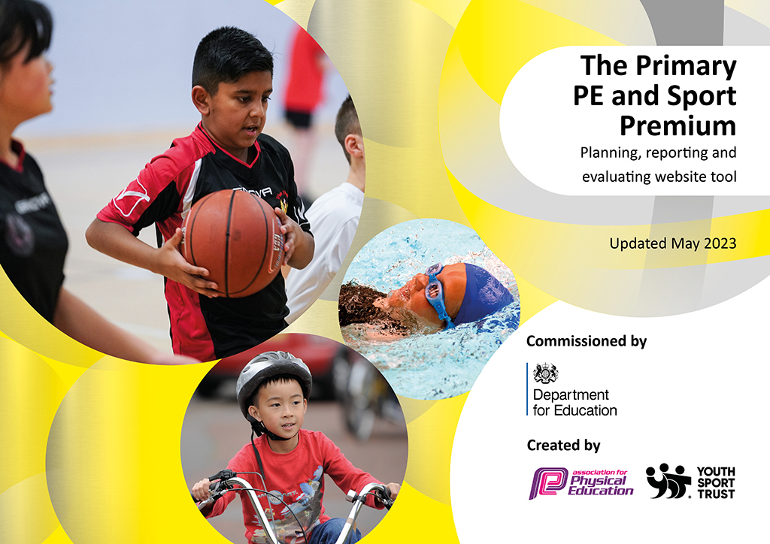
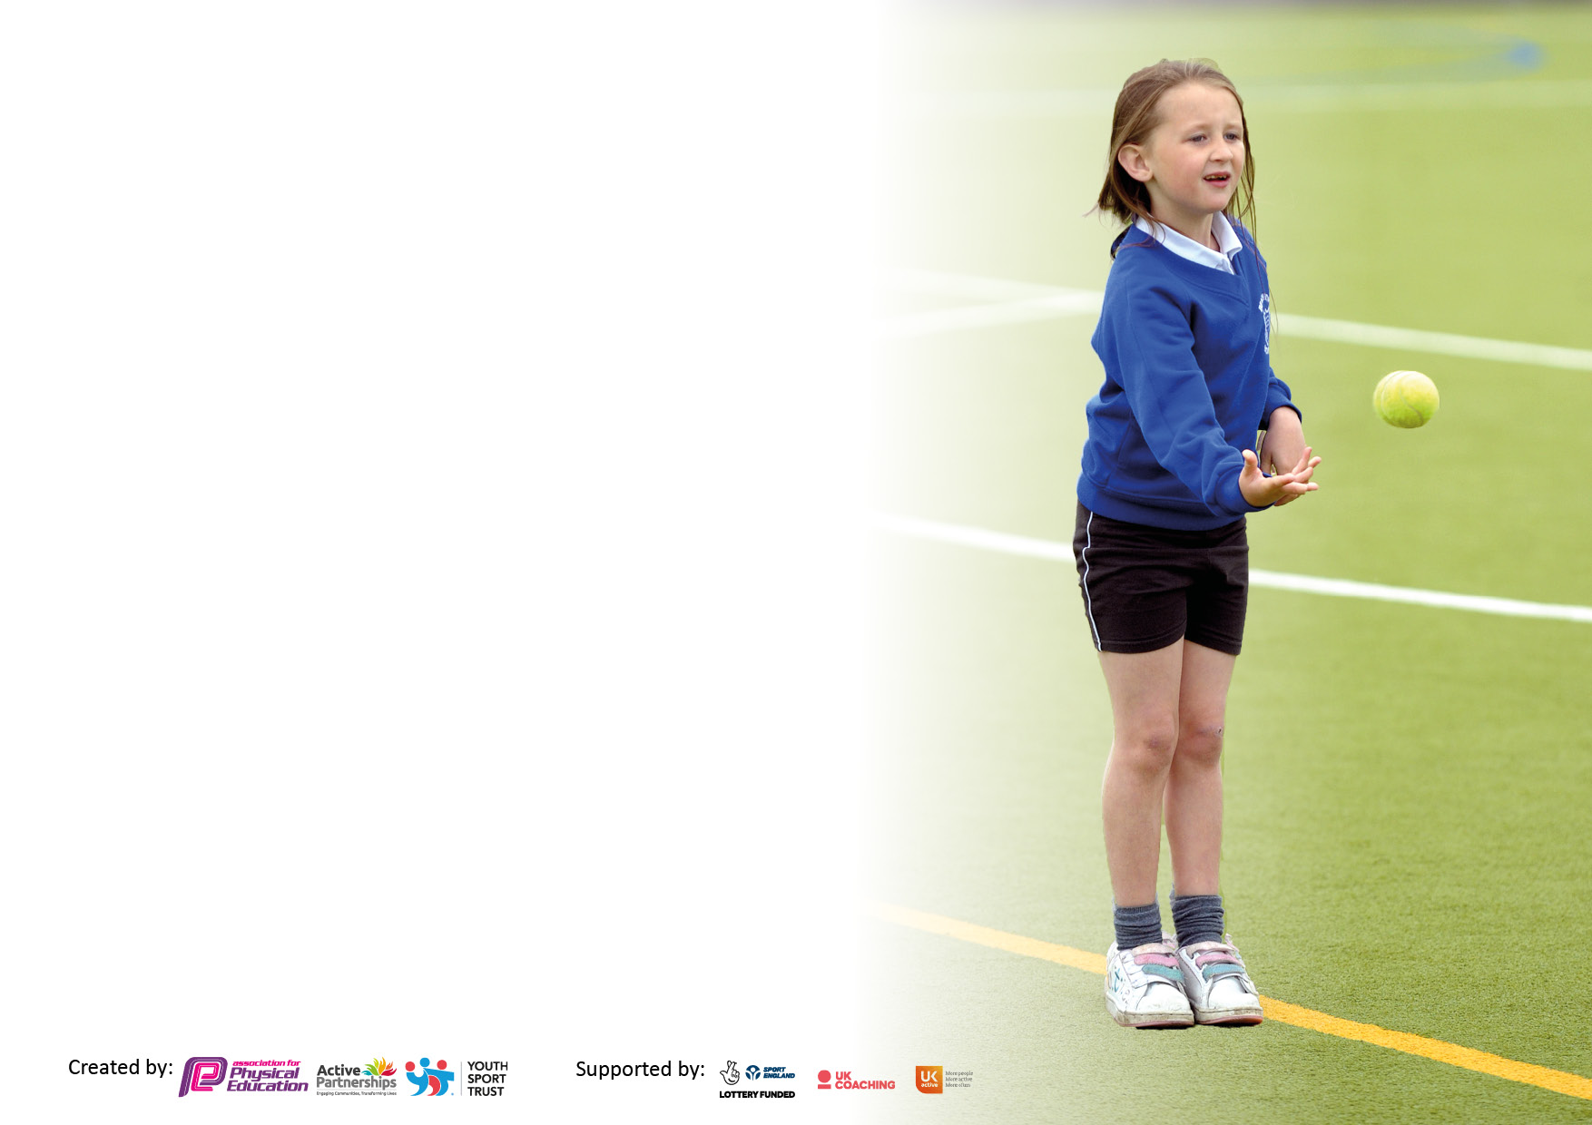

It is important that your grant is used effectively and based on school need. The Education Inspection Framework makes clear there will be a focus on ‘whether leaders and those responsible for governors all understand their respective roles and perform these in a way that enhances the effectiveness of the school’.

Under the Quality of Education Ofsted inspectors consider:
Intent - Curriculum design, coverage and appropriateness
Implementation - Curriculum delivery, Teaching (pedagogy) and Assessment
Impact - Attainment and progress

To assist schools with common transferable language this template has been developed to utilise the same three headings which should make your plans easily transferable between working documents.

Schools must use the funding to make additional and sustainable improvements to the quality of Physical Education, School Sport and Physical Activity (PESSPA) they offer. This means that you should use the Primary PE and sport premium to:

- Develop or add to the PESSPA activities that your school already offer
- Build capacity and capability within the school to ensure that improvements made now will benefit pupils joining the school in future years
- The Primary PE and sport premium should not be used to fund capital spend projects; the school’s budget should fund these.

Pleasevisitgov.ukfortherevisedDfEguidanceincludingthe5keyindicatorsacrosswhichschoolsshoulddemonstrate animprovement.Thisdocumentwillhelpyoutoreviewyourprovisionandtoreportyourspend.DfEencouragesschools to use this template as an effective way of meeting the reporting requirements of the Primary PE and Sport Premium.

We recommend you start by reflecting on the impact of current provision and reviewing the previous spend.

Schools are required to publish details of how they spend this funding, including any under-spend from 2021/2022, as well as on the impact it has on pupils’ PE and sport participation and attainment. All funding must be spent by 31st July 2023.

We recommend regularly updating the table and publishing it on your website throughout the year. This evidences your ongoing self-evaluation of how you are using the funding to secure maximum, sustainable impact. Final copy must be posted on your website by the end of the academic year and no later than the 31st July 2023. To see an example of how to complete the table please click HERE.

Details with regard to funding
Please complete the table below.

Total amount carried over from 2020/21 | £18000
Total amount allocated for 2021/22 | £36920
How much (if any) do you intend to carry over from this total fund into 2022/23? | £0
Total amount allocated for 2022/23 | £17760
Total amount of funding for 2022/23. To be spent and reported on by 31st July 2023. | £12489.20
Swimming Data
Please report on your Swimming Data below.

Meeting national curriculum requirements for swimming and water safety.

N.B. Complete this section to your best ability. For example you might have practised safe self-rescue techniques on dry land which you can then transfer to the pool when school swimming restarts.
Due to exceptional circumstances priority should be given to ensuring that pupils can perform safe self rescue even if they do not fully meet the first two requirements of the NC programme of study
What percentage of your current Year 6 cohort swim competently, confidently and proficiently over a distance of at least 25 metres?  N.B. Even though your pupils may swim in another year please report on their attainment on leaving primary school at the end of the summer term 2022.  Please see note above | %
What percentage of your current Year 6 cohort use a range of strokes effectively [for example, front crawl, backstroke and breaststroke]?  Please see note above | %
What percentage of your current Year 6 cohort perform safe self-rescue in different water-based situations? | %
Schools can choose to use the Primary PE and sport premium to provide additional provision for swimming but this must be for activity over and above the national curriculum requirements. Have you used it in this way? | Yes/No

Action Plan and Budget Tracking
Capture your intended annual spend against the 5 key indicators. Clarify the success criteria and evidence of impact that you intend to measure to evaluate for pupils today and for the future.

Academic Year: 2022/23 | Total fund allocated: £12489.20 | Date Updated: 21/07/2023
Key indicator 1: The engagement of all pupils in regular physical activity – Chief Medical Officers guidelines recommend that primary school pupils undertake at least 30 minutes of physical activity a day in school |  |  |  | Percentage of total allocation:
 |  |  |  | 62.67%
Intent | Implementation |  | Impact
Your school focus should be clear what you want the pupils to know and be able to do and about  what they need to learn and to  consolidate through practice: | Make sure your actions to achieve are linked to your intentions: | Funding allocated: £7826.70 | Evidence of impact: what do pupils now know and what can they now do? What has changed?: | Sustainability and suggested next steps:
Breakfast Club  Playtimes  Year 5 Sports Leaders  Athletics track and equipment  Walk to school initiative | Two dedicated supervisors to run breakfast club offering a healthy meal to start the day and physical activities before school starts.  Replace and purchase varied play equipment for the children to use during play times within the school day including lunch times.  Through our NELSSP partnership our year 5 children were taught how to lead and set up sports and games for younger children within school.  To allow children to practice athletics skills during play times and lunch times, a 60m running track and equipment for jumping events bought for use during these times.  National walk to school week promoted within school through posters and assemblies. | £5035.00  £500.00  £1650.00  £591.70  £50.00 | More pupils are engaged in coming to school.  More pupils are receiving healthy food before the start of the school day.  More pupils are engaging in physical activity before school.  More children able to use equipment at the same time during unstructured play times within the school day so more children are being active.  The year 5 children had more confidence to deliver games to younger children which allows for more structured physical activity to take place at the same time.  Children from every year group had the opportunity to practice skills learnt in P.E lessons during lunch and play times with enough equipment for more children to be involved.  Continued amount of children either walking, scooting or cycling to school. | To review and purchase new equipment and plan a timetable for allocated times for more structured physical activity to take place on a rotation.  To assess the quality and safety of equipment to see what needs replacing and to assess what new equipment could be bought to give children more of a range of activities to be able to do independently or in a group.  The year 5 children will be moving into year 6 so will be able to run the games during lunch times and can train the new year 5 children to be able to lead and run games to younger children.  To assess equipment needed to run more athletics clubs for jumping and throwing next summer.  To look at how walking, scooting and cycling to school can be prompted throughout the year.
Key indicator 2: The profile of PESSPA being raised across the school as a tool for whole school improvement |  |  |  | Percentage of total allocation:
 |  |  |  | 0%
Intent | Implementation |  | Impact
Your school focus should be clear what you want the pupils to know and be able to do and about  what they need to learn and to  consolidate through practice: | Make sure your actions to achieve are linked to your intentions: | Funding allocated: £0.00 | Evidence of impact: what do pupils now know and what can they now do? What has changed?: | Sustainability and suggested next steps:

Key indicator 3: Increased confidence, knowledge and skills of all staff in teaching PE and sport |  |  |  | Percentage of total allocation:
 |  |  |  | 41.14%
Intent | Implementation |  | Impact
Your school focus should be clear | Make sure your actions to | Funding | Evidence of impact: what do | Sustainability and suggested
what you want the pupils to know | achieve are linked to your | allocated: £5137.50 | pupils now know and what | next steps:
and be able to do and about | intentions: |  | can they now do? What has
what they need to learn and to |  |  | changed?:
consolidate through practice:
NELSSP Partnership  Gymnastics CPD for teaching staff.  Dance CPD for teaching staff. | From the partnership we received a curriculum day from an expert physical education leader who worked with the P.E lead to assess our curriculum and physical activity offer in school.  CPD from quality coaches to run a sequence of gymnastics sessions in line with our sports scheme of learning to allow staff to see the progression within lessons and to gain confidence around the modelling of actions and vocabulary from experts.  CPD from quality coaches to run a sequence of gymnastics sessions in line with our sports scheme of learning to allow staff to see the progression within lessons and to gain confidence around the modelling of actions and vocabulary from experts. | £1650.00  £1743.75  £1743.75 | P.E lead was able to create a new long term P.E plan for next year with increased confidence in creating a sequence of progression throughout the school as well as develop the physical activity offer we already have in school and to plan what the next steps will be.  Children absolutely loved receiving quality teaching from coaches and more students from each year group (especially boys) were more engaged than the previous year.  Children absolutely loved receiving quality teaching from coaches and more students from each year group (especially boys) were more engaged than the previous year. | P.E lead will be able to disseminate information to the rest of school staff and explain in more clarity where physical education is heading in school and what the plan, expectations and goals are ready to start in September.  P.E lead will conduct a staff voice survey to assess the effectiveness in developing confidence in the teaching of gymnastics or whether more CPD is needed with new staff joining.  P.E lead will conduct a staff voice survey to assess the effectiveness in developing confidence in the teaching of gymnastics or whether more CPD is needed with new staff joining.
Key indicator 4: Broader experience of a range of sports and activities offered to all pupils |  |  |  | Percentage of total allocation:
 |  |  |  | 8.73%
Intent | Implementation |  | Impact
Your school focus should be clear | Make sure your actions to | Funding | Evidence of impact: what do | Sustainability and suggested
what you want the pupils to know | achieve are linked to your | allocated: £1090.00 | pupils now know and what | next steps:
and be able to do and about | intentions: |  | can they now do? What has
what they need to learn and to |  |  | changed?:
consolidate through practice:
Football Club for year 5 and 6 boys and girls.  Girls only football club.  Swimming | After school football club run by an expert coach.  Two dedicated members of staff who are qualified for sports coaching to run a girls only football club during lunch time during the week for a half term.  Swimming lessons offered to Year 4 pupils at a local swimming pool. | £950.00  £140.00  £0.00 | Huge response and engagement from year 5 and 6 boys with a big waiting list. Year 5 and 6 girls that joined went on to join or sign for clubs outside of school.  More opportunities given to girls within different year groups to experience and try out football.  Year 4 children to experience and begin to learn how to swim as well as water safetly. | The club will be set up with new members for next year and run exactly the same with the hope for more competitive games between schools organized.  Review the staff able to run this club again and get a timetable set up to start in September.

Key indicator 5: Increased participation in competitive sport |  |  |  | Percentage of total allocation:
 |  |  |  | 0.68%
Intent | Implementation |  | Impact
Your school focus should be clear | Make sure your actions to | Funding | Evidence of impact: what do | Sustainability and suggested
what you want the pupils to know | achieve are linked to your | allocated: £85.00 | pupils now know and what | next steps:
and be able to do and about | intentions: |  | can they now do? What has
what they need to learn and to |  |  | changed?:
consolidate through practice:
Let Girls Play | We took part in the biggest event ever held before to engage and give as many girls as possible the opportunity to take part and join in with football. | £85.00 | Football was offered to year groups not previously offered to before to engage and experience football. | Look to offer more girls only football clubs for other year groups within school for next year.

Signed off by
Head Teacher: | S E Clapson
Date: | 21/07/2023
Subject Leader: | Mr O Walmsley
Date: | 21.7.23
Governor:
Date:

