Knowledge and understanding | Foundation – All About Me! | The Curriculum
History: We will talk about our families and past special events in our lives such as birthdays and future events such as what we want to be when we grow up. We will look at photographs from when we were babies and discuss similarities, differences, and changes over time. As a part of our daily routine, we will think about what day it was yesterday, what day it is today and what day it will be tomorrow.  As scientist we will be learning about…  We will learn about the changes in weather and seasonal features in the natural world around us through outdoor play, discussion, and books. We will go on an Autumn Welly Walk with our families to identify these features in our local community. We will also learn through Autumnal resources in our continuous provision. | Reading and writing outcomes  We will be…  - Learning GPCs, the formation of graphemes, blending for reading, and segmenting for writing in line with the Little Wandle Phonics Scheme.  - We will begin 3 weekly Reading Squad sessions matched to each child’s individual stage of progression in phonics.  - We will share fiction and nonfiction books related to the All About Me theme and show an interest in stories with repeated refrains.  - We will begin to understand the key concepts of print, engage in conversation about books and learn new vocabulary.  - We will be able to recognize and read our names in a self-registration activity.  - We will promote pre-writing skills through such activities as Dough Disco.  - We will begin to write our names, initial sounds for words and some CVC words.  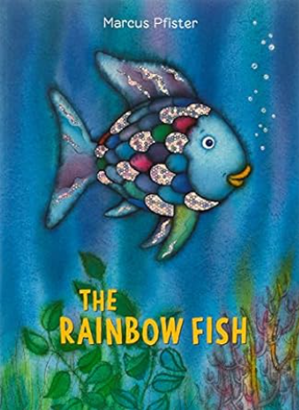  - We will participate in National Poetry Week to enjoy listening to and joining in with rhymes and learning new vocabulary.  - We will engage in Nursery Rhyme Challenge each week to promote language, vocabulary, and literacy development.  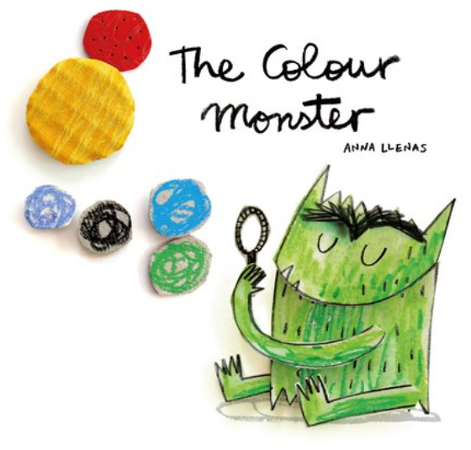  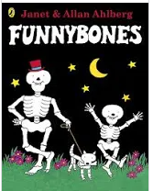  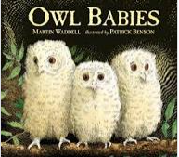  Maths  Match pictures and objects.  Identify a set.  Sort objects to a type.  Explore sorting techniques.  Create sorting rules.  Compare size, mass, capacity.  Explore, copy, continue and create simple patterns.  Find, subitise and represent 1,2 and 3.  1 more, 1 less.  Composition of 1,2 and 3.  Writing numerals.  Days of the week, seasons •Sequence daily events | P.E: Gymnastics  This half term we will be learning different ways of travelling across benches and mats. We will be able to demonstrate basic balances using patches and points. We will demonstrate a variety of jumping patterns and be able to perform some basic gymnastic rolls.  RE: Harvest Festival  Theme: Special People  Key Question: What makes people special?  Religions: Christianity, Judaism  PSHE: Black History Month  Jigsaw – Being Me in My World  - Help others to feel welcome  - Try to make our classroom community a better place  - Think about everyone’s right to learn  - Care about other people’s feelings  - Work well with others  MFL: Language Angels: We will learn greetings and to sing Twinkle Twinkle Little Star in Spanish via colourful and immersive lessons.  DT: This term we will experience the use of basic tools and different methods of joining through large-scale junk modelling. We will also construct using wooden blocks, crates, bricks, and wooden planks to build.  Music- Music Express- 'A sky full of colour'. We will introduce warmups and skills around BEAT using our bodies and percussion.  Art:- AccessArt- Self Portrait Photography- Firstly, we will look at self-portraits by different artists. Following this we will show and discuss a precious item brought from home, then we will have our photograph taken with our precious item whilst holding a big photo frame. Once the photograph is printed in black and white, we will make our precious item stand out with the use of colour and texture.
Parental Involvement- This term we will be going on an Autumn Welly Walk with our families, hosting a Halloween themed Stay and Play and we will be inviting parents to a consultation to discuss their child’s progress.

Fabulous Fifty-
- Nature Welly Walk.
- Receive a letter in the post.
- Make a phone to our family.

Visitis and Visitors- Autumn Welly Walk and visit from a nurse.

