Knowledge and understanding | Foundation – All About Me. | The Curriculum – Threshold Concepts
As Historians we will..  All about me helps me to understand the people who are important to me, events that are special to me and people who might help at special events. Words I might use are; past, present, future, family, friends, community, relative, event, order.  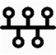  As scientist we will..  To be able to identify different parts of their body.  Have some understanding of healthy food and the need for variety in their diets  To be able to show care and concern for living things  Know the effects exercise has on their bodies  Have some understanding of growth and change  Can talk about things they have observed including animals | 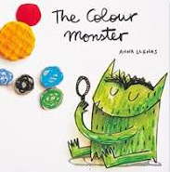  Reading and writing outcomes  Joining in with rhymes and showing an interest in stories with repeated refrains. Environment print. Having a favourite story/rhyme. Understand the five key concepts about print: - print has meaning - print can have different purposes - we read English text from left to right and from top to bottom - the names of the different parts of a book  Sequencing familiar stories through the use of pictures to tell the story. Recognising initial sounds. Name writing activities. Engage in extended conversations about stories, learning new vocabulary.  Dominant hand, tripod grip, mark making, giving meaning to marks and labelling. Shopping lists,  Writing initial sounds and simple captions.  Use initial sounds to label characters / images. Silly soup. Names Labels. Captions Lists Diagrams Messages – Create a Message centre!  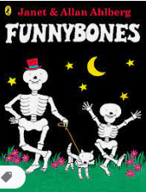  Link Reading:  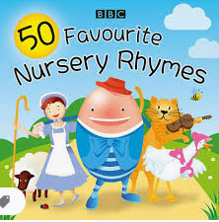  (Narrative)  (rhyme)  Maths – White Rose – Recognize, describe, copy and extend colour and size patterns. Count and represent the numbers 1 to 3. Estimate and check by counting. Recognize numbers in the environment. A number a week. | P.E: Agility, Space and Movements  Pupils will explore awareness for themselves and of others. They will develop basic skills of moving with control, coordination and imagination. Pupils will travel using different movements and directions. They will also explore different jumping movement skills.  RE: Theme: Special People  Key Question: What makes people special?  Religions: Christianity, Judaism  PSHE: Jigsaw Being Me In My World.  Music: Music Express- Who shall I be Today?  MFL: Incorporated in registration time
The Curriculum: Access Art
Understanding Identity and Exploring Relationships
In this area of focus, children are introduced to resources to help explore who they are, and how they might connect to those around them.

