Knowledge and understanding | Foundation – Traditional Tales | The Curriculum
History:  This term we will discuss Bonfire Night and contrast how it is celebrated today compared to events in the past. We will remember soldiers from the past and discuss their bravery on Remembrance Day. We will read Traditional Tales and sing nursery rhymes to compare vocabulary, language and characters from the past compared to today. As a part of our daily routine, we will think about what day it was yesterday, what day it is today and what day it will be tomorrow.  As scientist we will be learning about…  This term we will observe differences between light and darkness. We will make observations about animals in the natural world (hibernation and habitats). We will begin to understand that geographical features can be represented as maps and discuss features of our local environment. We will learn about the changes in weather and seasonal features in the natural world around us through outdoor play, discussion, and books. | 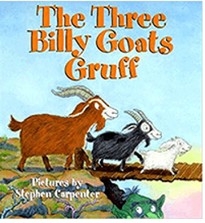  Reading and writing outcomes  - We will learn new GPCs and the formation of graphemes, spot digraphs in words, blend for reading, and segment for writing in line with the Little Wandle Phonics scheme. For exception words such as ‘the’ and ‘said’, we will identify the sound that is tricky to spell.  - We will engage in 3 weekly Reading Squad sessions matched to each child’s individual stage of progression in phonics.  - We will know that print is read from left to right and know how to touch with our finger as we say each sound as we read.  - We will share fiction and nonfiction books related to the Traditional Tales theme and retell stories through role play.  - We will engage in conversation about books and learn new vocabulary.  - We will be able to recognize our name in a self-registration activity.  - We will promote pre-writing skills through such activities as Dough Disco.  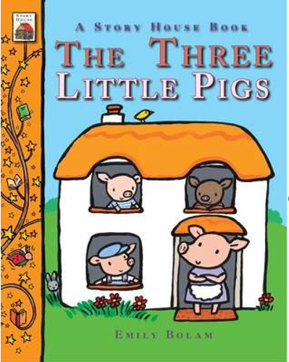  - We will begin to write our names, initial sounds for words and some CVC words.  - We will engage in Nursery Rhyme Challenge each week to promote language, vocabulary, and literacy development.  - We will write Christmas letters/lists and post them in the post box.  - We will sequence a story – using the vocabulary beginning, middle and end.  Maths  Identify, name and compare circles and triangles  Shapes in the environment  Describe position  Find, subitise and represent 4 and 5  1 more and 1 less  Identify, name and combine shapes with 4 sides  Shapes in the environment  My day and night  Writing numerals 0-10  Days of the week, Seasons. Sequence daily events | P.E: Catching and Throwing  This term we will be using both underarm and overarm throws with some accuracy when using a beanbag or tennis ball. We will practice rolling, throwing, and stopping circular equipment. We will begin to be able to catch a moving ball.  RE:  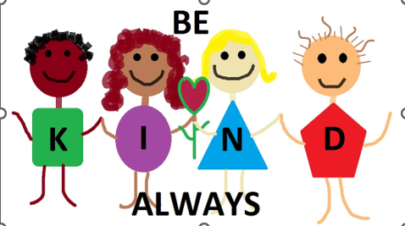  Theme: Christmas  Key Question: What is Christmas?  Religions: Christianity  PSHE:  Jigsaw- Celebrating Difference  - Accept that everyone is different  - Include others when working and playing  - Know how to help if someone is being bullied  - Try to solve problems  - Use kind words  - Know how to give and receive compliments  MFL: Language Angels: We will learn greetings, how to say 10 common colours and count from 1-10 in Spanish.  Art:- In Art this term, we will experiment with colour mixing, finger painting and printing to create a piece of group artwork for Remembrance Day. We will also create texture using a fork to give effect when creating a Christmas tree for a Christmas card. We will explore, use and refine a variety of artistic effects to express our ideas and feelings.  DT: As a part of our Traditional Tales theme this term, we will design and build castle models, use different textures and materials to make houses for the Three Little Pigs and build bridges for the Three Billy Goats. In doing so, we will develop our fine motor skills so that we can begin to use a range of tools competently, safely, and confidently. We will create collaboratively, sharing ideas, resources and skills.  Music:.- This term in music we will listen carefully to and learn songs, (paying attention to how they sound) in preparation for our Christmas nativity performance. We will sing in a group, increasingly matching the pitch and following the melody. We will explore music making with claves and listen carefully to match the beat, returning to and building upon previous learning of instruments. We will combine different movements and dance to music as a part of our performance.
Parental Involvement- This term we will be going on a walk to the local garden centre with our families to visit Father Christmas. We will be hosting a Christmas themed Stay and Play and we will be inviting parents to watch the children perform their nativity performance.

Fabulous Fifty-
- Post a letter in a post box.
- Perform on a stage.
- Watch a pantomime.

Visitis and Visitors- Walk to local garden centre and a visit from an author.

