Knowledge and understanding | Foundation – Amazing Animals | The Curriculum – Threshold Concepts
Geography:  During our learning about Amazing animals we will practice the following:  Key skills  Communicate geographically  Use simple locational and directional language (E.g. near and far, left and right) to describe the location of features.  Enquire geographically  Ask and answer geographical questions (e.g. What is this place like? What do people do in this place?)  Mapping  Use world maps, atlases and globes to identify the UK.  Use world maps, atlases and globes to identify the UK.  Use aerial photographs and plan perspectives to recognise landmarks and basic human and physical features.  Location  (Space)  Name, locate and identify England and London and its surrounding seas.  Name, locate and identify Africa and name some of its countries  Name and locate Europe  Place  Identify the key features of a city  Physical processes  Identify the weather daily and the seasons.  To identify key physical features including: Beach, coast, mountain and river  As scientist we will be learning about…  Animals including humans. During this will learn:  - To identify different parts of our body.  - Have some understanding of healthy food and the need for variety in our diets.  - Be able to show care and concern for living things.  - Know the effects exercise has on our bodies.  - Have some understanding of growth and change.  - To be able to talk about things they have observed including animals | 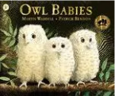  Reading and writing outcomes  During this half term we will be learning all about stories with animal characters and be making up stories with themselves as the main character.  We will practice reading simple phrases and sentences made up of words with known letter–sound correspondences and, where necessary, a few exception words.  During our literacy lessons we will practise writing some of the tricky words such as I, me, my, like, to, the as well as CVC words, Labels using CVC, CVCC, CCVC words.  We will also do some guided writing based around developing short sentences linked to the stories we read.  We will make our own story boards.  We will make our own mini-beast fact files.  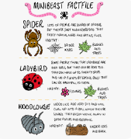  Link Reading:  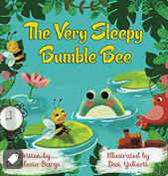  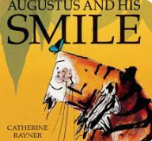  Maths  Numbers within 10  Count up to ten objects •Represent, order and explore numbers to ten •One more or fewer, one greater or less  Addition and subtraction within 10  Explore addition as counting on and subtraction as taking away | P.E: Dance- Mini-beasts  This half term we will practice creating shapes and patterns within a group, travelling in spaces, using arm movements to form shapes, practice using mirroring and symmetry and then choreographing our own ‘mini-beast’ dance.  RE: Theme: Celebrations  How do people celebrate? Religion: Hinduism.  PSHE: Jigsaw- Dreams and goals  Circle time themes  Good to be me Feelings  Learning about qualities and differences  Celebrating differences  Identify and moderate their own feelings socially and emotionally.  Encourage them to think about their own feelings and those of others by giving explicit examples of how others might feel  Music: Music Express- 'Amazing African Animals'.  MFL: Greetings during morning and afternoon register.  DT: Use different junk modelling resources to make instruments.
Art: Painting the Savannah
During this half term we practise a range of skills including drawing and colour mixing. We will also develop our fine motor skills through physical sessions.
During this we will work collaboratively to make backgrounds for our artwork and then individually to create animals to college onto paper.

