Knowledge and understanding | Foundation – Ticket to Ride | The Curriculum
History:    In history, we will explore images from the past through stories to compare past and present vehicles, previous journeys and the mood landing. We will find out information about past/present vehicles and historical events from different sources e.g. internet, books. We will also have discussions around where children have been in the world in the past and talk about places they have previously visited with school.  Science:  In Science, we will explore seasons through stories, videos and books. We will make a record of the weather in a weather chart.  Parental Involvement  This half term we will host a Valentine’s themed stay and play for the parents. We will also invite the parents to a stay and read with your child morning for Mental Health Week.    Fabulous Fifty-  - Food tasting – different cultures.    - Speak to someone from another country.  - Go on a bus!  Visits and Visitors-  - Visit from a transport driver.  - Go on a bus ride. | Reading and writing outcomes:  During this half term, we will share our favourite books and say what we like or dislike about the story. When listening to a story, we will use the images to help us read. We will display our increasing confidence with our understanding of new words in stories and we will be able to use a book’s front cover or blurb to make a prediction about the story.  During Phonics, we will say the corresponding phonemes to match graphemes shown and use these skills at guided reading time. We will recognise digraphs and read the two graphemes as one phoneme. We will be encouraged to segment and then blend the sounds together in both phonics lessons, literacy lessons and guided reading time. We will be introduced to new tricky words and learn the tricky parts of the word. We will recognise that double letters make one sound, and we will be able to use the ‘chunk it’ method to blend and segment longer words.  We will be becoming more independent at orally sounding out and writing VC and CVC words. We will begin to show a dominant hand and form more recognisable letters.  We will continue to use Greg Bottrill’s Drawing Club to allow the children to get creative and use their imagination to develop a love of story telling and adventure. We will focus on a book a week and use this as a focus to amplify the children’s language, writing and mathematics development.  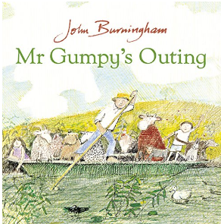  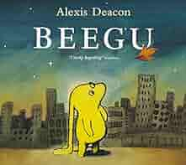  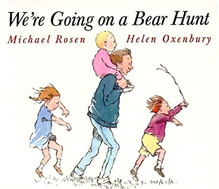  Maths  Alive in 5  Introduce zero/Find, subitise and represent 0-5/One more or fewer, one greater or less/Composition/Conceptual subitizing to 5.  Mass and Capacity  Compare mass/Find a balance/Explore and compare capacity.  Growing 6,7,8  Find, represent and composition of 6,7,8/One more or less/Odd and even/Double to 8/Combine 2 groups/Conceptual subitizing.  Length, Height and Time  Explore and compare length/Explore and compare height/Talk about, order and sequence time | P.E.: Striver: Dance (Minibeasts)  In P.E., we will engage in a unit of dance based on the theme of minibeasts. We will use movement to express ourselves and understand how different music can make people move in different ways.  RE: NATRE: Theme: Being special: Where do we belong?  In R.E., we will focus on Christianity, Hindu Dharma, and Islam. We will also reflect upon the things that are special to us and why we value these things.  PSHE: Jigsaw: Dreams and Goals  - Setting goals  - Identifying successes and achievements  - Learning styles  - Working well and celebrating achievement with a partner  - Tackling new challenges  - Identifying and overcoming obstacles  - Feelings of success  Music: Music Express- Beyond the Stars/Busy City  In music, we will explore musical instruments, including body percussions, and play the instruments in time and in a simple composition.  MFL: Language Angels  In MFL, we will learn how to recognise, recall, and remember up to 7 modes of transport in Spanish.  DT: DT Association- Let’s Look at Vehicles: Transporting Aliens  In D.T., we will understand the purpose of different materials, for e.g., material needed to make a vehicle. We will continue to develop our understanding of transient art and further develop our scissors skills to cut curved lines.  Art: Access Art: Angry Cat/Calm Cat  In Art this half term, we will show different emotions in our drawing e.g. happiness, sadness. We will draw with increasing complexity and detail, such as representing a face with a circle, including details. We will create a wash background and combine colour, whilst exploring different paint types - watercolour, powder paint, acrylic, ready mix paint. We will also print with sponges and rollers, shapes.

