Knowledge and understanding | Foundation –Come Outside | The Curriculum – Threshold Concepts
Geography:  Through our learning about ‘Come Outside’ we will ask and answer geographical questions (e.g. What is this place like? What do people do in this place?). We will use aerial photographs to recognise landmarks and basic human and physical features including beach, coast, mountain, river, and countryside. We will also identify the weather daily and the season.  As scientist we will be learning about: Living things:  - Exploring the life cycle of frogs, butterflies, and birds.  - Taking care of plants and living creatures in our environment.  - Planting a seed and watching it grow.  - Global warming and the impact on polar regions.  - Comparing and contrasting food produce/grown in different climates around the world.  - Multiple STEM activities including sinking and floating.  - The seasons and looking at what Spring means in our country.  Parental Involvement  This half term we will host an Easter themed stay and play for the parents to attend. We will invite the parents to join us for a trip to the local Garden Centre and also a ‘Signs of Spring’ nature walk. We will also hold a parents evening for the parents this term.  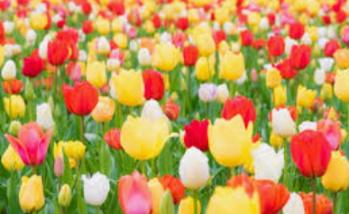  Fabulous Fifty-  • Plant it, grow it, eat it.  - Produce some wild art.  - Go on a nature walk.  Visits and Visitors-  • Visit to local Garden Centre.  - Visit from a gardener.  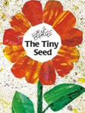 | 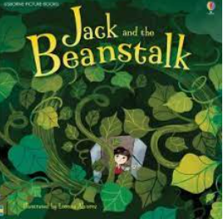  Reading and writing outcomes  During this half term, we will use vocabulary from the text of books related to our ‘Come Outside’ theme to retell familiar stories and narratives and sequence the main events from a familiar story whilst making sensible and appropriate predictions.  We will say the correct phonemes for known graphemes and record these with some accuracy. We will blend simple words with increasing independence and accuracy as well as longer words with two or more digraphs. We will understand that words form phrases/simple captions and sentences and begin to read these aloud. We will review the tricky words we have learnt so far and secure the spellings of these words.  We will continue Greg Bottrill’s Drawing Club to allow the children to get creative and use their imagination to develop a love of storytelling and adventure. We will focus on a book a week linked to our ‘Come Outside’ theme and use this as a focus to amplify the children’s vocabulary, writing and mathematics development.  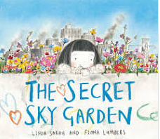  Maths  Number  Comparison  Count objects, actions and sounds. Compare numbers.  Cardinality  Subitise. Link the number symbol (numeral) with its cardinal number value.  Composition  Understand the ‘one more than/one less than’ relationship between consecutive numbers. Explore the composition of numbers to 10. Automatically recall number bonds for numbers 0-5 and some to 10.  Space, Shape & Measure  Spatial Awareness  Select, rotate, and manipulate shapes in order to develop spatial reasoning skills.  Shape  Compose and decompose shapes so that children recognise a shape can have other shapes within it, just as numbers can.  Pattern  Continue, copy, and create repeating patterns. | P.E: This half term we will practice our ball skills. We will learn how to move with confidence in different ways, whilst holding an object. We will also develop a range of different ball skills including bouncing and perform underarm and overarm throwing actions.  RE: Theme: Celebrations  How do people celebrate? Religion: Hinduism.  PSHE: Jigsaw- Healthy me  Circle time themes.  Relationships  What makes a good friend?  Healthy me  Random acts of Kindness  Looking After our Planet  Give children strategies for staying calm in the face of frustration.  Music: Music Express- 'Our growing world’.  MFL: Greetings- In this unit we will learn the vocabulary for basic greetings in Spanish.  DT: Let’s Get Practical- Food Skills. We will create a salad using the skills we learn to cut food.  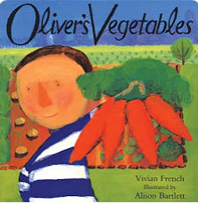  Art- Transforming natural objects- We will have the opportunity to transform natural objects from the outdoors with paint and pattern.

