Knowledge and understanding | Foundation –Come Outside | The Curriculum – Threshold Concepts
Geography:  During our learning about Come Outside we will practice the following:  Key skills  Enquire geographically  Ask and answer geographical questions (e.g. What is this place like? What do people do in this place?)  Mapping  Use aerial photographs and plan perspectives to recognise landmarks and basic human and physical features.  Place  Identify the key features of a the countryside  Physical processes  Identify the weather daily and the seasons.  To identify key physical features including: Beach, coast, mountain and river  As scientist we will be learning about…  Living things: Plants  . During this will learn:  - What plants need to grow  - The lifecycle of seed  - Introduce an element of fair testing  - Different types of plants and trees  We will also discuss the seasons and look at what Spring means in our country. This will end with a visit to the farm to see the baby animals who have been born.  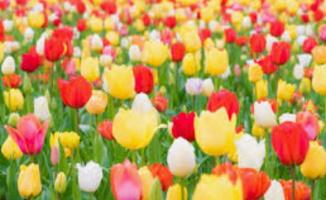 | 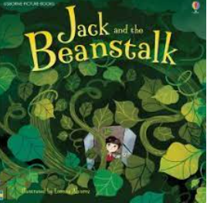  Reading and writing outcomes  During this half term we will be writing Information leaflets about animals in the garden/plants and growing.  We also apply our writing skills by writing a timeline of how plants grow.  We will also retell the story of Jack and the Beanstalk and use this to make story maps. We will use this to look at story structure-beginning, middle, end and will be innovating and retelling stories to an audience.  We will be looking at writing 2 sentences independently using our phonic skills.  We will be learning our phase 3 and phase 5 sounds and practise reading some longer words made up of letter-sound correspondences they know: ‘rabbit’, ‘himself’, ‘jumping’.  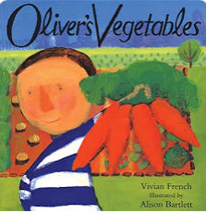  Link Reading:  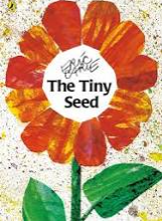  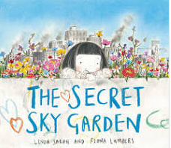  Maths  Counting and sharing in equal groups •Grouping into fives and tens •Relationship between grouping and sharing  Count up to 10 objects •Represent, order and explore numbers to 15.  One more or fewer  Doubling and halving & the relationship between them | P.E:  This half term we will practice our ball skills. We will learn how to move with confidence in different ways, whilst holding an object. We will also develop a range of different ball skills including bouncing and perform underarm and overarm throwing actions.  RE: Theme: Celebrations  How do people celebrate? Religion: Hinduism.  PSHE: Jigsaw- Healthy me  Circle time themes  Relationships  What makes a good friend?  Healthy me  Random acts of Kindness  Looking After our Planet  Give children strategies for staying calm in the face of frustration  Music: Music Express- 'Our growing world’  MFL: Greetings during morning and afternoon register.  DT: Preparing fruit and vegetables ready for our picnic at the farm.
Art: One Colour

During this half term we looking at a unit called One Colour. This involves a playful exploration of colour, how it makes us feel and how it feeds into other senses.
• Encourages playful exploration
• Helps children explore sensory perception
• Promotes teachers & children to create their own learning pathways
. Explores colour as a medium beyond paint.

