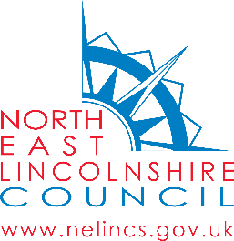
September 2021

Dear Parent/Carer

Flu Vaccination – Online Consent Form

During September - December the School Nursing Service will be offering your child the influenza vaccination in school. This vaccination is recommended to help protect your child against flu. Flu can be an unpleasant illness and can cause serious complications. Vaccinating your child will also help protect more vulnerable family and friends by preventing the spread of flu. With COVID-19 still in circulation it is important to reduce the number of those becoming ill with flu this winter to help protect them, the NHS and social care.

The vaccination is free and is a quick, simple and painless spray up the nose. If your child has not had the vaccine before and you require more information, please visit Child flu vaccine - NHS (www.nhs.uk)

To consent to your child receiving the vaccination click or search the link below:

www.nelincs.gov.uk/flu

YOU NEED TO COMPLETE THIS BY 28TH SEPTEMBER
If your child becomes wheezy, has a bad attack of asthma, or has started oral steroids for their asthma after you return this form, please contact us.

To find out when your childs school session will take place, please visit School age immunisations - NELC | NELC (nelincs.gov.uk)

If you have any queries, email the service on schoolnursingadvice@nelincs.gov.uk or phone 01472 323660.

Yours sincerely

Leisa Gaskell
Immunisation Coordinator

Please tell us if you need us to communicate with you in a different format, for example if you find it hard to read our letters or if you need someone to support you at appointments.

