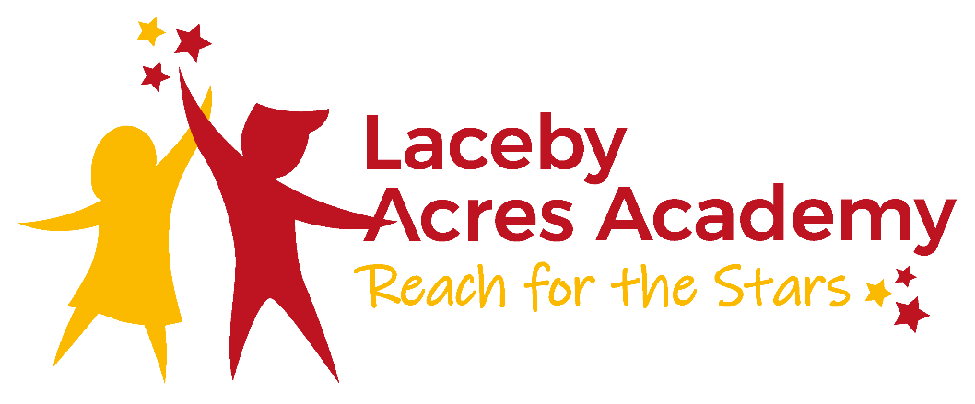

A Graduated Response (Cognition and Learning) 2021-2022
Cycle 1: Classroom Based
- Child causes concerns due to poor progress (if in Year One, continue with FS targets)
- Collaborate with parents
- Assess – class teacher to discuss with the support staff
- Plan – Quality First Teaching/differentiation/in-class and home support
- Do
- Review – including a discussion with parents
- Collaborate with parents

Cycle 2: SENCO involved
- Continued concern over lack of progress
- Assess – teacher to seek support from SENCO, include the parents and the child
- Plan – Quality First Teaching/differentiation/interventions/provision map
- Do
- Review – what further interventions may be required, include parents
- Collaborate with parents

Cycle 3: Support Services/Agencies Involved
- Continued lack of progress – involve advisory teacher
- Assess (AT)
- Collaborate with parents (AT)
- Plan – personalised programme
- Do – follow service guidance
- Review
- Collaborate with parents

Cycle 4: EP or other relevant Special Service Involved
- Continued lack of progress
- Collaborate with parents (EP)
- Assess (EP)
- Plan – personalised programme/Quality First Teaching
- Do – follow EP guidance
- Review
- Collaborate with parents

Cycle 5: Consideration to EHCAR
- Continued lack of progress
- Meeting with parents, school and agencies
- Begin EHCAR, if appropriate
- Collaboration between parents, school and agencies
- Submit EHCAR with evidence/reports from above process

