Characteristics of Computing

- Competence in coding for a variety of practical and inventive purposes, including the application of ideas within other subjects.
- The ability to connect with others safely and respectfully, understanding the need to act within the law and with moral and ethical integrity.
- An understanding of the connected nature of devices.
- The ability to communicate ideas well by using applications and devices throughout the curriculum.
- The ability to collect, organise and manipulate data effectively.

ICT Intent and Implementation
🔩
🏹

Intent
At the Laceby Acres we believe that our students should have the opportunity to follow an IT and Computing curriculum that prepares them for life in modern Britain and take advantage of opportunity this can offer them in both Britain and the wider world. Good quality IT skills enable student to engage positively within the modern work place, while Computer Science skills enable students to take an active part in the design, development and creation of new technologies to be used in the world in which they live.
In line with the 2014 National Curriculum for Computing, our aim is to provide a high-quality computing education, which equips children to use computational thinking and creativity to understand and change the world. The curriculum will teach children key knowledge about how computers and computer systems work, and how they are designed and programmed. Learners will have the opportunity to gain an understanding of computational systems of all kinds, whether or not they include computers.
It is our intention to enable children to find, explore, analyse, exchange and present information in a safe, responsible and respectful manner. We also focus on developing the skills necessary for children to be able to use information in a discriminating and effective way. Our computing curriculum enables children to develop their problem solving and reasoning abilities. It enables children to understand and apply the essential principles and concepts of Computer Science, including logic, algorithms and data representation, analyse problems in computational term, and have repeated practical experience of writing computer programs in order to solve such problems.

Computing Intent and Implementation
🔩
🏹
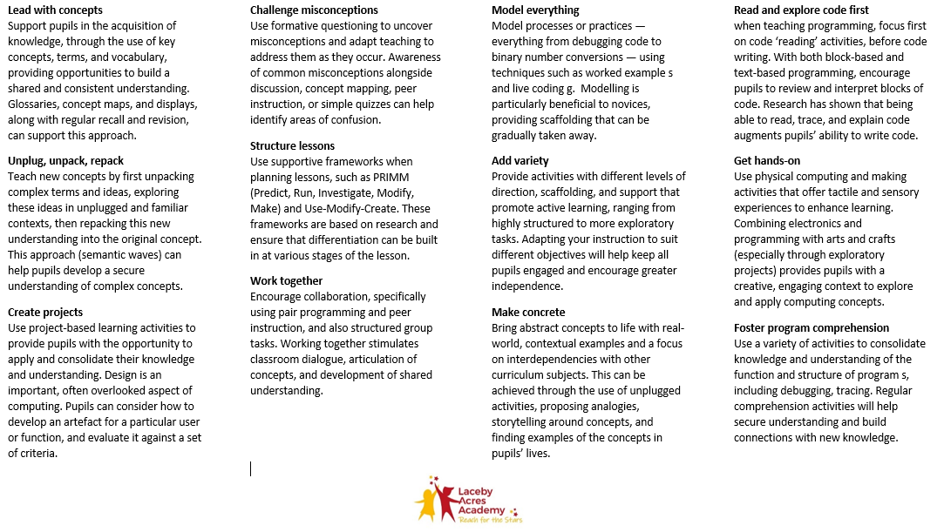
Implementation How we teach computing is underpinned by our 12 principles of Computing Pedagogy (NCCE)

