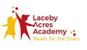
Curriculum Statement for Writing.

“You don’t write because you want to say something, you write because you have something to say.” – F. Scott Fitzgerald.

Intent (Our Aim).
At Laceby Acres, we want our children to be confident cohesive writers who have a great attitude towards writing. We want to give them the skills and tools necessary to develop into young writers in which they can express themselves and communicate their view points in any subject across the curriculum. We also set high standards and expectations of our children and their writing, supporting and challenging them to create the very best piece of writing they can. In our writing process we give children time to explore and engage with our stimulus text before time to craft, construct, draft and edit their writing. We want to give children valuable input and feedback to their writing through editing and entering into deep and meaningful conversations about why changes need to be made to push children’s understanding of how to use the English language.
There are strong links between reading and writing and we want to entwine both elements into our English curriculum using a reading to writing approach using a high quality text and supporting texts as the driver. By engaging with high quality texts we want to broaden and enrich our children’s language acquisition, spoken language and depth of vocabulary from when they begin in our school up to when they leave. We want children to see writing as a combination of English elements such as handwriting, spelling and grammar and become secure and confident in using them all together within their writing. We also want to encourage children’s writing across the curriculum in every subject through the writing to learn approach to deepen the children’s understanding and retention of curriculum content in their writing.

Implementation (Our Approach).
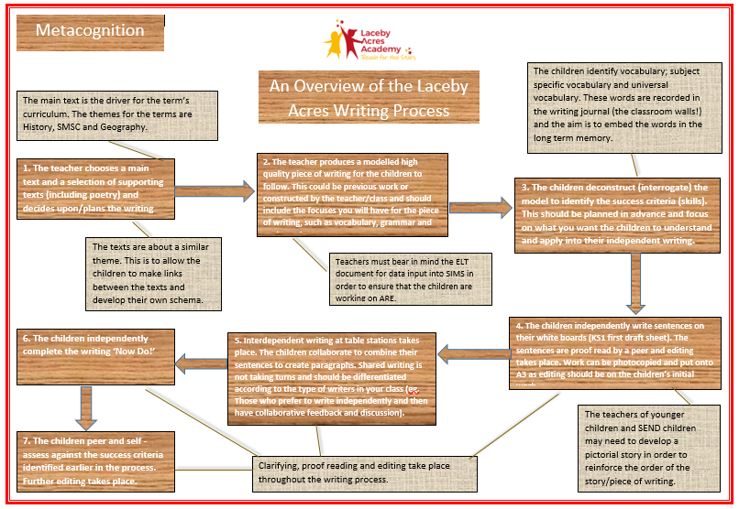
To develop our children into young writers we have implemented our own metacognitive approach to writing where we follow the reading to writing methodology and immerse our children in a world of wonder through the high quality picture books and novels we choose. The high quality texts then become our drivers in planning and delivering a well-balanced and progressive scheme of work. Around the text we then continue to grow our children into confident spellers who have a rich and wide vocabulary and have created our handwriting policy to ensure the quality of presentation is to a high standard and reflects the quality of the ideas our children have. We then use editing stages throughout the crafting of writing where children can respond, reflect and start to become independent with their push for creating a beautiful draft. Coupled with using the editing stages within our writing process we assess children’s writing using a ‘rubrics’ in which depict the features being focused on for the different text types as well as allowing for judgements to be made on each class’s non-negotiables of expectations.

Impact.
The impact of our writing approach is to ensure all children in all year groups acquire the age-related knowledge in line with the latest National Curriculum of reading, writing, spelling, punctuation and grammar. We tailor our planning and approach to make sure these are covered in each year group and each year builds on these.
Long term we hope pupils will:
- Become more confident fluent readers,
- Develop a love and passion for reading and books as much as our practitioners do,
- Be confident when speaking and listening to use discussion to communicate to further their learning,
- Enjoy learning a wide range of different genres and text types and learn how to write for different purposes,
- Pupils of all abilities will be able to access and succeed in our English lessons because there will be appropriate models and scaffolds in place to engage with the work,
- Have a wide vocabulary and be adventurous with vocabulary choices within their writing,
- Have a good knowledge of how to adapt their writing based on the context and audience,
- Leave primary school being able to effectively apply spelling rules and patterns they have been taught,
- Make good and better progress from their starting points to achieve their full potential.
We want to see a real impact of quality and quantity of curriculum content being retained and used by the children within their writing through our work implementing disciplinary literacy. We want our English books to show a clear, progressive journey from the start the end of year but also of the journey each child makes through exploring the texts in their class and how they work towards and build up to creating extended pieces of writing. Our books should be a showcase of our writing process and how reading, spelling, handwriting and grammar work we entwine throughout our curriculum all play a vital part in crafting a piece of writing. We know the vital role that reading has in allowing children to access the entire curriculum and the impacts it has not just on primary school life, but into KS3 and beyond and we feel writing is no different in the depths of the impact it can have on a child’s future. Through our text progression and long term curriculum map the writing styles and text types being covered in each year group throughout the year are carefully mapped out to ensure children experience creating a range of text types but to ensure that skills, understanding and knowledge is built upon in each year group as they progress through our school. We want to strive towards a whole class approach to writing, where children who require extra time, support and quality first teaching (such as SEND and pupil premium children), are able to receive what they need in order to be able to access the texts being focused on and make the progress they are capable of. We want our children to find their own writing style an author voice.
Creating an author’s voice.
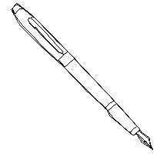Conscience corridor.
Role on the wall.
Freeze-frame.
OSIE (observation, senses, imagination and emotion).
Role-play.
Prediction.
Summarising.
Inferring.
Interrogating texts.
Deconstructing texts.
Text marking.
Story mapping.
Story telling.
Vocabulary exploration.

A Laceby Acres Reading to Writing Sequence.
We understand that writing isn’t a one off lesson. It is the combination of different skills, experiences and time given to craft every piece of writing.
- As a school we understand the role reading plays in developing writers and the value of being immersed in high quality literature across the school beginning in Foundation Stage and KS1 through picture books, moving into short novels in LKS2 to the most challenging novels covered in UKS2.
- We choose our texts carefully to make sure they provide the children with rich language models, an array of deepening vocabulary and different structures and purposes to them. We include texts that introduce them into worlds beyond their own and absorb them into the complex English language.
- We ensure children are given plenty of meaningful opportunities to write for different purposes and audiences to build our children into authors. We want our children to be expressive through the words they write and become critical not only of their own work but of the texts and stories they are studying. We want our feedback to validate and push forward our children’s writing focusing on the effect their writing had on the reader.
- We delve into the craft of writing and look at writing as a process in which small steps help us to build towards an end piece of writing. We look at how different authors have created their books and question why they used the features they did and why they wrote it in the way they did to improve our understanding of the writing process through interrogations of extracts.
- We enter into deep discussions when modelling exactly how we put together a piece of writing authentically, involving children into the process so they can see first-hand how writing develops. We model and talk about our writing choices everywhere across the curriculum articulating our process to the children, how we overcome difficulties and how we reflect critically.
- We support children to find their own authors voice and their own writing style. We try to ensure children get 1:1 writing support throughout a writing sequence in which they can discover and pursue their own ideas with the scaffolds in place for them to work more independently but have the support and guidance to take their writing to the next level.
- We make sure our children are given time and space to write freely. We want our children to use the scaffold we put in place as a basis for them to push forward and create their own pieces of work more independently taking ownership of their choices and work. We give time for the children to edit their work with support and discussions with teachers as well as developing their own skills of self-reflection in which they begin to edit their own work throughout their writing journey.
- We study different creative techniques and approaches to help build the children’s imagination as well as the experiences they need to write creatively.
- We ensure the teaching of phonics, grammar, spelling and punctuation is embedded across our curriculum so children see the links between what they learn in English lessons and its wider applications into other subjects. We centre the children in a language rich environment with a focus on enriching the children’s vocabulary and how they can use the words they know expertly.
- We celebrate the children’s writing through our beautiful draft in which the children explore how they set out their writing and present their final piece for the focus audience as well as giving time for children to read their work aloud in a final performance.

Assessment of writing:
Writing with support and scaffolding Writing independently

Through our writing approach and process we begin with support and scaffolds that the children can then use in their independent writing. We discuss and explore a piece of text by practicing different reading skills around the chosen text as well as the vocabulary used. As the children’s understanding and retention of content from the text grows we then focus on modelling and constructing the chosen text type they are working towards together in a shared approach which is then deconstructed and interrogated to identify the different features and structures used for the text type, becoming the criteria for writing a successful piece. By deconstructing the model the children are then exposed to the skills and grammatical elements used in that type of writing and can refer back to them when writing independently so they are assessing their own writing as they craft it. In the moment feedback is key in helping the children understand the crafting process of writing and allows them to change and improve as they write rather than have a extended piece of writing to then edit. When the first draft is complete our children are then given time to read, assess and edit their own work as well as receive support through editing groups and 1:1 conversations with teachers to push their writing forward with feedback being tailored and focused on the objectives being covered for the chosen text type. It is our aim in the assessment of writing that we build children’s knowledge and understanding of different text types, grammatical techniques and spelling of different vocabulary that as they progress through the key stages they become more confident and able to assess their own writing whilst they are crafting their piece and the roll of the teacher is to give constructive feedback to help take their writing to the next level. We want to close the feedback loop by using verbal feedback, meaningful conversations and precise learning objectives children work towards becoming independent reflective writers who are able to proof read their own writing thoroughly, identify areas for improvement in spelling, grammatical features and overall composition of their writing.

Planning:
Each half term there should be an overview plan of the extended writing outcome desire for that half term. Our approach for writing planning is to have a clear focused text types/genre as your desired outcome and plan backwards from that starting point. By doing so you can really unpick the key steps the children will need to know and have practiced identifying and using before they are able to write an independent piece of writing for the chosen text type. By planning in this way it will focus each week on the skills needed for each text type.
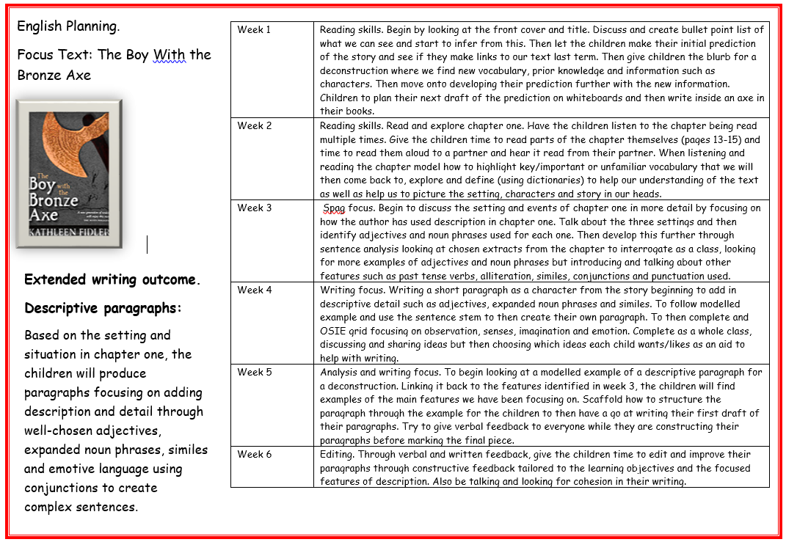
Example.
Model:
Week 1 – Reading skills and understanding of the text/chapter/story being covered and focused on.
Week 2 – Developing those reading skills further and unpicking the text in more detail.
Week 3 – Beginning to think about the SPAG features the children need to identify and know how to use.
Week 4 – Move into a writing focus where the children are completing mini process linked the end writing goal and having time to collect ideas through shared and model sessions.
Week 5 – Start to analyse modelled pieces of work alongside constructing and crafting piece of writing.
Week 6 – Focussing more on the editing of the first draft of writing through constructive in the moment feedback with useful comments relating to the objectives to improve things in their next draft.

Writing:
In each half term the writing process was split in half (3weeks on skills and 3 weeks on writing and editing). Beginning with reading skills to unpick and understand the text (length of focus to vary for key stages) before using it as a basis for writing. Once the children are aware and understand the events and content of the book/chapter/story they can start to look at the spelling, grammar, punctuation and vocabulary that underpins the text focusing on those skills and features needed for your chosen text type. The reading and skills book will then show a variety of different skills being looked at as the small steps towards the end writing goal. In the writing book you will then move on to interrogating and deconstructing your chosen text type so the children can identify the features and skills they have learnt in previous weeks work before being given time to begin their first draft. Whilst they are writing their first draft is where in the moment feedback and conversations between children and teacher can develop their understanding of how to craft a piece of writing together without it adding to teacher workload and give the children much more useful constructive feedback in which they are being shown how to think about what they are doing through the metacognitive approach. By giving children in the moment feedback, when it comes time to read through every ones first draft you have more of an idea of their own thought process behind their writing and have already begun to have discussions about how they can take their writing forward. A feedback comment then reflecting something they have done well linked to the focus objectives and then some areas to think about in their next draft will minimize the time taken for editing whilst getting more worthwhile critiques of the children’s work, with the children being more included in the crafting process and why they need to make certain changes rather than just being told to.

