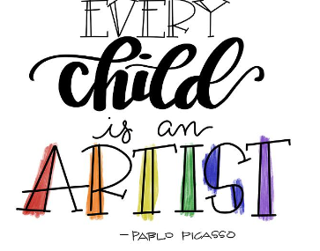
Intent
Art teaching at Laceby Acres Primary Academy aims to give all children a strong understanding of their own uniqueness and creative abilities and to help build understanding of why art and artists are relevant to our history, our culture and contemporary society. Art is one way to improve creative and critical thinking skills whilst providing them with the knowledge to help them think artistically. Children will gain an understanding of a range of art techniques and processes and also an understanding of the implications of Art, from the past, today and in the future. The great tragedy is that they're removing art completely, not because they're putting more science in, but because they can't afford the art teachers or because somebody thinks it's not useful. An enlightened society has all of this going on within it. It's part of what distinguishes what it is to be human from other life forms on Earth - that we have culture. (Neil deGrasse Tyson)
At Laceby Acres Primary Academy, Art will be holistic and outward looking in terms of approach, activities and artists, making the curriculum fully inclusive and relevant to all pupils. It will celebrate art as a unique subject through which children will develop their skills and personal sense of creativity and well-being. It will consist of pathways, focusing on a pedagogy-approach, these will be revisited in each year group. During each year’s pathways, the key concepts are suggested and disciplines mapped. This model supports the retrieval process for learning.
All children are encouraged and inspired to develop and use a range of skills including exploration, questioning and making as they progress through a journey of self-discovery and re-invention. Each journey allowing for the development of each child individually, encouraging them to be confident when expressing their ideas creatively. Specialist vocabulary for art is taught and built up, and effective questioning to communicate ideas is encouraged. By providing a safe structure to explore their creativity, the children are able to develop their creative risk taking and willingness to experiment. Ultimately, a strong understanding of Art will allow children to understand and appreciate cultures in society, broaden their vocabulary, all while developing a sense of creativity and critical thinking. Here at Laceby Acres Academy our belief is “Our creativity is part of our humanity. If we fail to provide opportunities for pupils to develop their creativity, we are not only letting them down, but we are negatively affecting future society. That’s how important teaching art is.” (Paula Briggs, CEO & Creative Director, AccessArt)
Implementation
To ensure high standards of teaching and learning in art and design, we implement a curriculum that is progressive throughout the whole school. Art and design is taught as part of a half-termly topics, focusing on knowledge and skills that extends beyond the National Curriculum. At Laceby Acres, we ensure that art and design is given the same importance as the core subjects, as we feel this is important in enabling all children to gain ‘real-life’ experiences.
Teachers plan lessons for their class following Access Art pathways which are designed to inspire and enable high quality visual arts teaching and learning. We believe that art is far more than a series of technical skills, our holistic curriculum nurtures creative thinking skills and helps ensure children learn through art as well as about art. Our progression of knowledge and skills document ensures the curriculum is covered and the skills/knowledge taught is progressive from year group to year group. Our progression document also details the substantive and disciplinary knowledge the children will learn in each year group. Our art curriculum is knowledge rich and aims to develop knowledge and understanding that builds children to go beyond technical and factual knowledge. Our curriculum balances declarative knowledge with experimental knowledge, building self-knowledge and nurturing traits in learners which will hold them in good stead whichever direction a child’s learning takes them. Our art learning is built through weaving, layering and revisiting experiences. Each year the children acquire knowledge and skills in drawing, sketchbooks, print making, painting and collage as well as developing knowledge about a range of artists. Our curriculum is also supported by a range of talking points which are carefully curated to introduce children to a variety of artists, designers and craftspeople. We juxtapose contemporary artists with more traditional artists to allow children the opportunity to revisit artists they have already studied. Each pathway tells a story and follows the format of:
- Warm-up: activity: Crit/ Reflection
- Artists: materials: Activity: Crti/ Reflection
- Challenge or Brief: Artist: Activity: Crit/ Reflection
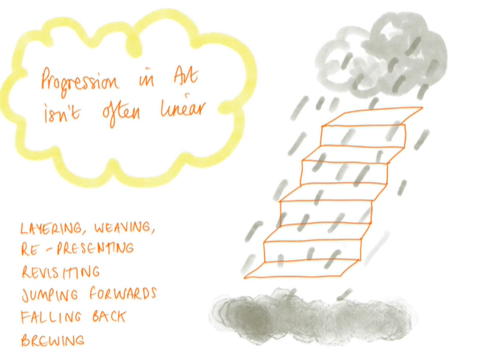
We believe that creativity likes rhythm therefore each pathway follows a repeated rhythm which provides lots of time to balance repeated practice with new experiences, quiet approaches with active and dynamic activities, time to work alone with collaborative and community based activities… all geared to create energy and momentum throughout the year.
As the arts are a cornerstone of our wider curriculum the children have an art room in which they learn art skills. This is equipped with all the resources and stools for working to model the process of being an artist. The room is richly resourced with books about artists, famous artwork and key art vocabulary. We also arrange for annual visits from a range of artists including Jim Connor and Francesca Young. The room also hosts our art club in which we use external specialists to further extend the children who have a specific interest in the arts.
At Laceby Acres, each of our artists has their own sketch book in which they can record ideas, practise new techniques and further refine their skills. We believe that our sketchbooks should:
- give permission. We show pupils what sketchbooks can be in the widest sense, and we give permission for pupils to embrace that potential in an aspirational way.
- create opportunity for pupils to practice sketchbook skills and explore exciting projects.
- nurture ownership, by reminding pupils that they can take control of their journey in and through their sketchbooks.

Our sketchbooks are key to how we implement our art curriculum. When we move too quickly towards a preconceived outcome (a painting, sculpture, drawing etc) we deprive ourselves of an exciting journey. Sketchbooks provide us with the opportunity to develop our journeying skills (exploration, testing, reflecting, understanding), which in turn offers us the potential of arriving at an exciting end result, alongside greater understanding and development of skills.

Sketchbooks provide the space for children to play, explore, try, and wonder. They also provide a safe space in which to fail, struggle and get lost, all of which bring growth in vital skills. A sketchbook should be a safe place in which to take creative risks, without fear of judgement. Sketchbooks are places where it is ok not to know the answer. Nothing has to be resolved in a sketchbook, and so conversely, things can be resolved. Sketchbooks should be places in which mistakes can occur, and revelations made. Breakthroughs can be made through repetitive practice, or spontaneous leaps. Sketchbooks are safe spaces in which you can make connections between disparate elements, by daring to put them together.

Sketchbooks are an opportunity to “think around”. Sketchbooks should be a place of exploration and discovery, used to gather, experiment, reflect and understand. We encourager teachers to not be afraid if sketchbooks seem chaotic. Artist’s sketchbooks are full of personality – some sketchbooks are neat and tidy, others are not. All are valid. Sketchbooks are a place to put unresolved ideas into the world, which can be assimilated later. Sketchbooks are rarely linear and a good sketchbook will raise more questions than answers.

Although we have set art lessons we also believe that Regular opportunities for practice, combined with open access to sketchbooks will help create momentum and energy, which in turn will help creativity flourish in all areas. Therefore we have frequent mini drawing skills sessions throughout the week.

Educational visits are another opportunity for the teachers to plan for additional art learning outside the classroom. At Laceby Acres, the children have had many opportunities to experience art and design on educational visits. The children have explored local museums/art galleries and had visitors into school to share art and design learning and have hands on experiences.

Impact
Our art curriculum is high quality, well thought out and is planned to demonstrate progression. We focus on progression of knowledge and skills and discreet vocabulary progression also form part of the units of work. We measure the impact of our curriculum through the following methods:
- Assessing children’s understanding of topic linked vocabulary before and after the unit is taught.
- Summative assessment of pupil discussions about their learning.
- Images and videos of the children’s practical learning.
- Interviewing the pupils about their learning (pupil voice).
- Moderation staff meetings where pupil’s books are scrutinised and there is the opportunity for a dialogue between teachers to understand their class’s work.
- Annual reporting of standards across the curriculum.
Examples of our artists’ work is also exhibited throughout the school, both on classroom and communal displays situated on our school corridors.
We believe that art cannot be assessed in the same way as other curriculum subjects. Art is a unique subject and if we are to truly enable creativity in schools then we need to rethink our approach to assessment. Assessment in art is done through a conversation with a child not something done to the child.
