KS1 Mini Processes Examples
Writing without a process
(Mini Process)

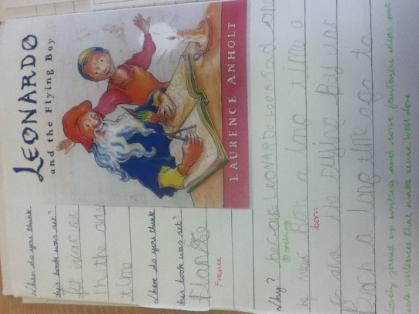
Reading pictures.
Using the artwork from the story is a really good skill for ks1 children, especially those who aren’t strong readers. Teaching children to read pictures and to be able to pick out features such as where they think the setting is, who they think is in the story, how they might be feeling and what might be happening are all a stimulus for reading into writing in ks1.

Predictions
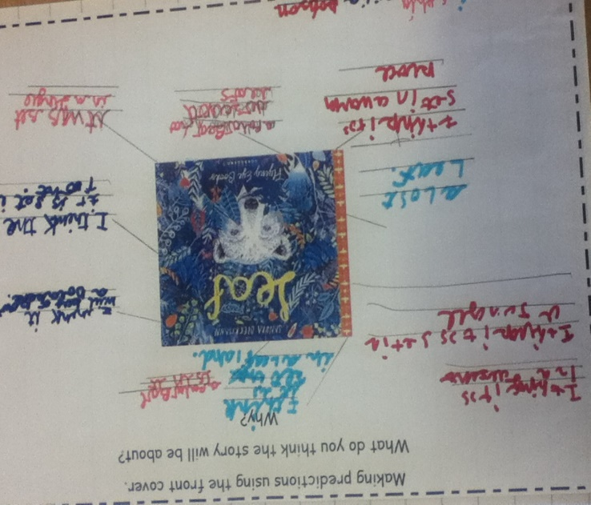
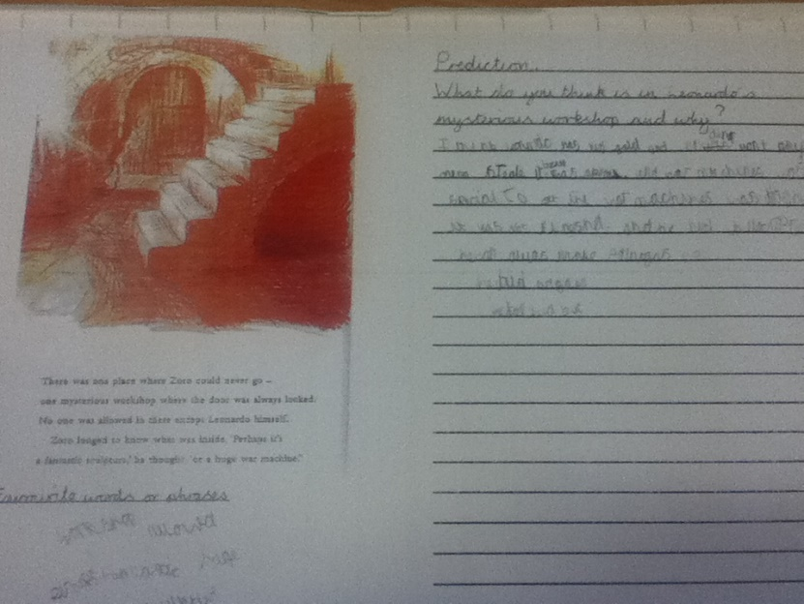
Knowing what a prediction is teaches the children to think deeper about what they are reading in the text and seeing through the illustrations. It is a good way to start teaching children inference skills and how to use the text/illustrations to support what they think. Some examples are; using the front cover to predict what the story might be about and why and reading so far into the story and stopping for reflection about what might happen next.

Emotional literacy.
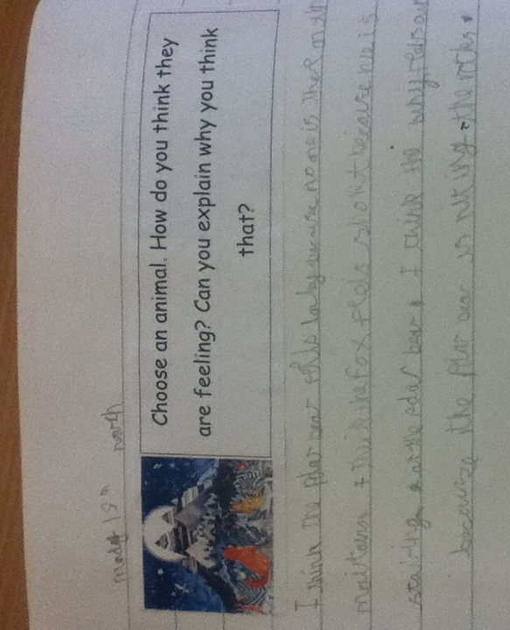
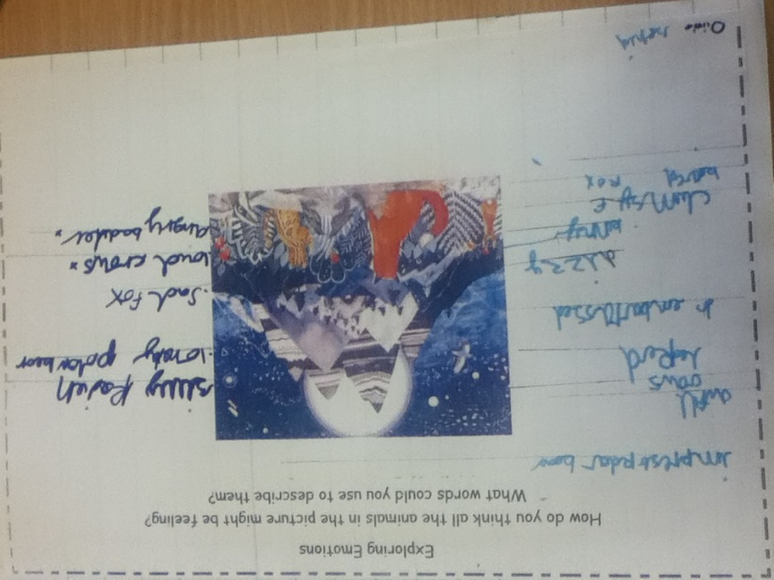
Focusing on the character in the story and how they are feeling is another way of getting the children to infer using the illustrations and text as a basis for their thoughts. It gets the children looking for and thinking about where the characters are positioned, their facial expressions and what they are doing. These skills will prepare the children for ks2 focuses about why the author has chosen to include things in a certain way.
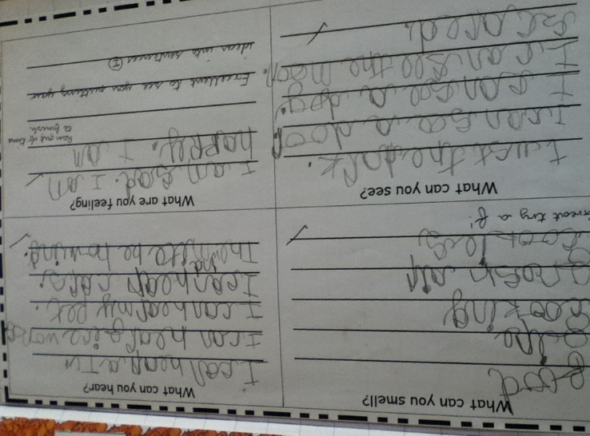

Summarising
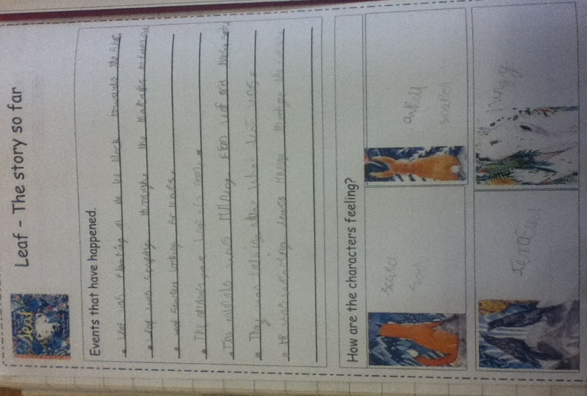
Summarising the story so far helps to consolidate the children’s comprehension of what they have read so far as well as allowing them to re-write the story independently. By starting using bullet points or notes to write down the key events in the right order also helps children’s understanding of sequencing the story in the right order and then can be used to aid children’s independent writing.

Non-Fiction.
Using dictogloss to teach note taking skills has worked well in ks1. It teaches children to be discerning when listening to information and helps them understand what the most important parts are to focus on writing down. It is a good way of preparing children for ks2 where they are expected to be able to re-create their own information pieces from notes.
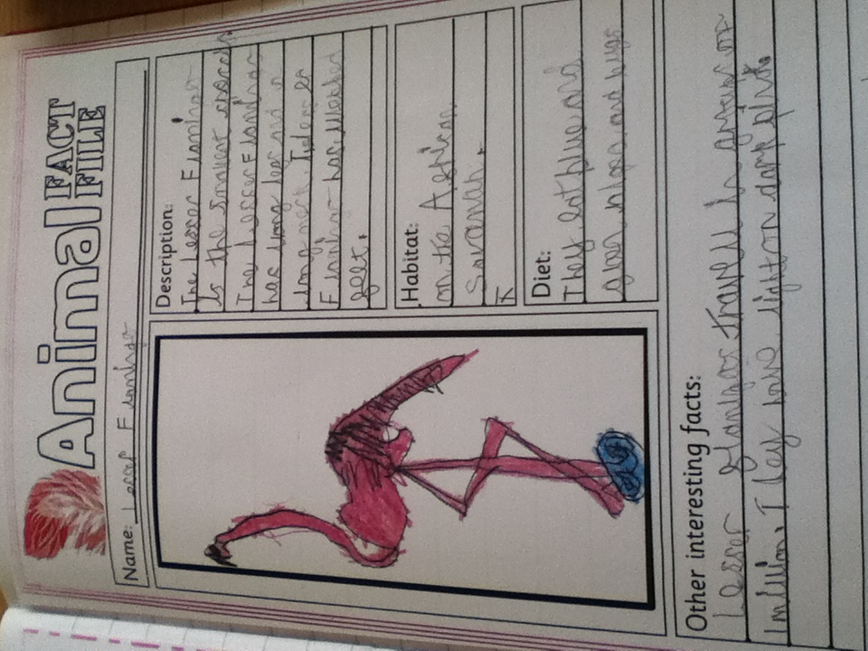
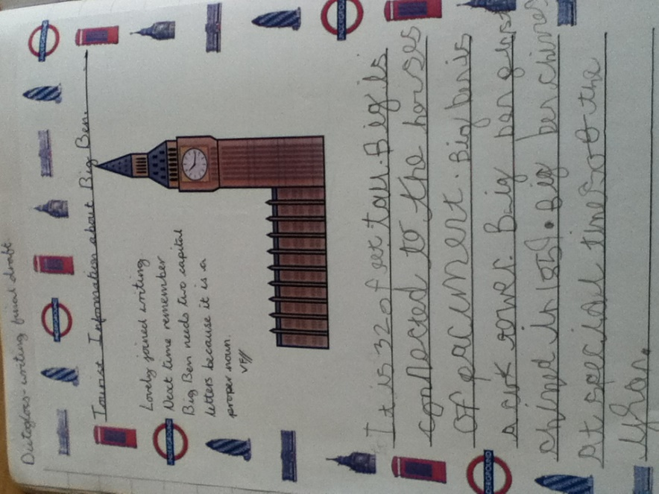
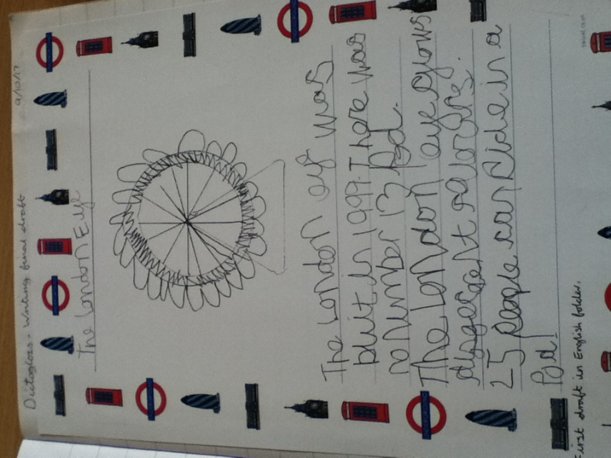

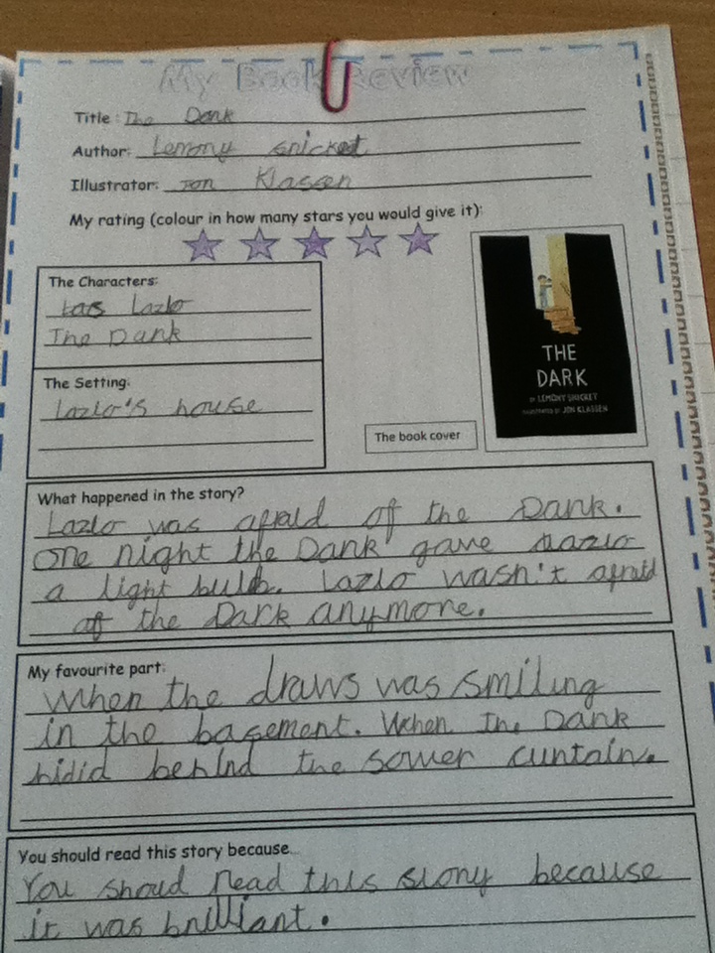
Reviewing
Similar to summarising, reviewing helps the children sequence and retell what happens in a story deepening their comprehension but it also allows them to connect with a story or book on a personal level, where they are asked what they think. It helps them to condense their writing and focus on the key points when writing their own synopsis.

Drama
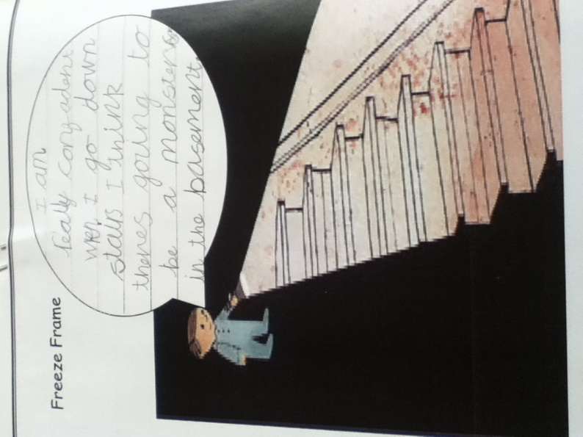
The use of drama in literacy can be very useful when trying to get the children to understand thoughts, feelings and the emotions of the text and characters. Strategies such as freeze framing are a way of recording drama where the children are able to write down their ideas. (Really good when focusing on speech).

