Knowledge and understanding | Foundation – Ticket to Ride! | The curriculum – Threshold concepts
History  In history we will be comparing the similarities and differences between the transport we use today and in the past.  We will also be learning about the important historical figure, Neil Armstrong and his exploration of the moon.  We will be developing the key historical skills of:  Chronological understanding  Understanding that there are differences between past and present and that there are events which occurred before we were born.  Historical enquiry  Ask and answer historical questions such as why? and how? In relation to artefacts.  Continuity and change between periods  Identifying some similarities/differences between the past and now.  Significance of events and people  Discussing historical figures through storytelling.  Science  As scientists this half term we will learning about changes of matter.  We will be observing and comparing the impact that heat and freezing have on different materials. We will also be exploring the seasonal changes to our natural environment as we move from spring to summer.  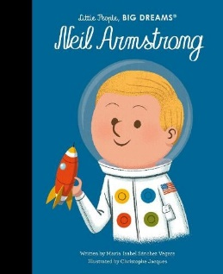 | 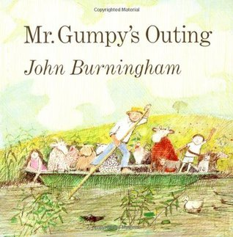  Reading and writing outcomes  During this half term we will be exploring different types of transport both modern and historical. We will also look at the moon and discover how we would travel to space and what we might see on our travels.  We will be further developing our writing skills by creating posters which showcase our own transport designs.  Our school trip to the farm will be incorporated into our retelling of Mr Gumpy’s outing. We will use our experiences to create our own character for the story. We will use our knowledge of different types of transport to create our own adventure for Mr Gumpy.  When learning about space, we will be creating our own travel brochures which will tell you all about our new planet and how to get there.  We will continue to work on using our phonic skills to write sentences, that include tricky words, independently. Our sentences will include finger spaces and full stops.  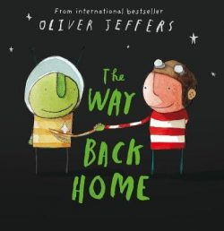  Link Reading:  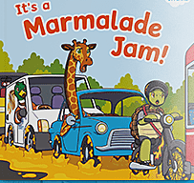  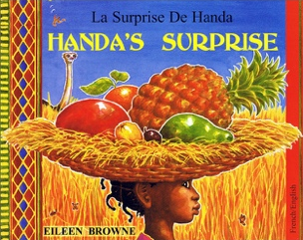 | P.E:  This half term we will be developing our skills of throwing and catching. We will practice using both underarm and overarm throwing.  PSHE  Jigsaw – Relationships  Circle time themes:  Know how to make friends  Try to solve friendship problems when they occur  Help others feel part of a group  Show respect in how they treat others  Know how to help themselves and others when they feel upset and hurt  Know and show what makes a good relationship  R.E.  Theme – Story time  Key question – What can we learn from Stories?  Religions: Christianity, Islam, Hinduism, Sikhism  Music:  ‘Beyond the stars’  We will be discovering the wider universe and hearing about adventures to space.  We will explore this through:  - Singing  - Playing  - Listening and responding to the music  - Moving to the music  Our skill builder this half term will be pitch.  MFL  We will be learning our colours and how to count to ten in Spanish.  DT:  Using different junk modelling resources to create our own vehicles.  Art: Wildflower Meadow  During this half term, we will be learning to create an atmospheric, wildflower meadow painting. We will be developing our artistic skills of using colour washes, printing, drawing and collage to produce our final piece.  - Explores different ways to use paint  - Promotes individual and collaborative working
Maths
*Building numbers beyond 10 *Counting patterns beyond 10 * Spatial reasoning – Match, rotate and manipulate shapes within a given area
* Adding more * Taking away * Spatial reasoning – compose and decompose

