History – Enquiry Question  Would the Vikings do anything with Money? | Y5- The Viking and Anglo-Saxon struggle for the Kingdom of England  Would the Vikings do anything with money? | The Curriculum – Threshold Concepts
Working goegraphically to:  History Enquiry:  - Understand how knowledge of the past is constructed from a range of sources.  Communicate Historically:  - Develop the appropriate use of historical terms.  - Construct informed responses that involve thoughtful selection and organisation of relevant historical information.  Interpret Historically:  - Address and devise historically valid questions about change, cause, similarity, difference and significance.  Understand Chronology:  - Develop a chronologically secure knowledge and understanding of British, local and world history.  - Learn about the Vikings and the significant developments during this period. | 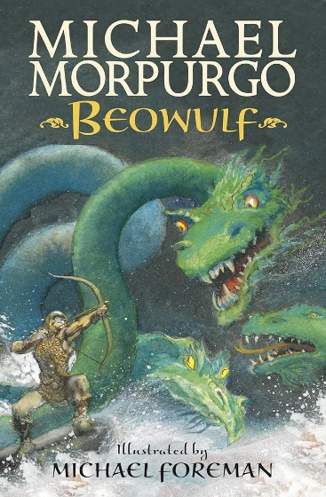  English Focus text:  Micheal Morpurgo: Beowulf  Writing Outcomes:  Main:  Adventure story (fantasy narrative)  Mini process:  letter  Poetry: Viking kenning (about an object, person)  Reading Outcomes:  Reading skills: predicting, clarifying, questioning and summarising.  Grammatical Skills:  Figurative language (similes, metaphors, personification). Alliteration. Subject verb agreement.  Contextual Knowledge:  To understand that despite the Viking being ruthless invaders, among themselves they were a very sociable nation. They came from dark and cold lands, where it was easy to believe in the existence of mythical creatures and superstitions. Children to understand the importance of engaging storytelling (as a social event and as a historical evidence)  Link Reading:  "How to Train Your Dragon" by Cressida Cowell - "Viking Boy" by Tony Bradman  Maths: White Rose  Multiplication and Division B  - multiply and divide numbers mentally drawing upon known facts  - multiply and divide whole numbers and those involving decimals by 10, 100 and 1000  - multiply numbers up to 4 digits by a one- or two-digit number using a formal written method, including long multiplication for two-digit numbers  - divide numbers up to 4 digits by a one-digit number using the formal written method of short division and interpret remainders appropriately for the context identify multiples and factors, including  - solve problems involving multiplication and division including using their knowledge of factors and multiples, squares and cubes  Fractions B  - recognise and use thousandths and relate them to tenths, hundredths and decimal equivalents compare and  - order fractions whose denominators are all multiples of the same number  - read, write, order and compare numbers with up to three decimal places  - round decimals with two decimal places to the nearest whole number and to one decimal place  - add and subtract fractions with the same denominator and multiples of the same number  - recognize mixed numbers and improper fractions and convert from one form to the other and write mathematical statements | P.E  Dance: Sports Coach – Performing The Haka  ICT  E-safety: Project Evolve Online Reputation  Computer Science: Lightbot – Algorithms Procedures. Loops and Debugging  PSHE  Jigsaw: Dreams and Goals  Understanding the role of money  Exploring job opportunities and different roles  Understanding self-motivation, different cultures and broaden aspiration  R.E  Theme: Beliefs and Moral Value  Key Question: Are Sikh stories important today?  Religion: Sikhism  MUSIC  Unit 3 Life Cycles  Pupils appreciate and understand a wide range of recorded music drawn from different traditions, styles, and genres, including the works of the great composers and musicians  Pupils develop an understanding of musical composition  Pupils play and perform in solo and ensemble contexts, using their voices and playing musical instruments with increasing accuracy, fluency, control, and expression  MFL  Unit: My Home  To be able to say where I live, using first person  I will learn 5 nouns and their determiners  I will learn how to say I don’t have a particular room using the negative structure in Spanish  Art  Pathway: Set Design, Making, Drawing, Sketchbooks  -That designers and makers design “sets” which form the backdrop/props to give context to drama (theatre, film or animation).  -That we can use many disciplines including painting, making, drawing to create sets, as well as thinking about lighting, scale, perspective, composition, and sound.  -That we can create our own “sets” to create models for theatre design, or backgrounds for an animation.  -That we can take our inspiration from the sources of literature or music to inform our creative response and to capture the essence of the drama.  DT Unit Focus: Electrical Systems: Circuits and Switches  That mechanical and electrical systems have an input process and output  Constructed a simple series electrical circuit in science.
Science Biology – Animals including humans
Working Scientifically to:
- Describe the changes as humans develop to old age.
- Different animals mature at different rates and live to different ages.
- Puberty is something we all go through, a process which prepares our bodies for being adults, and reproduction and Hormones control these changes, which can be physical and/or emotional.

Scientific Enquiry:

