Knowledge and Understanding | Foundation – Celebrations Around the World | The Curriculum
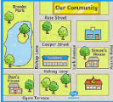  Geography:  In Geography, we will explore maps, learn how to draw a simple map and listen to stories with maps in. We will also learn to recognise some common signs and how to use positional language.  As scientist we will be learning about…  In Science, we will explore Antarctic animals and learn how to describe them using scientific vocabulary. We will begin to understand Antarctic animal habitats and what animals need to survive in different environments.  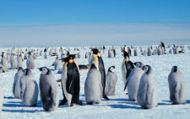 | Reading and Writing Outcomes:  This term, we will learn how to sequence two events from a familiar story and will be discussing and listening to a range of books – non-fiction and fiction. We will use text and images in the books to answer simple questions.  During Phonics lessons we will recognise graphemes and say the corresponding phonemes, imcluding digraphs. During group reading times we will say the phoneme in our books to match the graphemes seen. We will be encouraged to segment and then blend sounds together in phonics lessons, literacy lessons and group reading time. We will be introduced to tricky words and learn the tricky parts of the word. We will also learn how to add s to the end of a word to make it plural.  When writing, we will continue to develop a phoneme/grapheme relationship. We will have increasing control when making marks and drawing. We will copy adult ‘writing behaviour’, use some recognisable letters and our own symbols such as our name or some initial sounds to write. We will form letters from our name mostly correctly. We will understand that we write from left to right and from top to bottom. We will be able to orally spell VC and CVC words by identifying the sounds.  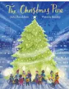  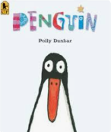  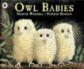  Maths  It's me 1, 2, 3  Circles and triangles  1, 2, 3, 4, 5  Shapes with 4 sides  Writing numerals  Days of the week, months of the year, seasons.  Sequence daily events. | P.E: Ball Skills  We will learn how to move with confidence in different ways, whilst holding an object. We will develop a range of different ball skills including bouncing and perform underarm and overarm throwing actions.  RE: Why do Christians perform Nativity plays at Christmas? (Why is Christmas special for Christians?)  We will learn the key events from the Christian Christmas story.  PSHE: Celebrating differences  - Similarities and differences  - Understanding bullying and knowing how to deal with it.  - Making new friends.  - Celebrating the differences in everyone.  Spanish- Colours & Numbers  We will learn to name and recognise up to 10 colours and count from 1-10 ten in Spanish.  DT: Cooking and Nutrition- Christmas Ginger Biscuits  We will understand how different textures feel and explore freely e.g. malleable. We will create work to celebrate special days e.g. decorations (paper chains, bunting). We will use one-handed tools and equipment, for example, a knife for chopping food in a recipe.  Music- An Indian Wedding/When Snowflakes Fall  We will be listening to music, joining in with the words and use actions to move to the music.  Art- Bold Autumn Still Life  We will be learning how to do observational drawings in Art this term. We will understand how to create closed shapes with continuous lines and begin to use these shapes to represent objects. We will explore colours and how colours can be changed, as well as identifying light and dark colours. We will also be printing with natural objects/food e.g. leaves, pinecones.
Parental Involvement- This term we will be hosting a Christmas themed Stay and Play and we will be inviting parents to watch the Christmas concert performance.

Celebrations & Experiences-
- Diwali
- Bonfire Night
- Children in Need
- Remembrance Day
- Advent
- Christmas
- Hannukah
- Road Safety
- Anti- Bullying Week

Fabulous Fifty-
- Post a letter in a post box.
- Perform on a stage.
- Watch a pantomime.

Visitis and Visitors
- Pantomime
- Local post office visit

