YEAR 5 (Autumn Term 1)
Miss Orlowska and Mrs Bowyer
History (Rising Stars)  Focus: The Anglo-Saxons  Enquiry question: Was the Anglo-Saxon period really a Dark Age?  Objectives:  - To build an overview of the world history – describe the social, ethnic, cultural and religious diversity (incl.: ideas, beliefs, attitudes and experiences) of the past society  - To investigate and interpret the past – use more than one source of evidence to ask questions and give accurate answers about the past, suggest causes and consequences for some of the changes in history.  - To understand chronology – develop an appreciation of changes taking place over time and be able to present them on the timeline.  - To communicate historically – use appropriate historical vocabulary to communicate your ideas, findings and observations. | English – planning around the texts:  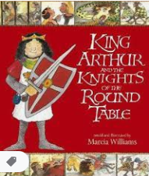  King Arthur and the Knights of the Round Table by Marcia Williams (main) and The Usborne Illustrated Tales of King Arthur (supplementary).  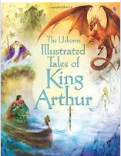  Anticipated Writing Outcomes:  - play script (write and perform)  - character description  - diary entry  - chapter summary  - inference / prediction / questioning  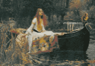  Poetry Focus:  - Lady of Shalott by Alfred Tennyson | Computing - E-Safety  Objectives:  - understand how to keep sensitive data private  - discerning and evaluating online content  - understand, prevent and respond to cyberbullying threats.
Art - amazed by architecture
Artist spotlight: Zaha Hadid
Objectives:
  - To develop ideas
  - To master techniques
  - To take inspiration from the greats creating original pieces of art.

DT- frame structures
Focus: Anglo-Saxon village and its surroundings
PE (Striver)
Focus: Hockey

Science - properties and changes of materials  To work scientifically – ask relevant questions, gather, record, classify and present data, identify similarities, differences and changes related to ideas and processes.  Objectives:  - describe and compare differences between 3 states of matter  - investigate insulators  - investigate magnetic properties of various materials.  - investigate dissolving  - investigate reversible and irreversible changes |  | PSHE (Jigsaw)  Being me in my world – who am I and how do I fit?  Explored themes: challenges, personal goals, rights and responsibilities, choices, rewards and consequences, democracy
 | Maths  Objectives:  - Place Value (incl.: Roman Numerals and Negative Numbers)  - Addition and Subtraction (column method)  - Statistics (interpret and draw: charts, line graphs and tables) | Music (Charanga)  Focus: Livin’ on a Prayer  Objectives:  - explore rhythm and synchronisation

