CORE SUBJECTS |  | WIDER CURRICULM
History (Rising Stars)  Focus: Vikings  Enquiry question: Would Vikings do anything for money?  - To build an overview of the world history – describe the social, ethnic, cultural and religious diversity (incl.: ideas, beliefs, attitudes and experiences) of the past society.  - To investigate and interpret the past – use more than one source of evidence to ask questions and give accurate answers about the past, suggest causes and consequences for some of the changes in history.  - To understand chronology – develop an appreciation of changes taking place over time and be able to present them on the timeline.  - To communicate historically – use appropriate historical vocabulary to communicate your ideas, fin dings and observations. | 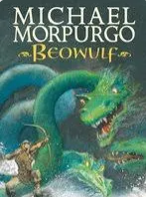  English  Focus text:  Beowulf by Michael Morpurgo  Extended writing outcomes:  - Adventure Story (setting description)  Mini writing process:  - letter  - prediction / inference  - summary  Link Reading:  Poetry: Viking kennings  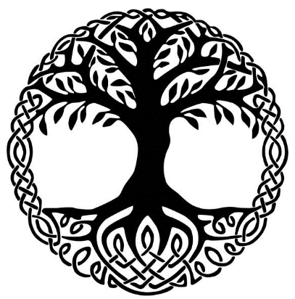  Norse Mythology by Neil Gaiman  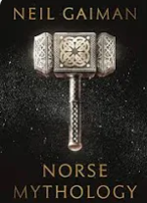 | P.E: (Striver)  Focus: Gymnastics 1  This unit focuses on forward and backward rolls  And includes a range of routines with rolling  I.C.T: (Enquire Trust)  Computer Science:  E-Safety (Project evolve): Online reputation  Computer Science: Lightbox – algorithms, procedures, loops, debugging.  RE (Discovery)  Sikhism - Beliefs and moral values  Focus: Are Sikh stories important today?  PSHE: (Jigsaw)  Focus: Dreams and Goals  - my dream job  - reasons and steps to achieving it  - exploring people in other cultures  - supporting each other  Music: (Music Express)  Musical Focus: Singing, performing, composing.  Unit: Life Cycles  Composers: Brahms, Berio, Liszt, Monteverdi  MFL: (Language Angels)  Spanish
Science (Grammarsaurus)  Biology – Animals including humans  Focus: Describe the changes as humans develop to old age.  - To know that that different animals mature at different rates and live to different ages.  - To know that puberty is something we all go through and it is a process which prepares our bodies for being adults and for reproduction.  - To know that hormones control the changes which can be physical and / or emotional. | Maths (White Rose)  Focus: Number  * Multiplication and Division B  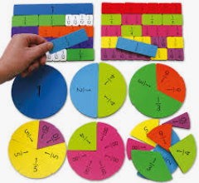  * Fractions B | Art and Design: (Access Art)  Focus: Set Design  Pupils will explore creating a model set for theatre or animation inspired by poetry, prose, film or music.  DT: Electrical Systems

