YEAR 5 (Spring Term)
History (Rising Stars)  Focus: The Vikings  Enquiry question: Would the Vikings do anything for money?  Objectives:  - To build an overview of the world history – describe the social, ethnic, cultural and religious diversity (incl.: ideas, beliefs, attitudes and experiences) of the past society  - To investigate and interpret the past – use more than one source of evidence to ask questions and give accurate answers about the past, suggest causes and consequences for some of the changes in history.  - To understand chronology – develop an appreciation of changes taking place over time and be able to present them on the timeline.  - To communicate historically – use appropriate historical vocabulary to communicate your ideas, findings and observations. | English – planning around the texts:  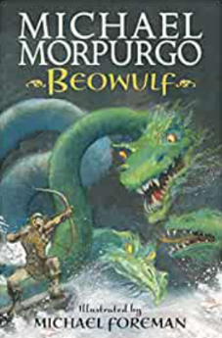  Beowulf by Michael Morpurgo  Anticipated Writing Outcomes:  - Adventure story  - Setting description  - Letter  - Chapter summary  - Inference / prediction  - Retrieval  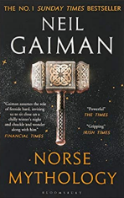  Supporting Text – Norse Mythology  by Neil Gaiman | Computing - E-Safety and Computer Science  Objectives:  - Google be Internet Safe  - Lightbot Hour
Art – the explosion of pop art
Artist spotlight: Any Warhol
Objectives:
  - To develop ideas
  - To master techniques
  - To take inspiration from the greats creating original pieces of art.

DT- frame structures
Focus: Viking longships
PE (Striver)
Focus: Gymnastics 1

Science – Animals including Humans  To work scientifically – ask relevant questions, gather, record, classify and present data, identify similarities, differences and changes related to ideas and processes.  Objectives:  - Human Life Cycle  - Development in the womb  - Puberty  - Seniors |  | PSHE (Jigsaw)  Dreams and Goals  - my dream job  - reasons and steps to achieving it  - exploring people in other cultures  - supporting each other
 | Maths  Objectives:  - Multiplication and Division (multiplication – up to 3-digits by 2-digits; division – up to 4–digits by 1-digit)  - Fractions (equivalent, improper, mixed numbers, sequences, compare and order)  - Decimals and Percentages (numbers up to 2 dp, decimals as fractions, thousandths, rounding, order and compare, percentages as fractions and decimals) | RE (Jigsaw)  Sikhism - Beliefs and moral values  Focus: Are Sikh stories important today?
Music (Charanga)
Focus: May you feel my love
Objectives:
- explore rhythm and synchronisation

