YEAR 5 (Summer 1)
Geography (Rising Stars)  Focus: Journeys  Enquiry question: What makes people go on a journey?  In this unit the children will look at five very different types of journey in depth. The journey choices will span from the Tudor period to those undertaken today by the refugees.  Disciplinary knowledge:  - To be able to develop a chronologically secure knowledge and understanding of British and world history  - To be able to establish clear narratives  - To be able to address and devise historically valid questions about significance and cause and change  - To understand how our knowledge of the past is constructed from a range of sources  - To be able to note connections, contrasts and trends over time. | English – planning around the texts:  Titanic Survivor by Stephen Davies  Gripping first-hand account of one the most dangerous events in history.  At that moment, the big bell up in the crow’s nest clanged three times.  “Iceberg!” yelled the lookout, “Iceberg, right ahead!”  Titanic is supposed to be unsinkable, but when the ship strikes an iceberg in the dead of night, she will sink within tree hours. Can twelve-year-old Jimmy help his friends and family escape an icy death in the waters of the Atlantic?  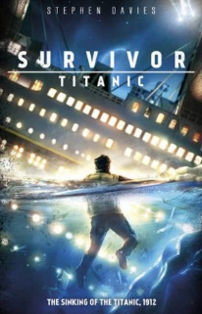  Anticipated Writing Outcomes:  - Mini biography * Diary Entry  - Newspaper Article * Summary  - Changing POV * Retrieval  - Inference * Prediction  Supporting text:  Ice Trap! Shackleton’s Incredible Expedition by M. Hooper and M. P. Robertson.  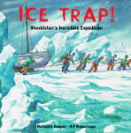  Linked texts:  - ‘Polar, The Titanic Bear’ by Daisy Corning Stone  - ‘Kaspar: King of Cats’ by Michael Morpurgo  - ‘Titanic’ by Anna Claybourne and Katie Daynes  - ‘Titanic (I was there) by Margi Mcallister | 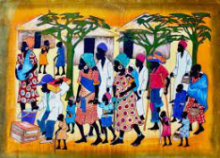  Art  Focus: Cultural Tradition in Art  Artist spotlight: Richard Kimbo  Objectives:  - To develop ideas  - To master techniques  - To take inspiration from the greats creating original pieces of art.
PSHE (Jigsaw)

Relationships:
- Recognising me
- Safety with online communities
- Being in an online community
- Online gaming
- My relationship with technology: screen time
- Relationships and Technology

PE (Striver)

Focus: Football

This unit focuses on controlling, dribbling, turning, passing and receiving the ball. Pupils will also develop their skills of tackling, marking and shooting and have an opportunity to apply all learned skills in a game of football.
Science
Physics: Earth and Space (1)

To work scientifically – ask relevant questions, gather, record, classify and present data, identify similarities, differences and changes related to ideas and processes.

Objectives:
- Describe the movement of the Earth, and other planets, relative to the Sun in the solar system
- Describe the movement of the Moon relative to the Earth
- Describe the Sun, Earth and Moon as approximately spherical bodies
- Describe the idea of the Earth’s rotation to explain day and night and the apparent movement of the sun across the sky.
RE (Discovery RE)

Theme: Hinduism

Concept: Beliefs and moral values

Key Question: Do beliefs in Karma, Samsara and Moksha help Hindus lead good lives?
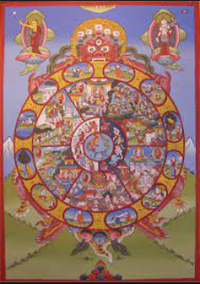
Maths (White Rose)

Objectives:
- To understand decimals and percentages (decimals as fractions, thousandths, rounding, ordering and comparing decimals, understanding percentages, equivalent F.D.P.)
- To be able to convert units
