YEAR 5 (Summer 2)
Geography (Rising Stars)  Focus: Journeys  In this unit, the children will find out about the UK’s global trade links, investigating where everyday products come from and the journeys they take to our homes. This builds on work children may have done in KS1 looking at the geography of food. The children will also map the journeys taken by items, and research the pros and cons of buying local or imported goods.  Disciplinary knowledge:  - describe and understand key aspects of human geography, including: types of settlement and land use, economic activity including trade links, and the distribution of natural resources including energy, food, minerals and water  - use maps, atlases, globes and digital/computer mapping to locate countries and describe features studied. | English: The many worlds of Albie Bright- Christopher Edge  How far would you go to change your world?  When Albie’s mum dies, it’s natural he should ask where she’s gone. His parents are both scientists and they usually have all the answers. Dad mutters something about quantum physics and parallel universes, so Albie gets a box, a laptop and a rotting banana, and sends himself through time and space in search of his mum. What he finds may or may not be what he’s looking for, but he does learn the answers to some big questions.  Writing Outcomes:  - Story writing * Diary Entry  - Alternative ending * Summary  - Changing POV * Retrieval  - Inference * Prediction  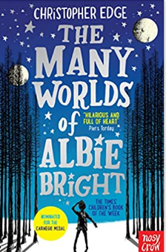  Supporting text: Journeys by Aaron Becker.  Linked texts:  - ‘Every day journey of Extraordinary Things- Libby Deutsch  -‘Diver’s daughter’ Patrice Lawrence  -‘My friend Walter’ Micheal Morporgo  -Curiosity by Markus Motum.  -Explorers by Nelly Huang. | 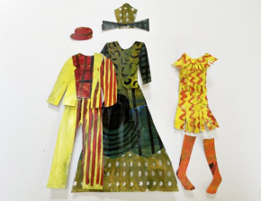  Art  Focus: Fashion Design  Disciplines: Fashion, Painting, Collage, Sketchbooks  Children are introduced to contemporary fashion designers and use sketchbooks to record things about the designers which interest them, or to note ways of working which may be useful.
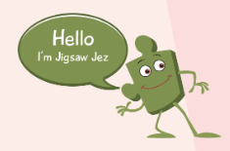
PSHE (Jigsaw)

Changing Me

I am aware of my own self-image and how my body image fits into that
I can describe how boys’ and girls’ bodies change during puberty
I can identify what I am looking forward to about becoming a teenager and understand this brings growing responsibilities
PE
Focus: Athletics
We will be preparing for Sports day during this half term.
• Combine sprinting with low hurdles over 60 metres.
• Choose the best place for running over a variety of distances.
• Throw accurately and refine performance by analysing technique and body shape.
• Show control in take- off and landings when jumping.
• Compete with others and keep track of personal best performances, setting targets for improvement.

Science: Physics: Earth and Space

To work scientifically – ask relevant questions, gather, record, classify and present data, identify similarities, differences and changes related to ideas and processes.

Objectives:
- Describe the movement of the Earth, and other planets, relative to the Sun in the solar system
- Describe the movement of the Moon relative to the Earth
- Describe the Sun, Earth and Moon as approximately spherical bodies
- Describe the idea of the Earth’s rotation to explain day and night and the apparent movement of the sun across the sky.
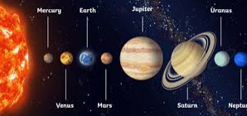

Music- Celebrations- We will learn a song to perform at our Talent show
Singing a song in unison and three-part harmony • Learning a melody and harmony part on instruments to accompany a song
Performing ostinati and body percussion accompaniments to a song • Exploring a song arrangement and its structure
Performing a song with a complex structure in four parts • Developing a song performance with awareness of audience
RE (Discovery RE)

Theme: Christianity

Concept: Beliefs and practices

Key Question: What is the best way for a Christian to show commitment to God?

ICT- Computer Science- Microsoft Kodu
How to use the Kodu tools to create a 3D environment. ​​​​​​
How to create and control sprites in this game world. Control with input or automatically. Including shooting, following a path, random wandering.
How to create scenery such as trees, factories, clouds, and lakes. Change the scenery settings (Day/night, waves)
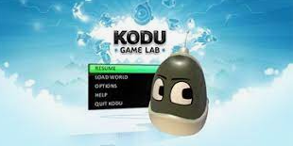
Building a maze game 1 – How to build a maze with different colour walls. Building a maze game 2 – How to use smart tools to create our maze.
Maths (White Rose)

Negative Numbers:
Understand negative numbers
Count through zero in 1s
Count through zero in multiples
Compare and order negative numbers
Find the difference

Converting Units:
Kilograms and kilometres
Millimetres and millilitres Step 3 Convert units of length Step 4 Convert between metric and imperial units Step 5 Convert units of time Step 6 Calculate with timetables

