Geography Focus – Enquiry Question  Changes in our local environment. | Y5 Changes in our Local Environment  How has our area changed from past to how might it look in the future? | The Curriculum – Threshold Concepts
          Working goegraphically to:  Communicate Goegraphically  - name and locate counties and cities of the UK, geographical regions and their identifying human and physical characteristics, key topographical features (including hills, mountains, coasts and rivers), and land-use patterns; and understand how some of these aspects have changed over time  Enquire Goegraphically  - understand geographical similarities and differences through the study of human and physical geography of a region of the UK  Use mapping techniques  - use maps, atlases, globes and digital/computer mapping to locate countries and describe features  - use the eight points of a compass, four- and six-figure grid references, symbols and key (including the use of OS maps) to build their knowledge of the UK and the wider world  Study Location  - use fieldwork to observe, measure, record and present the human and physical features in the local area using a range of methods, including sketch maps, plans and graphs and digital technologies. | 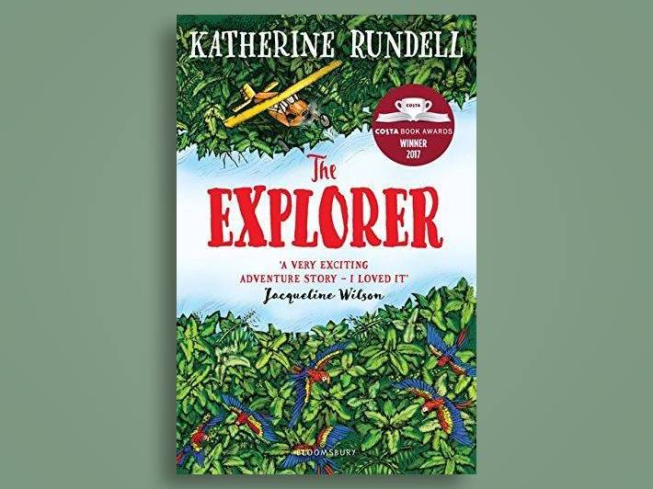  English Focus text: The Explorer by Katherine Rundell  Writing Outcomes:  Extended piece: Play script  Mini process: setting description (from a character point of view).  Poetry: War Poetry – Narrative Poetry  Reading Outcomes:  Reading skills: predicting, clarifying, questioning and summarising.  Grammatical Skills:  Subject related vocabulary (incl. old English) Basic punctuation Present Tense (for stage directions) Word classes Adverbs (character’s actions) Pronouns Determiners Prepositions (scene description)  Link Reading:  ‘Bombs and Blackberries – WW1 – a play script’ by Julia Donaldson  ‘Journey to the river Sea’ – Eva Ibbotson  Maths: White Rose  Multiplication & division  • Identify multiples and factors, including finding all factor pairs of a number, and common factors of two numbers.  • Know and use the vocabulary of prime numbers, prime factors and composite (non-prime) numbers  • Establish whether a number up to 100 is prime and recall prime numbers up to 19  • Multiply numbers up to 4 digits by a one- or two-digit number using a formal written method, including long multiplication for two-digit numbers • Multiply and divide numbers mentally drawing upon known facts  • Divide numbers up to 4 digits by a one-digit number using the formal written method of short division and interpret remainders appropriately for the context  • Multiply and divide whole numbers and those involving decimals by 10, 100 and 1,000 • Recognise and use square numbers and cube numbers, and the notation for squared (2 ) and cubed ( 3 )  • Solve problems involving multiplication and division  Fractions  - Identify, name and write equivalent fractions of a given fraction, represented visually, including tenths and hundredths  - Recognise mixed numbers and improper fractions and convert from one form to the other and write mathematical statements > 1 as a mixed number  - Compare and order fractions whose denominators are all multiples of the same number  - Add and subtract fractions with the same denominator, and denominators that are multiples of the same number | P.E  Invasion Games – Football  -To be able to control the ball, dribble and turn.  -To be able to pass the ball accurately and find space to receive a pass  -To be able to tackle and mark players.  -To be able to apply learned skills in a game of football.  ICT  Computer Science: Spreadsheets – Using Formula to automate mathematical problems.  Computer Science: Networks: Search Algorithms  E-Safety project: Project evolve – online bullying  PSHE  Jigsaw: Celebrating difference  To explore culture and cultural differences.  I will learn about…  -The lives of people in other countries,  - My own and other people’s cultures  RE  Enquiry Questions: What does it mean to be a Muslim in Britian today?  -To understand Muslim beliefs about God, the Prophet and the Holy Qur’an.  -To gain an understanding about ibadah and the links to the Five Pillars, festivals, and places of worship.  MUSIC  Unit 2: Solar Systems  Key Skill: Listening  1. Listening to music with focus and analysing using musical vocabulary  2. Relating sound sequences to images  3. Interpreting images to create descriptive sound sequences  4. Developing the use of dynamics in a song  MFL  Intermediate Skills  Unit: The Date  -Learn to recognise and recall the 7 days of the week in Spanish.  -Learn to recognise and recall the 12 months of the year in Spanish.  -Learn to recognise and recall numbers 1-31 in Spanish.  Art  Pathway: Making Monotypes  - To be able to learn that we can combine monotype with other disciplines such as painting and collage.  -To be able to understand that Monotype is a process where we make images by transferring ink from one surface to another to make a single print.  DT  Unit Focus: Structures  -To understand that structures can be large (e.g. buildings and bridges) or small (e.g. chairs and tables)  -To understand that freestanding structures are structures that can stand up without being attached to something else.  -To understand that freestanding structures need to support their own weight and also the weight of the things/people using them.  -Use designing, making and evaluating skills to create a bridge strong enough to transport a vehicle over water. (Use historical evidence of bridges being used in the past to support the movement of goods/ people
Science Physics – Forces
Working Scientifically to:
- Explain that unsupported objects fall towards the Earth because of the force of gravity acting between the Earth and the falling object and the impact of gravity on our lives.
- Identify the effects of air resistance, water resistance and friction, which act between moving surfaces.
- Recognise that some mechanisms, including levers, pulleys, and gears, allow a smaller force to have a greater effect.
Scientific Enquiry:
