- Focus: Changes in Britain from the Stone Age to the Iron Age | Planning Around A Text: Stone Age Boy by Satoshi Kitamura | Y3 Medium Term Plan – Autumn 2019
History Objectives:  To investigate and interpret the past:  - Use evidence to ask questions and find answers to questions about the past.  - Use more than one source of evidence for historical enquiry in order to gain a more accurate understanding of History.  - Suggest causes and consequences for some of the changes in History.  To build an overview of word history:  - Describe the social, ethnic, cultural or religious diversity of past society.  - Describe the characteristic features of the past including ideas, beliefs, attitudes and experiences of men, women and children.  To understand chronology:  - Understanding of change over time, representing, along with evidence, on a timeline.  To communicate historically:  Use appropriate historical vocabulary to communicate including: time period, era, change and chronology.  Mathematics Themes:  Fractions  Time  Properties of Shape  Place Value  Times tables and division tables - 8x tables, 7x tables, 9 x tables and 12x tables | 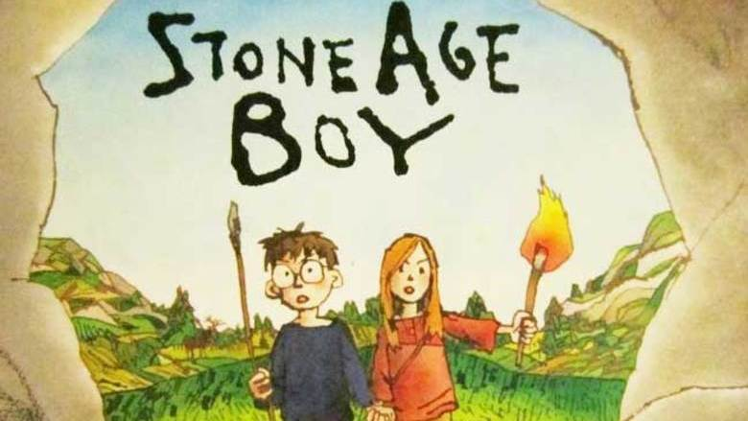  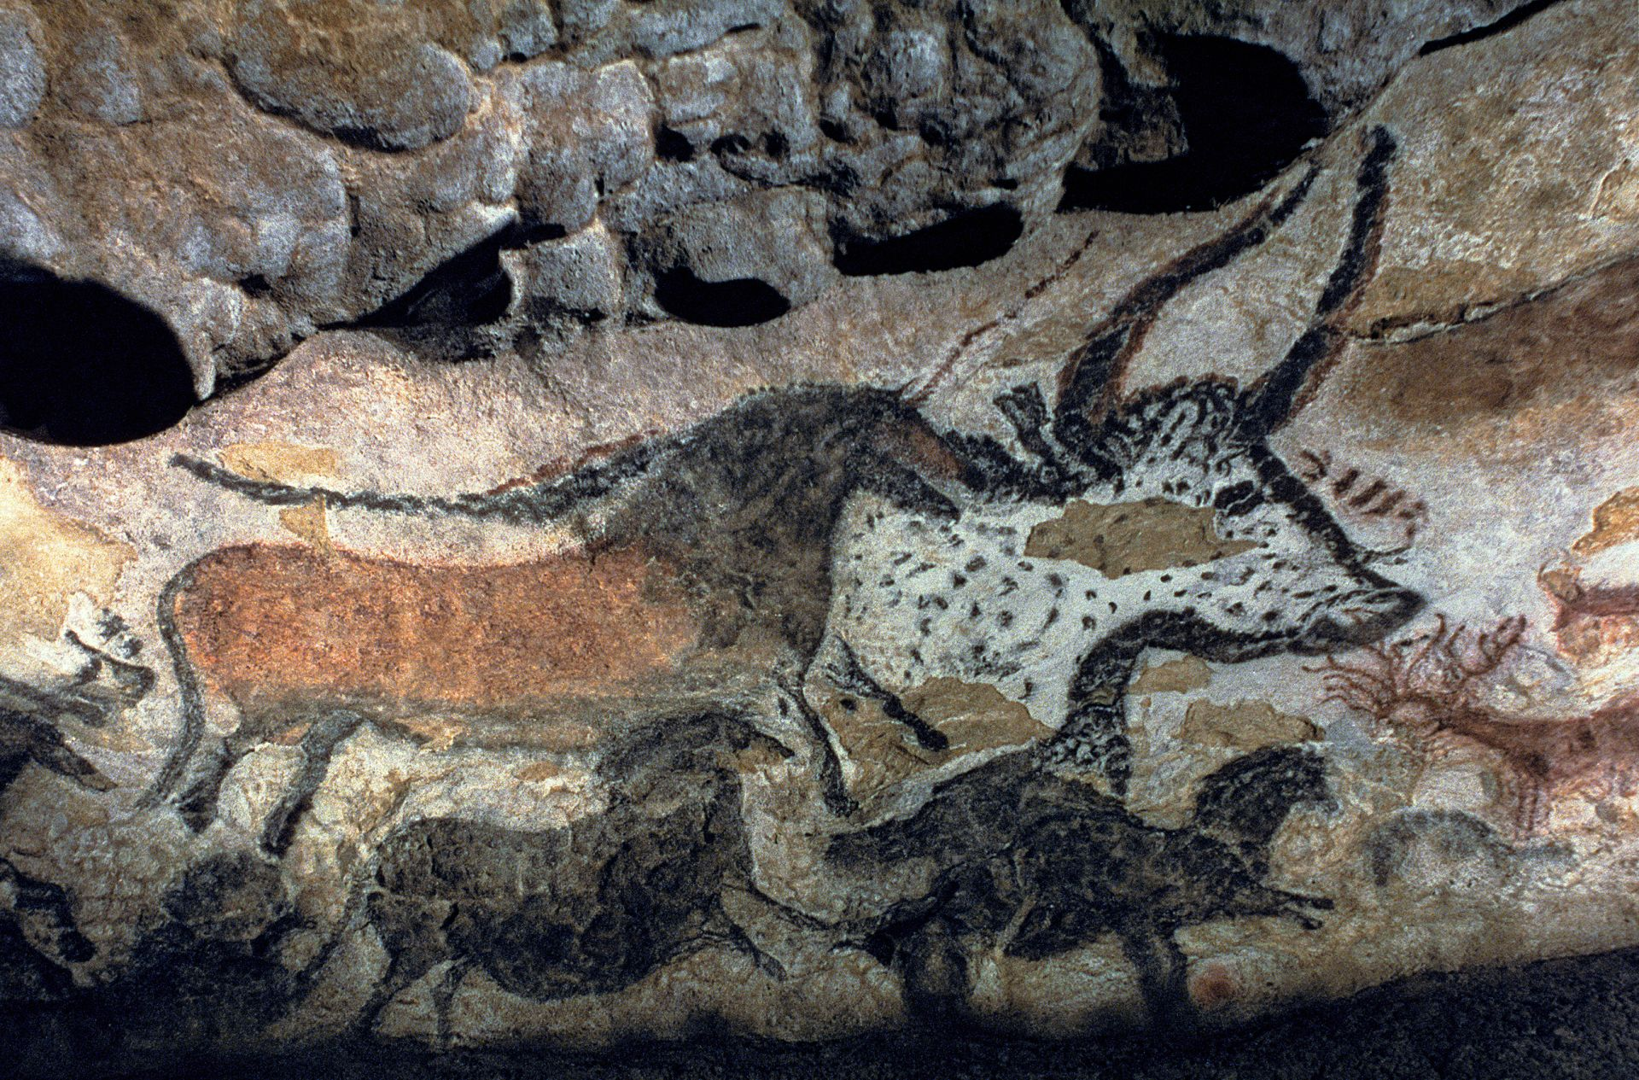  Science Objectives:  To work scientifically:  Ask relevant questions, gather record, classify and present data in a variety of ways to help in answering questions and identify differences, similarities or changes related to simple, scientific ideas and processes  Rocks:To compare and group together different kinds of rocks on the basis of their appearance and simple physical properties ♣ describe in simple terms how fossils are formed when things that have lived are trapped within rock and recognise that soils are made from rocks and organic matter.  To investigate materials: Compare and group materials together, according to whether they are solids, liquids or gases.  • Observe that some materials change state when they are heated or cooled and measure the temperature at which this happens in degrees Celsius (°C), building on their teaching in mathematics.  • Identify the part played by evaporation and condensation in the water cycle and associate the rate of evaporation with temperature. | Art Objectives:  To develop ideas:  - Comment on artwork using visual language  - Collect information, sketches and resources.  - Explore ideas in a variety of ways.  - Develop ideas from starting points in history.  To master techniques:  Drawing:  • Annotate sketches to explain and elaborate ideas.  • Use shading to show light and shadow.  Painting:  - Mix colours effectively.  - Use water colour paint to produce washes for backgrounds and then add detail.  To take inspiration from the greats (classic and modern)  - Create original pieces that are influenced by studies of others.
Anticipated Writing Outcomes:
Exploration of writing for pleasure.
(Have a go at a range of text types!)
Writing Process (2 different text types):
Text interrogation; teacher modelling; shared writing; independent writing; edit to improve writing; re-write (further draft).
Text Types:
1. Character description of cave children (compare and contrast)
2. Poetry: write and perform
3. Description of a setting
4. Diary writing: The day in the life of a Stone Age child.
5. Imaginative writing – adapt the end of the story
6.Description of the main character.

